Instructions of using the GxE_Weather_Data_Format_Transfer

1. This program will put data into the following Postgresql database:  
   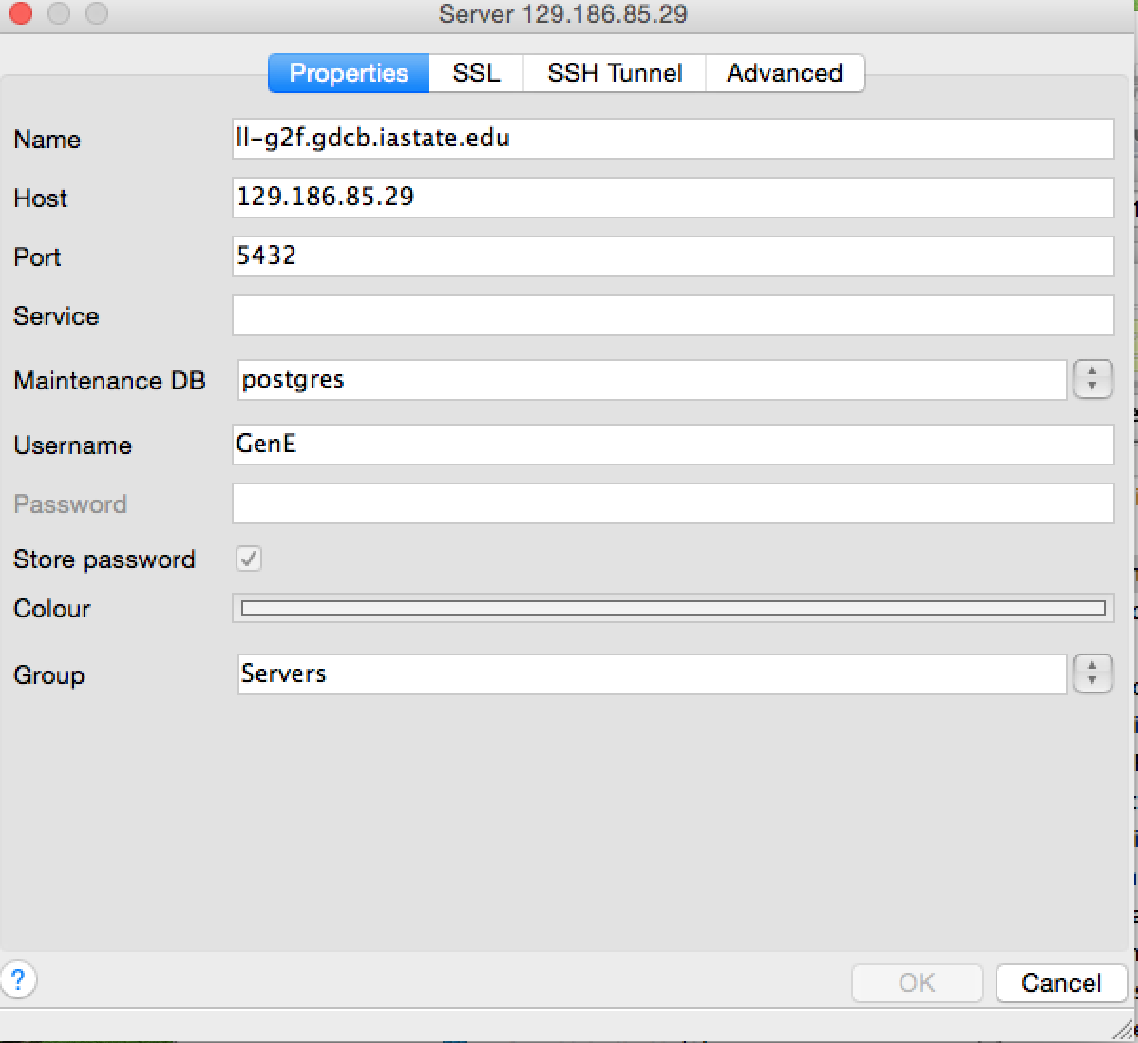
2. Use the Automator to get the file_Name_List in Desktop folder (file_Names_2015.txt in my case on Desktop);

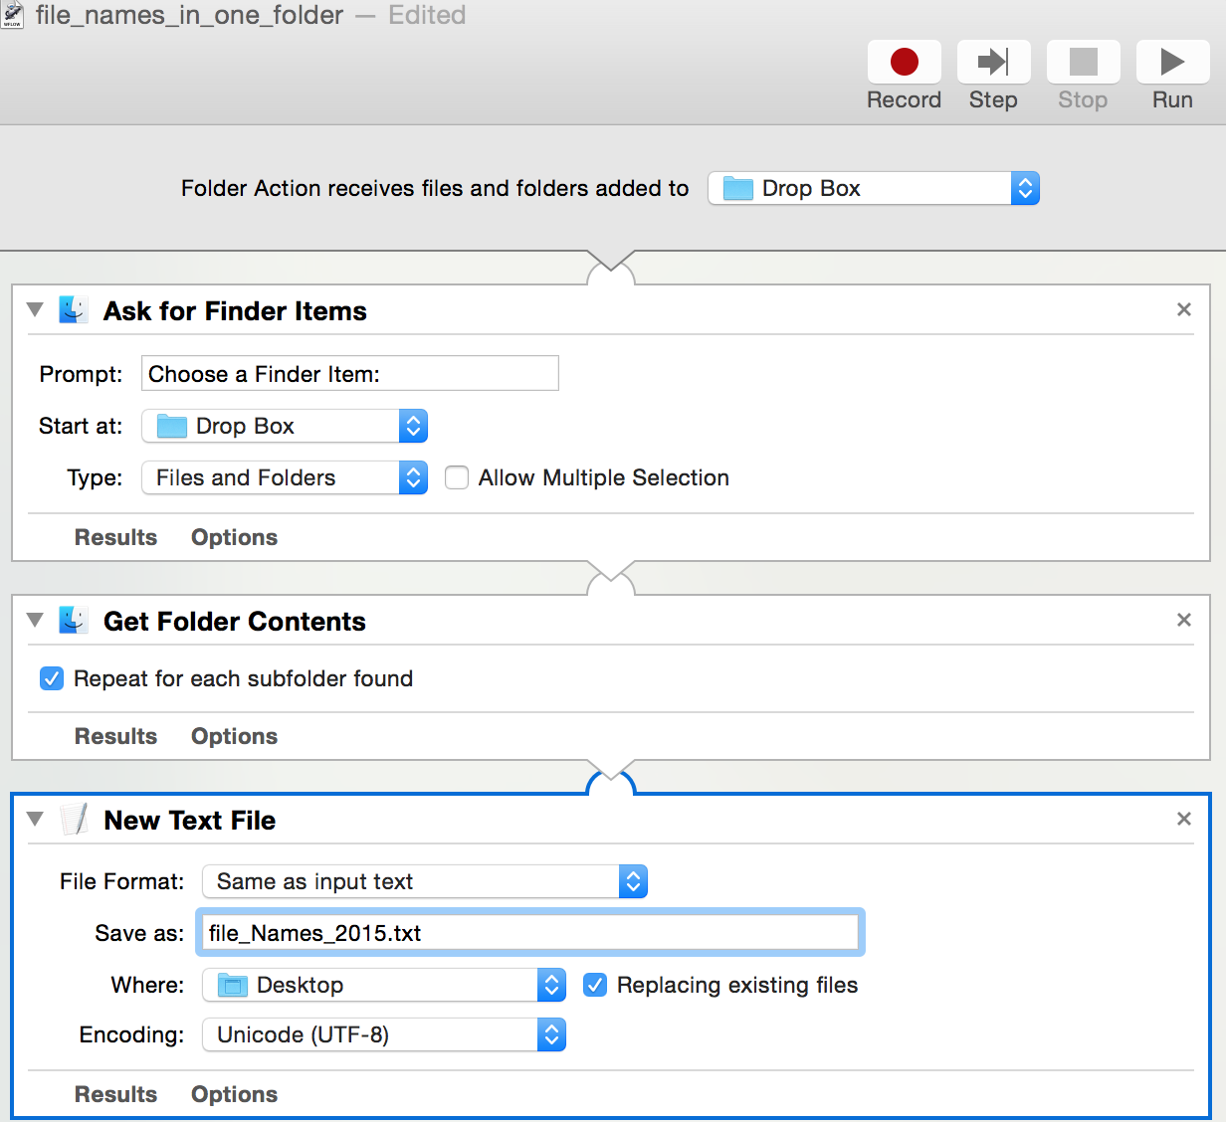

1. In Eclipse, run the GxE_Weather_Data_Format_Transfer/ Weather_Data_Format_Transfer_Manager as java application;

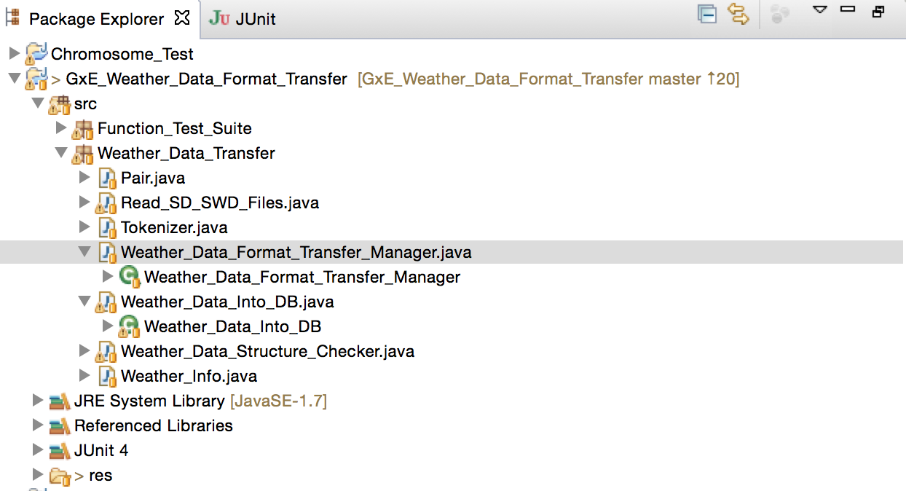

1. Then choose the file_Names_List, for example, file_Names_2015.txt from Desktop folder, click Open;

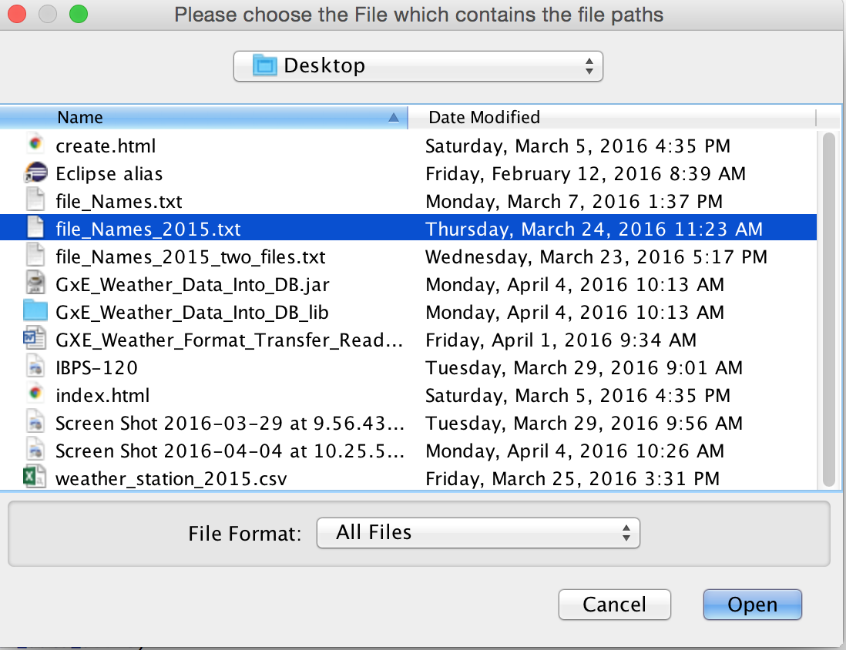

1. Done!
2. If you would like to add another year data(SWD files) into the same DB, same table, please follow the rules of folder names as 2015 like this:

Station id 9087: /Users/yiweisun/Public/Drop Box/weather_stn_0001/9087/SD201505.SWD

Station id 2700 with "_": /Users/yiweisun/Public/Drop Box/weather_stn_0005_2700/SD201505.SWD

Then, comment off this line in Weather_Data_Format_Transfer_Manager.java: *db_tester*.drop_Then_Create_Table(Weather_Data_Into_DB.*getConnection_Remote*());

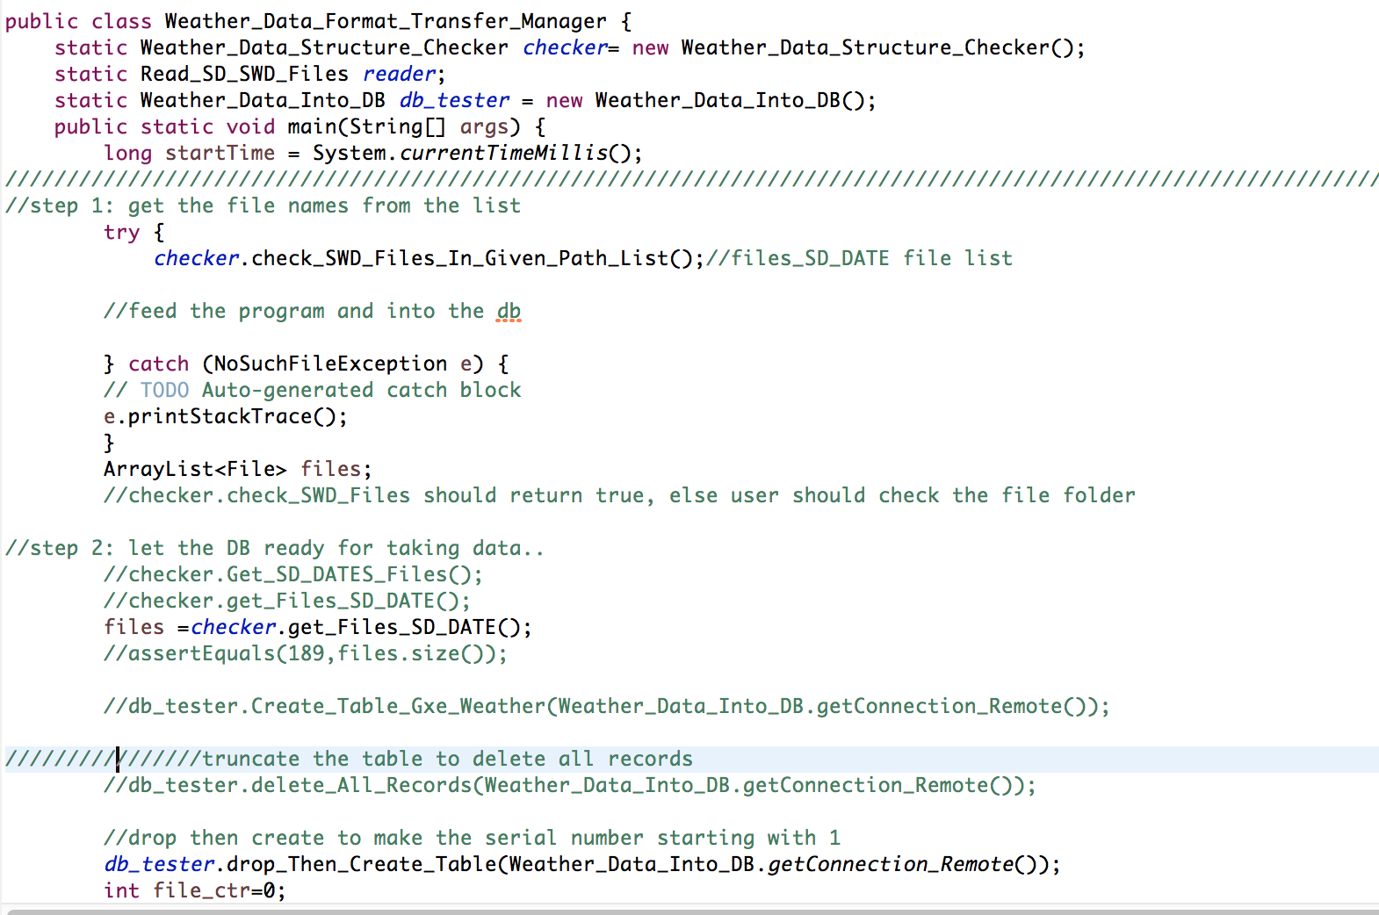  
Finally, run step 2-4 again.