Instructions of using the GxE_Weather_Data_Format_Transfer

- This program will put data into the following Postgresql database:
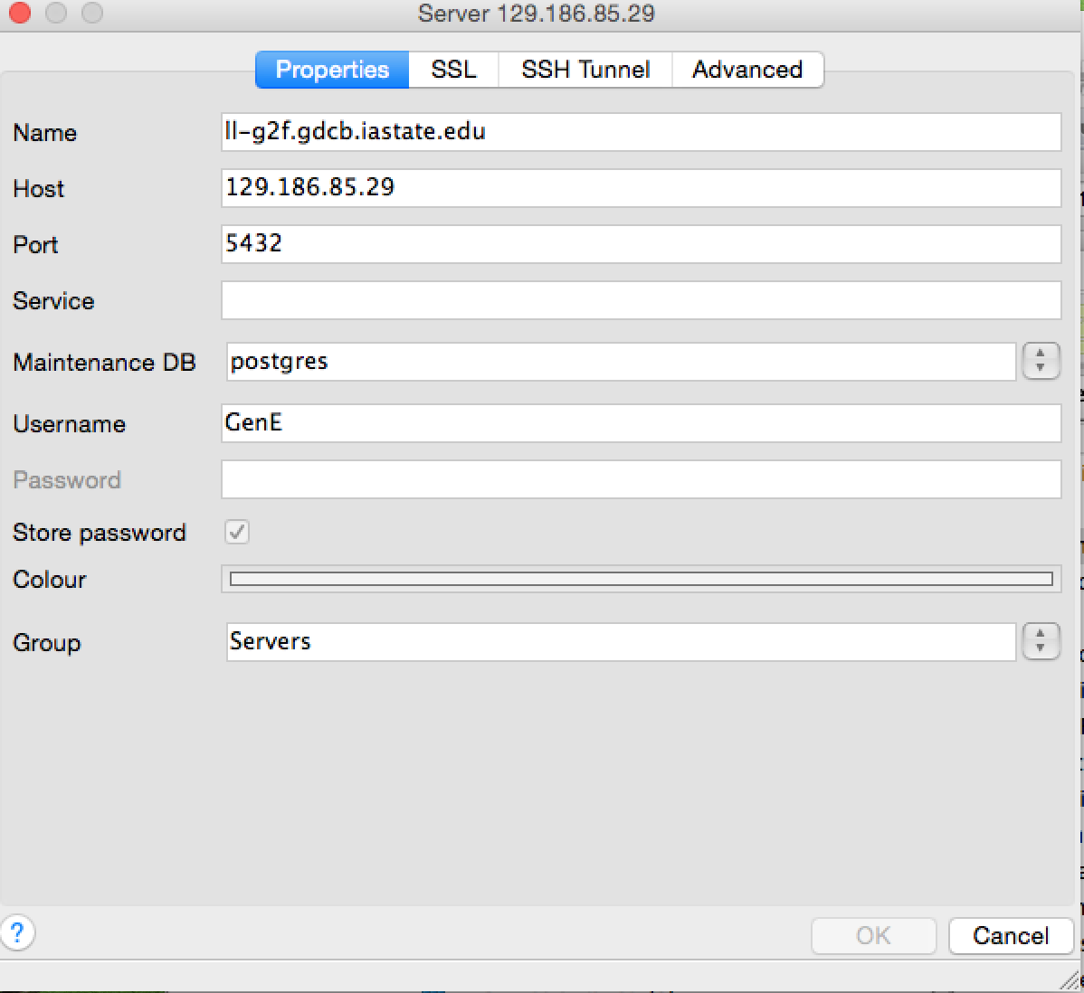
- Use the Automator to get the file_Name_List in Desktop folder (file_Names_2015.txt in my case on Desktop);
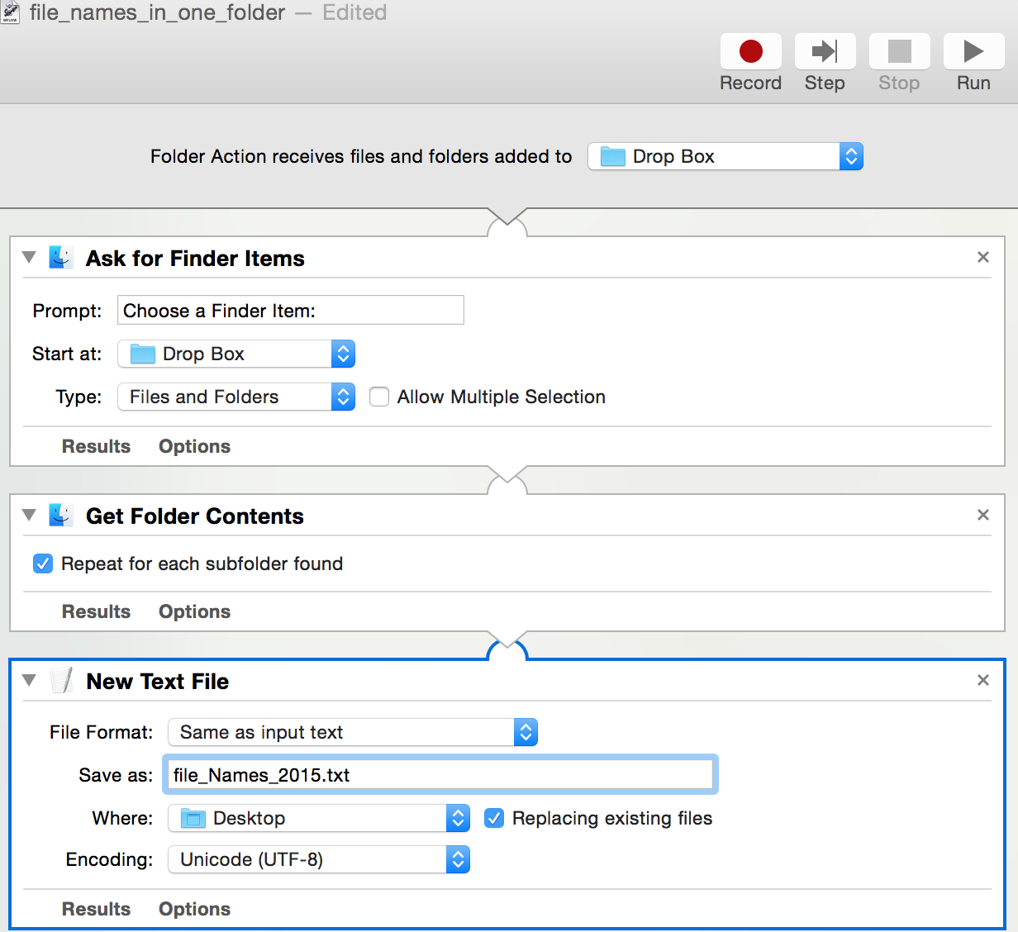
- In Eclipse, run the GxE_Weather_Data_Format_Transfer/ Weather_Data_Format_Transfer_Manager as java application;
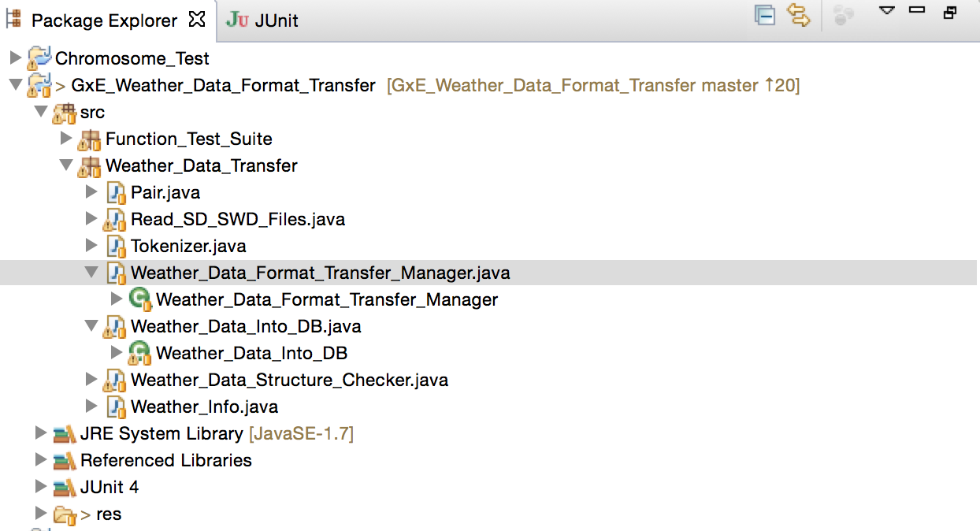
- Then choose the file_Names_List, for example, file_Names_2015.txt from Desktop folder, click Open;
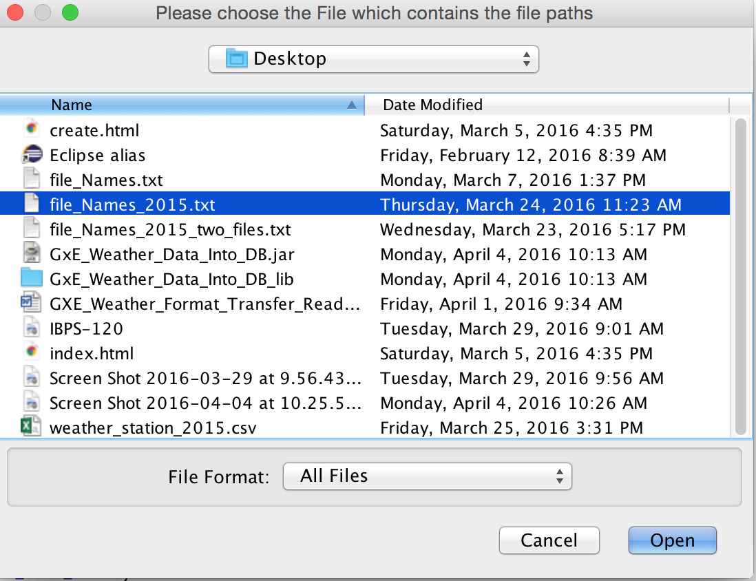
- Done!
- If you would like to add another year data(SWD files) into the same DB, same table, please follow the rules of folder names as 2015 like this:
Station id 9087: /Users/yiweisun/Public/Drop Box/weather_stn_0001/9087/SD201505.SWD
Station id 2700 with "_": /Users/yiweisun/Public/Drop Box/weather_stn_0005_2700/SD201505.SWD
Then, comment off this line in Weather_Data_Format_Transfer_Manager.java: db_tester.drop_Then_Create_Table(Weather_Data_Into_DB.getConnection_Remote());
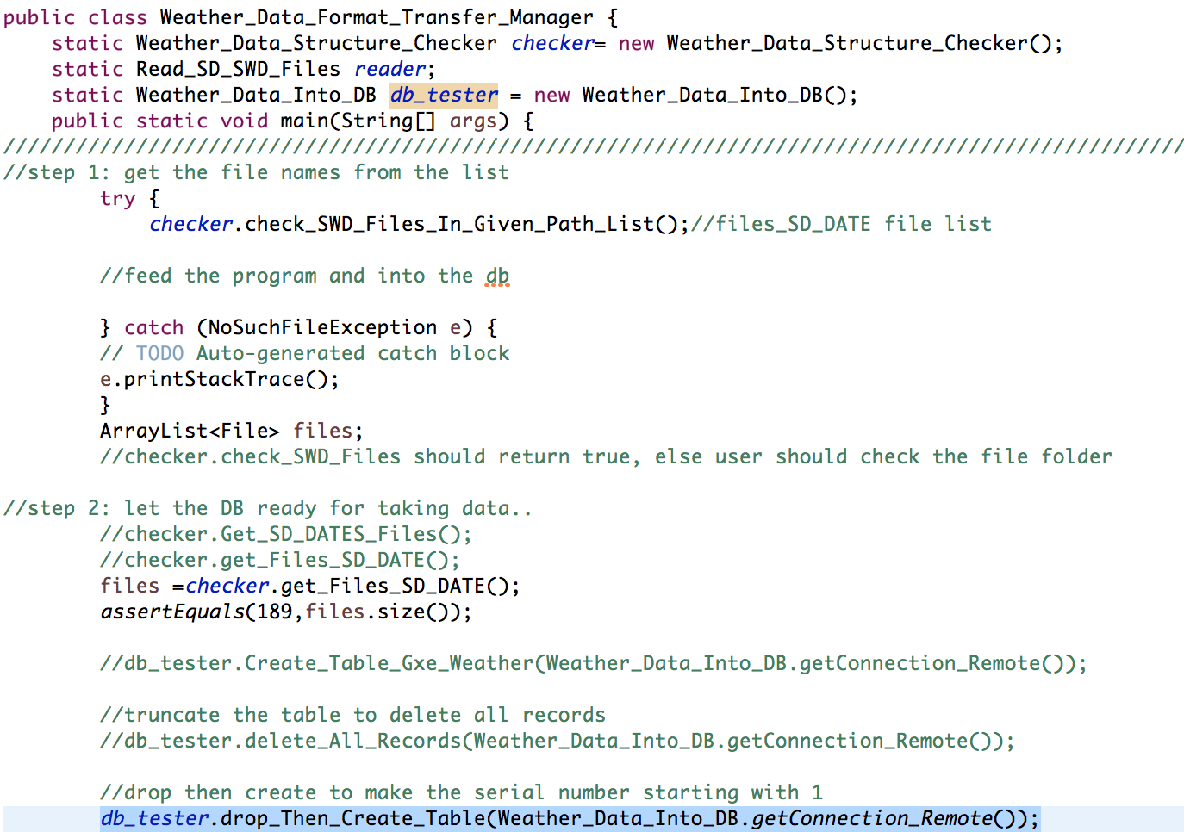
Then run step 2-4 again.

