|  |  |  |
| --- | --- | --- |
|  |  | User Requirement Analysis  Google Sheet Into DB |

May 25, 2016 Yiwei Sun

# Purpose

This open source project is for G2F collaborators to have a web interface to exchange their experiment data in Google sheet, so it would be easy for the collaborators retrieve all the data from a database with easy to use web interface. We would like to use Django framework to put the data into a Postgresql database since Django and Postgresql are all open source software, plus, Django is easy to learn/create web interfaces.



## User diagram

The user diagram is created through an open source software design tool [www.lucidart.com](http://www.lucidart.com). Here is the link for the user diagram: <https://www.lucidchart.com/documents/edit/91daddcb-de2d-4d87-8844-cae0189c6eb4>

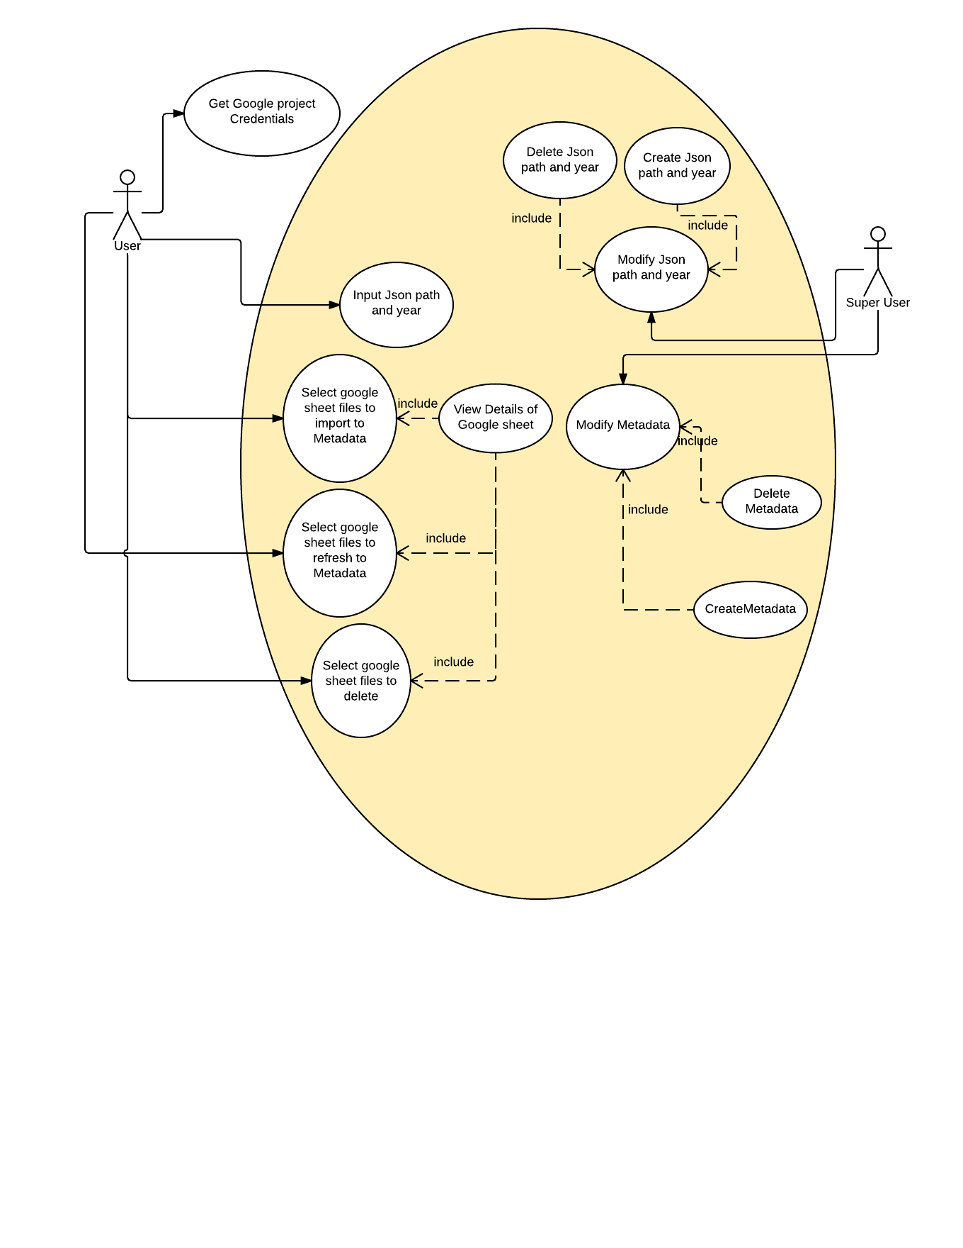

## Requirement analysis

## Through the user diagram, the user will input the JSON file path for Google project credentials and trial year for the experiment. The JSON file is required for accessing the Google sheet through Python. The user also need to check the contents of each Google sheet, import them into database, refresh them or delete them. The user also need to add select all in both refresh and import data so that he/she can save some time since there could be over 40 Google sheets to deal with.

## Web page design

<https://www.lucidchart.com/documents/edit/384e09f3-3407-4e02-a777-2c4ef88198d0/6>

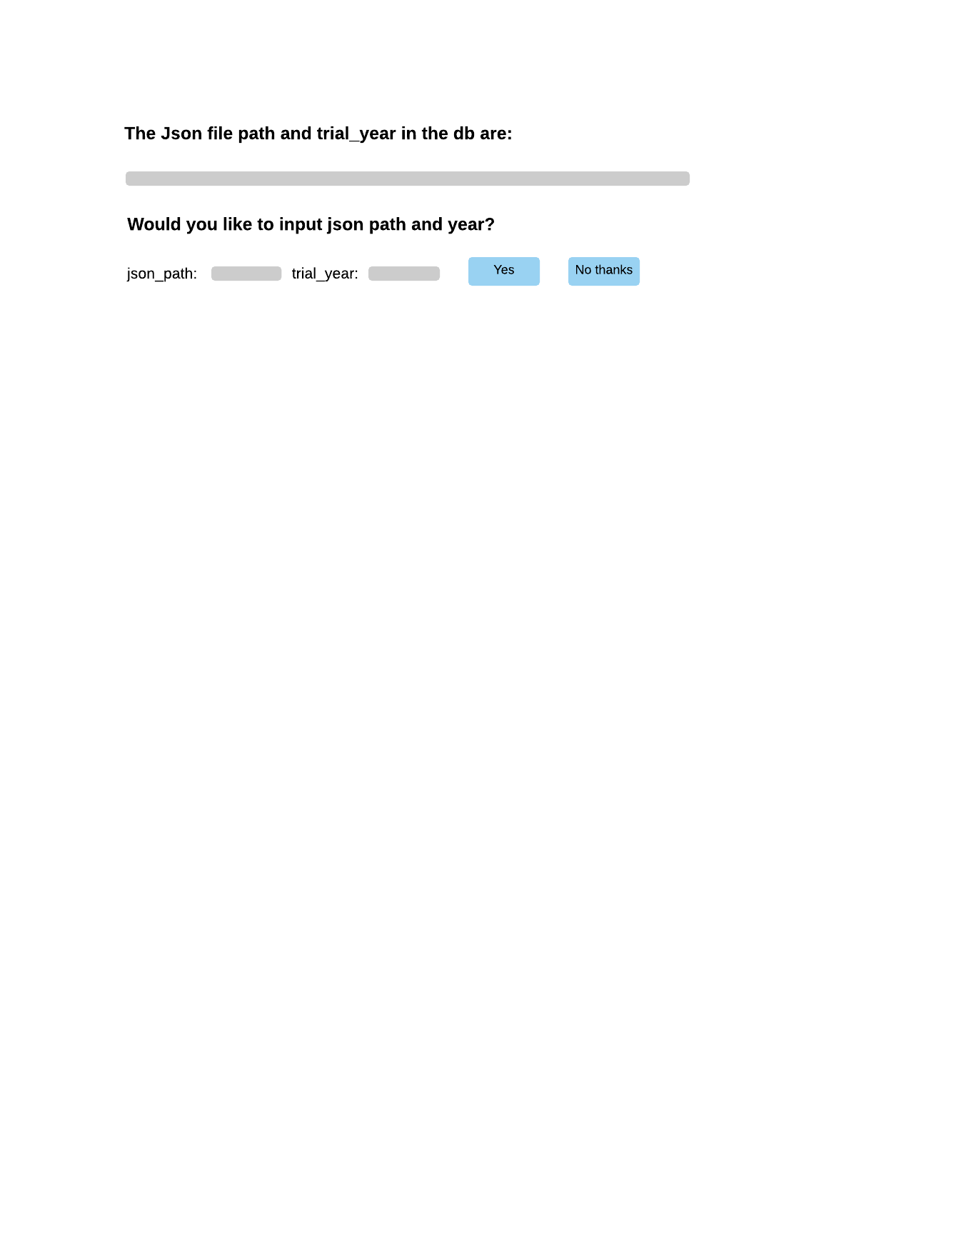

<https://www.lucidchart.com/documents/edit/384e09f3-3407-4e02-a777-2c4ef88198d0/4>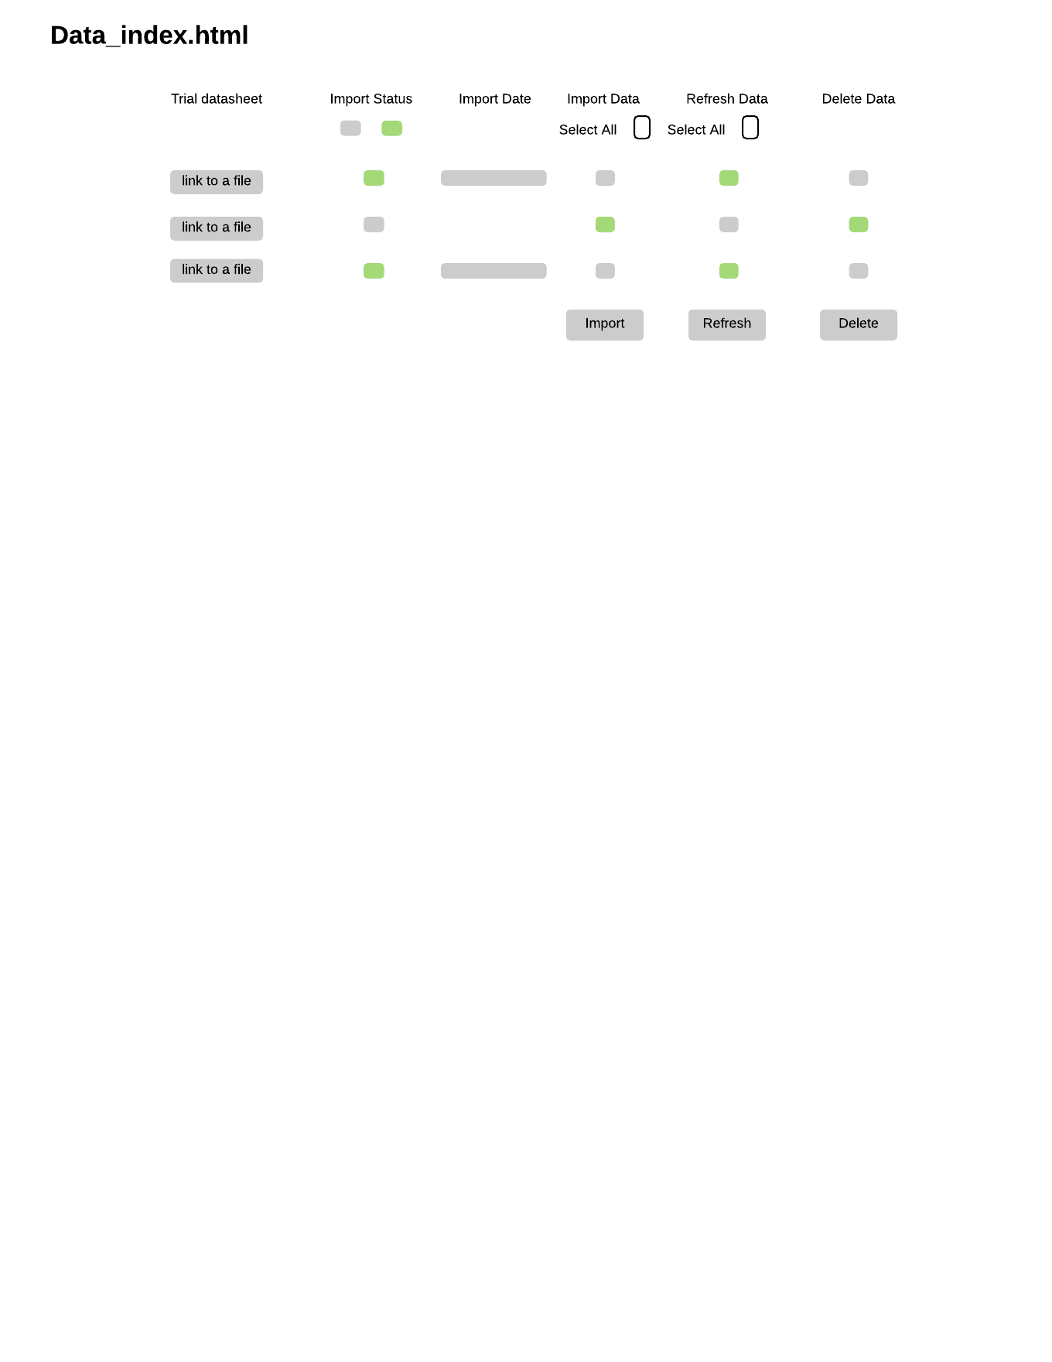

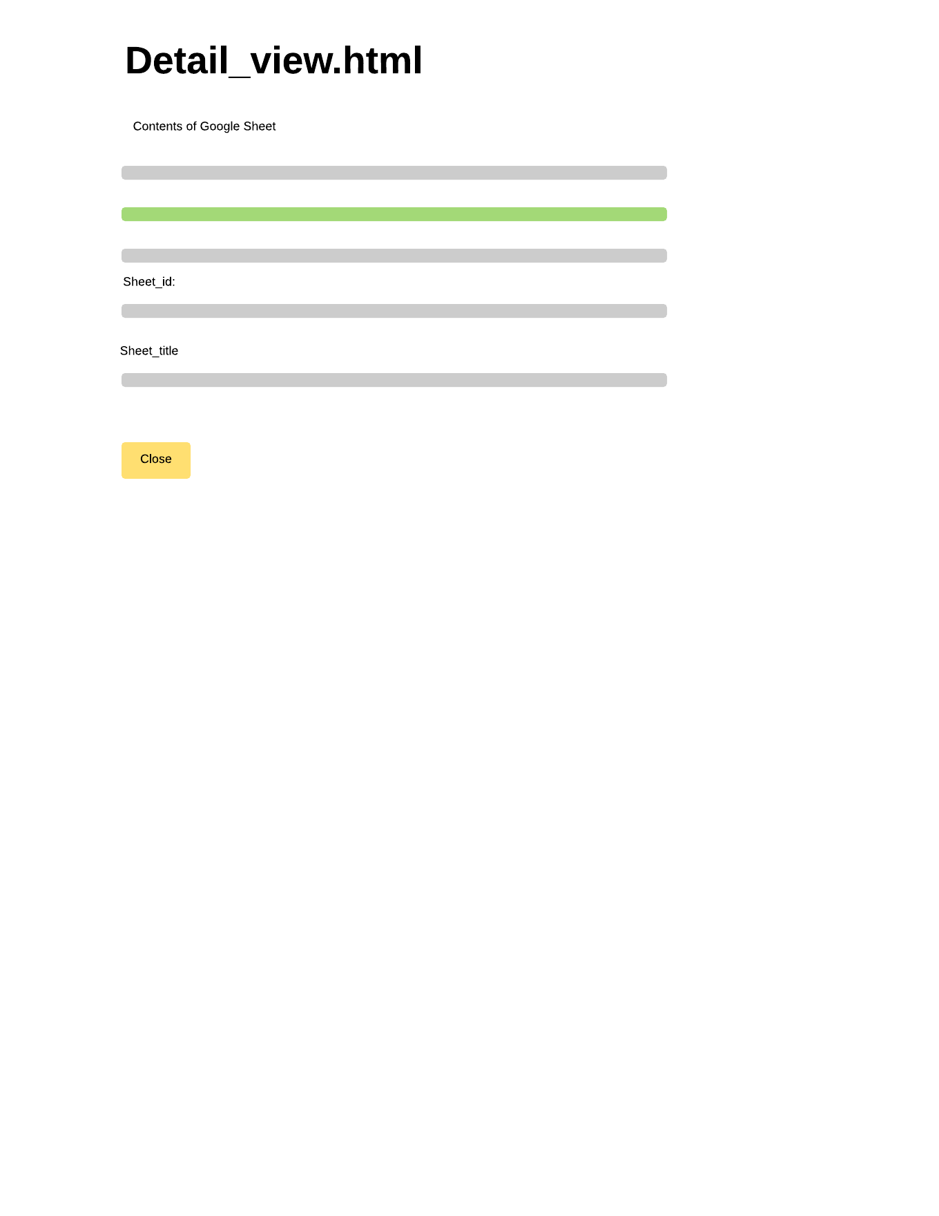

<https://www.lucidchart.com/documents/edit/384e09f3-3407-4e02-a777-2c4ef88198d0/5>

## Database design

Django database design followed the tutorial of Django, but there is one thing to mention here: only the Postgresql column names in table cannot contain either space or “/”, so I replaced space with “_” , “/” with “or” in the column names from Google sheet to column names of Metadata table, also, The table Metadata has all the columns from Google sheet plus sheet_id, title trial_year, date_import to support the data_index.html design.

The JSON path table is needed because JSON file path and trial year are inputted by user and it might change next year. So the program only get the last row value in the table to keep the data and trial year matching perfectly.

## Data structure and methods design

The data structures are designed to satisfy the need for certain step.

Step 1:

Get credentials from Google sheet project and download the credential JSON file

Step 2:

Show the JSON file local path and trial year or input them by user. We design a table Json_path to store the JSON path and trial year so that some files will be input later and the client site might lose the input data since it maybe shut down or lose power.

Step 3:

Select certain Google sheets to import, refresh or delete which shows in data_index.html.

To make the data_index.html showing as it designed, it needs a new dictionary design to contain all the information the design needed.   
single_object={**'title'**:googleSheet.title, **'id'**:googleSheet.id,**'imported_status'**:**'F'**,**'imported_date'**: **''**,**'import_data'**: **'T'**,**'refresh_data'**: **'F'**}

Also, it needs a method to compare the two lists from Google and from database to give the single objects in an array with certain Boolean or date values so that the table of Google sheets operations(to view details, to refresh, to import or to delete) can be shown in the data_index.html

**def** get_googleSheet_list(list_from_google, list_from_db)

Certain methods and lists are created in the views.py so that these lists of data can exchange freely between the methods in views.py. For example,

**def** set_import_sheet_titles():  
 **global** import_sheet_titles  
 import_sheet_titles=[]  
  
**def** add_import_title(title):  
 import_sheet_titles.append(str(title))  
  
**def** get_import_sheet_titles():  
 **return** import_sheet_titles

These methods are used to store the import sheet titles so that after the importation, the user can have a title list of import sheets.

## Exceptions design

When the button is clicked with no selections, the page should stay in the same page. For the refresh or delete action, the system should remind the user to confirm their action before the system actually accomplish it.

## Reference:

(Rajaraman, 2016)