**React: Great grandfather**

React – Context

The following exercise contains the following subjects:

* Context

**Instructions**

Create a Grandfather component.

The Grandfather component displays a Father component.

The Father component display a Son component.

The Son component displays a Grandson component.

Create a context that holds a state of an Array of gifts, which is initially empty.

From the father's component set Array of gift to the Context (can be anything you want)

Display to the screen the gifts in the Grandson component.

**Use only Context, and don't waste time on design.**

Example below:

Day Mode:

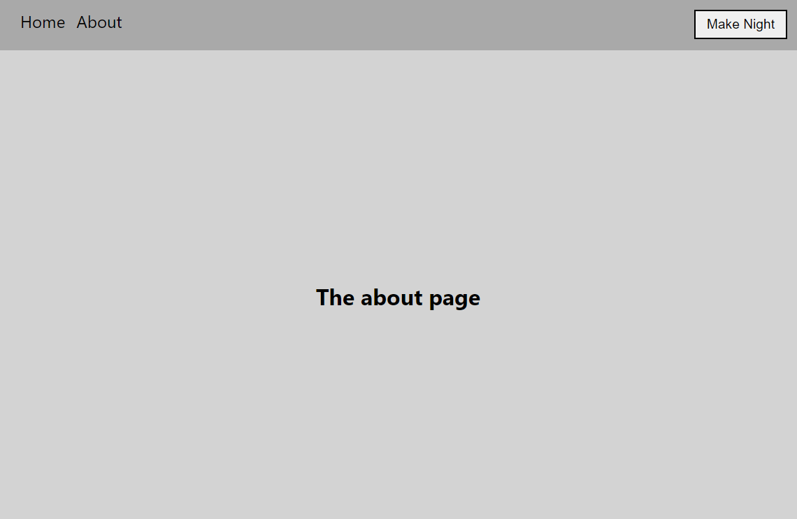

Night Mode:

