**React: Mood change**

React – Context

The following exercise contains the following subjects:

* Context

**Instructions**

Create an application with a top menu and two static pages, the top menu and each page will be a component.

In the top menu, create a toggle button that by clicking on it, will change the colors from day mode to night mode.

**The toggle button can be in a normal state, however, to change the colors use only the context.**

Example below:

Day Mode:

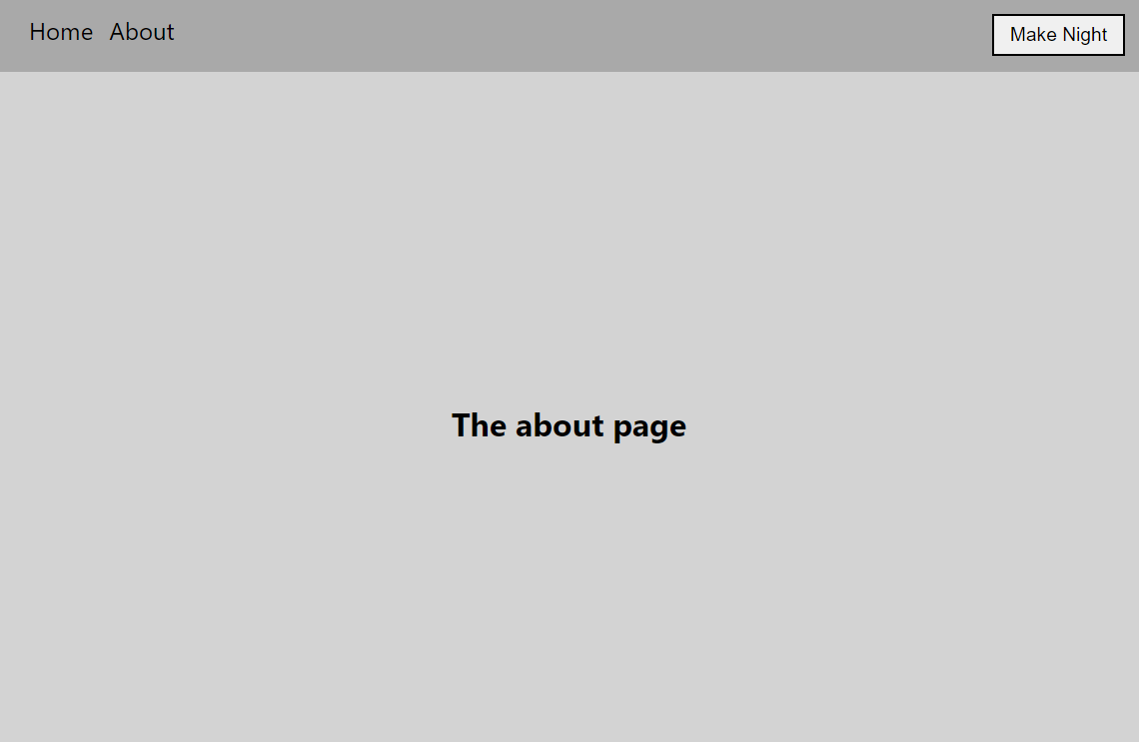

Night Mode:

