**React: JSX**

React – Quiz

The following exercise contains the following subjects:

* react components

**Instructions**

Create the following Front End Quiz:

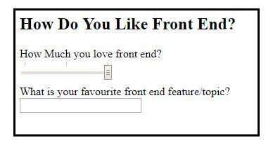

* Each element has to be a component
* You will have the following components:

Quiz, QuizTitle, Q1, Q1Title, Q1Input, Q2, Q2Title, Q2Input

* + Quiz: The overall container
  + QuizTitle: Quiz title
  + Q1: First question
  + Q1Input: First questions input

and so on…

Think where the components belong. Who is the father and who are the children.