**React: Forms**

React – form review

The following exercise contains the following subjects:

* forms
* state

**Instructions**

We want to create a survey that will include at least the following inputs:

1. At least two input text tags
2. At least one select tag
3. At least one text area tag
4. All inputs must be controlled

Before the user submits the form they have a chance to review their form before they submit it.

They have the opportunity to go back to the form and redo the form if they like.

**Mockup:**

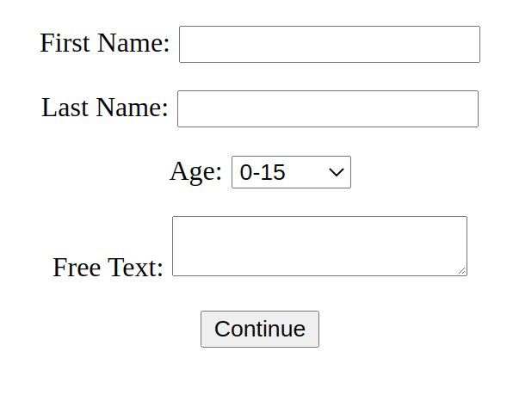

**Form:**

**Review their form:**

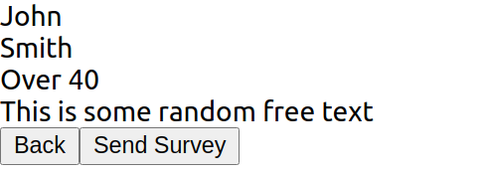

How to approach this exercise:

* Plan before you write any code.
* Think of the different components you would need to have.
* Think of where to keep your state. What components need to know about it? Do you need to drill the state down components? Do you need to do an event in a child component that will change the state of a parent component?