**Legends of Figures**

Fig. 1. Seasonality in leaf area index (LAI) of oak trees (a) and annual grasses (b) shown by the box-plots for each month. The top bars are three main pheno-stages, including Pheno I—the period between the dates of grass green-up and oak leaf-out, Pheno II—the period between the date sof oak leaf-out and annual grass die-out, and Pheno III—the period between the dates of annual grass die-out and germination.

Fig. 2. (a) The scatter plot between daytime net photosynthetic flux of oak tree canopy (*FA*) and air temperature (*Tair*) (in grey dots, n=108336), overlaid with means, median, quartiles within each I oC interval (each box plot). (b) An example of histogram and the Kernel density within the 23th bin. (c) Averaged photosynthetic flux (*FA*) within each bin assigned either by 1 oC interval or by a constant *n* (e.g., *n*=2000). Unweighted averages are compared to weighted averages according to the Kernel density. Smoothing curves for each group of averages show the relationship between *FA* and *Tair* extracted over the temperature range from 0 to 40 oC, in situ.

Fig. 3. Contour maps of light intensity (a, photosynthetically active radiation, *PAR*), air dryness (b, vapor pressure deficit, *VPD*), and soil moisture (c, volumetric moisture, *θv*) within the 2D domain of net photosynthetic flux of oak tree canopy (*FA*) and air temperature (*Tair*).

Fig. 4. Left panels: variations in light intensity (a, *PAR*), air dryness (b, *VPD*), and soil moisture (c, θv) during the daytime on Days of 100, 116, 123, 128,137, 152,158, and 185 in 2008 when leaf chamber experiments were carried out. The rectangles indicate controlled leaf chamber conditions—saturated light intensity, relatively no stress due to air dryness, and wet or dry soil moisture levels. Right panels: the Kernel Density of light intensity (d, *PAR*), air dryness (e, *VPD*), and soil moisture (f, θv) coinciding with *Tair* based on the half-hourly measurements from 2001 to 2015.

Fig. 5. The relationship of oak-leaf photosynthesis (*Aleaf*) to temperature inside of leaf chamber (*Tleaf*) (a) and the relationship of oak canopy photosynthesis (*FA_canopy*) to air temperature (*Tair*) during the days of leaf-chamber experiments (b) and bin-averages of *FA_canopy* extracted from available data collected during the second and third pheno-stages in 2008 (c). Smoothing curves in (a) and (b) are estimated directly from raw data, and smoothing curves in (c) are based on bin-averages while each bin is assigned by n=500.

Fig. 6. Left panels: the relationships of oak canopy photosynthesis (*FA_canopy*) to air temperature (*Tair*) under discrete experimental scenarios according to variations in light intensity (a), air dryness (b), or soil moisture (c). Right panels: the overall pattern of the *FA_canopy*-*Tair* relationship extracted from the tower-based measurements during growing seasons between 2001 and 2015, overlaying patterns of experimental scenarios of light intensity (d), air dryness (e), or soil moisture (f) (grey dots).

Fig. 7. Oak canopy photosynthesis (*FA_canopy*) responds to variations in light intensity (a), air dryness (b), or soil moisture (c) given five magnitude levels from 1 to 5 in the order of low to high levels (details in Methods). At each magnitude level, three values of *FA_canopy* are compared among temperatures of 10, 20, and 30 oC. Horizontal lines are overall averages of *FA_canopy* at the three temperature points, respectively.

Fig. 8. The overall patterns of the relationship between photosynthesis (*FA*) and air temperature (*Tair*) for oak canopy, understory grassland, savanna, and open grassland, extracted from the entire sampling domain (a), and the first-order differentials (d*FA*/d*Tair*) of smoothing curves presents a linear function of air temperature (*Tair*).

Fig. 9. Variations in optimum temperature of photosynthesis (*Topt*) in experimental scenarios of light intensity (*PAR*), air dryness (*VPD*), and soil moisture (*θv*) for oak canopy (a), understory grassland (b), entire savanna (c), and open grassland (d).

Fig. 1

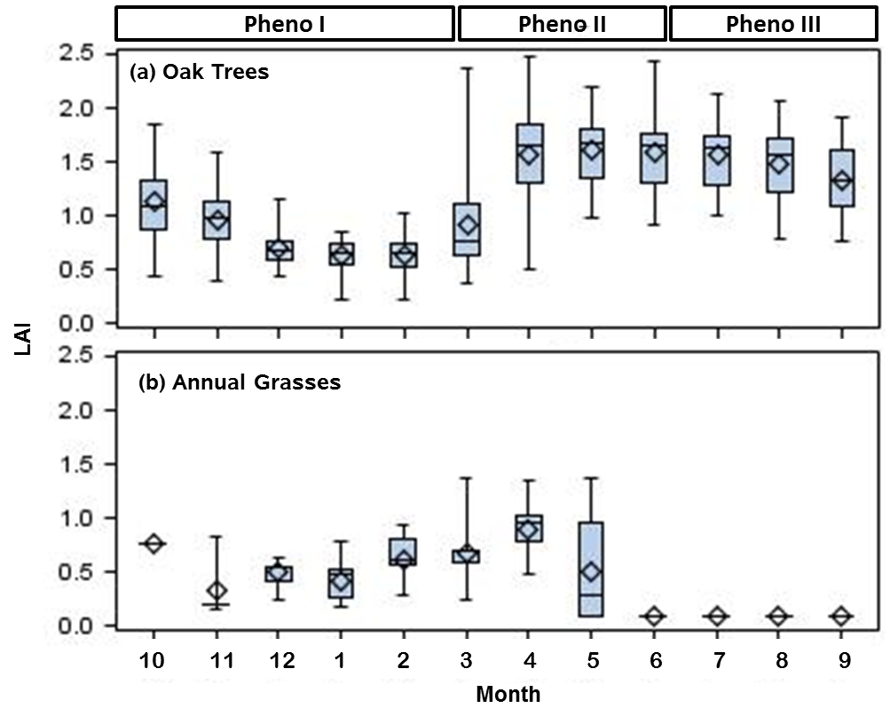

Fig. 2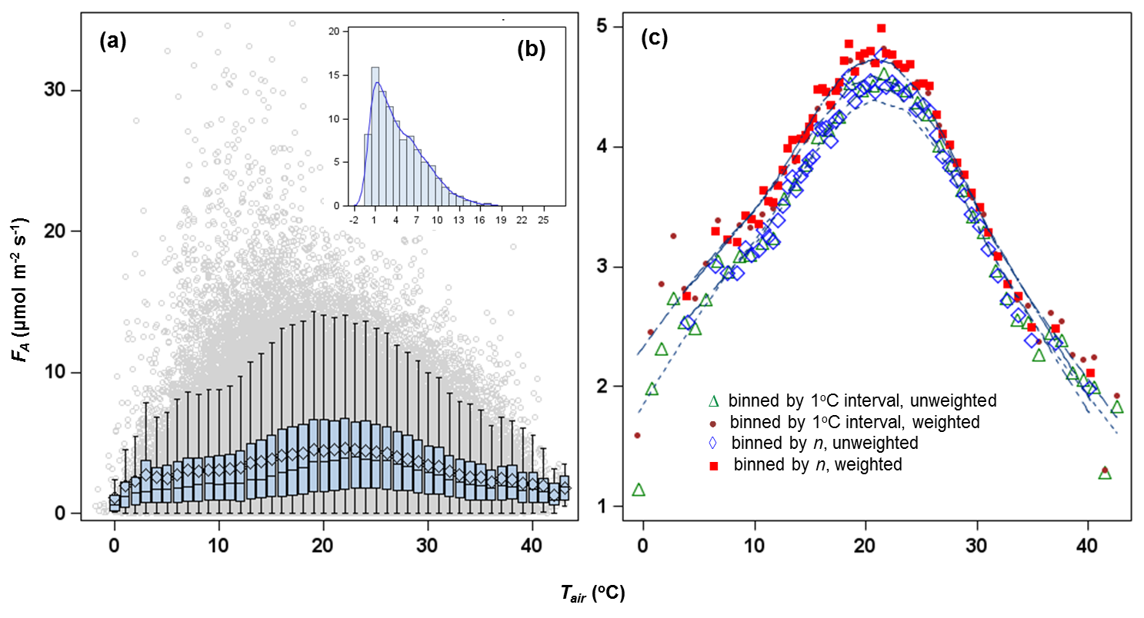

Fig. 3

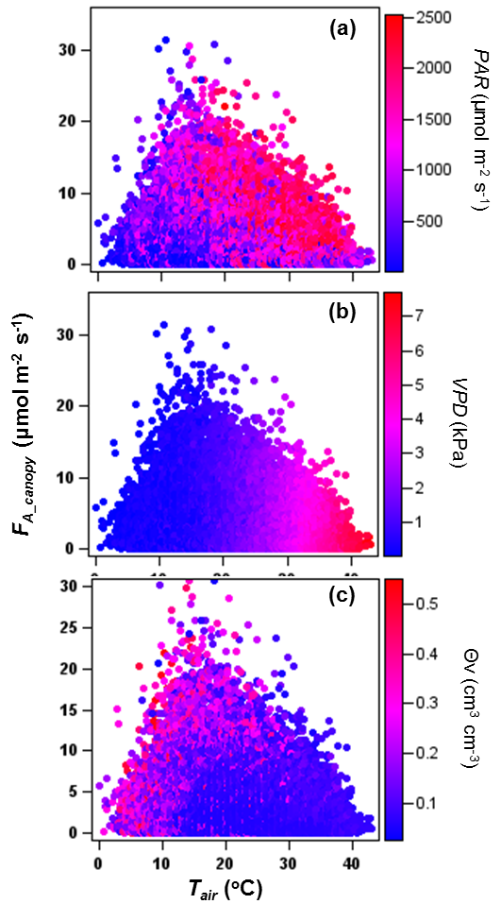

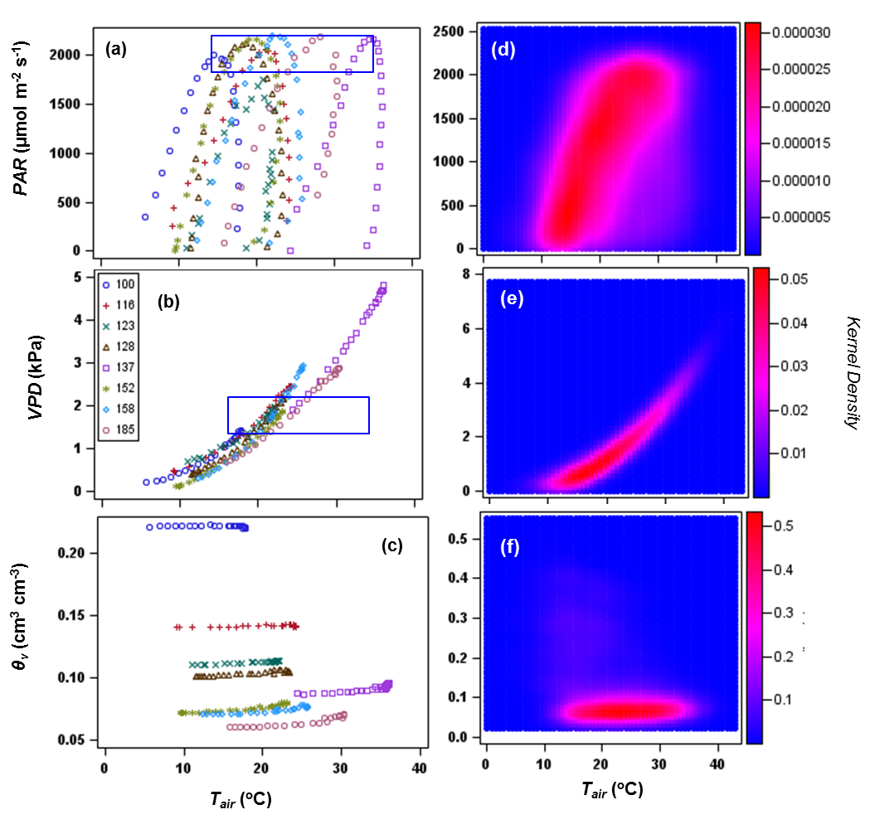

Fig. 4

Fig. 5

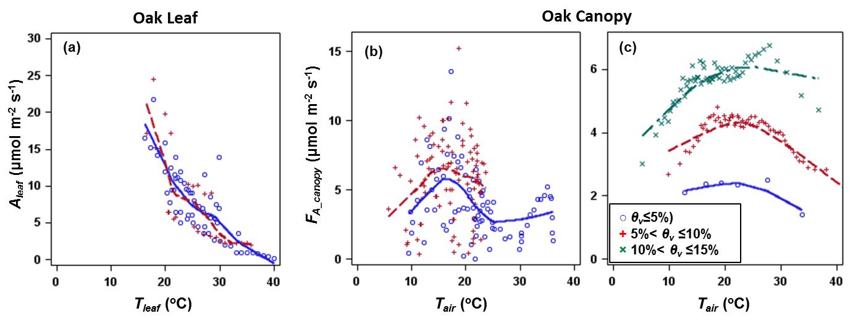

Fig. 6

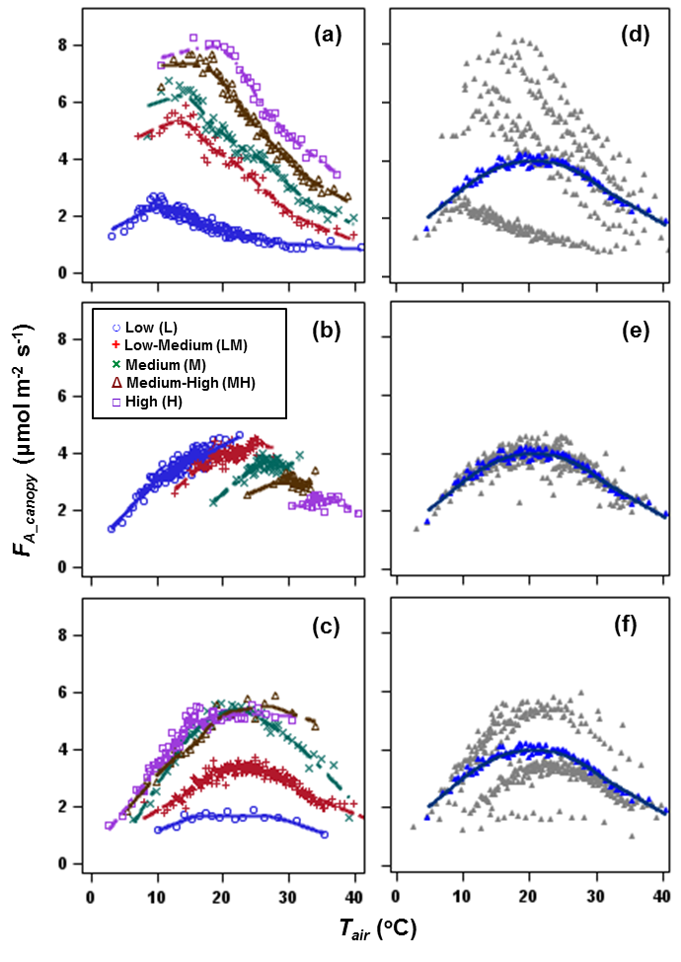

Fig. 7

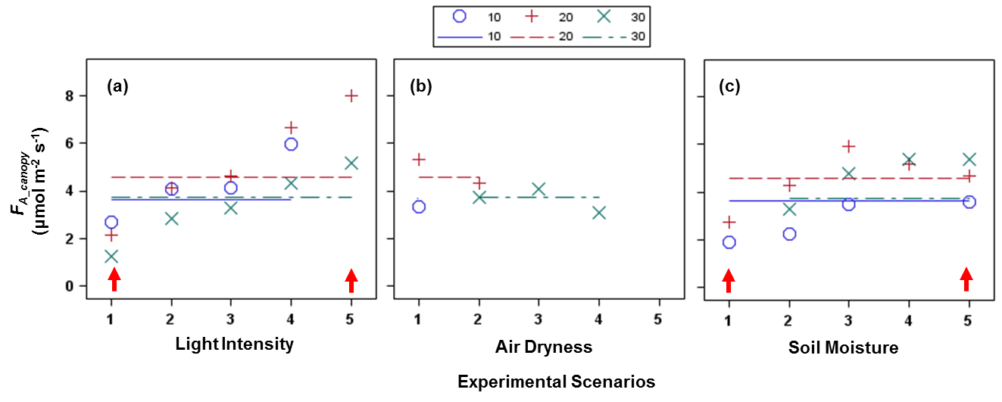

Fig. 8

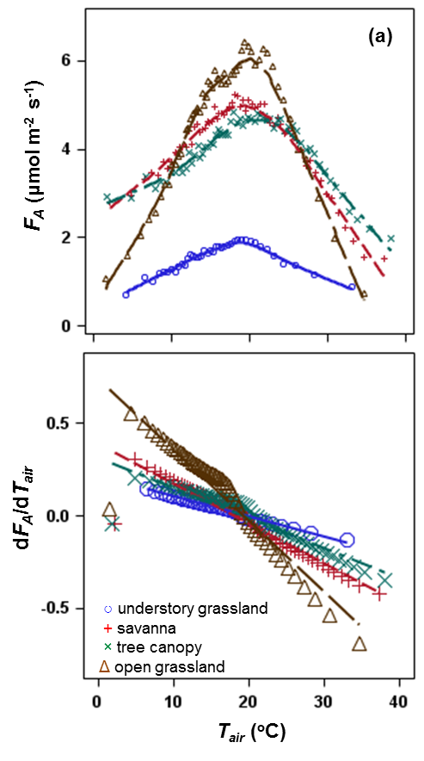

Fig. 9

