

didactics.co.in

**Application Work Flow**

*(This section displays the flow of information in the application)*

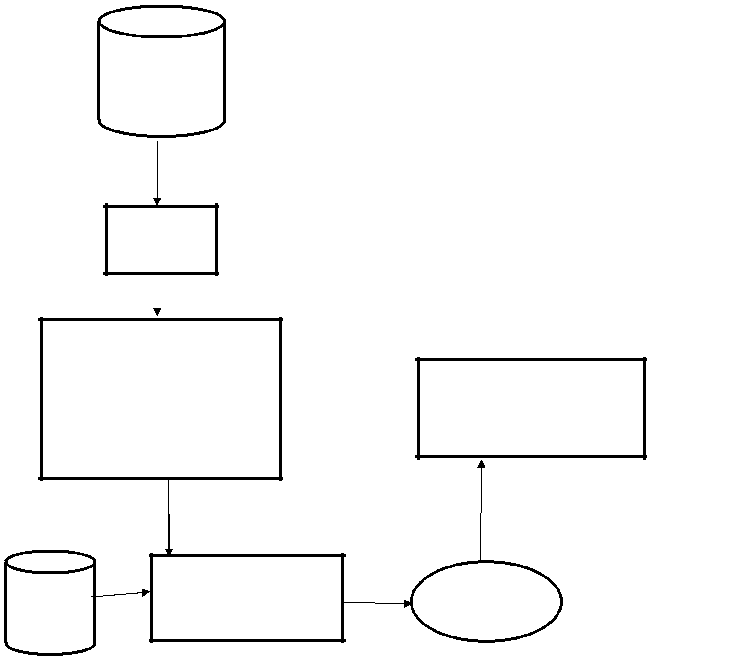

Training Data

Data Cleaning

Training Data

k-NN

Linear Regression

Moving Average

Random Forest

Evaluate

Test Data

Prediction

ML Algorithms

|  |  |  |  |
| --- | --- | --- | --- |
|  |  |  |  |
|  |  |  |
|  |  |



www.didactics.co.in