**The Canonical Sonic Hedgehog Pathway in Adult Vertebrate Neurons – a Computational Model**

**INTRODUCTION**

Sonic hedgehog has been the most extensively studied vertebrate homologue of the Hedgehog (Hh) family of signalling proteins as it regulates a diversity of post- and pre-natal processes (Ye and Liu, 2011). Most notably, Shh acts as a morphogen pivotal to the patterning of embryonic tissues, ranging from the limbs to the brain, as well as controlling the homeostasis and regeneration of several adult tissues (Ingham and McMahon, 2001; Lum and Beachy, 2004).

Recently, there has been emerging interest regarding Shh’s function in the adult brain following the discovery of its pattern of activity throughout several of its structures (Figure 1; Traiffort et al., 1998; Traiffort et al., 2010; Petralia et al., 2011). Studies suggest that Shh exerts its influence on neurons through its canonical signalling pathway and that the paucity on information surrounding this pathway’s reactions impedes gaining a comprehensive understanding of Shh’s neurological function (Yao et al., 2016; Patel et al., 2017). Therefore, further elaborating on the gaps in contemporary knowledge regarding the canonical signalling pathway’s reactions is essential before there can be further research into Shh’s impact on the brain.

In general, the influence of the canonical pathway on a target neuron is dictated by whether Shh is bound to the 12-transmembrane receptor Patched 1 (Ptch1) on its surface membrane and the intracellular cascade of reactions that follow (Carballo et al., 2018). In the absence of Shh binding, Ptch1 typically inhibits the activity of the 7-transmembrane receptor Smoothened (Smo) to instigate reactions that convert the zinc-finger transcription factors Gli2 and Gli3 into transcriptional repressors of Shh target genes (Figure 2A; Murone et al., 1999; Humke et al., 2010). The binding of Shh, however, induces an alternate set of reactions by relieving Ptch1’s inhibition of Smo to cause Gli2 and Gli3 to express the genes responsible for Shh’s numerous functions (Figure 2B; Wang et al., 2000; Ruiz et al., 2007).

When studying these biochemical reactions, special attention needs to be paid to where they take place within the neuron, as their exact intracellular locations are essential to determining this pathway’s activity. Primarily the canonical pathway takes place within two structures: the soma and the primary cilium. The soma facilitates this pathway to ensure the expression of target genes in the nucleus, whereas the primary cilium – a microtubule-based non-motile organelle on the soma – is generally believed to provide a unique environment that coordinates the majority of the pathway’s biochemical components, including Ptch1 and Smo (Rohatgi et al., 2007; Goetz and Anderson, 2010; Venkatesh et al., 2017). The primary cilium therefore is particularly influential on this pathway’s activity, which is reinforced by evidence that defects in its formation can eliminate canonical signalling and impair Shh’s influence on a tissue (Figure 3; Barakeh et al., 2015).

To gain a complete understanding of the canonical Shh pathway, this can only be achieved if we are able to integrate all associated experimental evidence to recreate its underlying biochemical kinetics (Southern et al., 2008; Cardelli et al., 2017). However, as contemporary knowledge of this pathway’s biochemical complexity increases, this can no longer be achieved purely through *in vivo* and *in vitro* experiments.

A possible solution to this problem is computational modelling – an integrative discipline that utilizes computational simulations to replicate non-linear biological systems with contemporary evidence of their biochemical kinetics and associated parameters (Le Novère, 2015). The primary advantage of this field is that it allows individuals to isolate a biological system to perform experiments over temporal and spatial scales that could not be achieved in a wet lab (Kitano, 2002; Kotaleski and Blackwell, 2010). Thus, with sufficient experimental data, computational modelling is an effective tool for investigating the dynamic complexity of any biological system (Southern, 2008).

Based on this idea, it is essential for there to be a computational model that replicates the canonical Shh pathway to elaborate on its activity in neurons of the adult vertebrate brain. As of yet, only one model has been proposed by Sivakumar et al. (2011) that replicates this pathway’s biochemical reactions, although it focusses predominantly on its activity in relation to other signalling pathways within the developing nervous system. Therefore, it was the focus of this project to solve this problem by creating a model that accurately replicates the canonical Shh pathway in the adult brain in isolation using more contemporary experimental evidence. This involved creating a model that replicated the canonical pathway’s biochemical reactions in rat hippocampal neurons and then analysing its parameters to determine its accuracy and robustness compared with experimental evidence. This was done with the aim of providing a valid model that can be used in further research surrounding Shh’s function in the vertebrate brain.

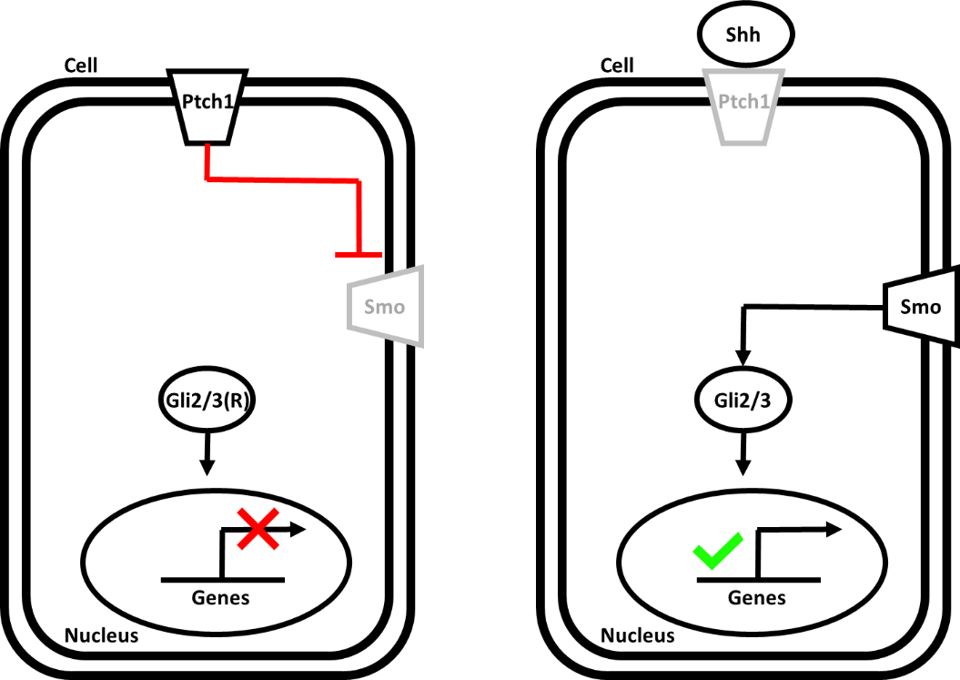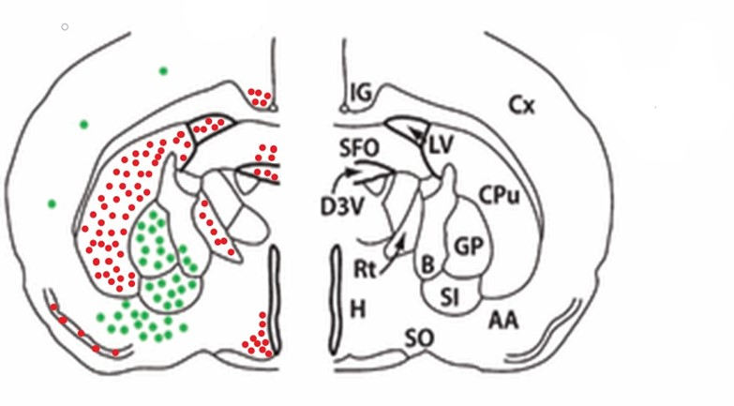

**Figure 1: The locations of Shh activity in the adult rat brain (modified from Traiffort et al. (2010).**

Each green dot represents the locations of Shh-expressing neurons, whilst each red dot represents the neurons through which Shh exerts its influence (Traiffort et al., 1999; Coulombe et al., 2004).

Key: AA, anterior amygdaloid area; B, basal nucleus of Meynert; CPu, caudate putamen; Cx, cerebral cortex; D3V, dorsal third ventricle; fi, fimbria; GP, globus pallidus; H, hypothalamus; IG, indusium griseum; Rt, reticular thalamic nucleus; SFO, subfornical organ; SI, substantia innominata; SO, supraoptic nucleus.

**Figure 2: A brief overview of the canonical Shh pathway in the absence (A) and presence (B) of Shh.**

Key: Ptch1, Patched 1; Smo, Smoothened; Shh, Sonic hedgehog; Gli2/3(R); Gli2 and Gli3 transcriptional repressors; Gli2/3, Gli2 and Gli3 transcription factors.

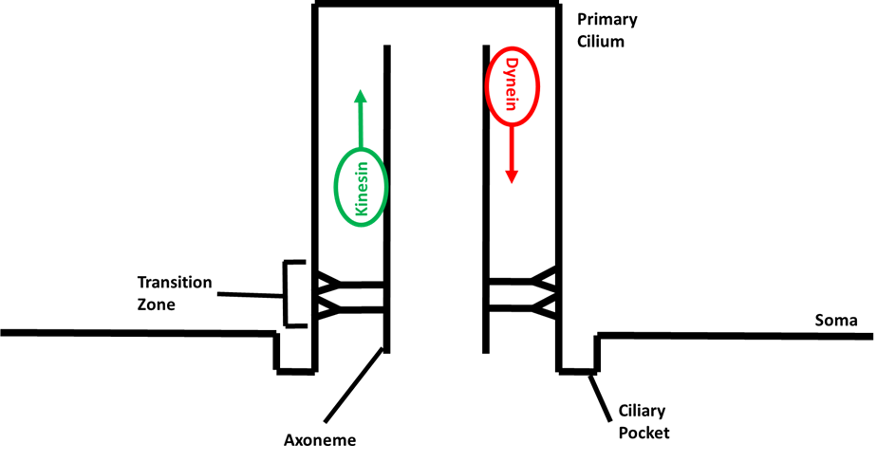

**Figure 3: The structure of the primary cilium.**

The primary cilium is located in a depression of the soma membrane, called the ciliary pocket (Molla-Herman et al., 2010). Its structure primarily consists of an axoneme that is connected to the ciliary membrane by Y-linker proteins in a region called the transition zone (Wheway et al., 2018). The axoneme allows the anterograde and retrograde transport of cargo throughout this organelle via kinesin and dynein motor proteins, respectively, whilst the transition zone acts as a diffusion barrier to phospholipids and proteins (Ishikawa and Marshall, 2017).

Key: green arrow, anterograde transport; red arrow, retrograde transport.

**RESEARCH QUESTIONS**

To achieve this project’s overall goal, the following questions were addressed:

1. **Can the biochemical architecture of the pathway be modelled, based on what has been reported of its reactions in contemporary literature?**
2. **What are realistic parameters for the model in relation to what has been reported in contemporary literature?**
3. **How robust is the model with respect to parameter choices?**
4. **How do the biochemical reactions of the model differ in response to the presence and absence of Shh?**

**METHODS AND MATERIALS**

The model was constructed and simulated using COmplex PAthway SImulator (COPASI) software as this allows users to specify a biochemical system by listing molecular species with their initial concentrations and reactions with their rate constants (Hoops et al., 2006). From these it will then create a system of differential equations which are numerically evaluated to track changes in concentration over time.

For all simulations, parameters for concentration, volume and time were defined in nanomolar (nM), litres (l) and seconds (s), respectively. All simulations were performed deterministically using the software’s LSODA algorithm so that, when investigating the model’s activity, its output would be the same for any given combination of parameters (Petzold, 1983).

**Experiment 1 – Modelling the Biochemical Architecture**

I generated a model based on the biochemical reactions of the canonical Shh pathway that have been reported in contemporary literature. To maintain biological accuracy, I chose not to include any reactions that were disputed in the literature or were not directly supported by experimental evidence.

When modelling, I entered biochemical species into COPASI in their respective reactions based on mass-action kinetics. If the exact details of a reaction mechanism were unknown, then the biochemical event was modelled as a mathematical statement called a ‘Global Quantity’ that can be used to determine the rate of a reaction based on the value of a given parameter, which for this model was assigned to the concentration of biochemical species (Hoops et al., 2006). For instance, if the concentration of species [X] is greater than 1 nM, the rate of a reaction is 0, but if the concentration of species [X] is 0 nM, then the rate of that reaction is 0. Once all biochemical reactions had been entered into the model, each biochemical species was assigned to a compartment based on where they are known to be active in the neuron.

To determine whether the modelled biochemical species reacted accordingly to what has been stated in the literature, I ran a simulation for all species in each biochemical reaction as concentration against time over 100 s with an interval size of 1 s. I chose this timeframe as it allowed the changes in concentration of the species to be observed with ease. Also, when performing these simulations, compartment volume, reaction rate and initial concentration of the reactant species were set to a value of 1, so as to observe the reactions as if all biochemical species were present without interference from their parameters.

**Experiment 2 – Identifying Realistic Parameters**

When investigating the parameters of this model, all values were altered using COPASI’s ‘Parameter Scan’ tool. This was used as this allowed me to repeatedly run a simulation repeatedly with different initial values for a given parameter.

Before identifying realistic parameters for this model, I first performed a preliminary experiment to identify the sensitivity of the model’s parameters. This was done by first setting all initial parameters to 1, like in Experiment 1, and then using the parameter scan tool to run simulations whilst either increasing or decreasing the values of individual parameters relative to the value of 1 at 3600 s with an interval size of 1 s, so as to observe when the concentrations of all biochemical species affected by that parameter stopped changing. In turn, this would allow the identification of a value relative to 1 at which each of the model’s parameters caused all affected biochemical reactions to equilibrate over a realistic time period, which were reported as ‘fold values’.

I obtained these values by first setting the minimum scan value to 1 for the compartment volumes and then progressively increasing the maximum scan value until equilibrium was reached. The maximum fold values for the compartment volumes were then applied to the model before examining its sensitivity for the reaction rates and initial species concentrations, so as to obtain realistic fold values when testing these parameters as both are proportional to the size of the compartment volumes. Afterwards, for the initial species concentrations, the minimum scan value was set to 1 and the maximum scan value was increased until equilibrium was reached, whilst for the reaction rates the maximum scan value was set to 1 and the minimum scan value was decreased until equilibrium was reached. I chose to alter the parameter values in this way as increasing and decreasing the volume and rate values, respectively, would cause the reactions to eventually be unable to equilibrate, whilst initial species concentrations were increased as this would directly affect how the reactions reached equilibrium. In turn, these provide a criterion for determining when a parameter’s values no longer influence the model over a selected time period.

Once the sensitivity of the model’s parameters were determined, I attempted to identify a range of realistic parameters for the model. This began by first searching the literature for any concentration, rate and volume values that were applicable to this model, which led to the discovery of values for all compartment volumes (Table 3) alongside several values for reactions species concentrations (Table 4) and rates (Table 5). All of these were then converted into the appropriate units and entered into the model.

For the parameters without precise values, realistic were determined relative to the experimental values discovered in the literature. I carried this out by using the same technique described above with the parameter scan tool to determine the lowest potential rates and the highest potential concentrations that cause the model’s biochemical reactions to equilibrate over 3600 s at an interval size of 1 s. However, instead of determining the values relative to 1, the minimum scan value for each species concentration was set to 0.1 nM, just under the lowest discovered concentration value, and the maximum scan value for each rate was set to 1, just above the largest discovered rate value. This was all done to generate a range of values in which a parameter’s true value could exist.

**Experiment 3 – Determining Model Robustness**

Using the methods described above, I was able to assign precise values to some parameters, whilst others were constrained to a biologically plausible range of values. Based on a method used by Rozendaal et al. (2019), I ran simulations using random combinations of parameters from within those plausible ranges and measured the model’s response. This was done to determine the robustness of the model as it would replicate the differences in the canonical Shh pathway’s activity that would exist between the neurons of different individuals.

I began this experiment by first using the ‘runif()’ command in RStudio (RStudio Team, 2015) to generate 10 random values within the ranges for each parameter that was generated in Experiment 2. This led to the formation of 10 sets of realistic parameter values which, alongside the literature values, were entered into the model and simulated over 3600 s with an interval size of 1 s, when Shh was added and removed from the model (Appendix Table 1; Appendix Table 2). Subsequently, this generated the output of 10 different simulations with Shh and 10 different simulations without Shh which were all saved as a CSV file into Excel using COPASI’s ‘Report’ function, so as to later be analysed using RStudio. Specifically, I analysed the maximum species concentrations that were generated in the simulations as most of the biochemical species reached equilibrium at a value of 0 nM.

This was performed by using RStudio to generate boxplots of the maximum concentrations achieved over the 10 simulations by several of the modelled biochemical species. I did this to determine the model’s overall robustness to its parameters. Afterwards, the output of the 10 simulations with Shh and the 10 simulations without Shh were statistically analysed for the maximum concentrations of their ‘Proteins’ species. Specifically, this was performed using a Wilcoxon signed-rank test as two paired samples were being analysed that were not normally distributed (Appendix Figure 1). This analysis was done to determine whether there is a difference in the robustness of the model’s activity between the presence and absence of Shh. I chose to analyse maximum ‘Proteins’ concentrations given that, if the biochemical reactions occur as expected, this should only change in the presence of Shh.

**RESULTS**

**Description of the Biochemical Architecture**

I created a model that qualitatively replicates the biochemical reactions of the canonical Shh pathway in neurons. This consists of 20 different reactions and 6 different global quantities that model what has been established about the pathway’s reactions through experimental investigation (Table 1). In turn, 33 different biochemical species have been modelled into 3 separate compartments (Table 2). Overall, the results of the model’s output and the corresponding biochemical reactions in the absence of Shh are illustrated in Figures 4 and 5, and in the presence of Shh are illustrated in Figures 6 and 7.

To accurately replicate the biochemical reactions in the presence and absence of Shh, this model was created as a monostable switch – a network with two steady states of reactions that occur either by adding or removing Shh from the system (Ferrell and Ha, 2014). For instance, when the initial Shh concentration is set to 1 nM, all associated reactions are active, whereas when the initial concentration is set to 0 nM, only the reactions that occur without Shh are active. Generating a model in this way allows greater control over the model when trying to understand the output of the simulated reactions.

I included all known intracellular biochemical reactions that occur from the interactions between Ptch1 and Smo to gene expression, both in the presence and absence of Shh. The only reactions that were not included were the interactions of the gene products that feed back into the pathway. Specifically, I did not include the expression of *HHIP*, *PTCH1* and *GLI1*, which produce Hedgehog interacting protein (Hhip) and Ptch1 that together negatively regulate Shh activity, as well as the transcription factor Gli1 which expresses these target genes (Jeong and McMahon, 2005; Riobo and Manning, 2007). The reason for removing these reactions is that they eventually occur independently of the pathway’s influence and so were not integral to understanding whether the biochemical reactions leading to gene expression could be modelled. Therefore, all products of gene expression were simply modelled as ‘Proteins’.

**Model Sensitivity and Realistic Values**

When examining the sensitivity of the model’s parameters, there was much variation between its fold values, particularly for the rates. Conversely, when determining realistic parameters for the model, there was little variation between their values, although they were all found to be within reasonable ranges relative to what has been reported in the literature.

From the fold values, it was identified that the model’s parameters were most sensitive to changes in volume of the Primary Cilium (Table 3), the concentration of both GPR161 and Smo (Table 4) and the rate of ‘GPR161 Activation’ (Table 5). Additionally, it was found that the model’s reactions were least sensitive to changes in volume of the Soma (Table 3), the concentration of ATP (Table 4) and the rate of ‘Shh Binding’ (Table 5).

With regards to the realistic parameters, it was found that Smo and ‘Protein Loss’ had the largest range of values for concentration (Table 4) and rate (Table 5), respectively. Also, several concentration and rate values were found to be the same as their initial set value as they failed to alter the model’s reactions over the set time course. Specifically, this was identified for the concentrations of CK1, βTrCP/Cul1 and SPOP/Cul3 (Table 4) and the rates of ‘Smoothened Inhibition’, ‘GPR161 Activation’, ‘SuFu Bindng’, ‘SuFu Loss’, ‘Smoothened Localisation’, ‘Kif7 Binding’, ‘Kif7 Translocation’ and ‘Gli2/3 Activation’ (Table 5).

**Model Robustness**

From examining the output of the model’s 10 simulations with and without Shh, two important findings were made. First, many of the species’ concentrations reached 0 nM almost instantly and second, the concentrations of SuFu(P)-Gli2/3, SuFu(P)-Gli2/3-Kif7, SuFu(P)-Gli2/3-Kif7(P) and Gli2/3(P) did not change from 0 nM, either with or without Shh. With this discovery, it was decided that boxplots of Proteins and Gli2/3(R) were to be generated as these illustrate the overall output of the model’s biochemical reactions with and without Shh, respectively, and they had realistically high concentrations. Therefore, from these boxplots, a relatively small distribution of their concentrations was identified with no outliers (Figure 9). This illustrates the model’s robustness as there can only be a discrete range of outcomes for this model’s biochemical reactions, irrespective of the set of parameter values that are entered into it.

Furthermore, after generating boxplots of Proteins concentration from the 10 simulations with and without Shh, it was identified that, with Shh, there was a relatively small distribution of values with no outliers and that, without Shh, Proteins concentration remained at 0 nM. In turn, this signifies that the model’s biochemical reactions are robust irrespective of whether Shh is added or removed and that the difference in activity of the biochemical reactions are found to be statistically significant (Figure 10; v = 55, p = 0.006).

|  |  |  |
| --- | --- | --- |
| Name | Reaction | Global Quantity |
| Smoothened Inhibition | Ptch1 + Smo -> Ptch1-Smo(I) | if({[Shh]} > 0,0,1) |
| GPR161 Activation | GPR161 -> GPR161(A) | if({[Ptch1-Smo(I)]} > 0,1, if({[Shh]} > 0,0,1)) |
| AC Activation | ATP + AC -> cAMP + AC | if({[GPR161(A)]} > 0,1,0) |
| PKA Activation 1 | PKA(I) + 2 * cAMP -> PKA(I/C) |  |
| PKA Activation 2 | PKA(I/C) + 2 * cAMP -> PKA |  |
| SuFu Phosphorylation | SuFu + GSK3β + PKA(S) -> SuFu(P) + GSK3β + PKA(S) |  |
| SuFu Binding | SuFu(P) + Gli2/3 -> SuFu(P)-Gli2/3 |  |
| SuFu Loss | SuFu -> |  |
| Gli2/3 Phosphorylation | SuFu(P)-Gli2/3 + PKA + CK1 + GSK3β -> SuFu + Gli2/3(P) + PKA + CK1 + GSK3β | if({[Ptch1-Smo(I)]} > 0,1,if({[Shh]} > 0,0,0)) |
| Gli2/3(R) Production | Gli2/3(P) + βTrCP/Cul1 -> Gli2/3(R) + βTrCP/Cul1 |  |
| Gli2/3(R) Degradation | Gli2/3(R) -> |  |
| Shh Binding | Shh + 2 * Ptch1 -> |  |
| Smoothened Phosphorylation | Smo + CK1 + GRK2 -> Smo(P) + CK1 + GRK2 | if({[Shh]} > 0,1,if({[Ptch1-Smo(I)]} > 0,0,0)) |
| Smoothened Localisation | Smo(P) + EvC-EvC2 -> Smo(A)-EvC-EvC2 |  |
| Kif7 Binding | SuFu(P)-Gli2/3 + Kif7(P) -> SuFu(P)-Gli2/3-Kif7(P) | if({[Smo(A)-EvC-EvC2]} > 0,1,0) |
| Kif7 Translocation | SuFu(P)-Gli2/3-Kif7(P) + PP2A/PPFIA1 -> SuFu(P)-Gli2/3-Kif7 + PP2A/PPFIA1 |  |
| Gli2/3 Activation | SuFu(P)-Gli2/3-Kif7 -> SuFu + Gli2/3(A) + Kif7(P) |  |
| Gli2/3(A) Degradation | Gli2/3(A) + SPOP/Cul3 -> SPOP/Cul3 |  |
| Gene Expression | Gli2/3(A) -> Gli2/3(A) + Proteins |  |
| Protein Loss | Proteins -> |  |

**Table 1: The reactions and global quantities of the biochemical model.**

The reactions replicate the biochemical interactions between species, whilst the global quantities were used to model reactions between species when their exact interactions were unknown. Specifically, global quantities were added to the reactions of ‘Smoothened Inhibition’, ‘GPR161 Activation’, ‘Gli2/3 Phosphorylation’ and ‘Smoothened Activation’ to ensure that they occur either when Shh is added or removed from the system. Apart from ‘Smoothened Inhibition’, all these reactions were dependent on the concentrations of ‘Ptch1-Smo(I)’ and ‘Shh’ as these were not present together in the system at any time. Also, a global quantity was added to ‘AC Activation’ so that it was activated by ‘GPR161(A)’, replication GPR161’s activation of adenylyl cyclases (Bishop et al., 2007). Similarly, a global quantity was added to ‘Kif7 Binding’ so that it was activated by ‘Smo(A)-EvC-EvC2’, ensuring that ‘SuFu-Gli2/3’ binds to ‘Kif7(P)’ only when Shh is added to the system, alongside replicating Smo’s activation of the Gli transcription factors (Pak and Segal., 2016).

|  |  |
| --- | --- |
| Biochemical Species | Compartment |
| GPR161 | Soma |
| Ptch1-Smo(I) | Soma |
| Shh | Soma |
| Smo | Soma |
| SPOP/Cul3 | Soma |
| SuFu | Soma |
| βTrCP/Cul1 | Soma |
| Proteins | Soma |
| Gli2/3(A) | Nucleus |
| Gli2/3(R) | Nucleus |
| AC | Primary Cilium |
| ATP | Primary Cilium |
| cAMP | Primary Cilium |
| CK1 | Primary Cilium |
| EvC-EvC2 | Primary Cilium |
| Gli2/3 | Primary Cilium |
| Gli2/3(P) | Primary Cilium |
| GPR161(A) | Primary Cilium |
| GRK2 | Primary Cilium |
| GSK3β | Primary Cilium |
| Kif7(P) | Primary Cilium |
| PKA | Primary Cilium |
| PKA(I) | Primary Cilium |
| PKA(I/C) | Primary Cilium |
| PKA(S) | Primary Cilium |
| PP2A/PPFIA1 | Primary Cilium |
| Ptch1 | Primary Cilium |
| Smo(A)-EvC-EvC2 | Primary Cilium |
| Smo(P) | Primary Cilium |
| SuFu(P) | Primary Cilium |
| SuFu(P)-Gli2/3 | Primary Cilium |
| SuFu(P)-Gli2/3-Kif7 | Primary Cilium |
| SuFu(P)-Gli2/3-Kif7(P) | Primary Cilium |

**Table 2: The modelled biochemical species and their corresponding compartments.**

All biochemical species were added to fixed compartments based on the subcellular locations in which they carry out their activity in the neuron: the primary cilium, the soma and the nucleus.

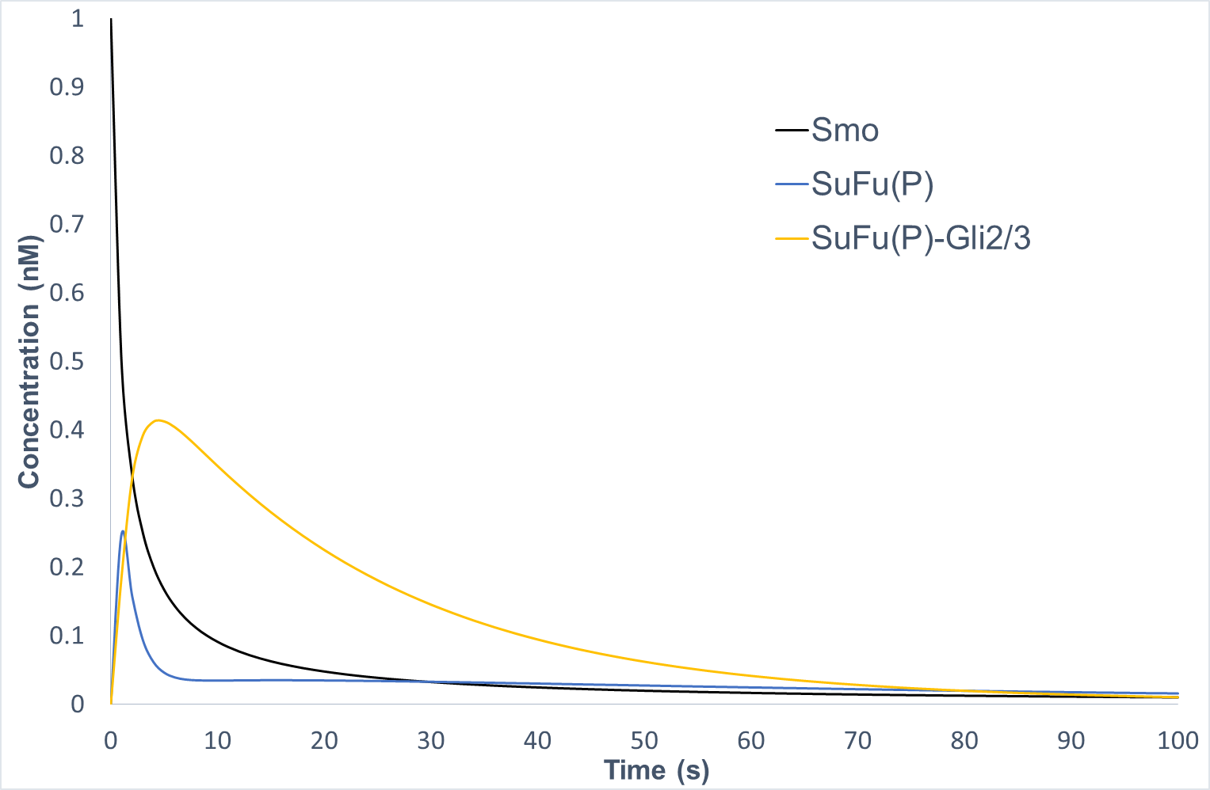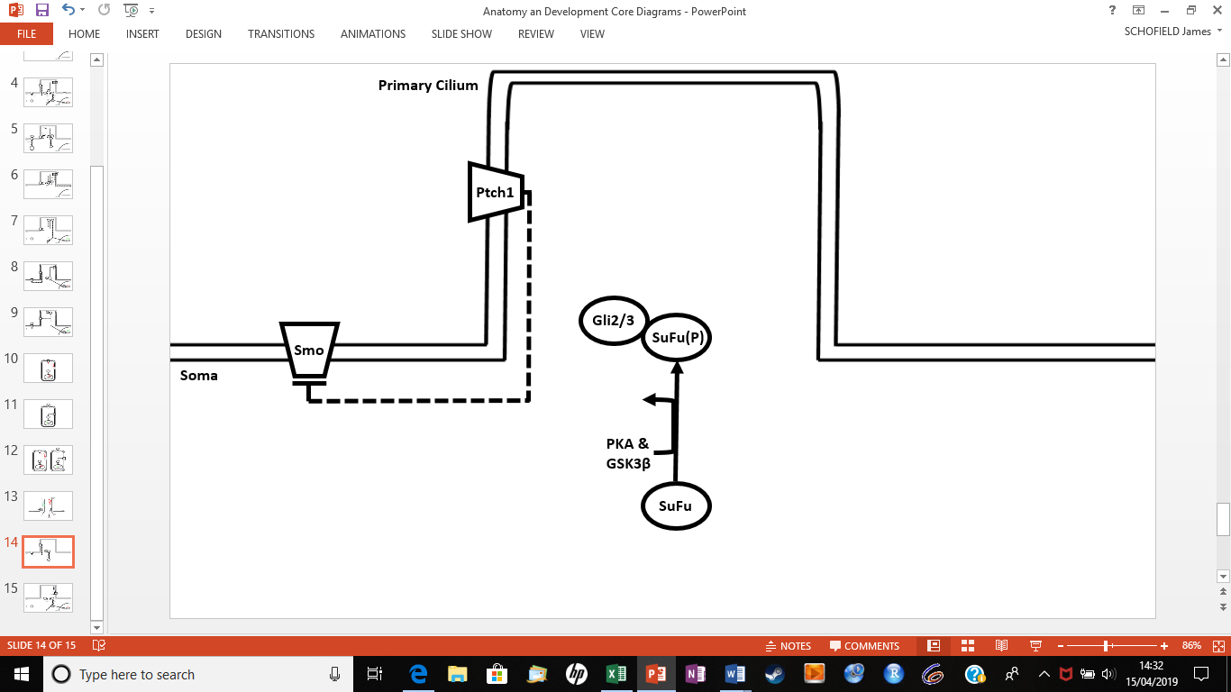

**Figure 4: Biochemical reactions that occur in the absence of Shh (A) and the corresponding output generated by the biochemical model (B).**

Ptch1 is localised along the entire length of the primary cilium where, through an undetermined mechanism, it supresses Smo activity and ciliary localisation (Murone et al., 1999; Tukachinsky et al., 2010). During this time, the protein Suppressor of Fused (SuFu) translocates to the primary cilium, where it is phosphorylated by both protein kinase A (PKA) and glycogen synthase kinase-3 beta (GSK3β; Chen et al., 2011a). Phosphorylated SuFu is then retained at the base of the PC, where it binds to either a Gli2 or Gli3 transcription factor to prevent their proteasomal degradation (Chen et al., 2009; Wang et al., 2010).

**(A)**

**(B)**

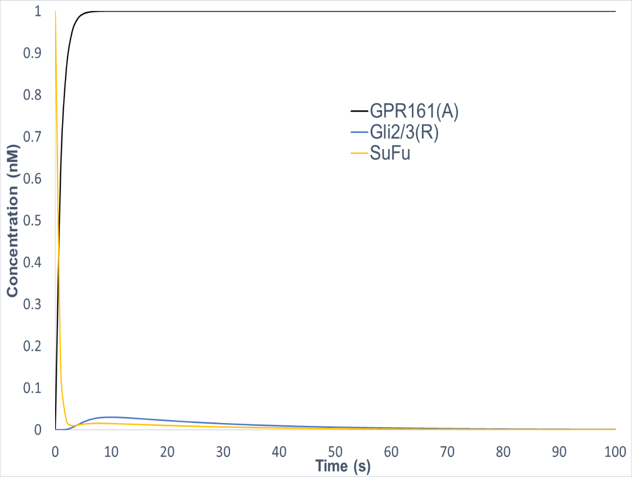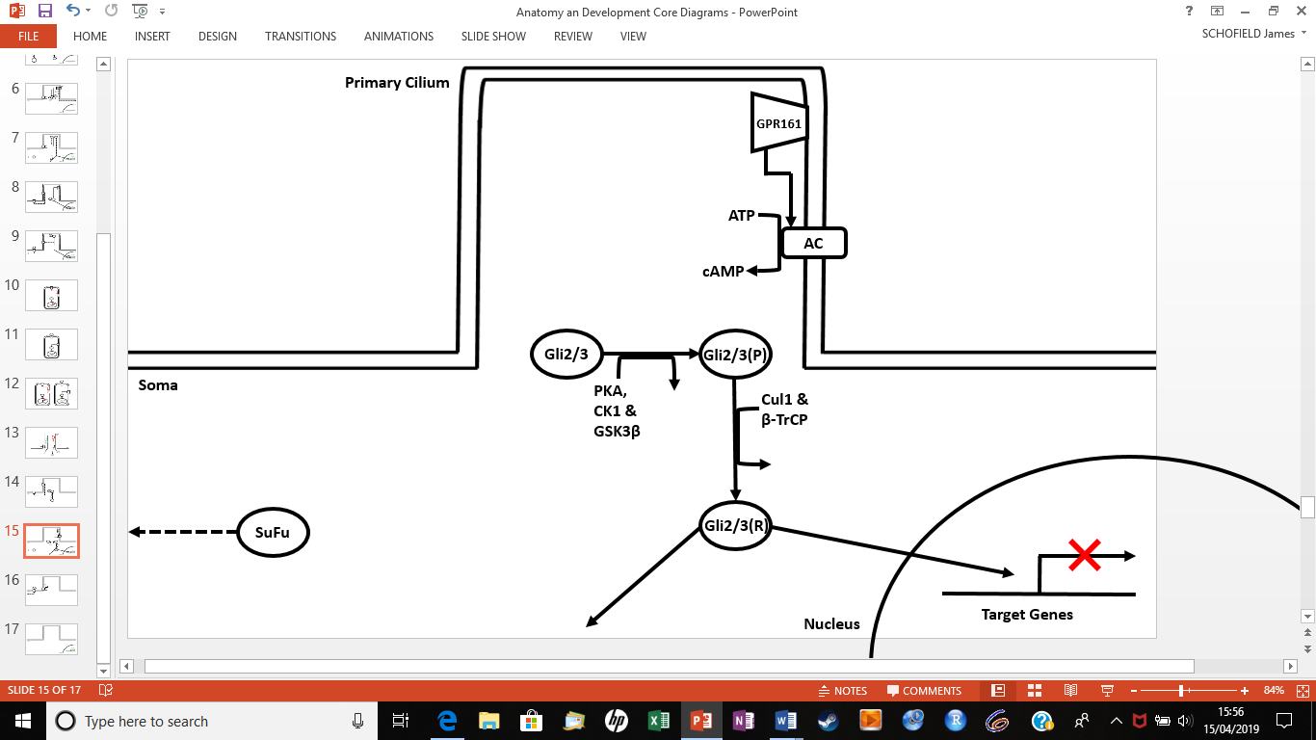

**Figure 5: Biochemical reactions that occur in the absence of Shh (A) and the corresponding output generated by the biochemical model (B).**

GPR161 translocates to the ciliary membrane from the soma where, through an undetermined mechanism, it activates adenylyl cyclases (Bishop et al., 2007; Mukhopadhyay et al., 2013). In turn, this generates sufficient cyclic AMP (cAMP) to activate a separate pool of PKA which, alongside casein kinase 1 (CK1) and GSK3β, simultaneously phosphorylate either the Gli2 or Gli3 that is bound to SuFu (Lodish et al., 2016; Pak and Segal, 2016). These phosphorylated Glis then detach from SuFu, and both translocate to the soma, where SuFu is degraded by an unknown mechanism, whilst the phosphorylated Glis are recruited by β-transducin repeat-containing protein (β‐TrCP) to be ubiquitinated by Cullin 1 (Cul1; Wang and Li, 2006). The Glis are then partially cleaved by the proteasome which always causes Gli3 and sometimes Gli2 to be converted into a transcriptional repressor of Shh target genes, which translocates to the nucleus to repress gene expression (Cohen, 2014). Once the repressor is no longer bound, it is degraded through unknown activity (Pak and Segal, 2016).

**(B)**

**(A)**

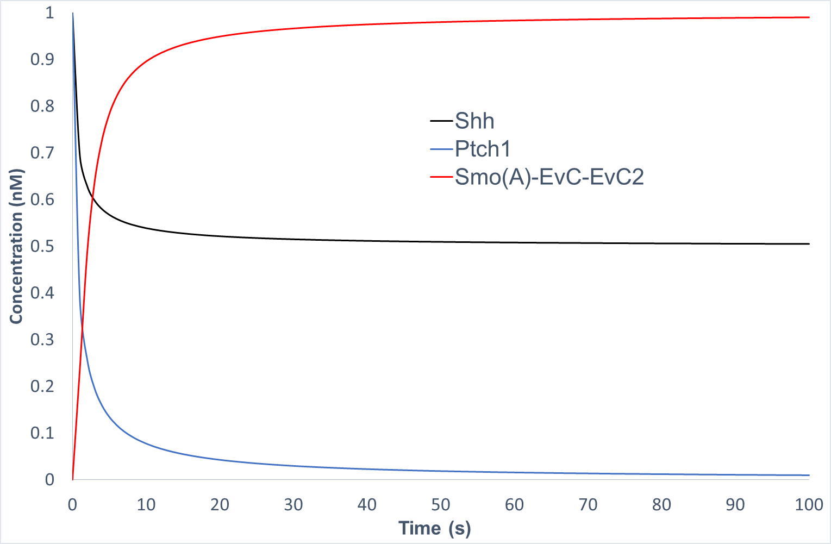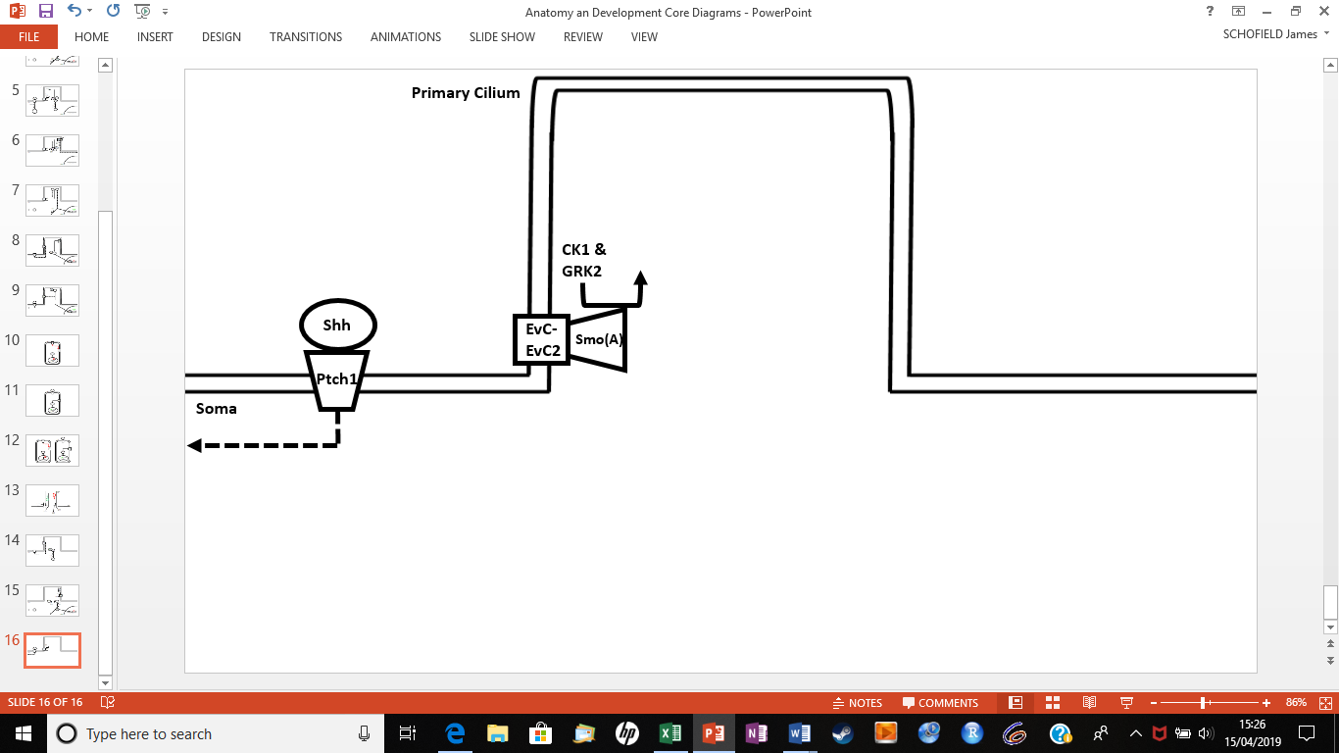

**(B)**

**(A)**

**Figure 6: Biochemical reactions that occur in the presence of Shh (A) and the corresponding output generated by the biochemical model (B).**

Shh forms a complex with two Ptch1 receptors on the surface of the soma, after which both are degraded (Yue et al., 2014; Qi et al., 2018). Through an unknown mechanism, Smo inhibition is then relieved and GPR161 is no longer localised to the ciliary membrane (Mukhopadhyay et al., 2013). Smo then, through an unknown mechanism, translocates to the primary cilium where it is simultaneously phosphorylated by G Protein-Coupled Receptor Kinase 2 (GRK2) and CK1 (Chen et al., 2011b). Phosphorylated Smo then binds to the EvC-EvC2 complex at the base of the primary cilium, where it becomes fully activated and influences several other reactions (Pusapati et al., 2014).

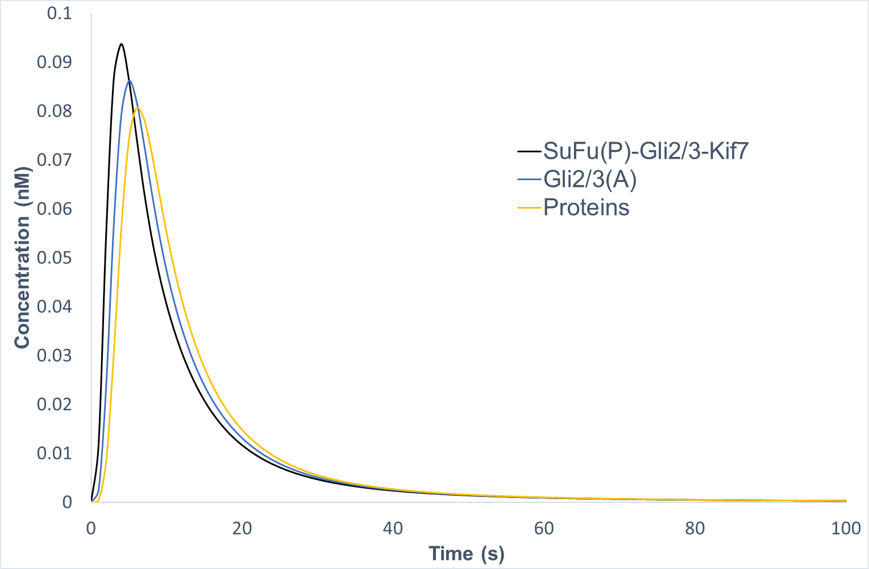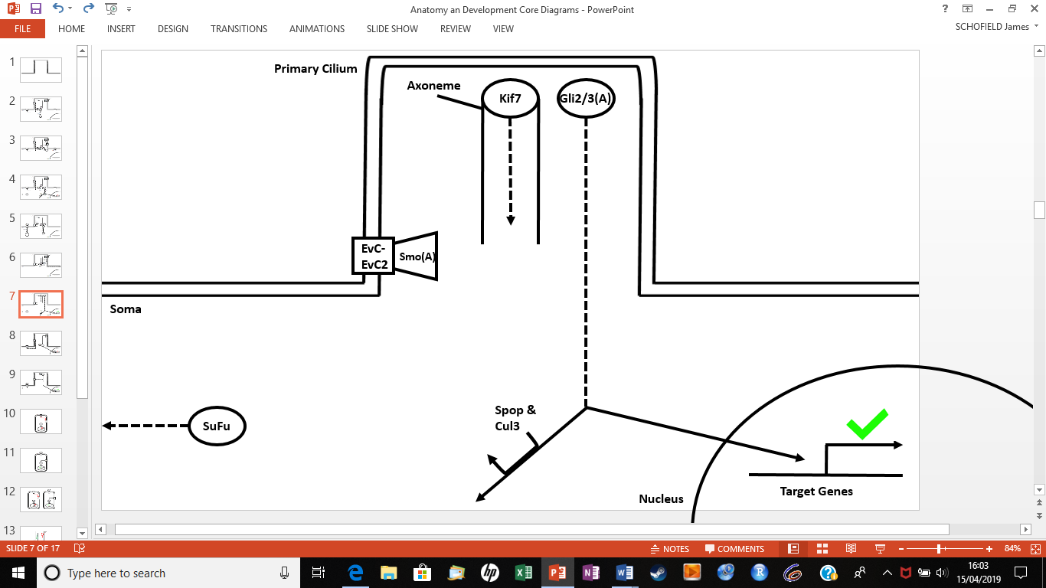

**Figure 7: Biochemical reactions that occur in the presence of Shh (A) and the corresponding output generated by the biochemical model (B).**

SuFu translocates to the base of the primary cilium, where it is phosphorylated by both PKA and GSK3β (Chen et al., 2011a). Phosphorylated SuFu is then retained at the base of the PC, where it binds to either a Gli2 or Gli3 transcription factor to prevent their proteasomal degradation (Chen et al., 2009; Wang et al., 2010). In the presence of Shh activity, the SuFu-Gli complex binds to kinesin family member 7 (Kif7), though exactly how is unknown (Cheung et al., 2009). Afterwards, the scaffold protein Liprin-alpha-1 (PPFIA1) recruits Protein Phosphatase 2A (PP2A) to Kif7, dephosphorylating it to allow it and the SuFu-Gli complex to translocate along the axoneme to the tip of the primary cilium (He et al., 2014; Bangs and Anderson, 2017). Here, the complex dissociates causing SuFu to no longer be phosphorylated and to translocate to the soma where it is degraded, whilst Gli2 or Gli3 would be activated, most likely via activated Smo, so as to translocate to the nucleus where they transcribe several target genes (Sasai and Briscoe, 2012). Once activated Gli activity has occurred, they are degraded following Speckle-type POZ protein (SPOP)-mediated Cul3-based E3 ligase ubiquitination (Wang et al., 2010).

|  |  |  |  |
| --- | --- | --- | --- |
| Compartment | Fold Value | Volume (L) | Source |
| Soma | 100 | 6.0 x 10-12 | Calculated from Routh et al. (2009). |
| Nucleus | 15 | 6.0 x 10-13 | Calculated from Bear et al. (2016). |
| Primary Cilium | 5 | 6.0 x 10-14 | Han et al. (2014) |

**Table 3: Values for compartment volumes.**

Volumes for the soma and primary cilium were taken from measurements in the hippocampus of murine models. These values were used as there is increasing interest into Shh’s function within this structure and given the anatomical similarities between human and murine neurons (Ellenbroek and Youn, 2016). The volume of the nucleus was calculated relative to the volume of the soma, as no exact values were identified, but it is accepted in the literature that a neuron’s nucleus is around a tenth of the volume of its soma (Bear et al., 2016).

|  |  |  |  |
| --- | --- | --- | --- |
| Species | Fold Value | Concentration (nM) | Source |
| ATP | 100 | 525.0 | Surin et al. (2014) |
| EvC-EvC2 | 80 | 0.1 – 10.0 | **-** |
| AC | 50 | 0.1 – 5.0 | **-** |
| PKA(S) | 25 | 590.0 | Saucerman (2003) |
| SPOP/Cul3 | 25 | 0.1 | - |
| SuFu | 20 | 100.0 | Tukachinsky et al. (2010) |
| Ptch1 | 15 | 0.3 | Saha and Schaffer (2006) |
| Kif7(P) | 15 | 500.0 | He et al. (2014) |
| PP2A/PPFIA1 | 15 | 240.0 | Padala et al. (2017) |
| Shh | 10 | 3.0 | Saha and Schaffer (2006) |
| PKA(I) | 10 | 590.0 | Saucerman (2003) |
| GSK3β | 10 | 49.1 | Padala et al. (2017) |
| GRK2 | 10 | 50.0 | Tesmer et al. (2012) |
| CK1 | 5 | 0.1 | **-** |
| βTrCP/Cul1 | 5 | 0.1 | **-** |
| Gli2/3 | 5 | 5.8 | Saha and Schaffer (2006) |
| Smo | 2 | 0.1 – 15.0 | - |
| GPR161 | 2 | 0.1 – 5.0 | **-** |

**Table 4: Values for initial species concentrations.**

Given the lack of information regarding these parameters, some of the literature values were taken from various cell types as well as signalling pathways associated with the canonical Shh pathway, as it is expected that such parameters would be similar to those replicated in this model. For Ptch1, Shh, Gli2/3, PKA(S), PKA(I) and GSK3β, values were taken from mathematical models, whilst for ATP, SuFu, Kif7(P), GRK2 and PP2A/PPFIA1, values were taken from physiological measurements.

Key: -, estimated value.

|  |  |  |  |
| --- | --- | --- | --- |
| Reaction | Fold Value | Rate | Source |
| Smoothened Inhibition | 10,000 | 1.0 | - |
| GPR161 Activation | 100 | 1.0 | - |
| AC Activation | 10,000 | 0.5 – 1.0 | - |
| PKA Activation 1 | 100,000 | 1.0 x 10-3 – 1.0 | - |
| PKA Activation 2 | 100,000 | 1.0 x 10-3 – 1.0 | - |
| SuFu Phosphorylation | 1000 | 0.5 | Vertommen et al. (2000) |
| SuFu Binding | 10,000 | 1.0 | - |
| SuFu Loss | 50,000 | 1.0 | - |
| Gli2/3 Phosphorylation | 25,000 | 0.5 | Vertommen et al. (2000) |
| Gli2/3(R) Production | 10,000 | 2.0 x 10-4 | Lai et al. (2004) |
| Gli2/3(R) Degradation | 1000 | 1.5 x 10-4 | Lai et al. (2004) |
| Shh Binding | 250,000 | 1.5 x 10-3 | French and Lauffenburger (1996). |
| Smoothened Phosphorylation | 50,000 | 0.5 | Vertommen et al. (2000) |
| Smoothened Localisation | 500,000 | 1.0 | - |
| Kif7 Binding | 10,000 | 1.0 | - |
| Kif7 Translocation | 10,000 | 1.0 | - |
| Gli2/3 Activation | 10,000 | 1.0 | - |
| Gli2/3(A) Degradation | 1000 | 1.5 x 10-4 | Lai et al. (2004) |
| Gene Expression | 1000 | 8.0 x 10-3 | Calculated from Lai et al. (2004). |
| Protein Loss | 25,000 | 1.0 x 10-5 – 1.0 | - |

**Table 5: Values for reaction rates.**

The values for ‘Gli2/3(R) Production’, ‘Gli2/3(R) Degradation’, ‘Shh Binding’ and ‘Gli2/3(A) Degradation’ were all obtained from physiological measurements and models associated with the canonical Shh pathway. The value for ‘Gene Expression’ was calculated as an average of Ptch1 and Gli1 gene expression in this pathway as this reaction replicates both of their activity and their values were of a similar magnitude. The values for ‘Smoothened Phosphorylation’, ‘SuFu Phosphorylation’ and ‘Gli2/3 Phosphorylation’ were all taken from an experimental value regarding general protein phosphorylation, as the rate of phosphorylation of one protein will not differ greatly from another (Lehninger et al., 2004).

Key: -, estimate value.

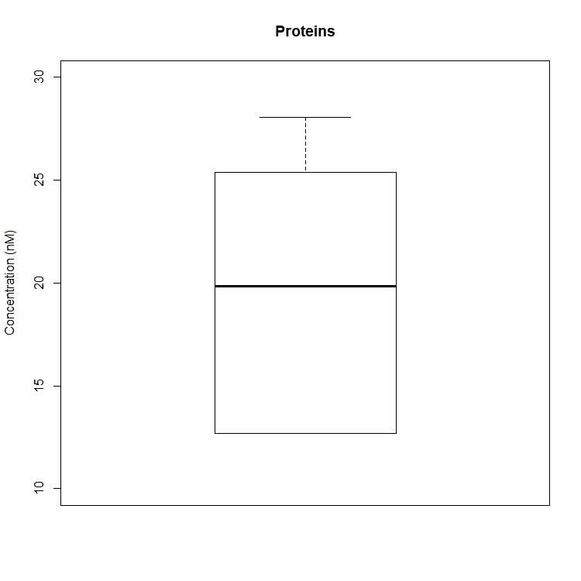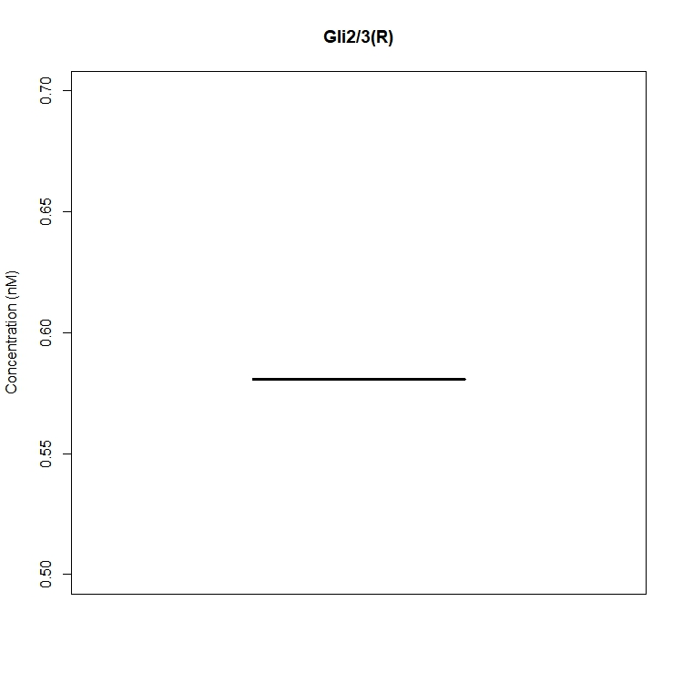

**Figure 9: Boxplots illustrating the robustness of the model with Gli2/3(R) (A) and Proteins (B) concentrations over the 10 model simulations.**

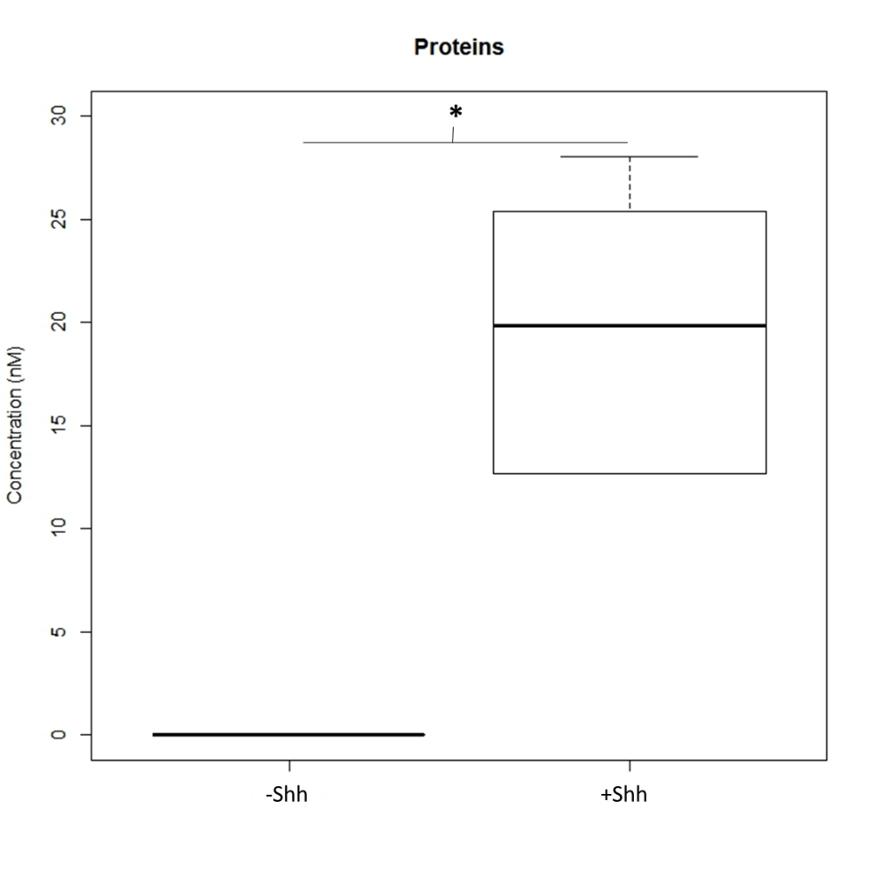

**Figure 10: Boxplots illustrating the robustness of the model with and without Shh, with regards to the concentration of Proteins.**

Key: *, P > 0.05.

**DISCUSSION**

By addressing my four research questions, I have created one of the first computational models that simulates the canonical Shh pathway in adult vertebrate neurons. I have proven that, despite a paucity of information, a model that accurately replicates this pathway’s biochemical architecture can be generated, from which ranges of realistic values can be obtained for certain concentration and rate parameters. I have also shown that this model is robust to these parameter choices and that there is a significant difference in the response of the modelled biochemical reactions, when Shh is either added or removed from the system. Based on these results, I have achieved my original aim of generating a model applicable to future biological research, as well as identified areas of further work that should be addressed if this model were to be improved upon in the future.

**A Logical Model of the Biochemical Architecture**

I have generated a ‘logical’ model of the canonical Shh pathway as a monostable switch that qualitatively replicates its intracellular biochemical reactions in the presence and absence of Shh (Morris et al., 2010; Ferrrel and Ha, 2014). By creating my model in this way, this allowed it to be more accurate to what is known of the pathway’s biochemical reactions, whilst separating them into two steady states that coexist in the same cellular conditions (Thomas, 1973; Zhou et al., 2013). As a logical model, this gives it a unique strength in that it allows individuals to study this signalling pathway when a lack of quantitative information prevents its investigation using chemical kinetic approaches in wet labs (Barabási and Oltavi, 2004; Le Novère, 2015). Alternatively, as a monostable switch, this allows the model to be more applicable to processes in the brain, such as signal transduction and cell fate decision, which necessitate a rapid ‘all-or-nothing’ activation of the canonical pathway in response to external stimuli or internal development (Lai et al., 2002; Cardelli et al., 2017).

**Problems Identified within the Literature**

When modelling the canonical Shh pathway, compromises with global quantities had to be made when replicating its activity, due to the limited information associated with the interactions between certain biochemical species. Despite this being a problem when creating my model, this helped to identify significant gaps in contemporary knowledge that need to be explored, before the canonical pathway’s activity in neurons can be fully understood.

By attempting to model the interaction between Ptch1, Smo and Shh, I identified a paucity of information on the exact interactions between these biochemical species and how they influence the downstream cascade of reactions. The reason for this is that it is debated in the literature as to whether Ptch1 inhibits Smo through direct binding or through the modulation of either phospholipid or sterol availability to Smo that prevents its trafficking to the ciliary membrane (Taipale et al., 2002; Huang et al., 2016; Jiang et al., 2016). Also, there is uncertainty as to how Shh relieves this activity upon binding to Ptch1, as it is unknown exactly how Shh triggers its degradation via the ubiquitin ligases, Smurf1 and Smurf2 (Yue et al., 2014). It is recommended, therefore, that future research should elaborate on these interactions as clarifying how they work together would establish how Shh causes the canonical pathway’s intracellular reactions to change and, in turn, would help to better model this pathway as a switch.

Another prominent gap identified in the literature is that it is unknown exactly how Smo activates Gli transcription factors. This is because there is uncertainty as to whether Smo acts similar to a GPCR when promoting the activation of the Gli transcription factors at the tip of the primary cilium (Arensdorf et al., 2016). Also, it is unknown as to whether Smo needs to undergo further post-translational modifications in the primary cilium so as to facilitate this activity (Sasai and Briscoe, 2012). If future studies were to elaborate on these reactions, this would clarify how activated Smo instigates the cascade of reactions necessary for target gene expression, as well as why it carries out this activity specifically in a neuron’s primary cilium.

When replicating the activity of GPR161, a similar problem to the above was recognized in terms of exactly how this protein influences the cascade of reactions that form the Gli transcriptional repressors. This is because despite knowing that GPR161 influences the eventual formation of these repressors via adenlyl cyclase, it is unknown as to whether its activation of this enzyme occurs directly through its Gα subunit or in combination with other GPCRs (Pal et al., 2016). To add to this, it has yet to be established why GPR161 activates these reactions in the absence of Shh, with studies debating as to whether Shh somehow triggers the decreased entry or increased removal of GPR161 from the primary cilium (Bachmann et al., 2016; Pal et al., 2016). Hence, further research is essential into GPR161 activity as this would further elaborate on why Shh target genes are suppressed in the absence of Shh binding to a target neuron.

**Implications of Model Parameters**

By generating fold values, it was revealed that the sensitivity of my model’s rates and concentrations were strongly influenced by the differences in volume between the soma and the primary cilium. This was demonstrated by the fact that the most sensitive rates and concentrations were those that replicated the translocation of species from the soma to the primary cilium, and the least sensitive were those that took place only in the soma. A plausible explanation for these results is that, by having such a comparatively small volume, the primary cilium increased each biochemical species’ concentration upon entry, and this caused their associated reactions to equilibrate more rapidly. Based on this result, my model reinforces the belief that, besides coordinating the pathway’s reactions, the primary cilium increases the concentration of their associated biochemical species so as to enhance their activity (Venkatesh et al., 2017).

When identifying realistic parameters for this model, it was found that several did not display a range of values and so did not alter the activity of my model’s reactions. This could be attributed to the fact that they were measured relative to literature values taken from various physiological processes, which had parameters potentially higher than those required for the canonical Shh pathway. Hence, it is likely that when the values were changed for the reaction rates and the concentrations of the biochemical species, which were modelled as enzymes, these could not alter the rate at which my model’s reactions equilibrated. This is reinforced by results from Boykin and Ogle’s (2010) mathematical model which revealed that species concentrations over 100 nM cause this pathway to exhibit ‘saturation-like’ behaviour, which was the case with several of the concentration values applied to my model.

With regards to the few parameters that did display values, these were all within a discrete range that were on a similar scale to the various literature values. A possible reason for why these parameters displayed a range of values compared with the others is that they influenced reactions that did not have direct biochemical interactions with the equilibrated reactions and so were not restricted by the literature values. For instance, by changing the concentration of Smo, this only influenced the reaction that replicated its translocation to the primary cilium, as the exact biochemical interactions through which Smo instigates other reactions is unknown, and so this had to be replicated indirectly through global quantities (Pak and Segal., 2016). Overall, these results illustrate that, for certain parameters, my model can give realistic values, whilst for others it is restricted by what little has been reported in the literature about exact parameter values for the canonical Shh pathway. It is recommended therefore that future studies should elaborate on the parameters used in my model, so as to gain a more comprehensive understanding of the chemical kinetic properties which underlie the canonical Shh pathway.

**Implications of Model Robustness**

By examining its robustness, it was revealed that my model will always simulate a small distribution of outcomes for different combinations of parameters. This is significant as it illustrates that my model can emulate a steady stable state of the canonical pathway that is necessary for it to resist small environmental fluctuations in Shh that could otherwise impede on its function in neurons (Barkai and Leibler, 1997). Additionally, alongside this discovery, it was unexpectedly revealed that the concentrations of SuFu(P)-Gli2/3, SuFu(P)-Gli2/3-Kif7, SuFu(P)-Gli2/3-Kif7(P) and Gli2/3(P) remained at 0 nM, whilst the concentrations for all other biochemical species changed. This is most likely the result of how these biochemical species were modelled into their respective reactions, which caused them to be highly sensitive to the combination of both realistic and literature values. Whilst this highlights a limitation of my model in that it does not display realistic values for these biochemical species, it is interesting in that it is those that emulate the SuFu-Gli complex and its downstream reactants. The reason for this is that it adds to the prevailing idea that the SuFu-Gli complex acts as a point that dictates whether the following cascade of reactions either activates or suppresses the Shh target genes and thus its activity needs to be highly regulated (Patel et al., 2017).

After examining whether the biochemical reactions of my model differ in response to the presence or absence of Shh, it was revealed that there is a significant difference in its two states of reactions. This is important as it validates that my model is a robust switch that effectively replicates the intracellular biochemical reactions of the canonical Shh pathway with no overlap between them. To date, only Lai et al. (2004) have generated a robust switch of this pathway, although this focusses only on gene expression, signifying that this model is unique in its potential application to future research.

**Further Improving the Model**

Upon further scrutiny of the model, it was identified that there are certain aspects that need to be improved upon, so as to enhance its function as a biological switch and its ability to accurately replicate the canonical Shh pathway’s parameters. Specifically, by creating it as a logical model, rather than initially building it around quantitative information, means that this model cannot effectively replicate the rate of the canonical Shh pathway’s biochemical reactions or switching between their steady states (Le Novère, 2015: Navlakha and Bar-Joseph, 2015). Furthermore, this model is limited in its accuracy as a switch in that it failed to display hysteresis – a threshold required for biological signalling pathways to switch between their two states of reactions so that they are insensitive to small fluctuations in the extracellular signal (Rao et al., 2002; Markevich et al., 2004). The reason for this is that, by only qualitatively modelling the canonical Shh pathway, this model could not replicate a threshold necessary for Shh to instigate its associated reactions.

Therefore, to improve on the model, it is recommended that its biochemical reactions should be remodelled around its parameters, once sufficient evidence of their exact values has been reported in the literature and once a threshold for its activity has been identified. For any parameters for which a value could not be found, an algorithm such as a Kalman filter could then be used to generate a value, as this has been shown to accurately measure a model’s parameters, based on sparse data (Lillacci et al., 2010). Together, these would help to develop my model into a hysteretic switch that can more accurately replicate the canonical Shh pathway’s chemical kinetic properties.

**Future Applications of the Model**

Despite the model’s limitations, it has significant potential to elaborate on contemporary research regarding Shh’s function in the brain. Notably, given that I have modelled the canonical Shh pathway in hippocampal neurons, it could elaborate on how Shh’s activity in the hippocampus can regulate epilepsy. The basis for this idea is that, for epilepsy to occur, glutamate needs to be released from pre-synaptic hippocampal neurons following high-frequency stimulation and Shh facilitates this activity after increased calcium ion entry into the post-synaptic neuron causes its release (Feng et al., 2016; Su et al., 2017). However, the exact biochemical reactions underlying Shh’s pre-synaptic activity is unknown, although studies have suggested that the canonical Shh pathway is most likely responsible due to its function in other biological processes in the hippocampus (Pino et al., 2017).

Based on these findings, it would be informative to use the model to elaborate on how the relationship between increased post-synaptic calcium ion entry and Shh release could influence the biochemical reactions underlying Shh’s pre-synaptic activity in epilepsy. This could be achieved by adding a relationship between calcium ion entry and Shh into the model and then using the calcium ion concentrations discovered by Su et al. (2017), alongside my realistic and literature values, to run various simulations of the pathway’s activity. Subsequently, these simulations could be compared to simulations run by the model without calcium ion influence as a control, to identify how there is a difference in the canonical pathway’s activity in hippocampal neurons during epilepsy.

**REFERENCES**

Arensdorf A., Dillard M., Mennke J., Frank M., Rock C. and Ogden S. (2017) ‘Sonic Hedgehog Activates Phospholipase A2 to Enhance Smoothened Ciliary Translocation’, *Cell Reports*, 19(10), pp. 2074-2087.

Bachmann V., Mayrhofer J., Ilouz R., Tschaikner P., Raffeiner P., Rock R., Courcelles M. et al. (2016) ‘Gpr161 anchoring of PKA consolidates GPCR and cAMP signaling’, *Proceedings of the National Academy of Sciences of the United States*, 113(28), pp. 7786.

Barakeh D., Faqeih E., Anazi S., S Al-Dosari M., Softah A., Albadr F. et al. (2015) ‘The many faces of KIF7’, *Human Genome Variation*, 2, pp. 15006.

Barkai N. and Leibler S. (1997) ‘Robustness in simple biochemical networks’, *Nature*, 387(6636), pp. 913.

Bangs F. and Anderson V. (2017) ‘Primary Cilia and Mammalian Hedgehog Signaling’, *Cold Spring Harbor Perspectives in Biology*, 9(5).

Barabási A. and Oltvai Z. (2004) ‘Network biology: understanding the cell’s functional organisation’, *Nature Review Genetics*, 5(2), pp. 101.

Bear M.F., Connors B.W. and Paradiso M.A. (2016) *Neuroscience: Exploring the Brain*. Philadelphia: Wolters Kluwer, Fourth Edition.

Bishop G., Berbari N., Lewis J. and Mykytyn K. (2007) ‘Type III adenylyl cyclase localizes to primary cilia throughout the adult mouse brain’, *Journal of Comparative Neurology*, 505(5), pp. 505(5), pp. 562-571.

Boykin E. and Ogle W. (2010) ‘Using heterogeneous data sources in a systems biology approach to modeling the Sonic Hedgehog signaling pathway’, *Molecular BioSystems*, 6(10), pp. 1993-2003.

Carballo G.B., Honorato J.R., Lopes G. and Sophr T.C. (2018) ‘A highlight on Sonic hedgehog pathway’, *Cell Communication and Signallling*, 16(1).

Cardelli L., Stelling J., Hernansaiz-Ballesteros R., Dalchau N. and Csikász-Nagy A. (2017) ‘Efficient Switches in Biology and Computer Science’, *PLOS Computational Biology*, 13(1).

Chen M., Wilson C., Ya J., Law K., Chi S., Gaycayan R., Zhang X., Chi C and Pao T. (2009) ‘Cilium-independent regulation of Gli protein function by Sufu in Hedgehog signaling is evolutionarily conserved’, *Genes and Development*, 23(16), pp. 1910-1928.

Chen Y., Yue S., Xie L., Pu X., Jin T. and Cheng S. (2011a) ‘Dual Phosphorylation of suppressor of fused (Sufu) by PKA and GSK3beta regulates its stability and localization in the primary cilium’, *The Journal of Biological Chemistry*, 286(15), pp. 13502-13511.

Chen Y., Sasai N., Ma G., Yue T., Jia J., Briscoe J and Jiang J. (2011b) ‘Sonic Hedgehog dependent phosphorylation by CK1alpha and GRK2 is required for ciliary accumulation and activation of smoothened’, *PLoS Biology*, 9.

Cheung H., Zhang X., Ribeiro A., Mo R., Makino S., Puviindran V, Law K et al. (2009) ‘The kinesin protein Kif7 is a critical regulator of gli transcription factors in mammalian hedgehog signaling’, *Science Signalling*, 2(76), pp. 29.

Cohen M. Page K.M., Perez-Carrasco R., Barnes C.P. and Briscoe J. (2014) ‘A theoretical framework for the regulation of Shh morphogen-controlled gene expression’, *Development*, 141(20), pp. 3868-3878.

Coulombe J., Traiffort E., Loulier K., Faure H and Ruat M. (2004) ‘Hedgehog interacting protein in the mature brain: membrane-associated and soluble forms’, *Molecular and Cellular Neuroscience*, 25(2), pp. 323-333.

Ellenbroek B. and Youn J. (2016) ‘Rodent models in neuroscience research: is it a rat race?’ *Disease Models and Mechanisms*, 9(10), pp. 1079-1087.

Feng S., Ma S., Jia C., Su Y., Yang S., Zhou K., Liu Y. et al. (2016) ‘Sonic hedgehog is a regulator of extracellular glutamate levels and epilepsy’, *EMBO Reports*, 17(7), pp. 682-694.

Ferrell J. and Ha S. (2014) ‘Ultrasensitivity part III: cascades, bistable switches, and oscillators’, *Trends in Biochemical Sciences*, 39(12), pp. 612-618.

French A.R. and Lauffenburger D.A. (1996) ‘Intracellular receptor/ligand sorting based on endosomal retention components’, *Biotechnology and Bioengineering*, 51(3), pp. 281-297.

Goetz S.C. and Anderson K.V. (2010) ‘The Primary Cilium: A Signalling Centre During Vertebrate Development’, *Nature Reviews Genetics*, 11(5), pp. 331.

Han Y.M., Kang G.M., Byun K., Ko H.W., Kim J., Shin M. et al. (2014) ‘Leptin-promoted cilia assembly is critical for normal energy balance’, *Journal of Clinical Investigation*, 124(5), pp. 2193-2195.

He M., Subramanian R., Bangs F., Omelchenko T., Liem K.F., Kapoor T.M. and Anderson K.V. (2014) ‘The Kinesin-4 Protein Kif7 Regulates Mammalian Hedgehog Signaling by Organizing the Cilia Tip Compartment’, *Nature Cell Biology*, 16, pp. 663-672.

Hoops S., Sahle S., Gauges R., Lee C., Pahle J., Simus N. et al. (2006) ‘COPASI – a Complex Pathway Simulator’, *Bioinformatics*, 22(24), pp. 3067-3074.

Huang P., Nedelcu D., Watanabe M., Jao C., Kim Y., Liu J. and Salic A. (2016) ‘Cellular cholesterol directly activates Smoothened in Hedgehog signaling’, *Cell*, 166, pp. 1176-1187.

Humke E., Dorn K., Milenkovic L., Scott M. and Rohatgi R. (2010) ‘The output of Hedgehog signaling is controlled by the dynamic association between Suppressor of Fused and the Gli proteins’, *Gene and Development*, 24(7), pp. 670-682.

Ishikawa H. and Marshall W. (2017) ‘Intraflagellar transport and ciliary dynamics’, *Cold Spring Harbor Perspectives in Biology*, 9(3).

Ingham P.W. and McMahon A.P. (2001) ‘Hedgehog signaling in animal development: paradigms and principles’, *Genes and Development*, 15(23), pp. 3059-3087.

Jeong J. and McMahon A. (2005) ‘Growth and pattern of the mammalian neural tube are governed by partially overlapping feedback activities of the hedgehog antagonists patched 1 and Hhip1’, *Development*, 132(1), pp. 143-154.

Jiang K., Liu Y., Fan J., Zhang Jie., Li X., Everes M., Zhu H. and Jia J. (2016) ‘PI(4)P Promotes Phosphorylation and Conformational Change of Smoothened through Interaction with Its C-terminal Tail’, *PLoS Biology*, 14(2).

Kitano H. (2002) ‘Systems Biology: A Brief Overview’, *Science*, 295(5560), pp. 1662-1664.

Kotaleski J.H. and Blackwell K.T. (2010) ‘Modelling the molecular mechanisms of synaptic plasticity using systems biology approaches’, *Nature Reviews Neuroscience*, 11(4), pp. 239-251.

Lai K., Kaspar B., Gage F. and Schaffer D. (2002) ‘Sonic hedgehog regulates adult neural progenitor proliferation in vitro and in vivo’, *Nature Neuroscience*, 6(1), pp. 21.

Lai K., Roberson M.J. and Schaffer D.V. (2004) ‘The Sonic Hedgehog Signaling System as a Bistable genetic Switch’, *Biophysical Journal*, 86(5), pp. 2748-2757.

Le Novère N. (2015) ‘Quantitative and logic modelling of molecular and gene networks’, Nature reviews, *Genetics*, 16(3), pp.146–58.

Lehninger A., Cox M. and Nelson D. (2004) *Principles of Biochemistry*, New York: Worth Publishers.

Lillacci G., Asthagiri A. and Khammash M. (2010) ‘Parameter Estimation and Model Selection in Computational Biology’, *PLoS Computational Biology*, 6(3).

Lodish H.F., Berk A., Kaiser C., Krieger M., Bretscher A., Hidde L. et al. (2016) *Molecular Cell Biology*, New York : W.H. Freeman/Macmillan Learning

Lum L. and Beachy P.A. (2004) ‘The Hedgehog Response Network: Sensors, Switches, and Routers’, *Science*, 304(5678), pp. 1755-1759.

Markevich N., Hoek J. and Kholodenko B. (2004) ‘Signaling switches and bistability arising from multisite phosphorylation in protein kinase cascades’, *The Journal of Cell Biology*, 164(3), pp. 353(7).

Molla-Herman A., Ghossoub R., Blisnick T., Meunier A., Serres C., Silbermann F. et al. (2010) ‘The ciliary pocket: an endocytic membrane domain at the base of primary and motile cilia’, *Journal of Cell Science*, 123, pp. 1785-1795.

Morris M., Saez-Rodriguez J., Sorger P. and Lauffenburger D. (2010) ‘Logic-Based Models for the Analysis of Cell Signaling Networks’, *Biochemistry*, 49(15), pp. 3216-3224.

Mukhopadhyay S., Wen X., Ratti n., Loktev A., Rangell L., Scales S.J. and Jackson P.K. (2013) ‘The ciliary G-protein-coupled receptor Gpr161 negatively regulates the Sonic hedgehog pathway via cAMP signaling’, *Cell*, 152(2), pp. 210-223.

Murone M., Rosenthal A. and Sauvage F.J. (1999) ‘Sonic hedgehog signaling by the patched-smoothened receptor complex’, 9(2), pp. 76-84.

Navlakha S. and Bar-Joseph Z. (2015) ‘Distribute information processing in biological and computational systems’, *Communications of the ACM*, 58(1), pp. 94-102.

Padala R., Karnawat R., Viswanathan S., Thakkar A. and Das A. (2017) ‘Cancerous perturbations within the ERK, PI3K/Akt, and Wnt/β-catenin signaling network constitutively activate inter-pathway positive feedback loops’, *Molecular BioSystems,*13(5), pp. 830-840.

Patel S., Toma S., Sharma D. and Mahindroo N. (2017) ‘Targeting sonic hedgehog signaling in neurological disorders’, *Neurological and Behavioural Sciences Review*, 74, pp. 76-97.

Pak E. and Segal R.A. (2016) ‘Hedgehog Signal Transduction: Key Players, Oncogenic Drives, and Cancer Therapy’, *Developmental Cell*, 38(4), pp. 333-344.

Pal K., Hwang S, Somatilaka B, Badgandi H., Jackson P.K., Defea K et al. (2016) ‘Smoothened determines β-arrestin-mediated removal of the G protein-coupled receptor Gpr161 from the primary cilium’, *The Journal of Cell Biology*, 212(7), pp.861-75.

Petralia R.S., Schwartz C.M., Wang Y., Mattson M.P. and Yao P. (2011) ‘Subcellular Localization of Patched and Smoothened, the Receptors for Sonic Hedgehog Signaling, in the Hippocampal Neuron’, *The Journal of Comparative Neurology*, 519(18), pp. 3684-3699.

Petzold L. (1983) ‘Automatic selection of methods for solving stiff and nonstiff systems of ordinary differential equations’, *SIAM Journal on Scientific and Statistical Computing*, 4(1), pp. 136-148.

Pino A., Fumagalli G., Bifari F. and Decimo I. (2017) ‘New neurons in adult brain: distribution, molecular mechanisms and therapies’, *Biochemical Pharmacology*, 1(141), pp. 4-22.

Pusapati G., Hughes C., Dorn K., Zhang D., Sugianto P., Aravind L and Rohatgi R. (2014) ‘EFCAB7 and IQCE regulate hedgehog signaling by tethering the EVC-EVC2 complex to the base of primary cilia’, *Developmental Cell*, 28(5), pp. 483-496.

Qi X., Schmiege P., Coutavas E., Wang J and Li X. (2018) ‘Structures of human Patched and its complex with native palmitoylated sonic hedgehog’, *Nature*, 560(7716), pp. 128-132.

Rao C., Wolf D. and Arkin A. (2002) ‘Control, exploitation and tolerance of intracellular noise’, *Nature*, 420(6912), pp. 231.

Riobo N. and Manning D. (2007) ‘Pathways of signal transduction employed by vertebrate Hedgehogs’. *The Biochemical Journal*, 403(3), pp. 369-379.

Rohatgi R., Milenkovic L. and Scott M.P. (2007) ‘Patched1 regulates hedgehog signaling at the primary cilium’, *Science*, 317(5836), pp. 372-376.

Routh B.N., Johnston D., Harris K. and Chitwood R.A.(2009) ‘Anatomical and Electrophysiological Comparison of CA1 Pyramidal Neurons of the Rat and Mouse’, *Journal of Neurophysiology*, 102(4), pp. 2288-2302.

Rozendaal Y., Wang Y., Hilbers P., van Riel N. and Natal A. (2019) ‘Computational modelling of energy balance in individuals with Metabolic Syndrome’, *BMC Systems Biology*, 13(1).

RStudio Team (2015) RStudio: Integrated Development for R. RStudio, Inc., Boston, MA URL http://www.rstudio.com/.

Ruiz I, Altaba A., Mas C. and Stecca B. (2007) ‘The Gli code: an information nexus regulating cell fate, stemness and cancer’, *Trends in Cell Biology*, 17, pp. 438-437.

Sasai N. and Briscoe J. (2012) ‘Primary cilia and graded Sonic Hedgehog signalling’, *Wiley Interdisciplinary Reviews: Developmental Biology*, 1(5), pp. 753-772.

Saha K. and Schaffer D.V. (2006) ‘Signal dynamics in Sonic hedgehog tissue patterning’, *Development*, 133(5), pp. 889-900.

Saucerman J.J., Brunton L.L., Michailova A.P. and McCulloch A.D. (2003) ‘Modelling beta-adrenergic control of cardiac myocyte contractility in silico’, *Journal of Biological Chemistry*, 278(48), pp. 47997-8003.

Sivakumar K., Dhanesh S., Shobana S., James J. and Mundayoor S. (2011) ‘A Systems Biology Approach to Model Neural Stem Cell Regulation by Notch, Shh, Wnt, and EGF Signaling Pathways’, *OMICS: A Journal of Integrative Biology*, 15(10), pp. 729-737.

Southern J., Pitt-Francis J., Whiteley J., Stokeley D., Kobashi H., Nobes R. et al. (2008) ‘Multi-scale computational modelling in biology and physiology’, *Progress in Biophysics and Molecular Biology*, 96(3), pp. 60-89.

Surin A., Gorbachev L., Savinkova I., Sharipova R., Khodorov B. and Pinelis V. (2014) ‘Study on ATP Concentration Changes in Cytosol of Individual Cutlured Neurons during Glutamate-Induced Deregulation of Calcium Homeostasis’, *Biochemistry*, 79(2), pp. 146-157.

Su Y., Yuan Y., Feng S., Ma S. and Wang Y. (2017) ‘High frequency stimulation induces sonic hedgehog release from hippocampal neurons’, *Scientific Reports*, 7.

Taipale J., Cooper M., Maiti T. and Beachy P. (2002) ‘Patched acts catalytically to suppress the activity of Smoothened’, *Nature*, 418, pp. 892-897.

Tesmer V.M., Lennarz S., Mayer G. and Tesmer J.J. (2012) ‘Molecular mechanism for inhibition of g protein-coupled receptor kinase 2 by a selective RNA aptamer’, *Structure*, 20(8), pp. 1300-1309.

Thomas R. (1973) ‘Boolean formalization of genetic control circuits’, *Journal of Theoretical Biology*, 42(3), pp. 563-585.

Traiffort E., Charytonuik D.A., Faure H. and Ruat M. (1998) ‘Regional Distribution of Sonic Hedgehog, Patched and Smoothened mRNA in the Adult Rat Brain’, *Journal of Neurochemistry*, 70(3), pp. 1327-1330.

Traiffort E., Charytoniuk D., Watroba L., Faure H., Sales N. and Ruat M. (1999) ‘Discrete localizations of hedgehog signalling components in the developint and adult rat nervous system’, *European Journal of Neuroscience*, 11(9), pp.3199-3214.

Traiffort E., Angot E. and Ruat M. (2010) ‘Sonic Hedgehog signaling in the mammalian brain’, *Journal of Neurochemistry*, 113(3), pp. 576-590.

Tukachinsky H., Lopez L.V. and Salic A. (2010) ‘A Mechanism for Vertebrate Hedgehog Signaling: Recruitment to Cilia and Dissociation of SuFu-Gli Protein Complexes’, *Journal of Cell Biology*, 191(2), pp. 415-428.

Venkatesh D. (2017) ‘Primary Cilia’, *Journal of Oral and Maxillofacial Pathology*, 21(1), pp.8.

Vertommen D., Rider M., Ni Y., Waelkens E., Merlevede W., Vandenheede J.R. and Van Lint J. (2000) ‘Regulation of protein kinase D by multisite phosphorylation. Identification of phosphorylation sites by mass spectrometry and characterization by site-directed mutagenesis’, *The Journal of Biological Chemistry*, 275(26), pp. 19567-19576.

Wang B., Fallon F. and Beachy P. (2000) ‘Hedgehog-regulated processing of Gli3 produces an anterior/posterior repressor gradient in the developing vertebrate limb’, *Cell*, 100, pp. 423-434.

Wang B. and Li Y. (2006) ‘Evidence for the direct involvement of {beta}TrCP in Gli3 protein processing’, *Proceedings of the National Academy of Sciences of the USA*, 103, pp. 33-38.

Wang C., Pan Y. and Wang B. (2010) ‘Suppressor of fused and Spop regulate the stability, processing and function of Gli2 and Gli3 full-length activators but not their repressors’, *Development*, 137, pp. 2001-2009.

Wheway G., Nazlamova L. and Hancock J. (2018) ‘Signaling through the Primary Cilium’, *Frontiers in Cell and Developmental Biology*, 6(8).

Yao P., Petralia R. and Mattson M. (2016) ‘Sonic Hedgehog Signaling and Hippocampal Neuroplasticity’, *Trends in Neurosciences*, 39(12), pp. 840-850.

Ye X. and Liu A. (2011) ‘Hedgehog signaling: mechanisms and evolution’, *Frontiers in Biology*, 6(6), pp. 504-521.

Yue S., Tang L., Tang Y., Shen Q., Ding J., Chen Y., Zhang Z. et al. (2014) ‘Requirement of Smurf-mediated endocytosis of patched1 in sonic hedgehog signal reception’, *eLife*, 3.

Zhou P., Cai S., Zengrong L., Chen L. and Wang R. (2013) ‘Coupling switches and oscillators as a means to shape cellular signals in biomolecular systems’, *Chaos, Solitons and Fractals*, 50, pp. 115-126.