Cmput 340 assignment 2

yiyang3

Exercise 1

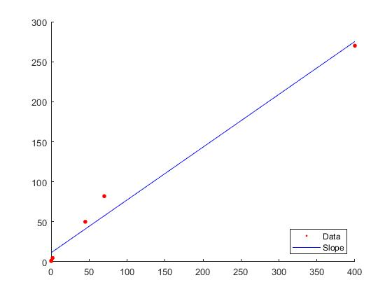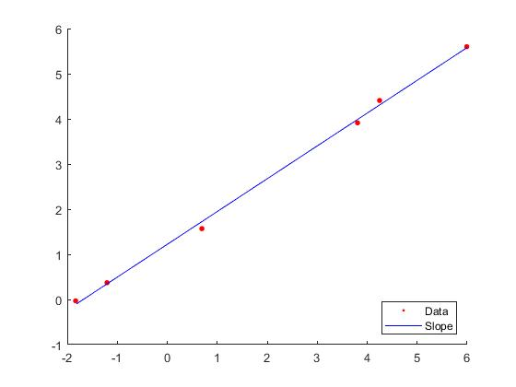

We regard energy data as W, the mass data as m. Then we can get [ m ] [x1 x2]­­­­^T = [ W ]

Using backslash in matlab, we get [x1 x2] = [11.2908 0.6599].

Mathematical model:

W(m) = 0.6599m + 11.2908

Fitting data to plot 1, we can observe that the trend of data fall along the line, but some data points off the line (m = 45 and m = 70). We can assume that metabolism and mass have a linear relation. As the mass increases, the metabolism increases with same trend.

When we use logarithmic data to draw the plot, the linear relation is much more obvious. According to the plot 2, all data points fall strictly along the line. And we can make sure the linear relation is correct and we have made a plausible model.

From my perspective, the surface area of bodies can affect the metabolism and emitted heat. Different animals have different shape. These differences can influence the heat to be emitted. Therefore, the data are not perfect fall on the line.

Exercise 3

Part a.

using matlab backslash

data =[

1.02 0.39

0.95 0.32

0.87 0.27

0.77 0.22

0.67 0.18

0.56 0.15

0.44 0.13

0.30 0.12

0.16 0.13

0.01 0.15

];

x = data(:,1);

y = data(:,2);

A = [y.^2,x.\*y,x,y,ones(length(x),1)];

b = [x.^2];

m = A\b

we got m =

a -2.6356

b 0.1436

c 0.5514

d 3.2229

e -0.4329

we have -2.6356y^2 +0.1436xy + 0.5514x + 3.2229y -0.4329 = x^2

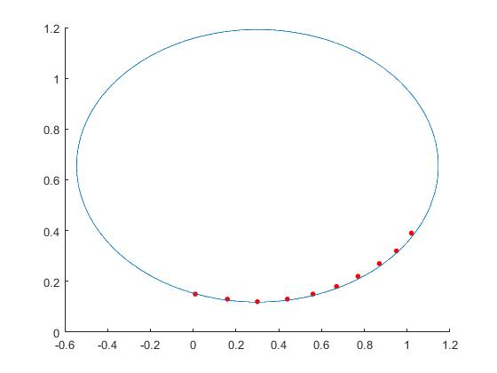

Part b

R = -0.005+(0.005-(-0.005))\*rand(10,1);

x = data(:,1)+ R;

R1 = -0.005+(0.005-(-0.005))\*rand(10,1);

y = data(:,2)+ R1;

A = [y.^2,x.\*y,x,y,ones(length(x),1)];

b = [x.^2];

m = A\b

m =

-3.2552

0.5141

0.4918

3.2299

-0.4243

a = -3.2552, b = 0.5141, c = 0.4918, d = 3.2299, e = -0.4243

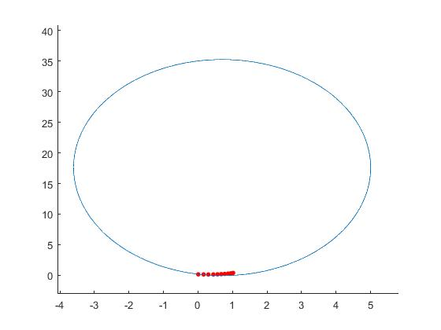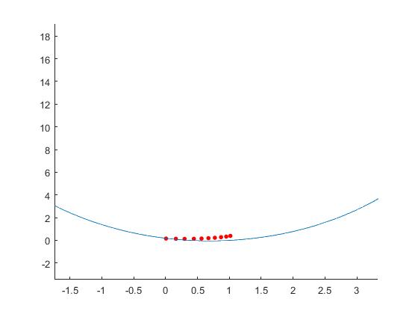

Compare to previous computed data, a is smaller; b and c vary in random; d and e didn’t change much. The ellipse is much larger than the previous one. We move a to the right, then it becomes -a, a positive value. As a decrease, -a increase. Dividing a, in the right we have x^2/-a + y^2.