Exercise 1 p.250 5.1

a.

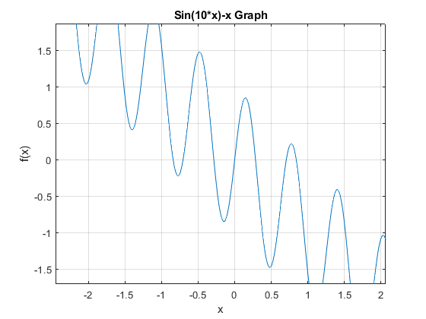

Based on the plot, we can view 7 roots. We can either manually or automatically find their brackets.

Here I use a routine as follows to find them.

fun = @(x) sin(10*x)-x;

x = linspace(-1,1,8);

y = fun(x);

Sy = sign(y);

Sy = Sy(1:end-1).*Sy(2:end);

bracketind = find(Sy <= 0);

disp(x);

>> e1_findBrackets

-1.0000 -0.7143 -0.4286 -0.1429 0.1429 0.4286 0.7143 1.0000

So brackets are (-1.0000 , -0.7143), ( -0.7143, -0.4286),( -0.4286 , -0.1429),

( -0.1429, 0.1429),( 0.1429, 0.4286),

( 0.4286, 0.7143),( 0.7143, 1.0000) respectively.

Implement Newton Method:

f(x) = sin(10x)-x

f’(x)=10cos(10x)-1

iteration step: xk+1 =xk – =

We input the initial point x = -1 to do the sequence of iteration.

error = – $\frac{f(xk)}{f'(xk)}$

When error equals 0, it convergent. Then we get the first root

r1 = -0.8423.

>> e1_findRoots

k xk f(x) f`(x) error

0 -1.0000 1.5440 -9.3907 0.1644

1.0000 -0.8356 -0.0411 -5.8102 -0.0071

2.0000 -0.8427 0.0022 -6.4182 0.0003

3.0000 -0.8423 0.0000 -6.3898 0.0000

4.0000 -0.8423 0.0000 -6.3898 0.0000

5.0000 -0.8423 0 -6.3898 0

6.0000 -0.8423 0 -6.3898 0

Using the same way, we get

r1 = -0.8423 r2 = -0.7068

r3 = -0.2852 r4 = 0

r5 = 0.2852 r6 = 0.7068

r7 = 0.8423

Exercise 2

>> e2

k xk f(x) f`(x) error

0 0.1000 -0.0007 0.0267 0.0250

1.0000 0.1250 0.0001 0.0333 -0.0025

2.0000 0.1225 0.0000 0.0327 -0.0000

3.0000 0.1225 0.0000 0.0327 -0.0000

Exercise 3

E3a plot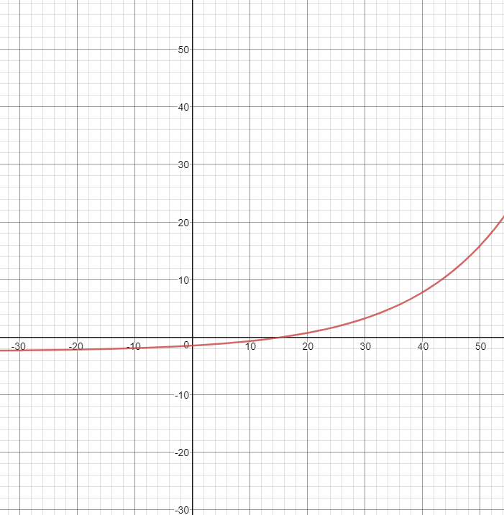

>> e3a

k xk f(x) f`(x) error

0 10.0000 -0.7092 0.1044 6.7959

1.0000 16.7959 0.1609 0.1550 -1.0379

2.0000 15.7579 0.0048 0.1460 -0.0327

3.0000 15.7252 0.0000 0.1457 -0.0000

4.0000 15.7252 0.0000 0.1457 -0.0000

>> e3b

k xk f(x) f`(x) error

0 0.1000 1.0000 67.2750 -0.0149

1.0000 0.0851 0.2382 37.2082 -0.0064

2.0000 0.0787 0.0318 27.5768 -0.0012

3.0000 0.0776 0.0009 26.0225 -0.0000

4.0000 0.0775 0.0000 25.9766 -0.0000

Procedure 1

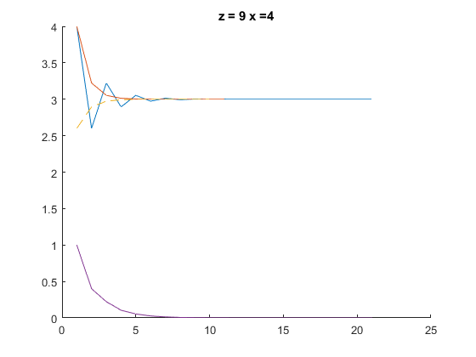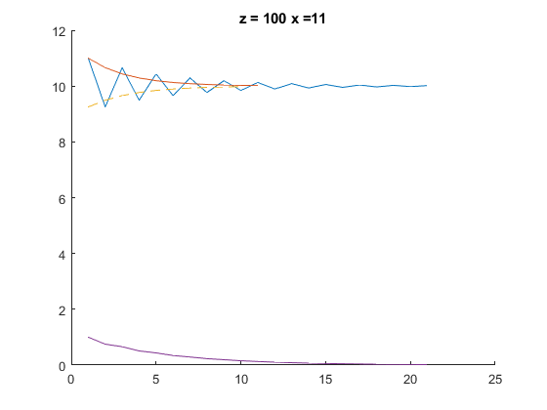

According to plots, it is converging to the square root of z. Odd sequence decreases until convergent, even sequence increases until convergent. The convergence rate is linear.

Procedure2:

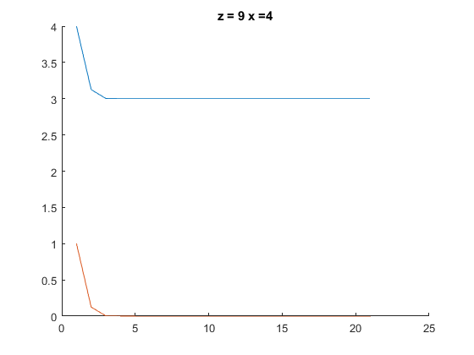Yes, it is monotonically converging to the square root of z.  The convergence rate is linear.