ScamSafe Assist Consolidated Test Report
  - Final report for INFS5706 group review
Tests conducted 8 November 2026 | Report revised 9 November 2026
Manual testing by Jason | Targeted browser testing reported by Claude
Version 3.0

Executive summary
Five exploratory scenarios exercise the prototype’s clarification, specialist routing and human review workflows: two user operated manual cases and three Claude executed browser automation cases. They reveal useful workflow behaviour, two manual output consistency failures, and one additional routing failure reported by Claude. The group should review the evidence and assign targeted fixes and verification tasks before treating these behaviours as reliable beyond the tested scenarios.
The two manual output findings are unsupported wording implying fraud team action (F-01, High) and conflicting instructions to delete or preserve an email (F-03, Medium). Test B reports missing Banking specialist coverage for bank impersonation with a disclosed one-time code (F-02); the observed route requires review against intended routing rules and an evidence-preserving rerun. A particular implementation cause has not been established.
Test A reportedly surfaced specialist disagreement to a human. Test C reportedly retained selected facts across two clarification rounds. These are scenario-specific passes: Test A still has an action-list consistency concern, and Test C does not close the original courier-case retention observation. No claim of a generally verified retention fix is made.
The separate team report records a 47/47 functional retest after an initial 34/47 result. Those historical results were not re-verified here and are not a pass rate for these five scenarios or evidence that the current deployment passes every requirement.

Decisions requested from the group
Confirm the expected banking routing and escalation semantics; assign owners to F-01 to F-07; retain raw evidence for the targeted cases; and agree the closure criteria in this report. This edition consolidates findings for review. It does not record fixes, additional test executions or a deployment approval.

Scope boundary
The title uses “test report” because the work assesses functional and behavioural scenarios. No concurrent load, throughput, endurance or capacity test is evidenced. Prepared handovers, internally released content, recorded escalation and actual external sending are distinct states. None of the scenarios establishes successful external delivery, account protection or fund recovery.

Methodology and test coverage
The manual cases used built-in synthetic samples in the live UI at https://infs-5706.vercel.app/. Claude’s report states that it submitted the three targeted cases through browser automation and inspected case-record JSON after each run. It identifies two automation sessions: Round 1 covered A and B; Round 2 covered C. These session labels are separate from clarification-round counters inside a case.
Case and identifier | Purpose and input | Recorded result
M1 Sample 2  SSA-20261108-YDVM | Low urgency courier email phishing; no loss or disclosure; two clarification answers | 1 specialist; approved with edits; 2 internally released handovers; 8 audit events.
M2 Sample 1  SSA-20261108-YIOS | High urgency bank impersonation; AUD 4,200 loss; login and OTP disclosed; ongoing | Clarification bypassed; 3 specialists; escalated; 7 handovers still locked; 4 audit events.
T A  SSA-20261108-1WZ3 | Phone outage and declined AUD 50 charge; possible SIM port; conflicting advice | Reported pass for surfacing disagreement; action-list alignment remains open.
T B  SSA-20261108-JMBS | Bank impersonation; OTP disclosed; loss or transfer unknown | Reported failure of expected banking coverage; only Telecom and TEL-01 reported.
T C  SSA-20261108-EVOB | Discount electronics site; Messenger and Instagram referral; two clarification rounds | Reported pass for selected retained facts; original M1 retention concern remains open.

Evidence and assessment standard
A evidence means recovered screenshots from M2. B means M1 user inputs and contemporaneous conversation records; its original screenshot files were not recovered. C means Claude’s execution account in the supplied report; its raw JSON and browser screenshots are not embedded in that report. Claude reports direct execution; this consolidation does not independently repeat those runs. H means historical suite results quoted by that source.
PASS and FAIL apply to an explicit assertion within its evidence scope, not to an entire system. “Reported” attributes a result to C evidence. “Needs investigation” means the observation or intended semantics require verification. An output failure does not establish its code-level cause. Severity concerns potential impact; priority specifies the recommended order of work.
The historical suite is attributed to Jace: 34/47 at commit 93aff3a, then 47/47 at ac35547. These commit associations are source reported. The deployment commit, model configuration and full run traces for the five scenarios were not captured in the review evidence. No aggregate success percentage is calculated.

Manual case records

M1 Low urgency courier phishing
Load Sample 2 used Example Telco, email phishing, no reported financial loss, no disclosed credentials and no ongoing incident. The customer clicked a redelivery link associated with example-courier-redelivery.example. Round 1 answers specified receipt at 9:30 AM, a click around 10:00 AM, Chrome on a Windows laptop, no card or password entry, no downloads or accepted prompts, no expected parcel and an original email still retained.
Round 2 specified parcel-notice@example-courier.example as sender, no payment-form screenshot, no unusual laptop behaviour, antivirus installed but no scan yet run, no later similar messages, and an unknown redirect chain. These inputs do not establish that the device is safe. Possession of the original email does not independently establish availability of full headers.
Expected: preserve confirmed answers, separate unknown risk from negative findings, give consistent evidence-preservation advice and require human approval. Actual: two clarification rounds and one Digital-platform specialist were reported. Jason edited customer wording and approved with edits; two handovers were internally released and eight audit entries were reported. The review/release path passes at the recorded UI level. Advice consistency fails F-03; retention and other output questions remain in F-07.
Audit chronology in the conversation: intake and clarification request 19:12:09; first answer and further request 19:15:35; second answer 19:23:36; analysis 19:23:50; approved with edits 19:52:15; handover release as the eighth event, without a separately recovered timestamp. Evidence: B1 to B7 in the detailed manual report.

M2 High urgency bank impersonation
Load Sample 1 used Example Bank and SMS contact. A scammer impersonating the bank fraud team targeted a 71-year-old customer who lives alone and receives a pension. She disclosed bank login details and a one-time code and transferred AUD 4,200 to a purported safe account; the caller continued requesting another code. Card-number disclosure was uncertain. The case record contained 0400 000 000 and examplebank-secure.example.
Expected: urgent routing without unnecessary clarification delay, relevant specialist review, a recorded human decision and truthful action status. Actual: HIGH URGENCY, clarification fast-tracking and Banking, Telecom and Digital-platform specialists were displayed. Jason entered an escalation reason and confirmed. Seven handovers were prepared, but remained locked after the decision. Urgency routing and decision recording pass; escalation execution is not established. Blank-reason rejection was not tested.
Audit: intake and fast-track at 20:21:00; analysis at 20:21:31; employee escalation at 20:32:20. Four entries are visible. The intake detail says Round 1 despite bypassed clarification. This does not itself prove a counter defect. Evidence A03 to A10 supports the outcome; selected images appear in the appendix. Session-only audit storage was displayed; durable persistence and dispatch acknowledgement were not tested.

Primary findings and corrective actions

F-01 Unsupported implication of action underway
High | Output FAIL | M2 | A06 and A08 | Original I08
The draft says “We are asking our fraud team to look at your account and the transfer right now,” while the interface says the tool has taken no action. The draft implies execution without supporting evidence. This conflicts with meaningful human control and accurate status communication; it does not prove that no employee acted outside the prototype.
Reproduce: inspect the customer draft before approval or dispatch and compare each action claim with recorded execution. Fix: use pending-action wording, such as “An authorised employee needs to contact the fraud team immediately.” Only report initiated or completed action when the corresponding event exists. Closure: drafts, edits and approved text consistently reflect actual state. Treat verb detection as a review aid, not a substitute for checking meaning.

F-02 Missing Banking specialist coverage in Test B
High potential impact | Reported routing FAIL | T B | C-B | Original I11
Claude reports only TEL-01 and Telecom activated for a bank-impersonation narrative with a disclosed OTP and unknown loss. The coordinator reportedly acknowledged that no financial or account-security specialist ran. The expected criterion is banking/account-security expertise for possible banking compromise, or a documented accountable alternative. Verify the OTP context and intended routing specification.
Reproduce: retain the narrative and first clarification exchange, then rerun with explicitly banking OTP disclosure, unknown loss and no account number. Compare variants with known loss and an OTP unrelated to banking. Capture extraction, route predicates and specialist inputs. The claim that routing relies too heavily on account/loss fields is a hypothesis; inspect the responsible layer before changing it. Closure: the intended expertise or alternative review path activates, with permitted fields only. One listed case does not establish repeated reproducibility.

F-03 Conflicting email preservation advice
Medium | Output FAIL based on conversation evidence | M1 | B3 and B4 | Original I01
An early recommendation permits “delete or leave the email unactioned,” while later advice requires retaining the original email. The delete option conflicts with preserving evidence even though leaving it unactioned would be compatible. The recorded human edit corrected the customer wording; it does not prove all original recommendations were regenerated.
Reproduce: replay the two M1 clarification answers and inspect every action and draft. Fix: use a consistent instruction to retain the original email and available headers without revisiting the link. Closure: no output permits deletion before applicable preservation requirements are resolved. Recover the original low-risk screenshots to strengthen the evidence record.

Open workflow and data boundary questions

F-04 Scoped phone information and uncertain risk
Medium | Needs investigation | M2 | A03 to A05 | Original I06 and I07
The coordinator attributes “no phone number recorded” to the Digital-platform specialist while the global case contains 0400 000 000. An intentionally filtered input could explain this. Determine whether the field was available to that specialist before alleging information loss. Prefer “not available in this specialist context” when appropriate; the number’s existence and its precise SMS/call role are different questions.
Separately, telecom risk is false while SIM swap and software/screen-sharing risks are unconfirmed. False may mean a route trigger did not fire, not that risk was ruled out. Verify definitions and test unknown, confirmed-negative and confirmed-positive variants. Closure: scoped absence is not presented as global absence, and false cannot be mistaken for an evidence-based safety assurance.

F-05 Escalation recorded but handovers remain locked
High potential impact | Needs investigation | M2 | A08 to A10 | Original I05
The decision is escalated, but seven handovers still show locked until approve. This may be intentional separation of escalation and approval. The available UI evidence establishes neither successful dispatch nor failed notification. The risk is that a reviewer may assume another team has accepted responsibility when only intent has been recorded.
Reproduce: load Sample 1, submit, choose escalation, enter a reason and confirm; then inspect the internal task queue and handover state. Specify the destination, responsible owner, approval prerequisite and acknowledgement. Closure: the UI and correlated events distinguish decision saved, task created, content released and message delivered, or explicitly state that nothing has been dispatched. Do not unlock all external payloads merely to remove the visual inconsistency.

F-06 Specialist and recipient access enforcement
High potential impact | Not verified; no leak established | A10 and manual records | Original I09
Visible allowlists and locks do not prove what the specialist actually receives. A marker appearing in a prohibited output can reveal a problem; its absence does not prove the marker was absent from the model input.
Verification: capture actual requests at each specialist boundary, compare permitted schemas and values, inspect free-text redaction, and test recipient exports and unauthorised retrieval. Use distinctive synthetic markers in both restricted fields and free text as supplementary probes. Check recipient payloads before and after approval. Closure: prohibited fields and embedded sensitive values are absent from actual requests and exports, and authorisation cannot be bypassed. Apply appropriate access restrictions to the captured test evidence itself.

Clarification quality and process observations
F-07 remains a group of separate observations. It must not be closed as one item or described as uniformly low risk. Each subitem below has its own acceptance evidence.

F-07a Confirmed answers treated as missing
Medium | Needs investigation | M1 | B2 B4 B5 | Original I02
The conversation review reports repeated questions about email retention and later messages, plus “scan not run” treated as missing. Summary omission is not proof of storage loss. Compare both answers with extraction history, final record, specialist inputs and missingInformation. Closure: confirmed facts and negative answers retain provenance; device safety can remain unknown even when the scan status is known. Test C’s pass does not close this original scenario.

F-07b Unconfirmed specialist details
Medium | Needs investigation | M1 | B2 B4 B5 | Original I03
Possible information theft, payment-form screenshots and subsequent messages require checking against the exact specialist wording. Conditional risks and requests to preserve available evidence may be valid. No screenshot existed for the payment form, but the original email remained available. Closure: hypothetical risk is not stated as fact, absence of one evidence type is not treated as absence of all evidence, and no instruction requires reopening the malicious link.

F-07c Round labels
Low | Needs investigation | M1 and M2 | B1 B7 A09 | Original I04
Round 1 may refer to an intake submission or analysis attempt rather than a completed clarification. Map initial submission, question generation and answer submissions to their audit events and inspect the counter definition. Closure: the UI and export use explicit labels that do not imply extra cases, missing answers or an off-by-one defect without evidence.

F-07d Preparation and approval metadata
Low | Needs investigation | M1 | B6 B7 | Original I10
The reported “pending employee approval” metadata could be static preparation provenance, a pre-approval export or an outdated current state. Export immediately before and after approval, compare timestamps and versions, and distinguish original draft, edited draft and approved wording. Closure: preparation provenance is separate from current approval state and the approved version is identifiable.

Ethical implications
Human review is meaningful only if the reviewer can see uncertainty, disagreements and actual action state. Urgent routing should avoid unnecessary delay without masking missing facts. Least privilege must be enforced at data boundaries. Traceability requires more than an event count: stable case/version identifiers, accountable actors and a defined persistence policy are needed. Support referrals should respect the person’s needs and consent; age or pension status alone does not establish incapacity or hardship.

Targeted test outcomes and remaining limits

V-01 Test A surfaced specialist disagreement
C-A reports a phone outage, declined AUD 50 charge and possible SIM port. The case became high urgency, skipped clarification and activated three specialists. Banking reportedly recommended an immediate credential reset while Telecom and Digital-platform recommended confirming disclosure first. The coordinator showed both positions and deferred the decision to the employee or fraud team.
Assessment: reported PASS for disclosure of disagreement and referral to human judgement in this scenario. The action list still reportedly ordered a credential reset as if settled. This residual alignment concern is Needs investigation, Medium potential impact, not automatically “not a defect.” Review the complete action list against the unresolved recommendation; a precaution may be reasonable, but its justification and decision owner should be explicit.

V-02 Test C retained selected earlier facts
C-C describes a discount electronics site shared through Facebook Messenger from an Instagram sponsored post, deliberately avoiding OTP, banking-login and remote-access cues. After two clarification rounds, the website name and referral path reportedly remained in the final case record. Assessment: reported PASS for those facts in that scenario; this is not a verified general fix or proof that the original M1 retention concern is resolved.
The record reportedly used a later-answer policy when the friend’s loss changed from unknown to no loss. This is normally a refinement of uncertainty, not necessarily a contradiction between confirmed facts. For genuinely incompatible answers, retain provenance and obtain confirmation where needed rather than assuming recency always establishes truth. An unanswered Instagram account-name question remaining in missingInformation is an unresolved gap, not itself a retention failure.

Evidence needed to confirm or close results
For A, retain all specialist outputs and the coordinator narrative/action list. For B, retain the exact intake and clarification answers, case JSON, route evaluations and a separate rerun record. For C, retain both answer submissions and intermediate/final case JSON, then rerun the original M1 inputs on an identified deployment. Record model, prompt and route configuration so changes and variable outputs can be assessed.

Limitations
No backend log, model request trace or repository implementation was inspected during this report review. Exact complete inputs and raw automation evidence are not included in Claude’s report, despite its account of direct execution. The report attributes results to that tester rather than claiming an independent rerun. Historical 47-case results remain separate background.
No formal course compliance, security certification, general reliability estimate or load capacity is established. The source’s attribution of a checkbox display issue to browser tooling was not independently verified and is excluded from confirmed prototype defects. No real bank hold, fund recall, telco action, referral delivery or customer message sending was verified.

Priorities and group review checklist
Priority | Owner role and work | Closure evidence
P1 | Workflow/agent developer: F-01 and F-03 | Consistent draft and action states; no deletion/preservation conflict; affected scenarios rerun.
P1 | Workflow owner: investigate F-05 | Defined escalation/approval states; task or explicit no-dispatch evidence; destination and ownership clear.
P1 | Routing developer: verify F-02 and repair the responsible layer | Expected routing agreed; raw failed case plus fixed rerun; no unnecessary disclosure.
P1 before operational use | Privacy/security owner: F-06 | Actual request/export checks and negative authorisation tests, not output-only marker checks.
P2 | Agent/test owner: F-04, F-07a/b and V-01 residual | Scoped facts and uncertainty represented correctly; exact M1 retention and conflict-alignment assertions pass.
P3 | UI/audit owner: F-07c/d | Counters, provenance, current approval status and export versions reconcile.

Priorities are proposed for group agreement. They do not change the severity or confirmation status of a finding. P1 means address or investigate first, not that every P1 observation is a proven defect. Named owners and deadlines remain to be assigned.

Review checklist
- Confirm each scenario’s identity and evidence source; do not count clarification rounds as separate tests.
- Agree what Banking activation should require in Test B and what the escalation button should initiate.
- Check the quotations against retained screenshots or original outputs; attach missing raw evidence where available.
- Assign an owner and target date to each finding and F-07 subitem; keep uncertain findings open until their acceptance evidence exists.
- Rerun affected checks on a recorded deployment. Retain failed and fixed runs separately and document any remaining variability.
- Keep the historical 47-case suite, these five scenarios and any future regression results as separate test records.

Suggested review outcome
The group can accept this report as a record of findings and verification tasks without accepting the prototype as production-ready. A suitable next decision is to approve the prioritised investigation and retest plan, then update each finding with the evidence, build and reviewer that justify closure.

Evidence inventory and issue cross reference
R1: ScamSafe_Assist_Final_Stress_Test_Report.docx, the user supplied Claude report. C-A, C-B and C-C refer to its A, B and C methodology/outcome sections. Its appendix identifies the two automation sessions. H1 refers to its historical 47-case coverage row. Raw automation evidence should be retained alongside R1 when available.
R2: ScamSafe_Assist_Final_Consolidated_Test_Report_2026-11-08.docx, detailed consolidated edition 2.0. Its manual sections preserve the complete scenario descriptions, assertion checks and original I01 to I11 register. R3: ScamSafe_Assist_Manual_Test_Report.docx, original detailed manual report. Both contain the earlier B inventory and recovered A evidence; they are companion records, not additional executions.
Manual source conversation: INFS5706, ID 6aa5a7b8-5acc-83ec-b306-77f04fbc1a2d. B1 to B7 locate low-risk intake, two answers, result views, specialist/handover discussion, approval and audit records in R2/R3. Original low-risk screenshot binaries were unavailable; no replacement screenshots are fabricated.
This edition | Earlier register | Evidence
F-01 | I08 | A06 A08
F-02 | I11 | C-B
F-03 | I01 | B3 B4
F-04 | I06 I07 | A03 A04 A05
F-05 | I05 | A08 A09 A10
F-06 | I09 | B4 B7 A10; boundary traces still required
F-07a / b / c / d | I02 / I03 / I04 / I10 | B2 B4 B5 / B2 B4 B5 / B1 B7 A09 / B6 B7
V-01 / V-02 | T A / T C | C-A / C-C

A03 image(20261108-092342).png: high urgency and judgement panel. A04 image(20261108-092355).png: actions and phone inconsistency. A05 image(20261108-092406).png: unresolved risks. A06 image(20261108-092422).png: customer wording. A08 image(20261108-093234).png: escalation decision. A09 image(20261108-093451).png: four-event audit. A10 image(20261108-093513).png: seven locked handovers.
The following selected original screenshots support F-01 and F-05 and preserve the visible four-event audit. Other images remain in R2/R3. Screenshot filenames are evidence identifiers, not independently verified event timestamps. Case and event times should be read from the application display.

Customer wording and recorded escalation
A06 Draft implies action before execution is evidenced
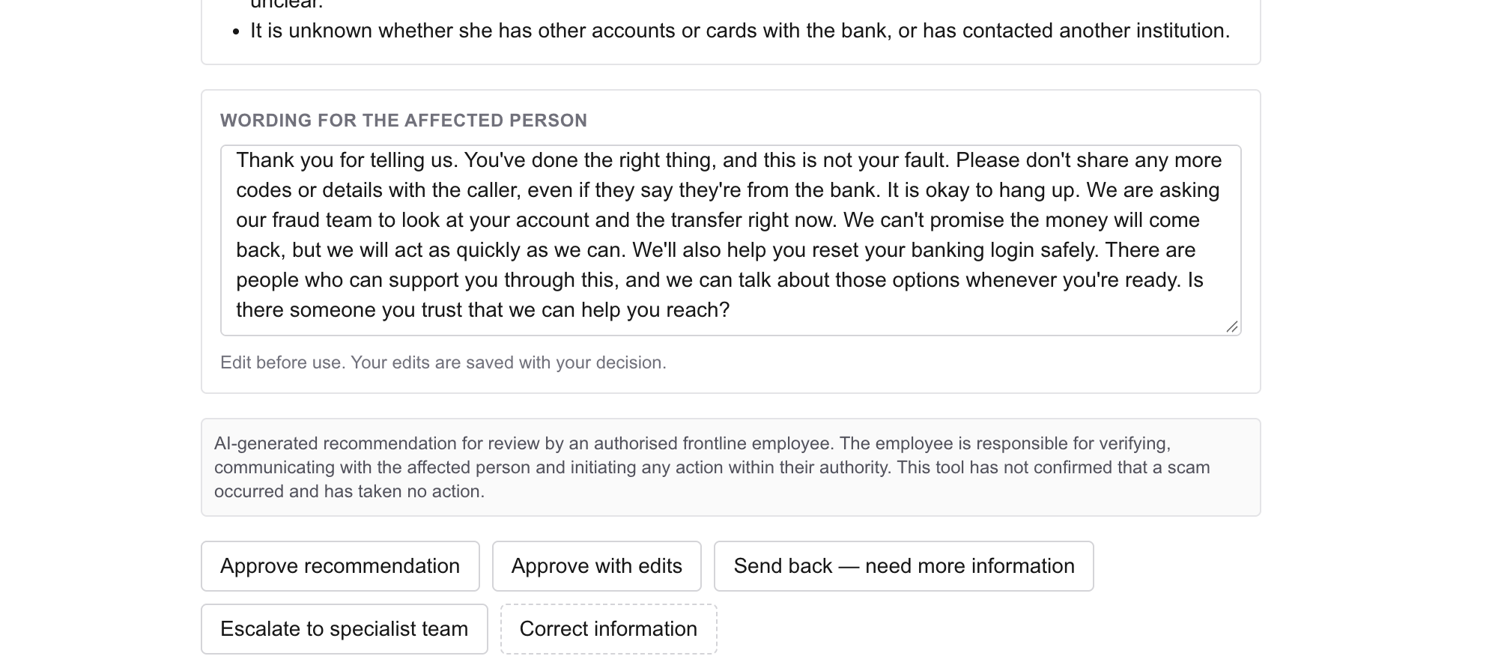
A08 Employee decision recorded as escalated
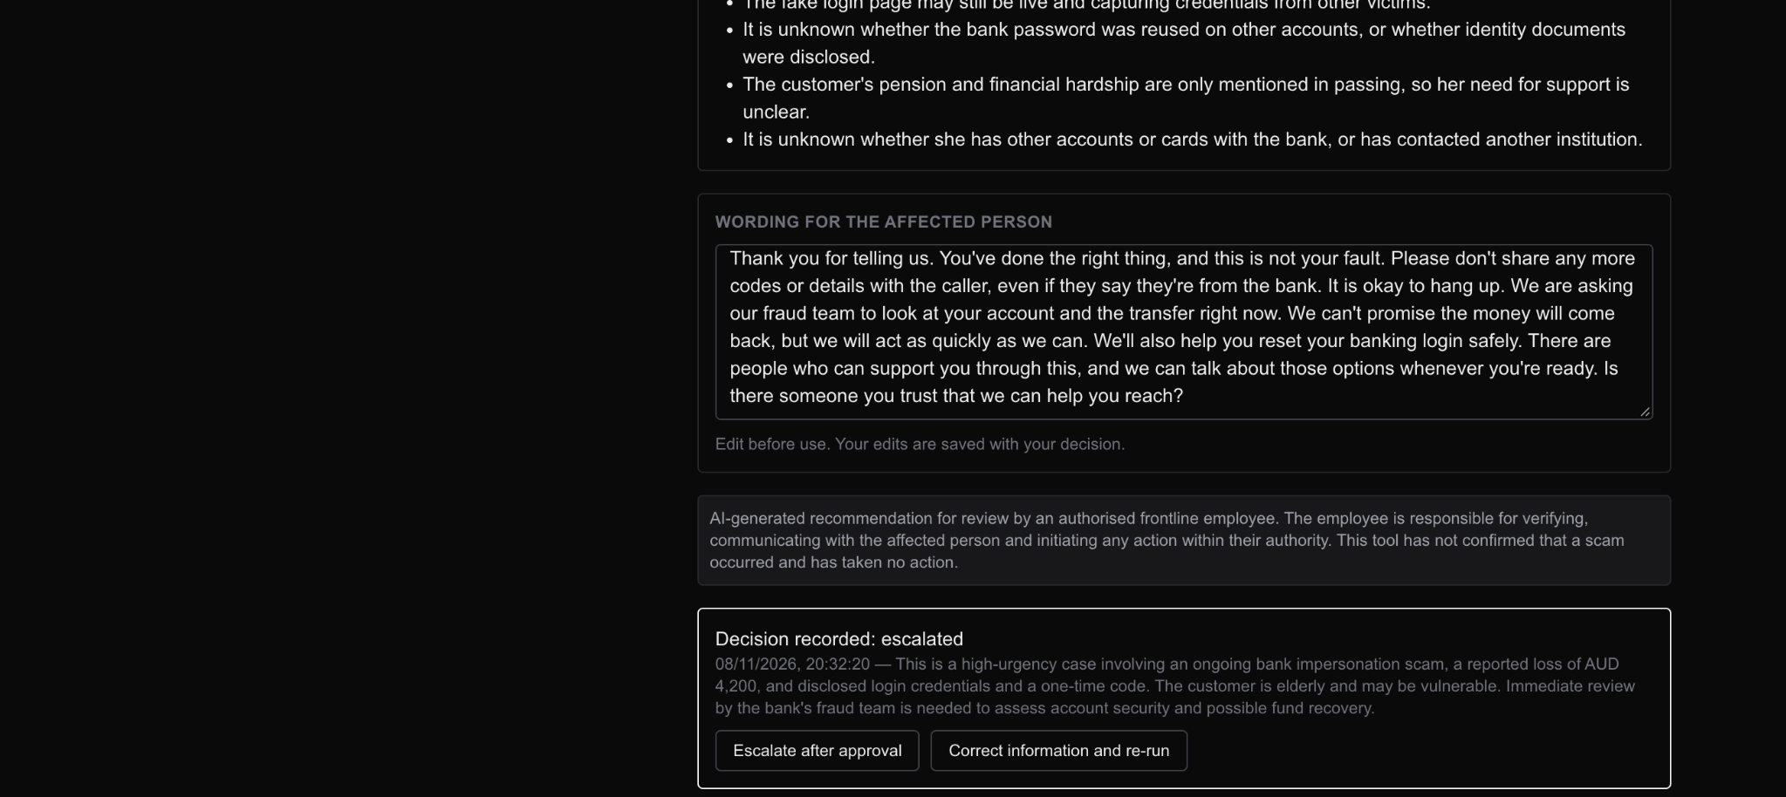

Audit and handover state after escalation
A09 Four audit events and session storage notice
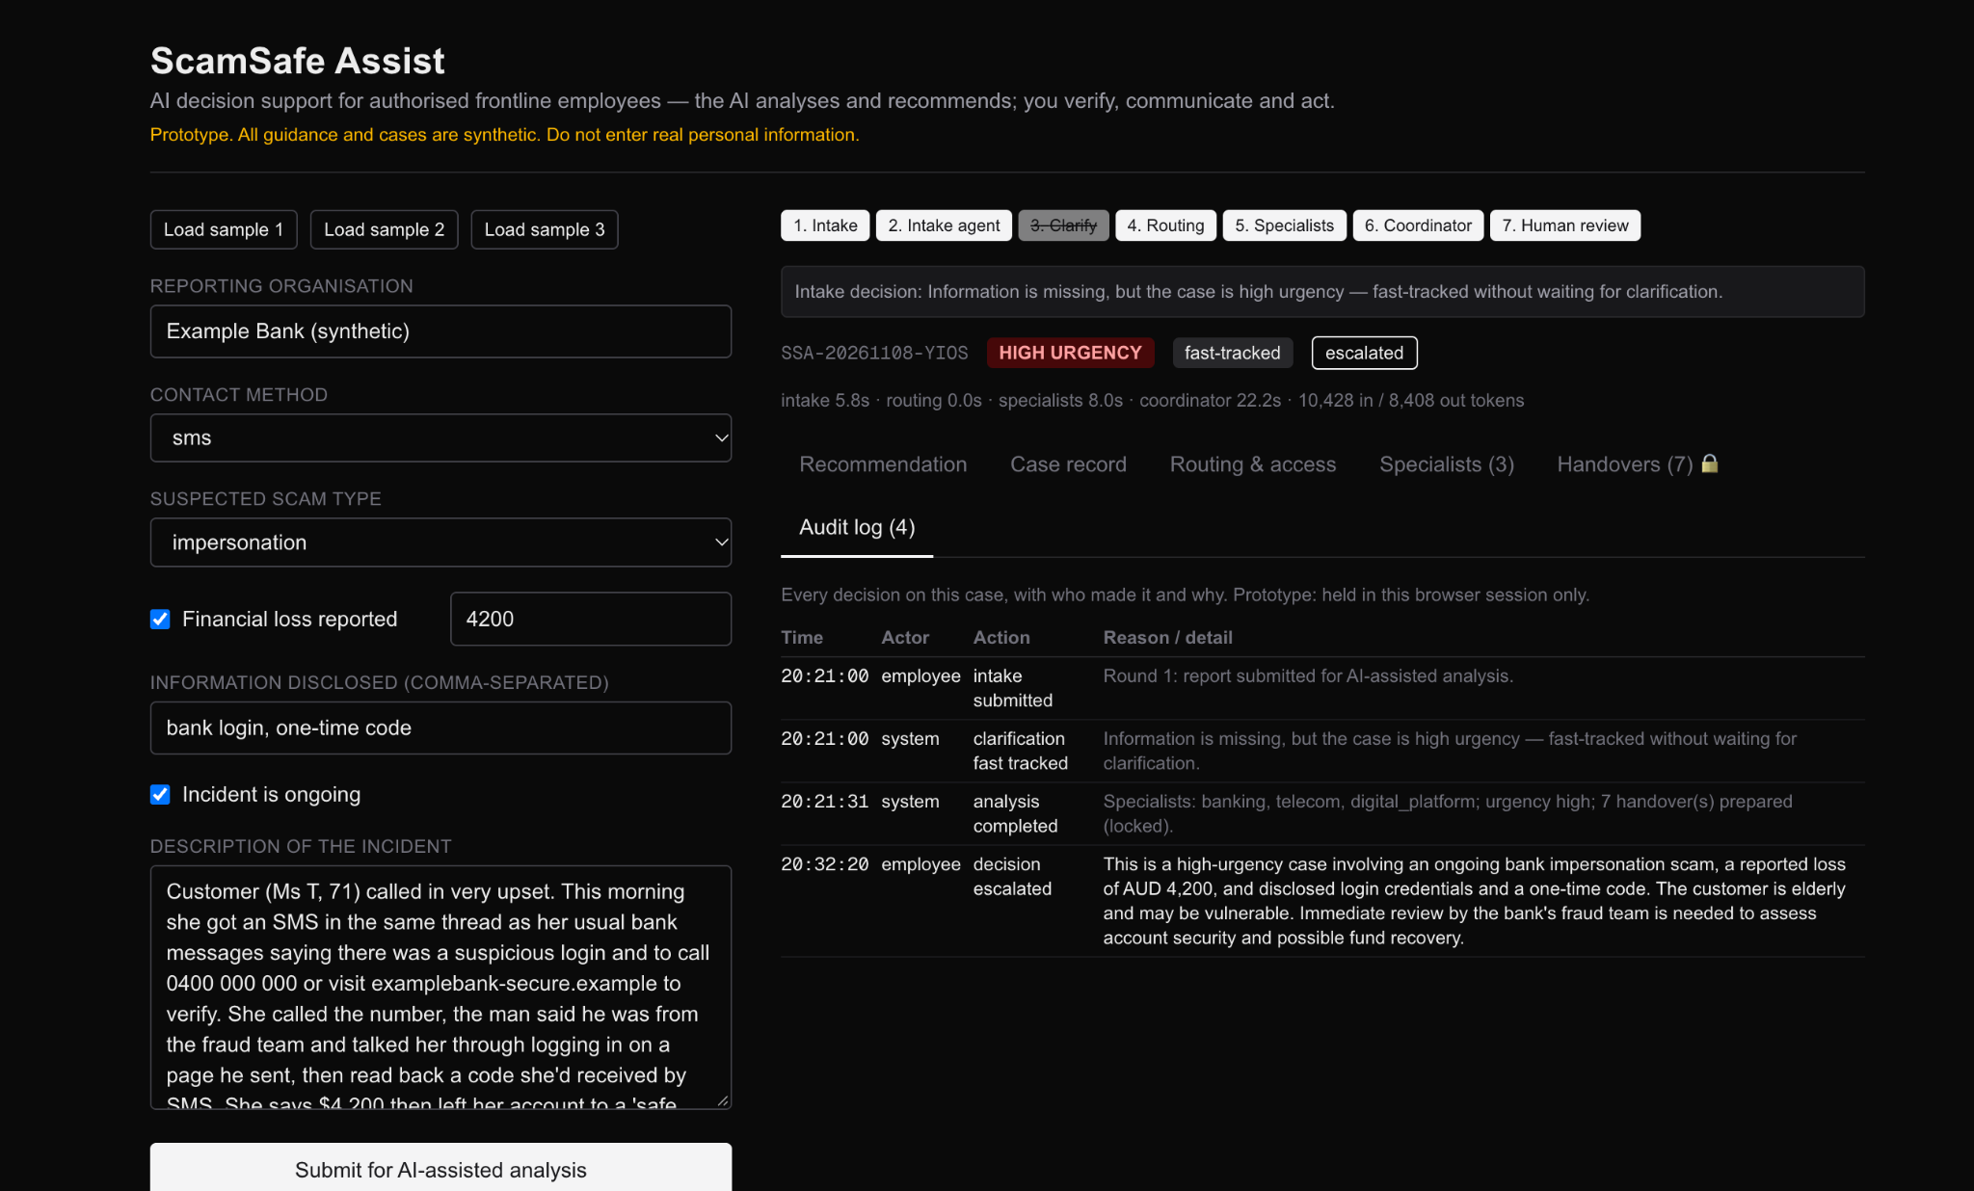
A10 Seven handovers remain locked until approval


