Before you start:
- Javascript is a client side programming language and runs within the browser ( server-side flavor is node.js )

- It adds interactivity to a web page.

- Contributes 50% in website or web app projects, rest 25%-25% is all html and css.

- Javascript is supported by all web browsers( it can be turned off but nobody does that) and hence web applications can be run on desktops, tabs, mobile etc.It is thus platform agnostic. Adobe developed action script but it requires all kinds of plugins that people aren’t willing to download.

- With jquery and jqueryUI it’s the number one choice for front-end development.

Note on where and how to add javascript in an html page:
- Add it within the <head></head> tag.
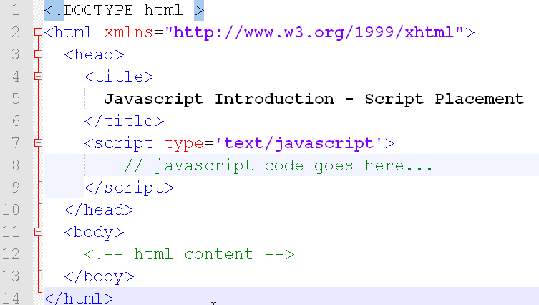
chap1.1.html

- Anywhere within the body.
Example

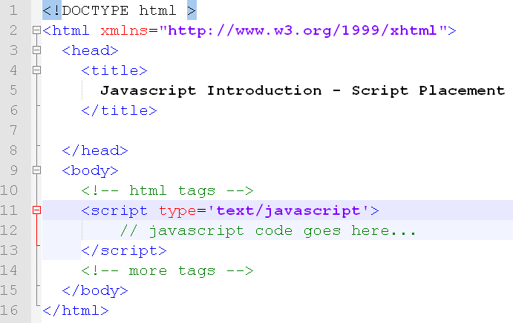
chap1.2.html

- Add it near the close of the body tag.
Example

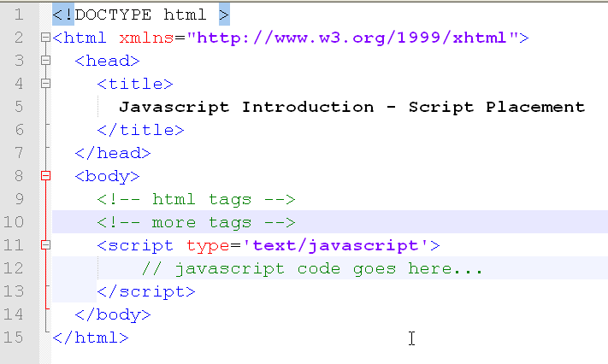

chap1.3.html

Points of Note:
Generally, in projects, you never write code in the same web page that has the html. JavaScript is put in a separate .js file. The extension of the file need not necessarily be .js it can be anything but we go with convention to easily identify all JavaScript files with .js extension.

- Adding an external JS in head
Example
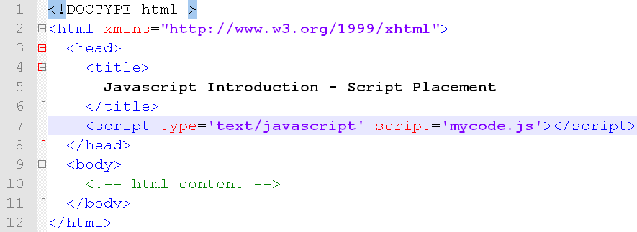
chap1.4.html

You should never skip the closing script tag even though you are using an external js
(i.e You should never use singleton tag syntax
<script type=’text/javascript’ src=’mycode.js’ />
That’s because it screws up loading in older browsers like IE 6 and even if it gets loaded in Firefox, you cannot debug in some version of firebug.

- Adding an external JS at the end of the body
(Most Preferred)
Example
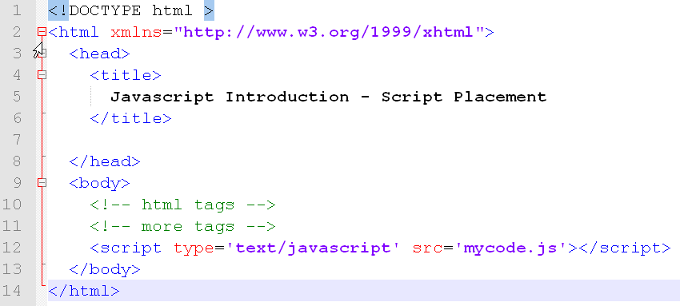

chap1.5.html

