**[ VIII ] 테블릿 레이아웃**

Visual Studio node에서 톱니바퀴 -> 코드조각 -> html.json선택 : html.json안에 아래의 내용을 추가

  "lec html form": {

    "prefix": "html-templateEx",

    "body": [

    "<!DOCTYPE html>",

    "<html lang=\"ko\" xmlns=\"http://www.w3.org/1999/xhtml\">",

    "<head>",

    "\t<meta charset=\"UTF-8\" />",

    "\t<meta name=\"viewport\" content=\"width=device-width, height=device-height, initial-scale=1.0, minimum-scale=1.0, maximum-scale=1.0\" />",

    "\t<title>$1</title>",

    "\t<style>",

    "\t\t",

    "\t</style>",

    "\t<script>",

    "\t\t",

    "\t</script>",

    "</head>",

    "<body>",

    "\t$2",

    "</body>",

    "</html>"

    ],

    "description": "HTML5 자동완성 추가"

  }

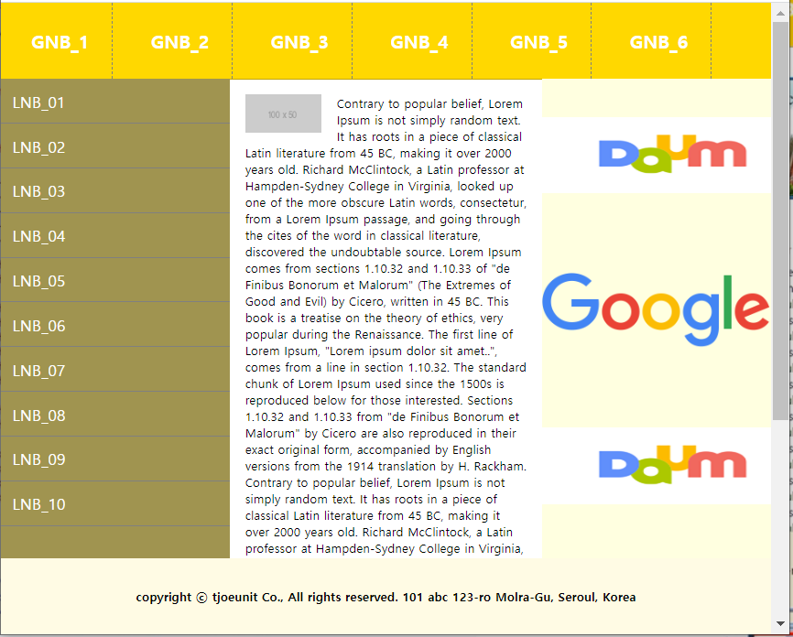

<!DOCTYPE html>

<html lang="en" xmlns="http://www.w3.org/1999/xhtml">

<head>

<meta charset="utf-8" />

<title></title>

<style>

*{margin:0; padding:0;}

html{height:100%;}

body{height:100%;}

li{list-style:none;}

a{text-decoration:none;}

/* * * * * * * * * #top_bar * * * * * * * * * * * */

#top_bar{position:fixed; top:0; left:0;right:0;

height:100px; line-height: 100px;

background-color:#ffd800; border-bottom:1px solid #c0a300;

}

#top_bar ul{overflow:hidden;}

#top_bar ul li{float:left;}

#top_bar ul li a {

display:block; padding:0 30px; margin:0 10px;

border-right: 1px dashed gray;

color:white; font-size:1.5em; font-weight:bold;

}

/* * * * * * * * * #top_bar * * * * * * * * * * * */

#bottom_bar{

position:fixed; bottom:0; left:0; right:0;

height:100px; line-height:100px;

background-color:#fffbe4;

font-weight:bold;

text-align:center;

}

#left_bar{

position:fixed;

top:100px; bottom:100px; left:0;

width:300px; background-color:#a09450;

}

#left_bar ul li a{

display:block;

padding:15px;

color:white;

font-size:1.3em;

border-bottom:1px solid gray;

}

#right_bar{

position:fixed; bottom:100px; top:100px; right:0;

width:300px; background-color:lightyellow;

}

#right_bar ul li{padding:50px 0;}

#right_bar img{

width:300px; height:100px;

}

#wrap {margin:100px 300px 100px 300px; padding:20px;}

#wrap img{float:left; margin-right:20px;}

</style>

</head>

<body>

<div id="top_bar">

<ul>

<li><a href="#">GNB_1</a></li>

<li><a href="#">GNB_2</a></li>

<li><a href="#">GNB_3</a></li>

<li><a href="#">GNB_4</a></li>

<li><a href="#">GNB_5</a></li>

<li><a href="#">GNB_6</a></li>

</ul>

</div>

<div id="left_bar">

<ul>

<li><a href="#">LNB_01</a></li>

<li><a href="#">LNB_02</a></li>

<li><a href="#">LNB_03</a></li>

<li><a href="#">LNB_04</a></li>

<li><a href="#">LNB_05</a></li>

<li><a href="#">LNB_06</a></li>

<li><a href="#">LNB_07</a></li>

<li><a href="#">LNB_08</a></li>

<li><a href="#">LNB_09</a></li>

<li><a href="#">LNB_10</a></li>

</ul>

</div>

<div id="right_bar">

<ul>

<li><a href="http://www.daum.net" target="_blank"><img src="https://t1.daumcdn.net/daumtop_chanel/op/20170315064553027.png" alt="다음" /></a></li>

<li><a href="http://www.google.com" target="_self"><img src="https://www.google.com/images/branding/googlelogo/2x/googlelogo_color_272x92dp.png" alt="구글" /></a></li>

<li><a href="http://www.daum.net" target="_blank"><img src="https://t1.daumcdn.net/daumtop_chanel/op/20170315064553027.png" alt="다음" /></a></li>

<li><a href="http://www.google.com" target="_self"><img src="https://www.google.com/images/branding/googlelogo/2x/googlelogo_color_272x92dp.png" alt="구글" style="width:400px; height:100p "/></a></li>

</ul>

</div>

<div id="bottom_bar">

<p>copyright ⓒ tjoeunit Co., All rights reserved. 101 abc 123-ro Molra-Gu, Seroul, Korea</p>

</div>

<div id="wrap">

<img src="http://placehold.it/100x50" />

<p>

Contrary to popular belief, Lorem Ipsum is not simply random text. It has roots in a piece of classical Latin literature from 45 BC, making it over 2000 years old. Richard McClintock, a Latin professor at Hampden-Sydney College in Virginia, looked up one of the more obscure Latin words, consectetur, from a Lorem Ipsum passage, and going through the cites of the word in classical literature, discovered the undoubtable source. Lorem Ipsum comes from sections 1.10.32 and 1.10.33 of "de Finibus Bonorum et Malorum" (The Extremes of Good and Evil) by Cicero, written in 45 BC. This book is a treatise on the theory of ethics, very popular during the Renaissance. The first line of Lorem Ipsum, "Lorem ipsum dolor sit amet..", comes from a line in section 1.10.32.

The standard chunk of Lorem Ipsum used since the 1500s is reproduced below for those interested. Sections 1.10.32 and 1.10.33 from "de Finibus Bonorum et Malorum" by Cicero are also reproduced in their exact original form, accompanied by English versions from the 1914 translation by H. Rackham.

Contrary to popular belief, Lorem Ipsum is not simply random text. It has roots in a piece of classical Latin literature from 45 BC, making it over 2000 years old. Richard McClintock, a Latin professor at Hampden-Sydney College in Virginia, looked up one of the more obscure Latin words, consectetur, from a Lorem Ipsum passage, and going through the cites of the word in classical literature, discovered the undoubtable source. Lorem Ipsum comes from sections 1.10.32 and 1.10.33 of "de Finibus Bonorum et Malorum" (The Extremes of Good and Evil) by Cicero, written in 45 BC. This book is a treatise on the theory of ethics, very popular during the Renaissance. The first line of Lorem Ipsum, "Lorem ipsum dolor sit amet..", comes from a line in section 1.10.32.

The standard chunk of Lorem Ipsum used since the 1500s is reproduced below for those interested. Sections 1.10.32 and 1.10.33 from "de Finibus Bonorum et Malorum" by Cicero are also reproduced in their exact original form, accompanied by English versions from the 1914 translation by H. Rackham.

</p>

</div>

</body>

</html>