1. **Ajax : 서버와 데이터 교환을 하는 기술.**

<http://api.jquery.com/category/ajax/> ajax관련된 API 정보

웹페이지의 특정부분(한파트)를 업데이트하고 서버와 데이터를 교환하는 기술.

우리가 기존의 웹페이지의 내용을 변경하기 위해서는 웹페이지에 떠있는 페이지를 다시 로딩해야 했었다.

그런데 Ajax를 이용하게 되면 특정부분의 영역에 있는 데이터 수정시 전체 페이지를 로딩하지 않고 서버와 데이터 교환이 가능하다

샘플을 보면 기존에 있었던 텍스트 대신 바꿔 치기 한다.

전체가 로딩되지 않고 일부분만 텍스트가 변경되었다.

Ajax는 웹페이지의 전체내용을 다시 불러들이지 않고 웹페이지의 일부분을 배경에서 서버와 데이터 교환이 일어나 원하는 부분에 뿌려 줄 수 있는 기술이다.

jQuery에서는 Ajax와 관련하여 몇 개의 메소드를 제공하고 있다.

jQuery Ajax메소드를 사용하게 되면 외부데이터를 로딩해서 보여질 수 있다.

jQuery를 이용하지 않으면 Ajax이용이 어려울 수 있으나 jQuery를 이용하면 쉬운 코딩이 될 수 있다.

1. Http Request : GET vs. POST

$.get(URL, callback);

$.post(URL, {파라미터이름:전달파라미터값, callback);

$.ajax({/* $.ajax(json형식으로 option 설정)

ex) $.ajax({url:'', type:'get', data:~ , success:function(data,status){} });

1. url : 요청 자원(서버)를 호출, 일반적으로 호출된 자원에서 json형식으로 데이터 return 해준다
2. type : 요청처리방식
3. data: 요청시, 함께 전달되는 데이터

ex. $(‘form’).serialize()

form안에 있는 데이터를 query로 변경하여 전달

1. dataType : 요청 후, 응답의 결과로 반환되는 데이터의 종류를 선언

ex. Xml, html, joson, text

1. success : 성공했을 때, 처리할 내용, 콜백함수로 나타냄.

ex. Function(data, status){}

1. error : 응답이 에러가 났을 때, 에러 상태에 대한 코드를 반환

ex. error : function(code){

code:에러에 대한 code 내용 전달...

}

*/})

**MemberDao.java**

**public** **class** MemberDao {

**public** **static** **final** **int** ***EXISTENT*** = 0;

**public** **static** **final** **int** ***NONEXISTENT*** = 1;

**private** **static** MemberDao *instance* = **new** MemberDao();

**public** **static** MemberDao getInstance() {

**return** *instance*;

}

**private** MemberDao() {}

**private** Connection getConnection() **throws** SQLException {

Connection conn = **null**;

**try** {

Context ctx = **new** InitialContext();

DataSource ds = (DataSource) ctx.lookup("java:comp/env/jdbc/Oracle11g");

conn = ds.getConnection();

} **catch** (NamingException e) {

System.***out***.println(e.getMessage());

}

**return** conn;

}

// mId 중복체크

**public** **int** mIdConfirm(String mId) {

**int** result = ***EXISTENT***;

Connection conn = **null**;

PreparedStatement pstmt = **null**;

ResultSet rs = **null**;

String sql = "SELECT * FROM MVC_MEMBER WHERE mId=?";

**try** {

conn = getConnection();

pstmt = conn.prepareStatement(sql);

pstmt.setString(1, mId);

rs = pstmt.executeQuery();

**if**(rs.next()) {

result = ***EXISTENT***;

}**else** {

result = ***NONEXISTENT***;

}

} **catch** (Exception e) {

System.***out***.println(e.getMessage());

}**finally** {

**try** {

**if**(rs != **null**) rs.close();

**if**(pstmt != **null**) pstmt.close();

**if**(conn != **null**) conn.close();

} **catch** (Exception e) {

System.***out***.println(e.getMessage());

}

}

**return** result;

}

}

**idConfirm.jsp**

<%@page import=*"com.tj.ex.dao.MemberDao"*%>

<%@ page language=*"java"* contentType=*"text/html; charset=UTF-8"*

pageEncoding=*"UTF-8"*%>

<!DOCTYPE html>

<html>

<head>

<meta charset=*"UTF-8"*>

</head>

<body>

<%

String mId = request.getParameter("mId");

MemberDao mDao = MemberDao.getInstance();

**int** result = mDao.mIdConfirm(mId);

**if**(result==MemberDao.EXISTENT){

out.print("중복된 ID입니다");

}**else**{

out.print("사용 가능한 ID입니다");

}

%>

</body>

</html>

**ex01_get.html**

<!DOCTYPE html>

<html>

<head>

<meta charset=*"UTF-8"*>

<script src=*"https://code.jquery.com/jquery-3.4.1.min.js"*></script>

<script>

$(document).ready(**function**(){

$('button').click(**function**(){

**var** mId = $('#mId').val();

$.get('idConfirm.jsp?mId='+mId, **function**(data, status){

**if**(status == 'success'){

$('#result').html(data);

}

});

});

$('#mId').keyup(**function**(){

**var** mId = $('#mId').val();

$.get('idConfirm.jsp?mId='+mId, **function**(data, status){

**if**(status == 'success'){

$('#result').html(data);

}

});

});

});

</script>

</head>

<body>

<p>아이디 <input type=*"text"* name=*"mId"* id=*"mId"*>

<button>중복체크</button></p>

<span id=*"result"*></span>

</body>

</html>

**ex02_Post.html**

<!DOCTYPE html>

<html>

<head>

<meta charset=*"UTF-8"*>

<title>Insert title here</title>

<style></style>

<script src=*"https://code.jquery.com/jquery-3.4.1.min.js"*></script>

<script>

$(document).ready(**function**(){

$('button').click(**function**(){

**var** mId = $('#mId').val();

$.post('idConfirm.jsp',{mId:mId}, **function**(data, status){

$('#result').html(data);

});

});

});

</script>

</head>

<body>

<p>아이디 <input type=*"text"* name=*"mId"* id=*"mId"*>

<button>중복체크</button></p>

<span id=*"result"*></span>

</body>

</html>

**ex03_ajax.html**

<!DOCTYPE html>

<html>

<head>

<meta charset=*"UTF-8"*>

<title>Insert title here</title>

<style></style>

<script src=*"https://code.jquery.com/jquery-3.4.1.min.js"*></script>

<script>

$(document).ready(**function**(){

$('button').click(**function**(){

**var** mId = $('#mId').val();

$.ajax({

// url : 요청경로

// type : get방식 / post 방식

// data : 요청 파라미터와 파라미터값

// dataType : html/json/... 요청경로로 실행한 결과의 타입

// success : 요청경로로 실행한 응답이 성공하였을 때 수행할 콜백함수

// error : 요청경로로 실행한 응답이 실패되었을 때 수행할 콜백함수

url : 'idConfirm.jsp',

type : 'get',

data : 'mId='+mId,

dataType : 'html',

success : **function**(data){

$('#result').html(data);

},

error : **function**(code){

alert(code.status);

}

});

});

});

</script>

</head>

<body>

<p>아이디 <input type=*"text"* name=*"mId"* id=*"mId"*>

<button>중복체크</button></p>

<span id=*"result"*></span>

</body>

</html>

**<오늘의 예제>**

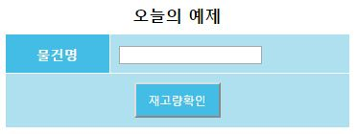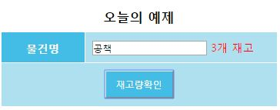

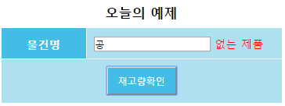

**DROP** **TABLE** PRODUCT **CASCADE** CONSTRAINTS;

**CREATE** **TABLE** PRODUCT (

PNO NUMBER(4) **PRIMARY** **KEY**, -- 코드

PNAME VARCHAR2(100) **NOT** **NULL**, -- 물건명

PSTOCK NUMBER(4) **NOT** **NULL** -- 재고량

);

**INSERT** **INTO** PRODUCT **VALUES** (1, '공책', 3);

**INSERT** **INTO** PRODUCT **VALUES** (2, '볼펜', 10);

**INSERT** **INTO** PRODUCT **VALUES** (3, '지우개', 13);

**SELECT** * **FROM** PRODUCT **WHERE** PNAME='공책'; -- DAO QUERY

**commit**;

**public** **class** **ProductDto** {

**private** **int** pno;

**private** String pname;

**private** **int** pstock;

**public** ProductDto() {}

**public** ProductDto(**int** pno, String pname, **int** pstock) {

**this**.pno = pno;

**this**.pname = pname;

**this**.pstock = pstock;

}

**public** **int** getPno() {**return** pno;}

**public** **void** setPno(**int** pno) {**this**.pno = pno;}

**public** String getPname() {**return** pname;}

**public** **void** setPname(String pname) {**this**.pname = pname;}

**public** **int** getPstock() {**return** pstock;}

**public** **void** setPstock(**int** pstock) {**this**.pstock = pstock;}

@Override

**public** String toString() {

**return** "ProductDto [pno=" + pno + ", pname=" + pname + ", pstock=" + pstock + "]";

}

}

**public** **class** **ProductDao** {

**private** **static** ProductDao *instance* = **new** ProductDao();

**public** **static** ProductDao getInstance() {

**return** *instance*;

}

**private** ProductDao() {};

**private** Connection getConnection() **throws** SQLException {

Connection conn = **null**;

**try** {

Context ctx = **new** InitialContext();

DataSource ds = (DataSource) ctx.lookup("java:comp/env/jdbc/Oracle11g");

conn = ds.getConnection();

} **catch** (NamingException e) {

System.***out***.println(e.getMessage());

}

**return** conn;

}

//SELECT * FROM PRODUCT WHERE PNAME='공책'

**public** ProductDto getProduct(String pname) {

ProductDto product = **null**;

Connection conn = **null**;

PreparedStatement pstmt = **null**;

ResultSet rs = **null**;

String sql = "SELECT * FROM PRODUCT WHERE PNAME=?";

**try** {

conn = getConnection();

pstmt = conn.prepareStatement(sql);

pstmt.setString(1, pname);

rs = pstmt.executeQuery();

**if**(rs.next()) {

product = **new** ProductDto();

product.setPno(rs.getInt("pno"));

product.setPname(pname);

product.setPstock(rs.getInt("pstock"));

}

} **catch** (Exception e) {

System.***out***.println(e.getMessage());

}**finally** {

**try** {

**if**(rs !=**null**) rs.close();

**if**(pstmt!=**null**) pstmt.close();

**if**(conn !=**null**) conn.close();

} **catch** (Exception e) {

System.***out***.println(e.getMessage());

}

}

**return** product;

}

}

**productStock.jsp**

<%@page import=*"com.tj.ex.dto.ProductDto, com.tj.ex.dao.ProductDao"*%>

<%@ page language=*"java"* contentType=*"text/html; charset=UTF-8"*

pageEncoding=*"UTF-8"*%>

<!DOCTYPE html>

<html>

<head>

<meta charset=*"UTF-8"*>

</head>

<body>

<%

String pname = request.getParameter("pname");

ProductDao pDao = ProductDao.getInstance();

ProductDto product = pDao.getProduct(pname);

**if**(product==**null**){

out.print("미취급상품");

}**else**{

out.print(product.getPstock()+"개 재고");

}

%>

</body>

</html>

**product.html**

<!DOCTYPE html>

<html>

<head>

<meta charset=*"UTF-8"*>

<title>Insert title here</title>

<style>

**table** {width:*400px*; margin: *0 auto*;}

**table** **th,** **input**[type=button] { width:*100px*; background-color: *#43BDE6*; color:*white*; padding: *10px*; text-align: *center*;}

**table** **td** { background-color: *#AFE0F0*; padding: *10px*; text-align: *center*; }

**table** **caption**{padding: *5px 5px 10px*; font-size: *1.2em*; font-weight: *bold*;}

**input**[type=text]*:FOCUS* { background-color: *lightyellow*; outline: *0*;}

*#stockCnt*{color:*red*;}

</style>

<script src=*"https://code.jquery.com/jquery-3.4.1.min.js"*></script>

<script>

$(document).ready(**function**(){

});

</script>

</head>

<body>

<table>

<caption>오늘의 예제1</caption>

<tr><th>물건명</th>

<td style="text-align: *left*;"><input type=*"text"* name=*"pname"*>

<span id=*"stockCnt"*> &nbsp; </span></td>

</tr>

<tr><td colspan=*"2"* style="text-align: *center*;">

<button id=*"confirm"*>재고량확인</button> <button id=*"alert"*>alert</button>

</td>

</tr>

</table>

</body>

</html>

**< MVC패턴 구조에서의 aJax >**

**위의 model1을 mvc패턴으로 구현**

회원 가입 시 반드시 사용가능한 ID, 비밀번호일치, 가입가능한 메일. 3가지 조건이 모두 만족일 시에만 가입하기(submit) 가능

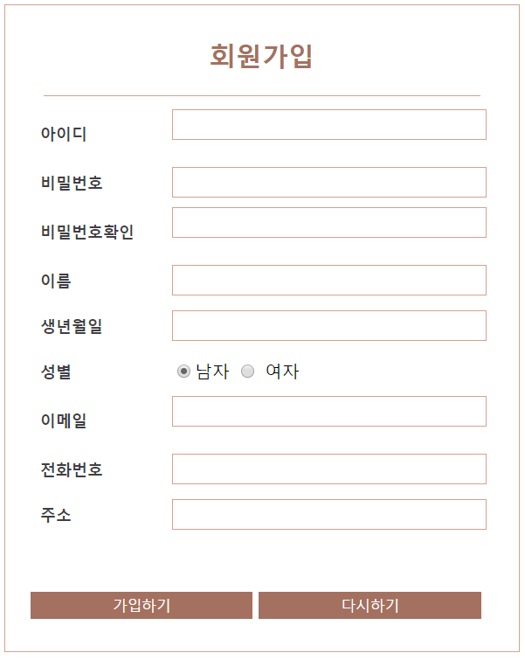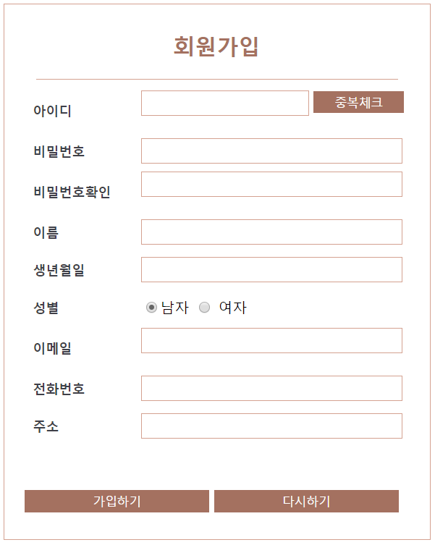

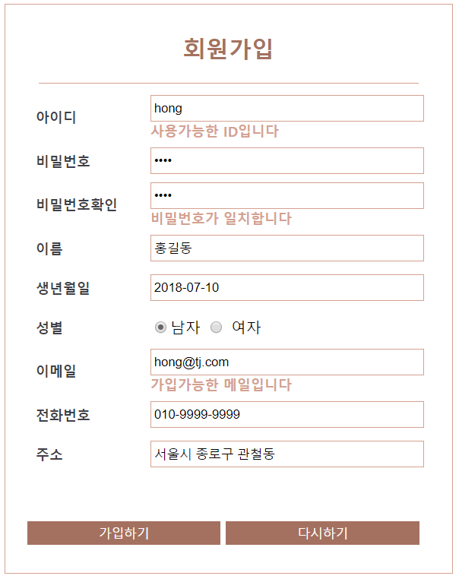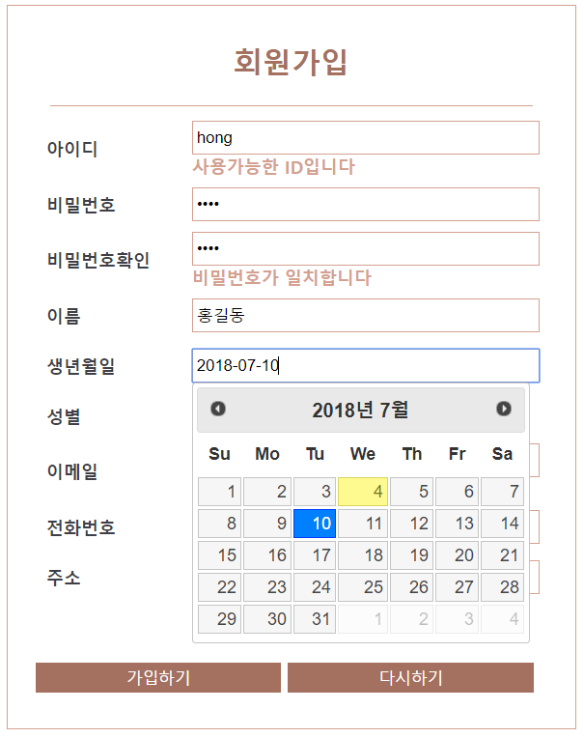

**Member.sql**

**CREATE** **TABLE** MEMBER(

ID VARCHAR2(30) **PRIMARY** **KEY**,

PW VARCHAR2(30),

NAME VARCHAR2(30),

BIRTH **DATE**,

GENDER VARCHAR2(30),

EMAIL VARCHAR2(30),

TEL VARCHAR2(30),

ADDRESS VARCHAR2(30)

);

**INSERT** **INTO** MEMBER **VALUES** ('aaa','111','hong','1990/01/01','m','hong@naver.com','010-9999-9999','서울');

**SELECT** * **FROM** MEMBER **WHERE** ID='aaa';

**SELECT** * **FROM** MEMBER **WHERE** EMAIL='hong@naver.com';

**commit**;

**MemberDto.java**

**public** **class** MemberDto {

**private** String id;

**private** String pw;

**private** String name;

**private** String birth;

**private** String gender;

**private** String email;

**private** String tel;

**private** String address;

}

**MemberDao.java**

**public** **class** MemberDao {

**public** **static** **final** **int** ***EXISTENT*** = 0;

**public** **static** **final** **int** ***NONEXISTENT*** = 1;

**public** **static** **final** **int** ***FAIL*** = 0;

**public** **static** **final** **int** ***SUCCESS*** = 1;

**public** **static** **final** **int** ***LOGIN_FAIL*** =0;

**public** **static** **final** **int** ***LOGIN_SUCCESS*** = 1;

**private** **static** MemberDao *instance* = **new** MemberDao();

**public** **static** MemberDao getInstance() {

**return** *instance*;

}

**private** MemberDao() {}

**private** Connection getConnection() **throws** SQLException {

Connection conn = **null**;

**try** {

Context ctx = **new** InitialContext();

DataSource ds = (DataSource) ctx.lookup("java:comp/env/jdbc/Oracle11g");

conn = ds.getConnection();

} **catch** (NamingException e) {

System.***out***.println(e.getMessage());

}

**return** conn;

}

// mId 중복체크

**public** **int** idConfirm(String id) {

**int** result = ***EXISTENT***;

Connection conn = **null**;

PreparedStatement pstmt = **null**;

ResultSet rs = **null**;

String sql = "SELECT * FROM MEMBER WHERE ID=?";

**try** {

conn = getConnection();

pstmt = conn.prepareStatement(sql);

pstmt.setString(1, id);

rs = pstmt.executeQuery();

**if**(rs.next()) {

result = ***EXISTENT***;

}**else** {

result = ***NONEXISTENT***;

}

} **catch** (Exception e) {

System.***out***.println(e.getMessage());

}**finally** {

**try** {

**if**(rs != **null**) rs.close();

**if**(pstmt != **null**) pstmt.close();

**if**(conn != **null**) conn.close();

} **catch** (Exception e) {

System.***out***.println(e.getMessage());

}

}

**return** result;

}

// 메일 중복 체크

**public** **int** emailConfirm(String email) {

**int** result = ***EXISTENT***;

Connection conn = **null**;

PreparedStatement pstmt = **null**;

ResultSet rs = **null**;

String sql = "SELECT * FROM MEMBER WHERE EMAIL=?";

**try** {

conn = getConnection();

pstmt = conn.prepareStatement(sql);

pstmt.setString(1, email);

rs = pstmt.executeQuery();

**if**(rs.next()) {

result = ***EXISTENT***;

}**else** {

result = ***NONEXISTENT***;

}

} **catch** (Exception e) {

System.***out***.println(e.getMessage());

}**finally** {

**try** {

**if**(rs != **null**) rs.close();

**if**(pstmt != **null**) pstmt.close();

**if**(conn != **null**) conn.close();

} **catch** (Exception e) {

System.***out***.println(e.getMessage());

}

}

**return** result;

}

**public** **int** joinMember(MemberDto member) {

**int** result = ***FAIL***;

Connection conn = **null**;

PreparedStatement pstmt = **null**;

String sql = "INSERT INTO MEMBER "

+ "(ID, PW, NAME, BIRTH, GENDER, EMAIL, TEL, ADDRESS) "

+ " VALUES (?,?,?,?,?,?,?,?)";

**try** {

conn = getConnection();

pstmt = conn.prepareStatement(sql);

pstmt.setString(1, member.getId());

pstmt.setString(2, member.getPw());

pstmt.setString(3, member.getName());

pstmt.setString(4, member.getBirth());

pstmt.setString(5, member.getGender());

pstmt.setString(6, member.getEmail());

pstmt.setString(7, member.getTel());

pstmt.setString(8, member.getAddress());

result = pstmt.executeUpdate();

} **catch** (Exception e) {

System.***out***.println(e.getMessage());

}**finally** {

**try** {

**if**(pstmt != **null**) pstmt.close();

**if**(conn != **null**) conn.close();

} **catch** (Exception e) {

System.***out***.println(e.getMessage());

}

}

**return** result;

}

// 로그인 체크

**public** **int** loginCheck(String id, String pw) {

**int** result = ***LOGIN_FAIL***;

Connection conn = **null**;

PreparedStatement pstmt = **null**;

ResultSet rs = **null**;

String sql = "SELECT * FROM MEMBER WHERE ID=? and PW=?";

**try** {

conn = getConnection();

pstmt = conn.prepareStatement(sql);

pstmt.setString(1, id);

pstmt.setString(2, pw);

rs = pstmt.executeQuery();

**if**(rs.next()) {

result = ***LOGIN_SUCCESS***;

}**else** {

result = ***LOGIN_FAIL***;

}

} **catch** (Exception e) {

System.***out***.println(e.getMessage());

}**finally** {

**try** {

**if**(rs != **null**) rs.close();

**if**(pstmt != **null**) pstmt.close();

**if**(conn != **null**) conn.close();

} **catch** (Exception e) {

System.***out***.println(e.getMessage());

}

}

**return** result;

}

// mId로 member dto가져오기

**public** MemberDto getMember(String id) {

MemberDto member = **null**;

Connection conn = **null**;

PreparedStatement pstmt = **null**;

ResultSet rs = **null**;

String sql = "SELECT * FROM MEMBER WHERE id=?";

**try** {

conn = getConnection();

pstmt = conn.prepareStatement(sql);

pstmt.setString(1, id);

rs = pstmt.executeQuery();

**if**(rs.next()) {

String pw = rs.getString("pw");

String name = rs.getString("name");

String birth = rs.getString("birth");

String gender= rs.getString("gender");

String email = rs.getString("email");

String tel = rs.getString("tel");

String address=rs.getString("address");

member = **new** MemberDto(id, pw, name, birth, gender, email, tel, address);

}

} **catch** (Exception e) {

System.***out***.println(e.getMessage());

}**finally** {

**try** {

**if**(rs != **null**) rs.close();

**if**(pstmt != **null**) pstmt.close();

**if**(conn != **null**) conn.close();

} **catch** (Exception e) {

System.***out***.println(e.getMessage());

}

}

**return** member;

}

}

**Mcontroller.java**

@WebServlet("*.do")

**public** **class** MController **extends** HttpServlet {

**private** **static** **final** **long** ***serialVersionUID*** = 1L;

**protected** **void** doGet(HttpServletRequest request, HttpServletResponse response) **throws** ServletException, IOException {

actionDo(request, response);

}

**protected** **void** doPost(HttpServletRequest request, HttpServletResponse response) **throws** ServletException, IOException {

request.setCharacterEncoding("utf-8");

actionDo(request, response);

}

**private** **void** actionDo(HttpServletRequest request, HttpServletResponse response) **throws** ServletException, IOException {

String uri = request.getRequestURI();

String conPath = request.getContextPath();

String command = uri.substring(conPath.length());

MService service = **null**;

String viewPage = **null**;

**if**(command.equals("/idConfirm.do")) {

service = **new** IdConfirmService();

service.execute(request, response);

viewPage = "member/idConfirm.jsp";

}**else** **if**(command.equals("/emailConfirm.do")) {

service = **new** EmailConfirmService();

service.execute(request, response);

viewPage = "member/emailConfirm.jsp";

}**else** **if**(command.equals("/joinView.do")) {

viewPage = "member/join.jsp";

}**else** **if**(command.equals("/join.do")) {

service = **new** JoinService();

service.execute(request, response);

viewPage = "member/login.jsp";

}**else** **if**(command.equals("/loginView.do")) {

viewPage = "member/login.jsp";

}**else** **if**(command.equals("/login.do")) {

service = **new** LoginService();

service.execute(request, response);

viewPage = "main/main.jsp";

}**else** **if**(command.equals("/logout.do")) {

service = **new** LogoutService();

service.execute(request, response);

viewPage = "main/main.jsp";

}

RequestDispatcher dispatcher = request.getRequestDispatcher(viewPage);

dispatcher.forward(request, response);

}

}

**EmailConfirmService.java**

**public** **class** EmailConfirmService **implements** MService {

@Override

**public** **void** execute(HttpServletRequest request, HttpServletResponse response) {

String email = request.getParameter("email");

MemberDao mDao = MemberDao.*getInstance*();

**int** result = mDao.emailConfirm(email);

**if**(result==MemberDao.***EXISTENT***) {

request.setAttribute("emailConfirmResult", "중복된 메일주소입니다");

}**else** {

request.setAttribute("emailConfirmResult", "사용가능한 메일주소입니다");

}

}

}

**IdConfirmService.java**

**public** **class** IdConfirmService **implements** MService {

@Override

**public** **void** execute(HttpServletRequest request, HttpServletResponse response) {

String id = request.getParameter("id");

MemberDao mDao = MemberDao.*getInstance*();

**int** result = mDao.idConfirm(id);

**if**(result==MemberDao.***EXISTENT***) {

request.setAttribute("idConfirmResult", "중복된 ID입니다");

}**else** {

request.setAttribute("idConfirmResult", "사용가능한 ID입니다");

}

}

}

**JoinService.java**

**public** **class** JoinService **implements** MService {

@Override

**public** **void** execute(HttpServletRequest request, HttpServletResponse response) {

String id = request.getParameter("id");

String pw = request.getParameter("pw");

String name = request.getParameter("name");

String birth = request.getParameter("birth");

String gender = request.getParameter("gender");

String email = request.getParameter("email");

String tel = request.getParameter("tel");

String address= request.getParameter("address");

MemberDto member = **new** MemberDto(id, pw, name, birth, gender, email, tel, address);

MemberDao mDao = MemberDao.*getInstance*();

**int** result = mDao.joinMember(member);

**if**(result == MemberDao.***SUCCESS***) {

HttpSession session = request.getSession();

session.setAttribute("id", id);

request.setAttribute("joinResult", "회원가입이 완료되었습니다");

}**else** {

request.setAttribute("joinResult", "회원가입이 실패되었습니다");

}

}

}

**LoginService.java**

**public** **class** LoginService **implements** MService {

@Override

**public** **void** execute(HttpServletRequest request, HttpServletResponse response) {

String id = request.getParameter("id");

String pw = request.getParameter("pw");

MemberDao mDao = MemberDao.*getInstance*();

**int** result = mDao.loginCheck(id, pw);

**if**(result == MemberDao.***LOGIN_SUCCESS***) {

MemberDto member = mDao.getMember(id);

HttpSession session = request.getSession();

session.setAttribute("member", member);

}**else** {

request.setAttribute("errorMsg", "아이디와 비번을 확인하세요");

}

}

}

**LogoutService.java**

**public** **class** LogoutService **implements** MService {

@Override

**public** **void** execute(HttpServletRequest request, HttpServletResponse response) {

HttpSession session = request.getSession();

session.invalidate();

}

}

**emailConfirm.jsp**

<%@ page language=*"java"* contentType=*"text/html; charset=UTF-8"*

pageEncoding=*"UTF-8"*%>

<!DOCTYPE html>

<html>

<body>${emailConfirmResult }</body>

</html>

**idConfirm.jsp**

<%@ page language=*"java"* contentType=*"text/html; charset=UTF-8"*

pageEncoding=*"UTF-8"*%>

<!DOCTYPE html>

<html>

<body>${idConfirmResult }</body>

</html>

**join.css**

@charset *"UTF-8"*;

*#joinForm_wrap* {width:*430px*; margin: *10px* *auto*; border: *1px* *solid* *#D4A190*; padding:*20px*;}

*#join_title*{

width:*400px*; margin:*10px* *auto*;

padding-bottom:*20px*; border-bottom:*1px* *solid* *#D4A190*;

color:*#A47160*; font-size:*1.5em*;

text-align:*center*; font-weight:*bold*;

}

*#joinForm_wrap* **table**{margin:*0* *auto*; color:*#A47160*;}

*#joinForm_wrap* **table** **tr**{height:*40px*; }

*#joinForm_wrap* **table** **th**{

width:*120px*; font-size:*0.9em*;

color:*#3F3F48*; text-align:*left*; padding-left:*10px*;

}

*#joinForm_wrap* **table** **td** {width: *300px*;}

*.name***,** *.id***,** *.pw***,** *.pwChk***,** *.birth***,** *.email***,** *.tel***,** *.address* {

border: *1px* *solid* *#D4A190*; height:*20px*; width:*95%*; padding:*3px*;

}

*.mailSend* {height: *60px*;}

*.joinBtn_style* {

color: *#ffffff*; background: *#A47160*;

border:*0*; outline: *none*;

width:*32%*; padding:*5px* *0*;

}

**join.jsp**

<%@ page language=*"java"* contentType=*"text/html; charset=UTF-8"*

pageEncoding=*"UTF-8"*%>

<%@ taglib prefix=*"c"* uri=*"http://java.sun.com/jsp/jstl/core"*%>

<c:set var=*"conPath"* value=*"*${pageContext.request.contextPath }*"*/>

<!DOCTYPE html>

<html>

<head>

<meta charset=*"UTF-8"*>

<title>Insert title here</title>

<link href=*'*${conPath }*/css/join.css'* rel=*'stylesheet'*>

<script src=*"https://code.jquery.com/jquery-3.4.1.min.js"*></script>

<script>

$(document).ready(**function**(){

$('#id').keyup(**function**(){

**var** id = $('#id').val();

$.ajax({

url : '${conPath}/idConfirm.do',

type : 'get',

dataType : 'html',

data : "id="+id,

success : **function**(data){

$('#idConfirmResult').html(data);

}

});//ajax

});

$('#pwChk').keyup(**function**(){

**var** pw = $('#pw').val();

**var** pwChk = $(**this**).val();

**if**(pw == pwChk){

$('#pwChkResult').html('비밀번호 일치');

}**else**{

$('#pwChkResult').html('비밀번호 불일치');

}

});

$('#email').keyup(**function**(){

**var** email = $('#email').val();

$.ajax({

url : '${conPath}/emailConfirm.do',

type : 'get',

dataType : 'html',

data : "email="+email,

success : **function**(data){

$('#emailConfirmResult').html(data);

}

});//ajax

});

$('form').submit(**function**(){

**var** idConfirmResult = $('#idConfirmResult').text().trim();

**var** pwChkResult = $('#pwChkResult').text();

**var** emailConfirmResult = $('#emailConfirmResult').text().trim();

**if**(idConfirmResult!='사용가능한 ID입니다'){

alert('사용가능한 ID인지 확인요망');

**return** **false**;

}**else** **if**(pwChkResult!='비밀번호 일치'){

alert('비밀번호가 일치하지 않아요');

$('#pw').focus();

**return** **false**;

}**else** **if**(emailConfirmResult!='사용가능한 메일주소입니다'){

alert('중복된 메일은 가입이 불가합니다');

**return** **false**;

}

});

});//mIdConfirm의 click이벤트

</script>

<link rel=*"stylesheet"* href=*"//code.jquery.com/ui/1.12.1/themes/base/jquery-ui.css"*>

<script src=*"https://code.jquery.com/jquery-1.12.4.js"*></script>

<script src=*"https://code.jquery.com/ui/1.12.1/jquery-ui.js"*></script>

<script>

$( **function**() {

$( "#datepicker" ).datepicker({

dateFormat : 'yy/mm/dd',

monthNames : ['1월','2월','3월','4월','5월','6월','7월','8월','9월','10월','11월','12월'],

showMonthAfterYear : **true**,

yearSuffix : '년', // "2020년 3월"

showOtherMonths : **true**,

dayNamesMin:['일','월','화','수','목','금','토']

});

} );

</script>

</head>

<body>

<div id=*"joinForm_wrap"*>

<form action=*"*${conPath }*/join.do"* method=*"post"*>

<div id=*"join_title"*>회원가입</div>

<table>

<tr>

<th><label for=*"id"*>아이디</label></th>

<td><input type=*"text"* name=*"id"* id=*"id"* class=*"id"* required=*"required"*>

<div id=*"idConfirmResult"*> &nbsp; &nbsp; &nbsp; </div></td>

</tr>

<tr>

<th><label for=*"pw"*>비밀번호</label></th>

<td><input type=*"password"* name=*"pw"* id=*"pw"* class=*"pw"* required=*"required"*></td>

</tr>

<tr>

<th><label for=*"pwChk"*>비밀번호확인</label></th>

<td><input type=*"password"* name=*"pwChk"* id=*"pwChk"* class=*"pwChk"*>

<div id=*"pwChkResult"*> &nbsp; &nbsp; &nbsp; </div>

</td>

</tr>

<tr>

<th><label for=*"name"*>이름</label></th>

<td><input type=*"text"* name=*"name"* id=*"name"* class=*"name"*></td>

</tr>

<tr>

<th><label for=*"birth"*>생년월일</label></th>

<td><input type=*"text"* name=*"birth"* id=*"datepicker"* class=*"birth"*></td>

</tr>

<tr>

<th>성별</th>

<td>

<input type=*"radio"* name=*"gender"* value=*"m"* checked=*"checked"* id=*"m"*><label for=*"m"*>남자</label>

<input type=*"radio"* name=*"gender"* value=*"f"* id=*"f"*><label for=*"f"*>여자</label>

</td>

</tr>

<tr>

<th><label for=*"email"*>이메일</label></th>

<td><input type=*"email"* name=*"email"* id=*"email"* class=*"email"* required=*"required"*>

<div id=*"emailConfirmResult"*> &nbsp; &nbsp; &nbsp; </div>

</td>

</tr>

<tr>

<th><label for=*"tel"*>전화번호</label></th>

<td>

<input type=*"tel"* name=*"tel"* id=*"tel"* class=*"tel"*>

</td>

</tr>

<tr>

<th><label for=*"address"*>주소</label></th>

<td>

<input type=*"text"* name=*"address"* id=*"address"* class=*"address"*>

</td>

</tr>

<tr>

<td colspan=*"2"*> </td>

</tr>

<tr>

<td colspan=*"2"*>

<input type=*"submit"* value=*"가입하기"* class=*"joinBtn_style"*>

<input type=*"reset"* value=*"다시하기"* class=*"joinBtn_style"*>

<input type=*"button"* value=*"로그인"* class = *"joinBtn_style"*

onclick=*"location.href='*${conPath}*/loginView.do'"*>

</td>

</tr>

</table>

</form>

</div>

</body>

</html>

**login.css**

@charset *"UTF-8"*;

*#loginForm_wrap* {

width:*430px*;

margin: *75px* *auto*;

border : *1px* *solid* *#D4A190*;

padding:*50px* *100px*;

}

*#login_title*{

text-align: *center*;

margin:*10px* *auto*;

padding-bottom: *20px*;

border-bottom: *1px* *solid* *#D4A190*;

color:*#A47160*;

font-size: *1.5em*;

font-weight: *bold*;

}

*#loginForm_wrap* **table** {margin: *0* *auto*;}

*#loginForm_wrap* **table** **tr**{height: *40px*;}

*#loginForm_wrap* **table** **th**{

width: *120px*;

color: *#A47160*;

text-align: *left*;

padding-left: *10px*;

}

*#loginForm_wrap* **table** **td** {

width:*300px*;

}

*#id***,** *#pw* { border: *1px* *solid* *#D4A190*; width: *95%*; padding: *3px*;}

*#loginForm_wrap* **table** **tr** *#login_findIdPw*{

height: *20px*;

text-align: *right*;

font-size: *0.8em*;

font-weight: *bold*;

color:*#3F3F48*;

}

*#loginForm_wrap* **table** **tr** *#login_findIdPw:hover*{ cursor:*pointer*;}

*#loginForm_wrap* *#login_join*{

text-align: *center*;

color:*#3F3F48*;

font-size: *.9em*;

}

*#loginForm_wrap* *#login_join* **a** {

text-decoration: *none*;

color:*#3F3F48*;

font-weight: *bold*;

}

*.loginBtn_style*{

color:*#ffffff*;

background-color: *#A47160*;

border-style: *none*; outline:*none*;

width: *100%*; height: *120%*; padding:*3px*;

}

**login.jsp**

<%@ page language=*"java"* contentType=*"text/html; charset=UTF-8"*

pageEncoding=*"UTF-8"*%>

<%@taglib prefix=*"c"* uri=*"http://java.sun.com/jsp/jstl/core"* %>

<c:set var=*"conPath"* value=*"*${pageContext.request.contextPath }*"*/>

<!DOCTYPE html>

<html>

<head>

<meta charset=*"UTF-8"*>

<title>Insert title here</title>

<link href=*"*${conPath }*/css/login.css"* rel=*"stylesheet"* type=*"text/css"*>

</head>

<body>

<c:if test=*"*${**not empty** joinResult }*"*>

<script>alert('${joinResult}');</script>

</c:if>

<div id=*"loginForm_wrap"*>

<div id=*"login_title"*>로그인</div>

<form action=*"*${conPath }*/login.do"* method=*"post"*>

<table>

<tr><td> </td></tr>

<tr>

<th><label for=*"id"*>아이디</label></th>

<td><input type=*"text"* name=*"id"* id=*"id"*

required=*"required"* autofocus=*"autofocus"*

value=*"*${id }*"*></td>

</tr>

<tr>

<th><label for=*"pw"*>비밀번호</label></th>

<td><input type=*"password"* name=*"pw"* id=*"pw"* required=*"required"*></td>

</tr>

<tr><td colspan=*"2"*>&nbsp;</td></tr>

<tr><td colspan=*"2"*><input type=*"submit"* value=*"로그인"*

class=*"loginBtn_style"*></td></tr>

<tr>

<td colspan=*"2"*>

<p id=*"login_findIdPw"* onclick="alert('id=aaa / pw=111');">

아이디/비밀번호를 잊으셨나요?</p>

</td>

</tr>

</table>

<p id=*"login_join"*>아직 회원이 아니신가요? <a href=*"*${conPath}*/joinView.do"*>회원가입</a></p>

</form>

</div>

</body>

</html>

**main.html**

<%@ page language=*"java"* contentType=*"text/html; charset=UTF-8"*

pageEncoding=*"UTF-8"*%>

<%@taglib prefix=*"c"* uri=*"http://java.sun.com/jsp/jstl/core"*%>

<c:set var=*"conPath"* value=*"*${pageContext.request.contextPath }*"*/>

<!DOCTYPE html>

<html>

<head>

<meta http-equiv=*"Content-Type"* content=*"text/html; charset=UTF-8"*>

<title>Insert title here</title>

</head>

<body>

<c:if test=*"*${**not empty** errorMsg }*"*>

<script>

alert('${errorMsg }');

history.back();

</script>

</c:if>

<c:if test=*"*${**not empty** member }*"*>

<h1>${member.name }님 어서오세요</h1>

<hr>

<button onclick=*"location.href='*${conPath}*/logout.do'"*>로그아웃</button>

</c:if>

<c:if test=*"*${**empty** member }*"*>

<h1>손님 어서오세요</h1>

<hr>

<button onclick=*"location.href='*${conPath}*/loginView.do'"*>로그인</button>

<button onclick=*"location.href='*${conPath}*/joinView.do'"*>회원가입</button>

</c:if>

</body>

</html>

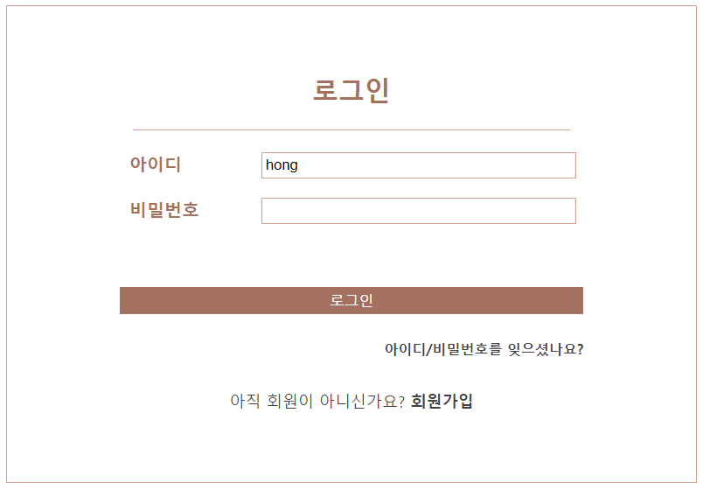

이 곳을 클릭하면 새창이 열리면서

이름과 메일을 입력하면 아이디와 비밀번호가 ajax로 출력되도록 구현