[ 17 ] 11장에서 MVC 게시판을 mybatis 프레임적용

훈련생 quiz

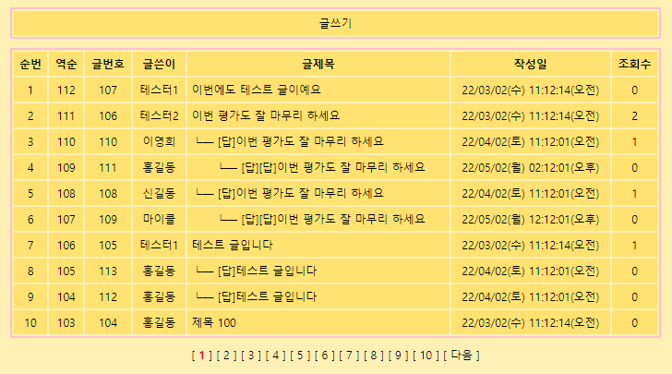 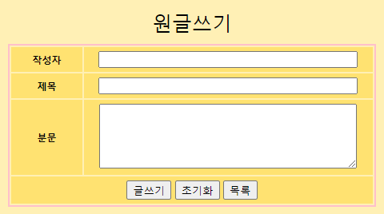 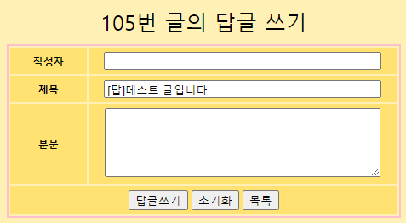

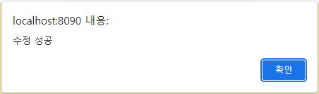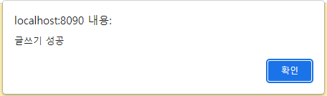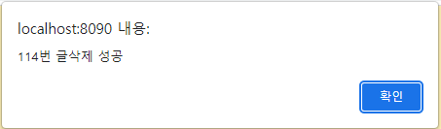

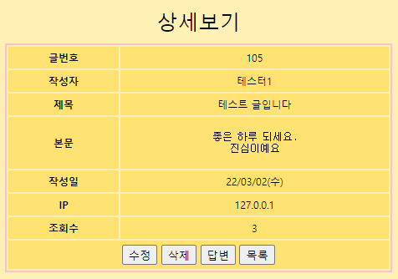 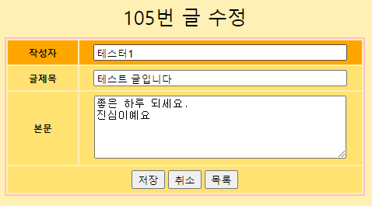

**Servlet-context.xml**

<?xml version=*"1.0"* encoding=*"UTF-8"*?>

<beans:beans xmlns=*"http://www.springframework.org/schema/mvc"*

xmlns:xsi=*"http://www.w3.org/2001/XMLSchema-instance"*

xmlns:beans=*"http://www.springframework.org/schema/beans"*

xmlns:context=*"http://www.springframework.org/schema/context"*

xmlns:mybatis-spring=*"http://mybatis.org/schema/mybatis-spring"*

xsi:schemaLocation=*"http://www.springframework.org/schema/mvc https://www.springframework.org/schema/mvc/spring-mvc.xsd*

*http://mybatis.org/schema/mybatis-spring http://mybatis.org/schema/mybatis-spring-1.2.xsd*

*http://www.springframework.org/schema/beans https://www.springframework.org/schema/beans/spring-beans.xsd*

*http://www.springframework.org/schema/context https://www.springframework.org/schema/context/spring-context.xsd"*>

<!-- DispatcherServlet Context: defines this servlet's request-processing infrastructure -->

<!-- Enables the Spring MVC @Controller programming model -->

<annotation-driven />

<!-- Handles HTTP GET requests for /resources/** by efficiently serving up static resources in the ${webappRoot}/resources directory -->

<resources mapping=*"/resources/**"* location=*"/resources/"* />

<resources mapping=*"/css/**"* location=*"/css/"* />

<!-- Resolves views selected for rendering by @Controllers to .jsp resources in the /WEB-INF/views directory -->

<beans:bean class=*"org.springframework.web.servlet.view.InternalResourceViewResolver"*>

<beans:property name=*"prefix"* value=*"/WEB-INF/views/"* />

<beans:property name=*"suffix"* value=*".jsp"* />

</beans:bean>

<context:component-scan base-package=*"com.lec.ch17"* />

**<mybatis-spring:scan base-package=*"com.lec.ch17.dao"*/>**

</beans:beans>

**src/main/java/com/lec/ch17/dao/BoardDao.java**

**package** com.lec.ch17.dao;

**import** java.util.List;

**import** org.apache.ibatis.annotations.Mapper;

**import** com.lec.ch17.dto.Board;

@Mapper

**public** **interface** BoardDao {

**public** List<Board> boardList(Board board);

**public** **int** boardTotCnt();

**public** **int** boardWrite(Board board);

**public** **int** boardHitUp(**int** bid);

**public** Board boardDetail(**int** bid);

**public** **int** boardReplyPreStep(Board board);

**public** **int** boardReply(Board board);

**public** **int** boardModify(Board board);

**public** **int** boardDelete(**int** bid);

}

**src/main/java/com/lec/ch17/service/BoardService.java**

**package** com.lec.ch17.service;

**import** java.util.List;

**import** javax.servlet.http.HttpServletRequest;

**import** com.lec.ch17.dto.Board;

**public** **interface** BoardService {

**public** List<Board> boardList(String pageNum);

**public** **int** boardTotCnt();

**public** **int** boardWrite(Board board, HttpServletRequest request);

**public** Board boardContent(**int** bid);

**public** Board boardModifyReplyView(**int** bid);

**public** **int** boardReply(Board board, HttpServletRequest request);

**public** **int** boardModify(Board board, HttpServletRequest request);

**public** **int** boardDelete(**int** bid);

}

**src/main/java/com/lec/ch17/service/BoardServiceImpl.java**

**package** com.lec.ch17.service;

**import** java.util.List;

**import** javax.servlet.http.HttpServletRequest;

**import** org.springframework.beans.factory.annotation.Autowired;

**import** org.springframework.stereotype.Service;

**import** com.lec.ch17.dao.BoardDao;

**import** com.lec.ch17.dto.Board;

**import** com.lec.ch17.util.Paging;

@Service

**public** **class** BoardServiceImpl **implements** BoardService {

@Autowired

**private** BoardDao boardDao;

@Override

**public** List<Board> boardList(String pageNum) {

Paging paging = **new** Paging(boardDao.boardTotCnt(), pageNum);

Board board = **new** Board();

board.setStartRow(paging.getStartRow());

board.setEndRow(paging.getEndRow());

**return** boardDao.boardList(board);

}

@Override

**public** **int** boardTotCnt() {

**return** boardDao.boardTotCnt();

}

@Override

**public** **int** boardWrite(Board board, HttpServletRequest request) {

board.setBip(request.getRemoteAddr());

**return** boardDao.boardWrite(board);

}

@Override

**public** Board boardContent(**int** bid) {

boardDao.boardHitUp(bid);

**return** boardDao.boardDetail(bid);

}

**public** Board boardModifyReplyView(**int** bid) {

**return** boardDao.boardDetail(bid);

}

@Override

**public** **int** boardReply(Board board, HttpServletRequest request) {

board.setBip(request.getRemoteAddr());

boardDao.boardReplyPreStep(board);

**return** boardDao.boardReply(board);

}

@Override

**public** **int** boardModify(Board board, HttpServletRequest request) {

board.setBip(request.getRemoteAddr());

**return** boardDao.boardModify(board);

}

@Override

**public** **int** boardDelete(**int** bid) {

**return** boardDao.boardDelete(bid);

}

}

**style.css**

@CHARSET *"UTF-8"*;

**body** {

background-color: *#fff0B5*;

font-size: *12px*;

}

**table** {border: *2px* *solid* *pink*; width:*95%*; margin: *10px* *auto*;}

**table** **tr** { background-color: *#FFE271*; }

**table** **tr***:hover* { background-color: *orange*;

cursor: *pointer*;

}

**td,** **th** {text-align: *center*; padding:*5px*; }

**caption** {font-size: *25px*; padding:*10px*;}

**h2,** **b**{text-align: *center*; color:*red*;}

**a** { text-decoration: *none*; color:*black*}

*.left*{text-align: *left*;}

*.paging* {text-align: *center*;}

**input***:not*(*.btn*)**,** **textarea** {

width: *90%*;

}