**Introduction:**

The housing price is highly dependent on both the surrounding items and the housing features. This research gathers historical information on the change of housing price and build a model in order to predict housing price according to features.

**Data:**

Data used in this project, besides foursquare, are a few historical housing price datasets collected from public data. This is because I am analyzing the correlation of housing price and surrounding neighborhoods.

Feature table after cleaning

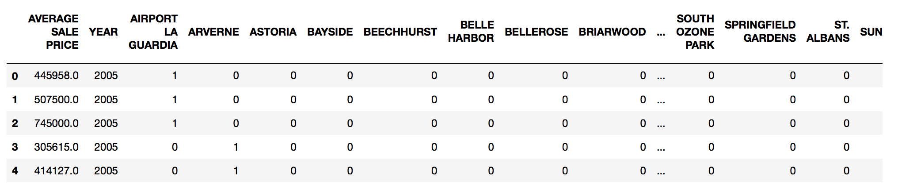

**Basic analysis:**

Sale Number Trend

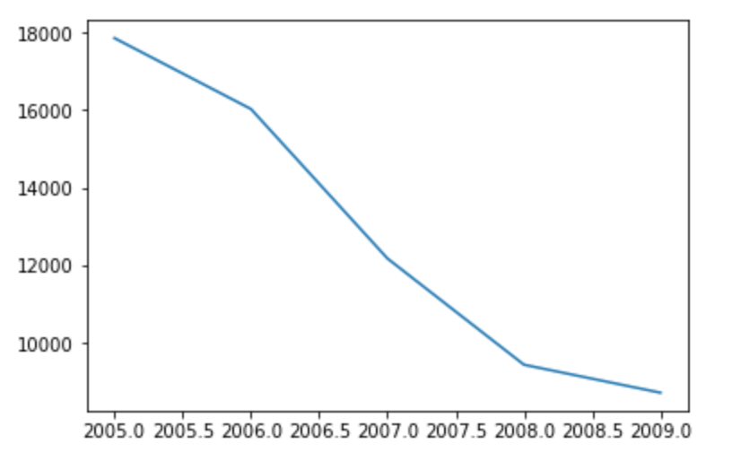

Sale Average Price Trend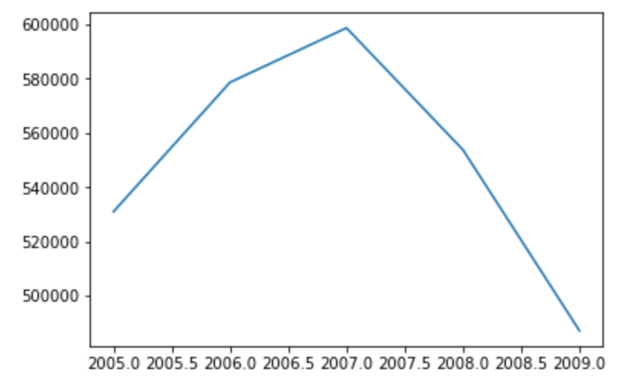

**Model Precision:**

