Events:
a) Interaction events
This type of events will form the biggest part of the gameplay. Single interactions that player will make with a character or an object will be considered as an interaction event. For example; crafting a wood, speaking with a character, fighting with an animal will be some of the interaction events that player can perform. On the main screen, objects or characters that are located near player at that moment will be listed so that player can select and interact with them. When player clicks on an object or character, a simple menu that will show the possible types of interaction with that item/character (e.g. craft, collect, throw, speak, fight, etc.) will be opened. Each item can have different types of interaction selections. For example, a wood can be crafted, collected, fired whereas a lake can offer interactions such as swim, drink water, fishing etc. This is also true for characters. Some characters will be attackable while some of them will offer only friendly interactions. Player can interact with items or characters by clicking the interaction type as he/she selects.
Example:
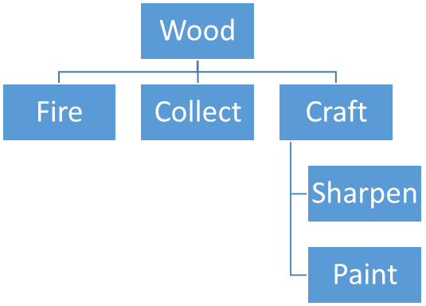

b) Story events
Story events will consist of series of tasks that promise rewards or improvements for player's survival chance. To complete the story events, player will have to fulfill all the tasks in the event's scenario. Player will be able to join this type of events by completing particular milestones, such as collecting all the parts of a puzzle or finding a mystic item, or interacting with special characters. Shortly, an interaction event or result of an interaction event/events may result in entering a story event. Before entering a story event, player will be informed with a text message on the screen that asks him/her if he/she wants to enter this event. Once he/she enters a story event, player will not be able to perform operations outside of the event's scenario until he/she completes it or quits without completing the event (this may result in some losses . After completing a story event, player may gain an item that has specialities (e.g. jacket with +10 hp) or may be given a clue for surviving the island (e.g. a map that shows the location of a radiotelephone). Rewards of the story events will be considerably more satisfactory than the possible ("possible", since not all of the interaction events may promise a reward) rewards of interaction events.
A detailed example for story event:

