1.0 TASK 1: Data Modeling and Core Tables

This document describes the design and implementation of an enterprise data warehouse built using a layered architecture (Medallion architecture) and Data Vault modeling methodology. The solution supports scalable data ingestion from multiple source systems, full historical tracking, and business-ready analytics through a governed semantic layer.
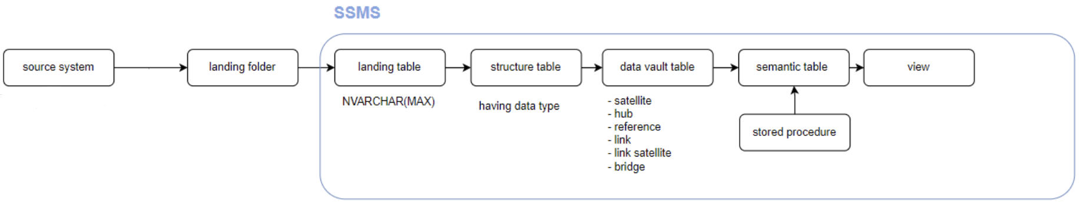
- Extracting Data
Pull data from multiple sources and place it into a landing folder or landing zone.
- Loading into Landing Table
Import the data from the landing folder/zone into a landing table (e.g., [db_lnd].[t_xxx]). All columns in this table are defined as NVARCHAR(MAX) to ensure that data from various sources can be ingested without data type conflicts.
- Transforming to Structured Table
Move data from the landing table into a structured table (e.g., [db_struc].[t_struc_xx]) where each column has a defined data type.
- Ingesting into Data Vault
Load data from the structured table into the data vault (e.g., [dv_rw].[t_sat_xx]). Data vault tables categorize the dataset into components like hubs, satellites, and links for proper data modeling.
- Applying Business Logic
Create stored procedures using data vault or semantic tables to implement business rules according to user requirements.
- Populating Semantic Tables
Execute the stored procedures to load the processed data into semantic tables.
- Making Data Available for Analysis
Synchronize semantic tables with views so that data analysts can use them for dashboards, reporting, and further analysis.
It is important to note that this document serves as a conceptual blueprint of the ETL workflow rather than a full end-to-end implementation. As such, the pipeline creation and data ingestion steps from source systems to the landing folder are intentionally excluded. The focus of this document is solely on the data transformation processes within the database layer, specifically as implemented using SQL Server Management Studio (SSMS).
From a data perspective, the document outlines the ETL process for conversational chatbot data collected from multiple existing websites. A small, mocked dataset is used to illustrate the transformations, and the examples shown represent landing tables derived from this sample data.
- User table: store user identities and attributes
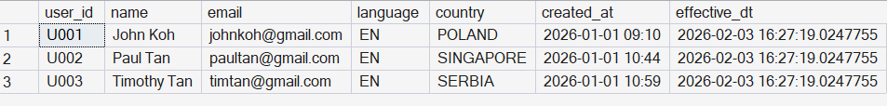
- Session table: store session-level conversation data
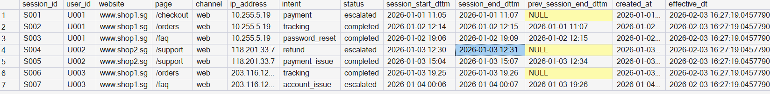
- Message table: store message-level data
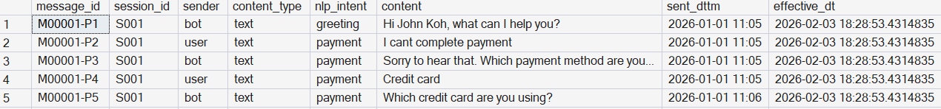
As mentioned earlier, the landing tables do not enforce specific data types, as their primary purpose is to ensure that data can be ingested into the database without encountering data type conflicts. When data is loaded from the landing tables into the structured tables, appropriate data types are explicitly defined. Any issues encountered during this stage are therefore most likely related to data type mismatches, which helps reduce debugging effort.
Since the data values remain unchanged between the landing and structured tables, the structured tables are not shown here. Hence, the next section will be jumping into data modelling. The following section therefore focuses on data modeling.
In this blueprint, the Data Vault 2.0 methodology has been selected as the modeling approach. Under this framework, business entities are represented as hubs, relationships between entities are captured in link tables, and descriptive attributes are stored in satellite tables. The Data Vault core layer is intentionally normalized to separate business keys, relationships, and descriptive attributes. This design reduces data redundancy, preserves historical changes, and enables the model to evolve without structural redesign when source systems or attributes change.
Although Data Vault modeling supports explicit relationship handling through link tables, link tables were not physically implemented in the current solution due to the simplicity of the dataset. However, the model is still Data Vault–compliant conceptually, and link tables can be introduced in future phases if relationship complexity increases or additional sources are onboarded.
Based on the current datasets, each entity is modeled using hub and satellite tables. The hub tables store the core business keys and therefore must contain:
- Hashed business key (ID hash key): provides a stable and system-agnostic identifier when integrating data from multiple source systems, and avoids issues caused by changes in natural key formats.
- Hub load datetime: records the timestamp when the business key was first loaded into the Data Vault. It supports data lineage, auditing, and historical tracking of when an entity entered the system.
- Natural business key (ID value): original identifier for traceability and reference.
The satellite tables store the descriptive and context-specific attributes related to each business entity and therefore include:
- Hashed business key (ID hash key): used to link satellite records back to their corresponding hub.
- Satellite load datetime: captures when the data was loaded, enabling full historical tracking and change detection.
- Remaining descriptive attributes: other fields associated with the business entity.
For detailed structures and examples, please refer to the Data Vault tables presented in the following sections.
1a. Hub user table
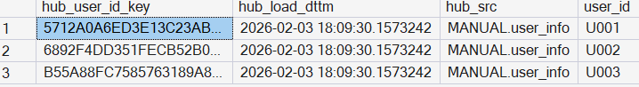

1b. Satellite user table

2a. Hub session table
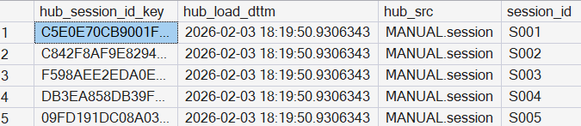

2b. Satellite session table

3a. Hub message table
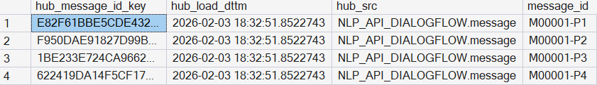

3b. Satellite message table
The semantic layer isolates business logic, KPI definitions, and aggregations from the core data model. This separation ensures consistency across reports while allowing business rules to evolve independently of the underlying data structures. In this layer, stored procedures (SP) are introduced to encapsulate business logic and to control data loading frequencies such as daily, monthly, yearly, or ad-hoc executions. This approach provides flexibility and repeatability while maintaining auditability and governance over data transformations.
The primary trade-off of this design is increased operational complexity, as additional orchestration and monitoring are required. However, this is mitigated through standardized stored procedures, consistent execution patterns, and logging mechanisms. The following section presents an example of stored procedures used to populate session-level semantic tables.
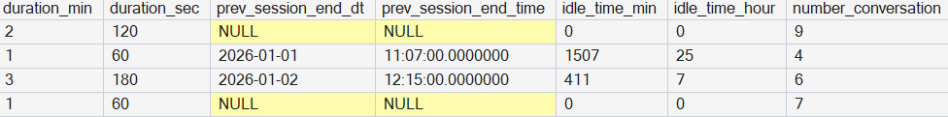
For reporting and analytics purposes, a presentation layer in the form of view tables is created for business analysts to consume when building dashboards. This layer prevents direct access to the semantic tables, which contain complex business logic, thereby minimizing the risk of unintended modifications to critical transformation rules.
In addition, view tables enable controlled data exposure by restricting the scope of data presented, such as limiting reports to the most recent two months of data rather than the full historical dataset. This approach improves usability, performance, and governance of analytical reporting. The following section presents an example of view tables. In this case, the view is mirroring the semantic tables due to the simplicity of the dataset; therefore, no additional or minor business logic is applied at this stage.

2.0 TASK 2: Success Metrics for Chatbot Service

2.1 Define success metrics
- Session Completion Rate
Percentage of sessions that end with a successful or resolved status. A completed or resolved session indicates that the user’s intent was likely addressed without escalation or abandonment. This metric provides a high-level view of chatbot effectiveness in fulfilling user needs and reducing manual intervention.
Required fields: session_id, session_start_dttm, session_end_dttm, nlp_intent, duration_minute
However, it is challenging to reliably validate whether a session marked as completed truly represents successful issue resolution, as users typically do not explicitly confirm success after receiving a satisfactory response. In many cases, users simply exit the chatbot once their problem is resolved, making it difficult for the system to distinguish between a genuinely completed session and an abandoned one. The only outcome that can be validated with high confidence is escalation to a human agent, as this event is explicitly recorded in the system. As a result, completion and abandonment statuses are inherently ambiguous and subject to user behavior rather than system signals.
Due to this limitation, this metric is not enforced in the semantic layer by default. However, if it is required for reporting or exploratory analysis, a recommended mitigation approach is to exclude very short sessions (e.g. session duration <= 1 minute).
- Average Session Duration
Time between session start and session end. Session duration acts as a proxy for engagement. Extremely short sessions may indicate early abandonment or failure to understand user intent, while reasonable durations suggest meaningful interaction. This metric helps identify both underperforming and overly complex conversations.
Required fields: session_id, session_start_dttm, session_end_dttm
Validation can be performed by capping extreme outliers (e.g. > 15 minutes) to avoid skewing and/or comparing duration distributions across websites and intents to identify inconsistencies that may indicate data quality issues or behavioral anomalies. While longer session durations are often associated with higher user engagement, however this relationship can be less reliable in a chatbot context. Extended durations may result from inactive sessions, delayed session termination, or technical artefacts, rather than continuous user interaction. In typical chatbot use cases, conversations are designed to resolve user intents quickly (e.g. enquiries, simple troubleshooting, or transactional support). As a result, chatbot conversations rarely require continuous engagement beyond a short time window, and prolonged sessions do not necessarily reflect sustained interaction.
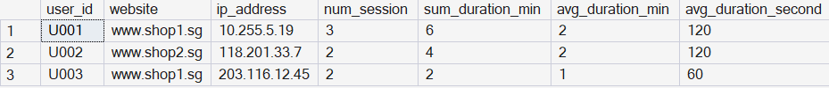
- Idle Time
Users who return to the chatbot after a non-zero idle period. Simply put, calculated time to track users who revisit the chatbot after a period of time are more likely to find it useful for recurring needs or problem resolution.
Required fields: user_id, session_start_dttm, session_end_dttm, previous_session_end_dttm
To ensure its validity and trustworthiness, sessions are analyzed and calculated in chronological order per user. Sessions corresponding to first-time users, where idle time is zero, are excluded from the analysis to avoid skewing the results. It is assumed that non-zero idle time represents a genuine revisit rather than automated system retries, and that users returning after hours or days reflect intentional engagement with the platform. Additional considerations include filtering out duplicate sessions caused by technical glitches and verifying that timestamps are consistent across source systems to maintain accuracy in the computed idle times.

2.2 Limitations
- Idle time assumes that non-zero gaps reflect intentional user revisits. However, system retries, automated bots, or network delays could artificially inflate idle time.
- Message sentiment, user satisfaction, and explicit feedback are not captured or difficult to capture.
2.3 Design Metrics Session Table
- user_id ensures we calculate idle time per user and don’t mix sessions from different users.
- session_id helps maintain chronological ordering, especially if a user has multiple sessions.
- session_start_dttm / session_end_dttm/ prev_session_end_dttm provide the timestamps needed for computing gaps between sessions.
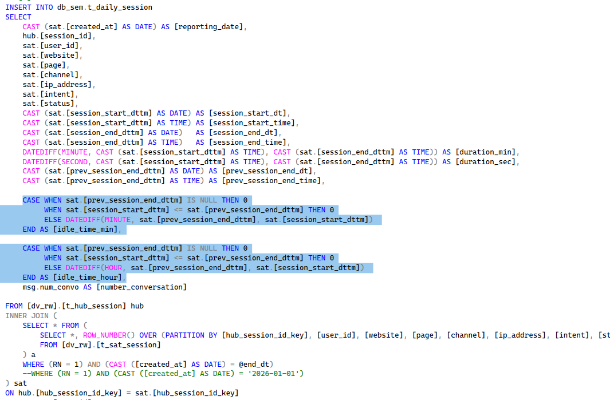
Assumptions
- Non-zero idle time reflects a genuine user revisit.
- First-time users’ idle time is null and not meaningful for their first session.
- Single-device assumption where each user_id represents one logical user; multi-device activity is treated as a single user.
- Chronological ordering based on session timestamps across source systems.
Limitations
- Multi-device or shared accounts: Users accessing from multiple devices could distort the actual idle time.
- Late-arriving data: If session events are delayed, idle time may appear negative or unusually long.
- Simplified dataset: With the current mock dataset, idle times are illustrative; production datasets may reveal edge cases not covered here.

