1.0 TASK 0: Business Objective
- How has tax collection trended over time?
While tax collection shows a general upward trend over time, an interesting insight is that this growth isn’t always purely driven by economic expansion. In some cases, it can be influenced by policy changes or improved compliance, such as the recent US political decision. Additionally, tax revenue is often highly concentrated among a small group of contributors, and we can also observe clear impacts during economic downturns. For example, typically, a small group of high-income individuals or large corporations contributes a disproportionately large share of total tax revenue, while the majority contribute relatively smaller amounts. From a data perspective, these patterns become more visible depending on how the fact tables are structured and the level of granularity we analyse.
- What are the income and tax patterns across different demographics?
From the data, income and tax patterns show clear segmentation across demographics. As mentioned, higher-income groups not only earn more but also contribute a larger share of tax, reflecting a progressive tax system. Age-wise, income tends to grow with experience and peaks during mid-career stages. Overall, the pattern shows that tax contributions are closely linked to age, occupation, and income level, reflecting both earnings distribution and the progressive tax structure. However, tax policies such as deductions and reliefs can create variations in effective tax rates across similar income groups.
- Which geographic areas contribute most to tax revenue?
In Singapore, tax revenue is generally concentrated in areas with higher economic activity and higher-income residents. For example, central regions such as the CBD and prime residential areas like Orchard or Marina Bay often contribute a disproportionate share of personal and corporate taxes. In contrast, suburban or industrial areas contribute less in proportion, reflecting lower average incomes or smaller business activity. This geographic pattern highlights that tax collection is closely tied to economic density, wealth distribution, and the concentration of business activity across the city. From a data perspective, mapping tax revenue by postal code or planning area shows a clear concentration in high-income and business-heavy districts, which can help policy-makers and analysts identify key revenue sources and potential areas for targeted compliance efforts.
- How do different occupations compare in terms of tax compliance?
Tax compliance tends to vary across occupations, but it is also influenced by the type of employer. Individuals working in formal sectors, such as finance, public service, or multinational tech companies like Meta, Apple, or Google, usually earn higher salaries and exhibit higher compliance because taxes are often automatically withheld through payroll systems. In contrast, self-employed professionals, freelancers, or those in informal sectors may have more variable compliance, as they are responsible for filing and paying taxes themselves. This pattern is reflected in data, where higher-income earners in structured, high-paying companies contribute a disproportionately larger share of tax revenue, while lower-income or less formal occupations show more variability in compliance.

2.0 TASK 1: Production Data Pipeline Development

This document describes the design and implementation of an enterprise data warehouse built using a layered architecture (Medallion architecture) with Dimensional Modeling methodology. The solution supports scalable data ingestion from multiple source systems and business-ready analytics through a governed semantic layer.
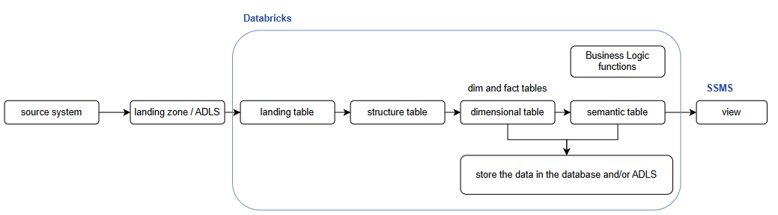
- Extracting Data
Pull data from multiple sources and place it into a landing folder or landing zone.
- Loading into Landing Table
Import the data from the landing folder/zone into a landing table. All columns in this table are not defined to any data type as to ensure that data from various sources can be ingested without data type conflicts.
- Transforming to Structured Table
Move data from the landing table into a structured table where each column has a defined data type.
- Ingesting in the Dimensional and Fact Tables
Load data from the structured table into the dimensional and fact tables for proper data modeling.
- Applying Business Logic
Create a Python-based “stored procedures” using dimensional and fact tables or/and semantic tables to implement business rules according to user requirements.
- Populating Semantic Tables
Execute the “stored procedures” to load the processed data into semantic tables based on the defined frequency – full load or incremental load (e.g. yearly, monthly, daily, ad-hoc).
- Making Data Available for Analysis
Synchronize semantic tables with views so that data analysts can use them for dashboards, reporting, and further analysis. This process will be developed in MSSQL platform / SQL database platform.
It is important to note that this document serves as a conceptual blueprint of the ETL workflow rather than a full end-to-end implementation. As such, the pipeline creation and data ingestion steps from source systems to the landing folder are intentionally excluded. The focus of this document is solely on the data transformation processes within the Python notebook layer or Databricks layer.
From a data perspective, a small, mocked dataset is used to illustrate the transformations, and the examples shown represent landing tables derived from this sample data.
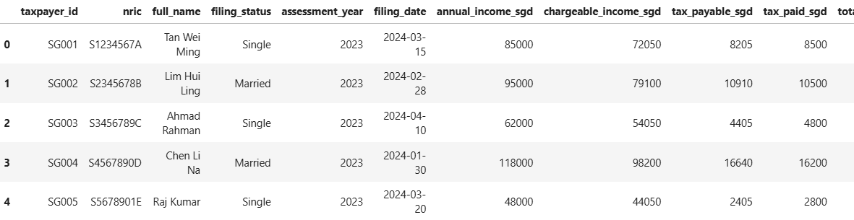
As mentioned earlier, the landing tables do not enforce specific data types, as their primary purpose is to ensure that data can be ingested into the Databricks / Python-notebook platform without encountering data type conflicts. When data is loaded from the landing tables into the structured tables, appropriate data types are explicitly defined. Any issues encountered during this stage are therefore most likely related to data type mismatches, which helps reduce debugging effort.
Since the data values remain unchanged between the landing and structured tables, the structured tables are not shown here. Hence, the next section will be jumping into data modelling. The following section therefore focuses on data modeling.
In this blueprint, the Dimensional methodology has been selected as the modeling approach. Under this framework, business entities are represented as fact and dimension tables. The core layer is intentionally designed to be stable and business aligned, optimized for analytics queries and serving as the foundation for the semantic and reporting layers.
Although dimensional modeling supports a wide range of design patterns, the current model remains conceptually compliant while intentionally simplified due to the relatively low complexity of the dataset. Additional table types, such as junk dimensions, can be introduced in future phases if data complexity increases or additional sources are onboarded.
Based on the current datasets, the entity is modeled using dim and fact tables. Both tables store the core business keys and therefore must contain:
- Hashed business key (ID hash key): provides a stable and system-agnostic identifier when integrating data from multiple source systems, and avoids issues caused by changes in natural key formats.
- load datetime: records the timestamp when the business key was first loaded into the table. It supports data lineage, auditing, and historical tracking of when an entity entered the system.
For detailed structures and examples, please refer to the dim and fact tables presented in the following sections.
1. Dim table
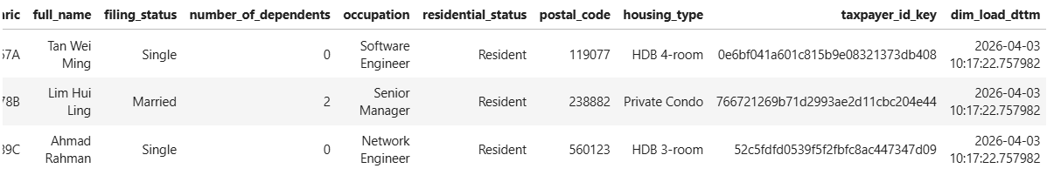

2. Fact table
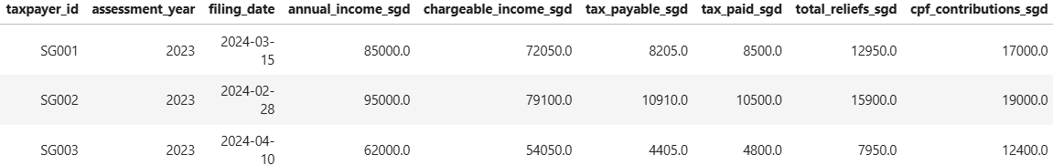
As the transformation process is performed on the Databrickss/Python platform, the data is stored temporarily during processing. To persist the data, developers can establish a database connection within the notebook to write the curated data to the target database and/or ADLS. Sample database connection code has been provided in the Python notebook; however, detailed configurations will need to be adjusted accordingly.
The semantic layer isolates business logic, KPI definitions, and aggregations from the core data model. This separation ensures consistency across reports while allowing business rules to evolve independently of the underlying data structures. In this layer, OOP functions / “stored procedures (SP)” are introduced to encapsulate business logic and to control data loading frequencies such as daily, monthly, yearly, or ad-hoc executions. This approach provides flexibility and repeatability while maintaining auditability and governance over data transformations.
The primary trade-off of this design is increased operational complexity, as additional orchestration and monitoring are required. However, this is mitigated through standardized functions, consistent execution patterns, and logging mechanisms. The following section presents an example of functions used to populate semantic tables.
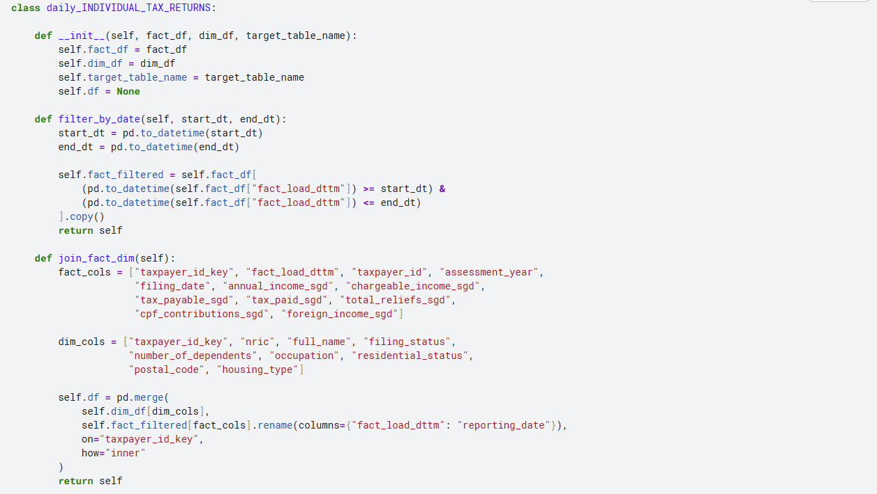
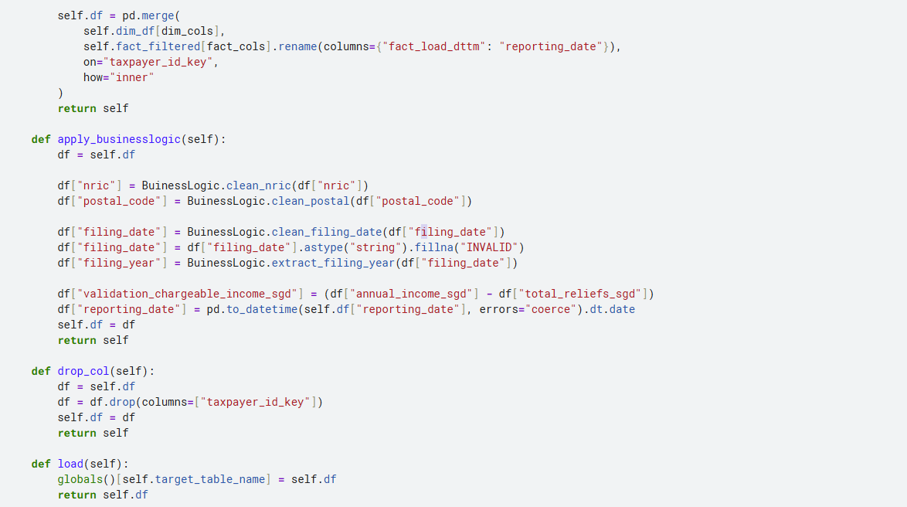
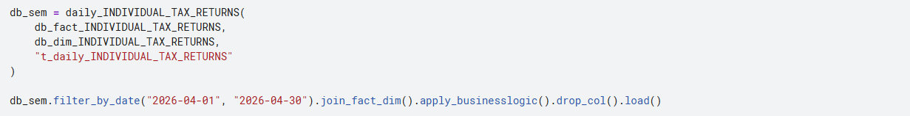
Similarly, to persist with the data, developers can establish a database connection within the notebook to write the curated data to the target database and/or ADLS.
For reporting and analytics purposes, a presentation layer in the form of view tables can be directly in the SSMS platform for business analysts to consume when building dashboards. This layer prevents direct access to the semantic tables, which contain complex business logic, thereby minimizing the risk of unintended modifications to critical transformation rules.
In addition, it enables controlled data exposure by restricting the scope of data presented, such as limiting reports to the most recent two months of data rather than the full historical dataset. This approach improves usability, performance, and governance of analytical reporting. In this scenario, the view layer is not included, as the views directly mirror the semantic tables due to the simplicity of the dataset. Plus, the ETL process is fully executed and presented within the notebook rather than through MSSQL, the view layer has been omitted in this case.

3.0 TASK 2: Cloud Deployment & Infrastructure
This document outlines the solution’s architectural blueprint on the Azure platform. As the scope discussed above is limited to Databricks, this section focuses on presenting an overview of the complete ETL process.
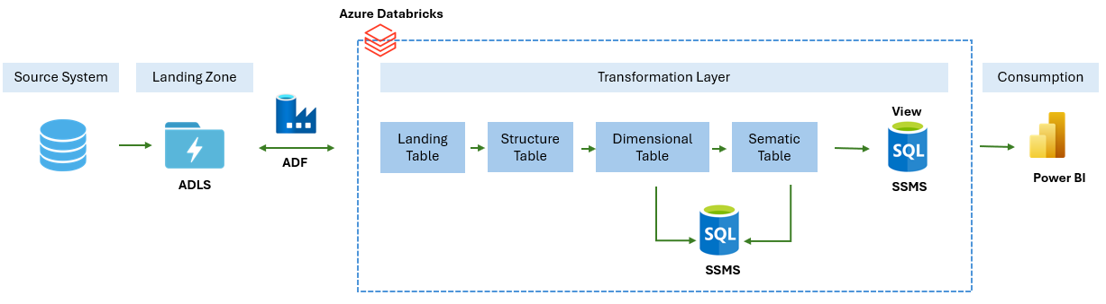
- Data from all source systems will be ingested into a centralized landing zone within Azure Data Lake Storage (ADLS).
- Data residing in ADLS will then be ingested into the transformation layer through Azure Data Factory (ADF), with pipelines scheduled to automatically move data from the landing zone to the view layer.
- Azure Databricks will be used to perform all data transformations, progressing the data from raw to curated states.
- The curated data will be consumed by downstream applications across various business streams, including visualization and reporting dashboards.

