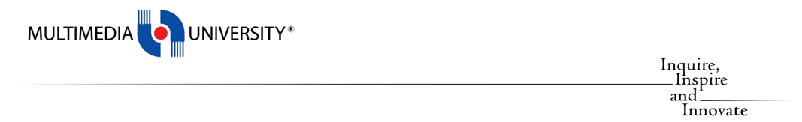  
**Term 2510**

**CSE 6224 SOFTWARE REQUIREMENTS ENGINEERING**

**Title: Campus Event Check-in System with Student ID and Payment Integration**

**Tutorial:** TT1L

**Group No:** Group 3

**Group Member:**

|  |  |
| --- | --- |
| **Student** | **Student ID** |
| Teng Huey Ting | 243UC2461A |
| Teoh Yi Xin | 243UC247NT |
| Yap Yi Ting | 243UC2462Y |
| Yee Lee Yiin | 243UC2461E |

1. **Introduction**

This document outlines the requirements elicitation plan for the Campus Event Check-in System using the Kano Model. The plan employs two elicitation techniques—brainstorming and questionnaires—to gather and prioritize stakeholder requirements. The goal is to classify requirements into dissatisfiers, satisfiers, and delighters to align development with user expectations and project goals.

1. **Justification for Kano model**

* **Student‑centred prioritisation** – The model explicitly links the presence or absence of a feature to the emotional response of students, ensuring that the system roadmap focuses first on what will avoid frustration and then on what will delight them.
* **Fit for early‑stage projects** – Our campus solution is still at concept stage, and hard numerical usage data are not yet available. Kano works well with qualitative feedback gathered through short surveys and workshops, giving clear, visual categories without requiring large datasets.
* **Communication clarity** – Kano’s three‑category vocabulary is easy for both technical and non‑technical stakeholders to grasp, streamlining discussions with event organisers, administrators and student representatives.
* **Alignment with continuous improvement** – As usage patterns emerge after deployment, repeating the survey allows rapid re‑classification of features whose perception changes over time, supporting an agile, iterative enhancement cycle.

1. **Elicitation Techniques** 
   1. Brainstorming

* Objective
  + Generate ideas for system functionalities, actors, and use cases
  + Align team understanding of core workflows and priorities
* Participants: All group member
* Execution:
  + Virtual Discussion
    - Conducted via Microsoft Teams chat to discuss initial ideas, actors (student, admin, event organizers), and system boundaries.
    - Mapped preliminary use cases
  + Physical Meeting:
    - Finalized use cases and actor roles.
    - Discuss the project and assign the work
    - Recorded a 2-minute session for the use case discussion
  + Outcomes:
    - Identified 3 core actors (Student, Event Organizers, Admin)
    - Defined 20 key use case
    - Prioritized features based on user workflows
  1. Questionnaire
* Objective
  + Validate requirements and gather feedback from stakeholders
  + Classify features into Kano categories based on user perceptions
* Participants: 21 student’s respondents
* Execution:
  + Design: Two type of question will be ask, functional question and non-functional question
    - Functional: Focused on core workflows
    - Non-functional: Addressed usability, security, and accessibility
    - Response Options:
      * I like it
      * I expect it
      * I am neutral
      * I am neutral
      * I can live with it
      * I dislike it
  + Distributor: deployed via Google Forms
  + Outcomes:
    - Validated prioritization of features
    - Highlighted non-functional needs

1. **Kano Model Integration**

Classification Process:

1. Dissatisfiers:

* Features causing dissatisfaction if absent
* Derived from direct stakeholder feedback

1. Satisfiers:

* Features that enhance satisfaction proportionally with quality
* Validated via questionnaire

1. Delighters:
   * Unexpected features that delight users
   * Identified through brainstorming
2. **Documentation and tools**

* Brainstorming:
  + Microsoft Teams chat logs.
  + Physical meeting recording (2 minutes).
* Questionnaire:
  + Raw response data and summaries
* Kano Analysis:
  + Mapped requirements to categories

1. **Conclusion**

This plan ensures a structured approach to requirements elicitation, combining collaborative ideation (brainstorming) and stakeholder validation (questionnaires). The Kano Model provides a clear framework to prioritize features, ensuring the system meets both essential needs and exceeds user expectations.

1. **Appendices**

**Appendix A: Questionnaire Design**

|  |  |
| --- | --- |
| **Question Type** | **Question** |
| Functional | 1. How would you feel if the system allows students to log in using their university-issued student ID? 2. How would you feel if students can check into events by scanning a QR code generated after ticket purchase? 3. How would you feel if event organizers can process ticket sales physically at the event venue? 4. How would you feel if organizers can monitor attendee check-ins in real time during events? 5. How would you feel if students can view a history of their past event ticket purchases? |
| Non-Functional | 1. How would you feel if the system works seamlessly on smartphones for check-in and ticket access? 2. How would you feel if student payment and personal data are encrypted and comply with university policies? 3. How would you feel if check-in stations can validate tickets even with temporary internet outages? 4. How would you feel if the system supports screen readers and assistive technologies for users with disabilities? 5. How would you feel if students can display their event QR tickets on any device (smartphone, tablet, laptop) for check-in? |

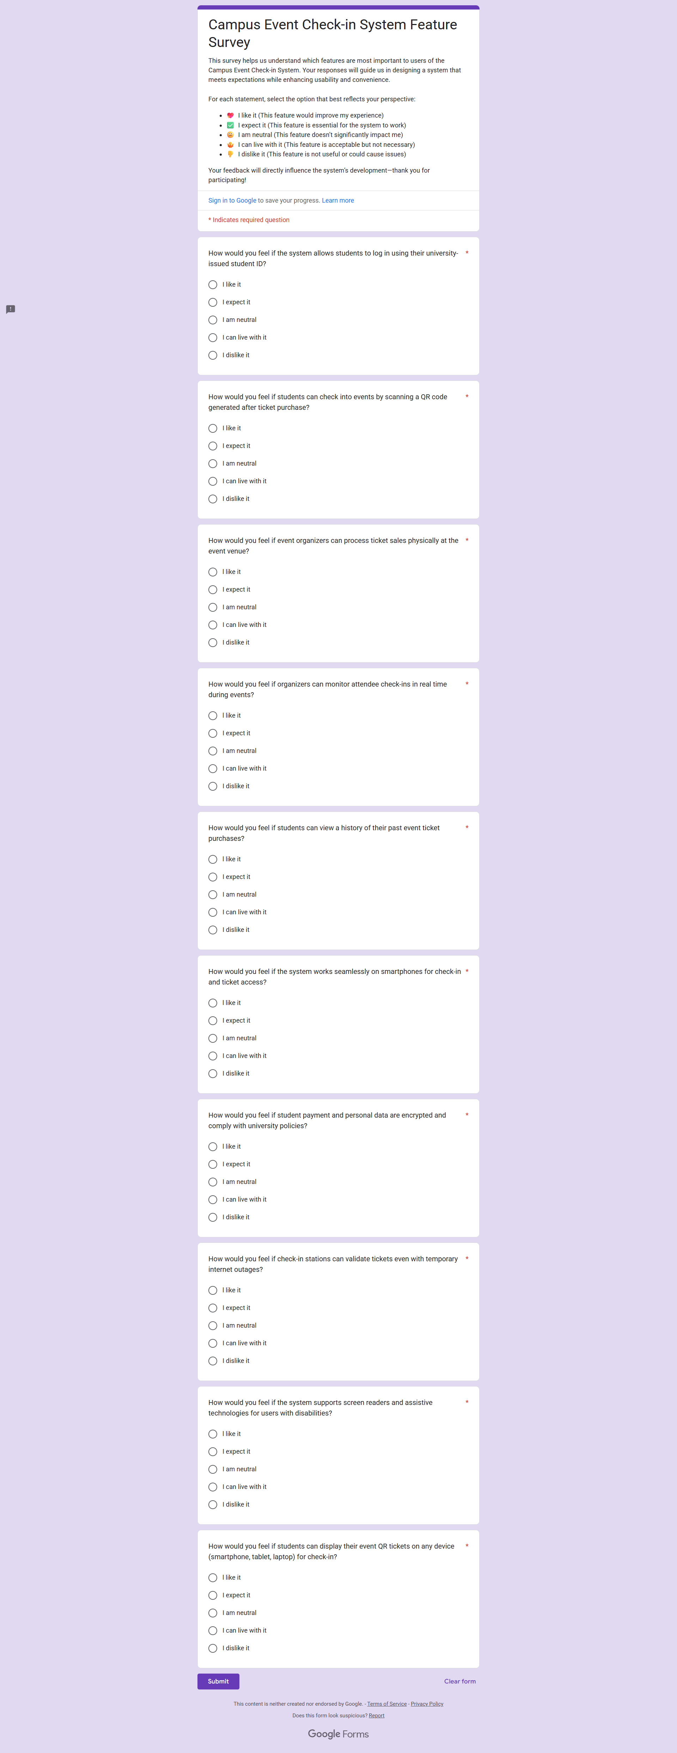





**Appendix B: Brainstorming Evidence**

1. **Physical Meeting**

1. **Brainstorming Session Recording**

You Tube link: <https://youtu.be/ljLO3InECNA>

1. **Virtual Collaboration**
   * Microsoft Teams Chat Screenshots

