  
**Term 2510**

**CSE 6224 SOFTWARE REQUIREMENTS ENGINEERING**

**Title: Campus Event Check-in System with Student ID and Payment Integration**

**Tutorial:** TT1L

**Group No:** Group 3

**Group Member:**

|  |  |
| --- | --- |
| **Student** | **Student ID** |
| Teng Huey Ting | 243UC2461A |
| Teoh Yi Xin | 243UC247NT |
| Yap Yi Ting | 243UC2462Y |
| Yee Lee Yiin | 243UC2461E |

1. **Introduction**

This document classifies the requirements for the Campus Event Check-in System using the Kano Model. The model categorizes requirements into dissatisfiers, satisfiers, and delighters to prioritize development efforts and align with stakeholder expectations. The classification is based on data from brainstorming sessions and a questionnaire administered to 21 student responds.

1. **Kano Model Classification**

|  |  |
| --- | --- |
| Kano Category | Requirements |
| Dissatisfiers | * User login/ authentication via Student ID * Student registration * Basic event creation/ deletion, edition |
| Satisfiers | * Real time attendance tracking * QR code ticket validation * Integration with payment gateway |
| Delighters | * Mobile-optimized interface for check-in and ticket access * Offline ticket validation during internet outages * Accessibility support |

1. **Supporting Evidence**
   1. Brainstorming Insights:
      * QR code validation was prioritized as a satisfier due to its direct impact on reducing check-in queues.
      * Offline functionality was identified as a delighter during the physical meeting
   2. Questionnaire Results:
2. Question 1

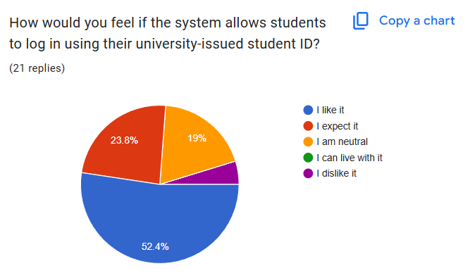

Classification: Dissatisfier (42.8% “expect it – essential for access”)

1. Question 2

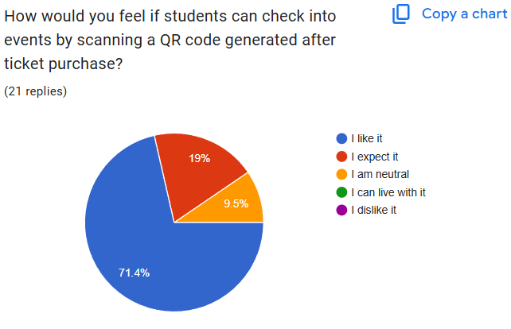

Classification: Satisfier (71.4% “like it” – enhances efficiency)

1. Question 3

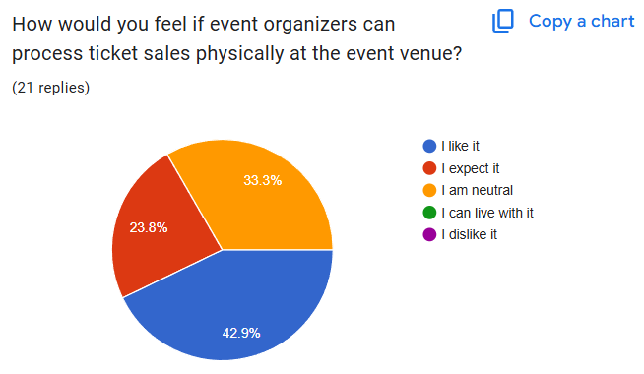

Classification: Satisfier (Mixed responses; critical for event flexibility)

1. Question 4

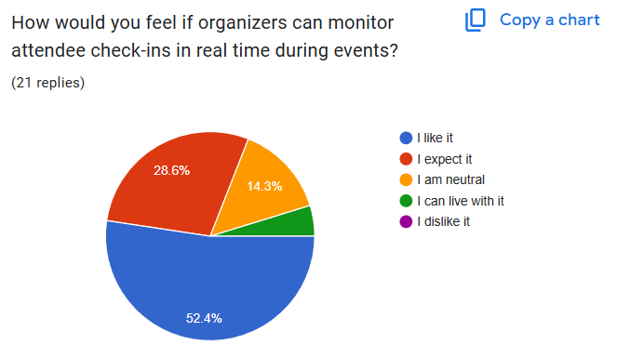

Classification: Satisfier (52.4% "expect it" – key for organizers)

1. Question 5

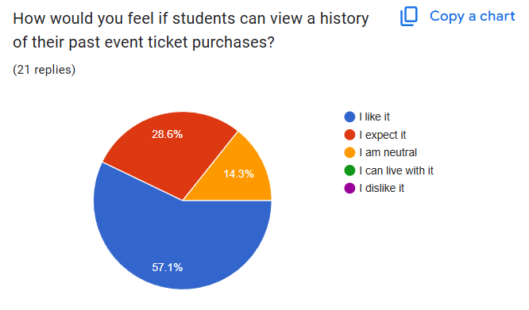

Classification: Satisfier (Neutral majority; nice-to-have but not critical)

1. Question 6

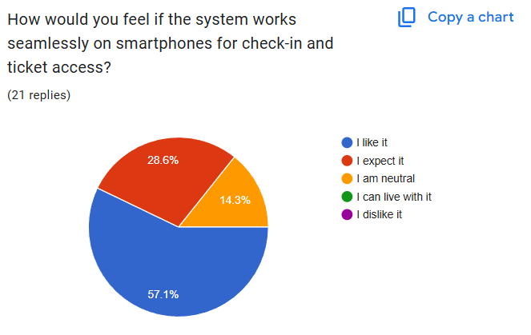

Classification: Delighter (57.1% "like it" – exceeds expectations)

1. Question 7

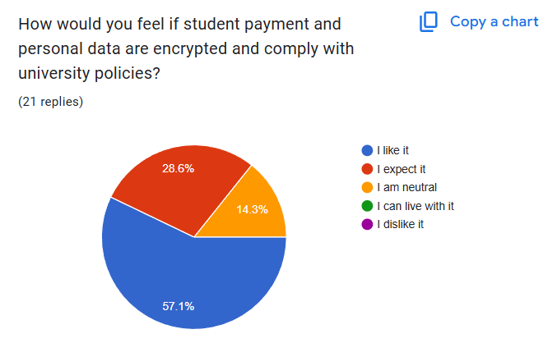

Classification: Dissatisfier (57.1% "expect it" – mandatory for security)

1. Question 8

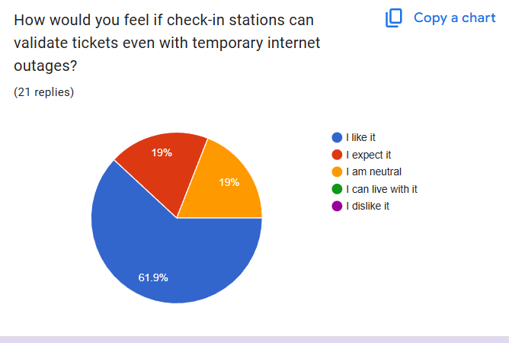

Classification: Delighter (61.9% "like it" – innovative and unexpected).

1. Question 9

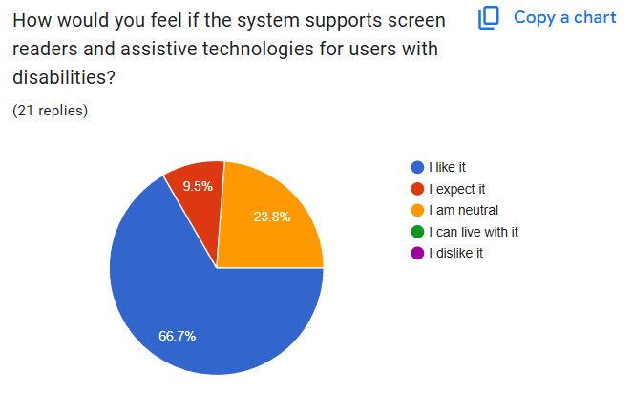

Classification: Delighter (66.7% "like it" – inclusivity adds value)

1. Question 10

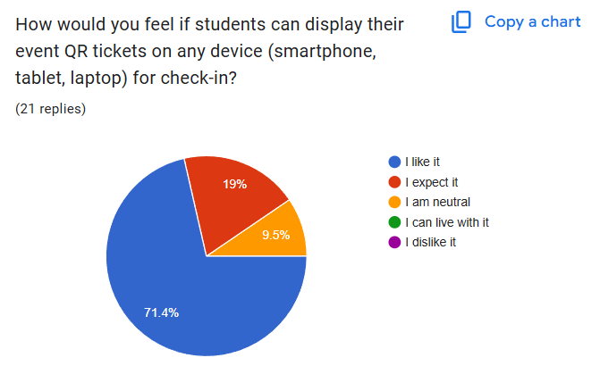

Classification: Delighter (71.4% "like it" – enhances convenience)

1. **Justification for Kano Categories**

* Dissatisfiers: These are non-negotiable features. For example, login via Student ID is mandatory for accessing the system, as confirmed by stakeholders.
* Satisfiers: Features like real-time attendance tracking improve efficiency proportionally to their implementation quality.
* Delighters: Mobile optimization and accessibility support were unexpected but highly valued, as shown by survey responses.

1. **Conclusion**

The Kano Model ensures a balanced focus on essential functionalities while incorporating innovative features that enhance user satisfaction. This alignment supports the project’s goals of streamlining event management and improving user experience.