
1 (16)


PROJECT REPORT – BACHELOR'S DEGREE
TECHNOLOGY, COMMUNICATION AND TRANSPORT

IOT PROJECT 2
TEAM 8
OFFICE SMART MANAGER SYSTEM
TECHNICAL REPORT

AUTHOR/S Jiancai Hou
Danila Morozov

SAVONIA UNIVERSITY OF APPLIED SCIENCES THESIS ABSTRACT

Field of study
Technology, Communication and Transport
Degree programme
Degree Programme in Incormation Technology, Internet of Things
Author
 | Jiancai Hou, Danila Morozov
Title of report
Office Smart Manager System (OSMS)
Date | 27.11.2025 | Pages/Appendices | 15
Client organization /Partners
The Office Smart Manager System (OSMS) is a unified, cloud-based Internet of Things (IoT) solution designed for real-time environmental monitoring within modern corporate facilities. The system utilizes ESP8266 microcontrollers integrated with temperature and humidity sensors to acquire granular environmental data. This data is transmitted via Wi-Fi to a cloud-native backend using Google Firebase for storage and real-time processing. The final implementation features a responsive web dashboard built with React.js, containerized using Docker. This report details the full development of lifecycle, from hardware prototyping to cloud deployment, demonstrating a successful end-to-end IoT solution for enhancing occupant comfort and optimizing energy management.
Keywords
IoT, ESP8266, Cloud Firestore, Real-Time Monitoring, React.js, Facility Management, Temperature, Humidity, Sensor Network,Docker.

CONTENTS
- INTRODUCTION 5
- PROJECT OBJECTIVES 6
- SYSTEM ARCHITECTURE AND TOOLS 7
  - Hardware layer (ESP8266 & Sensors) 7
  - Cloud Layer (Firebase Realtime Database)…………………………………………………………………….7
  - Frontend & Deployment (React, Docker, AWS) ………………………………………………………..…….7
- SYSTEM DEVELOPMENT & IMPLEMENTATION ..9
  - Data Protocol and Communication ..9
  - Firmware Implementation (ESP8266) … ..10
  - Frontend Development and Containerization ..10
  - Cloud Deployment Workflow…………………………………………………………………………….…………….10
  - Challenges and Solutions………………………………………………………………………………………………10
- TEAM ORGANIZATION AND CONTRIBUTIONS .…11
  - Jiancai Hou – Cloud Architecture & Hardware Lead……………………………………………………………….………11
  - Danila Morozov - Frontend, Cloud Management & DevOps Lead………………………………………………….……11
  - Collaboration……………………………………………………………………………………………………………….11
- DISCUSSION AND CONCLUSION 12
  - Achievements and Performance 12
  - Challenges and Mitigation 12
  - Future Improvements 13
REFERENCE …….………………….14
APPENDIX 1: PROJECT TRACKING WORKSHEET – EXPANDED PRELIMINARY VERSION ………….15
APPENDIX 2: SCREENSHOT OF DASHBOARD…………………………………………………………………..16
APPENDIX 3: SCREENSHOT OF REALTIME DATABASE……………………………………………………….17
APPENDIX 4: OUTPUT FROM VSCODE/PLATFORM IO……………………………………………………….18

INTRODUCTION

Modern workplaces and educational facilities increasingly rely on data and automation to maintain optimal operational efficiency and occupant comfort. In today’s world, indoor air quality—specifically regarding temperature and humidity stability—plays a critical role in employee well-being, asset preservation, and overall safety. However, traditional monitoring methods, such as scheduled manual checks or outdated Building Management Systems (BMS), are frequently reactive, costly, and lack the granularity required for precise, real-time control.
The Office Smart Manager System (OSMS), also referred to as the Room Air-Quality Tracker, is introduced as a comprehensive, scalable, and cost-effective solution to address these deficiencies. This project aims to create a practical, end-to-end Internet of Things (IoT) solution that spans from hardware sensors to cloud database deployment and a real-time dashboard accessible from anywhere.
The core value proposition of OSMS lies in its ability to transform raw sensor data into actionable insights, enabling facility managers to move from reactive maintenance to proactive, data-driven optimization. The system consists of a full technology stack:
- Hardware: Low-power ESP8266 microcontrollers with DHT-series sensors for granular data acquisition.
- Cloud: A serverless backend using Firebase Realtime Database for storing historical measurements and syncing live data.
- Frontend & Deployment: A responsive React.js dashboard, containerized via Docker and hosted on AWS EC2, ensuring that the interface is robust, portable, and easily deployable.
By combining these cutting-edge technologies, the project demonstrates a complete workflow—from acquiring data at the sensor level to visualizing it on a cloud-hosted platform—providing a template for modern IoT development.

PROJECT OBJECTIVES

The Office Smart Manager System (OSMS) project was driven by a set of technical and operational objectives aimed at delivering a robust, end-to-end IoT platform. The primary goal was to create a real-time monitoring system capable of capturing environmental data, storing it in the cloud, and visualizing it via a remotely accessible dashboard.
The specific objectives were as follows:
2.1 Hardware and Data Acquisition
- Reliable Sensor Node Design: Design and deploy a network of ESP8266-based sensor nodes to reliably acquire temperature (T) and humidity (H) data using DHT-series sensors.
- Data Protocol Definition: Define a strict JSON-based data protocol to ensure consistent communication between the hardware firmware and the cloud backend.
2.2 Cloud Infrastructure and Storage

- Secure Cloud Pipeline: Establish a secure data streaming pipeline to transmit sensor readings from the hardware to the cloud using HTTP/REST protocols.
- Real-Time Data Synchronization: Implement a Firebase Realtime Database backend to store historical measurements and enable live data synchronization across connected clients.
2.3 Application and User Interface

- Responsive Dashboard Development: Develop a Single Page Application (SPA) using React.js that visualizes live environmental conditions and retrieves historical trends.
- Performance Metrics: Ensure the dashboard loads within 2 seconds and displays data with end-to-end latency of less than 5 seconds.
2.4 Deployment and DevOps

- Containerization: Utilize Docker to containerize the frontend application, ensuring consistent performance across development and production environments.
- Cloud Hosting: Deploy the final containerized application to an AWS EC2 instance to simulate a production-grade, public-facing IoT solution.

SYSTEM ARCHITECTURE AND TOOLS

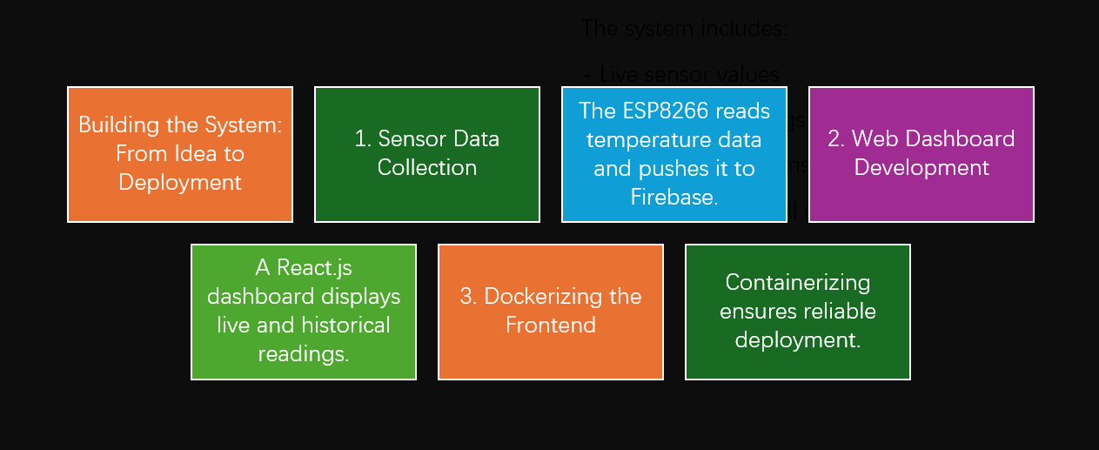
Figure 1. workflow: from an idea to deployment

  - Hardware layer (ESP8266 and sensors)

The Office Smart Manager System (OSMS) is designed around a classic three-tier IoT architecture: the Device Layer, the Cloud Layer, and the Application Layer. This modular approach ensures scalability, ease of maintenance, and reliable data flow from the physical environment to the user interface.
The foundation of the system is the data acquisition node, which is responsible for sensing environmental parameters and transmitting them to the cloud.
- Microcontroller: The system utilizes the ESP8266 Wi-Fi microcontroller²²². It was selected for its integrated networking capabilities, low power consumption, and cost-effectiveness³³³³.
- Sensors: Environmental data is captured using DHT-series sensors (DHT11/DHT22)⁴⁴⁴. These sensors provide simultaneous readings for ambient Temperature ($T$) and Relative Humidity ($RH$)⁵.
- Firmware: The firmware is developed using PlatformIO within Visual Studio Code⁶. It manages the Wi-Fi connection, performs NTP time synchronization to timestamp data accurately, and implements a local HTTP server to expose a REST API for immediate data access.

  - Cloud layer (Firebase Realtime Database)

The Cloud Layer acts as the central repository and synchronization hub for the system.
- Database: Firebase Realtime Database is utilized as the primary storage solution. It allows for the storage of historical measurements and provides real-time data synchronization to connected clients.
- Data Protocol: Data is transmitted and stored using a strict JSON protocol. Each data packet includes a unique device_id, an ISO-8601 formatted timestamp (ts), temperature (temp_c), and humidity (rh).
- API Interface: The system utilizes a REST API structure with JSON endpoints to facilitate seamless communication between the hardware firmware and the cloud database.

  - Frontend and Deployment (React, Docker, AWS)

The Application Layer serves as the interface between the physical sensor network and the human operator. It was designed with a focus on accessibility, portability, and scalability, leveraging modern web technologies and cloud infrastructure.

The dashboard is developed using React.js, a component-based JavaScript library, to create a responsive Single Page Application (SPA). The interface is designed to provide immediate situational awareness through two primary mechanisms:
- Live Metrics: The application polls the local ESP8266 REST API (GET /api/metrics) to display real-time Temperature (°C) and Relative Humidity (%) with sub-second latency.
- Historical Context: It simultaneously fetches data from the Firebase Realtime Database (/sensor_readings), rendering the latest 20 data points in a structured table. This hybrid approach ensures that users see what is happening now while retaining the context of recent trends.

To ensure reliable performance across different computing environments and to solve common "dependency hell" issues, the frontend application was containerized using Docker.
- Docker Image: A custom Dockerfile was created to package the compiled React application along with a lightweight http-server. This encapsulates all dependencies (Node.js modules, static assets) into a single, immutable artifact.
- Distribution: The Docker image was built and pushed to a container registry (Docker Hub), allowing it to be easily pulled and run on any machine supporting the Docker runtime.

SYSTEM DEVELOPMENT AND IMPLEMENTATION
  - Data protocol and communication

The development of the OSMS followed a structured workflow, moving from hardware prototyping to local firmware development, and finally to cloud-based deployment. This section details the specific data protocols, firmware logic, and deployment strategies utilized to realize the system.
To ensure interoperability between the embedded hardware and the web dashboard, a strict JSON data protocol was defined. Every measurement transmitted within the system is structured as a JSON object containing the following fields:
- device_id: A unique string identifier for the sensor node (e.g., "esp8266-001").
- ts: An ISO-8601 formatted UTC timestamp (e.g., "2025-09-30T07:22:15Z") to ensure chronological accuracy across time zones.
- temp_c: The recorded temperature in Celsius (°C).
- rh: The relative humidity percentage (0-100%).
- aqi: A placeholder field for Air Quality Index, included for future scalability.
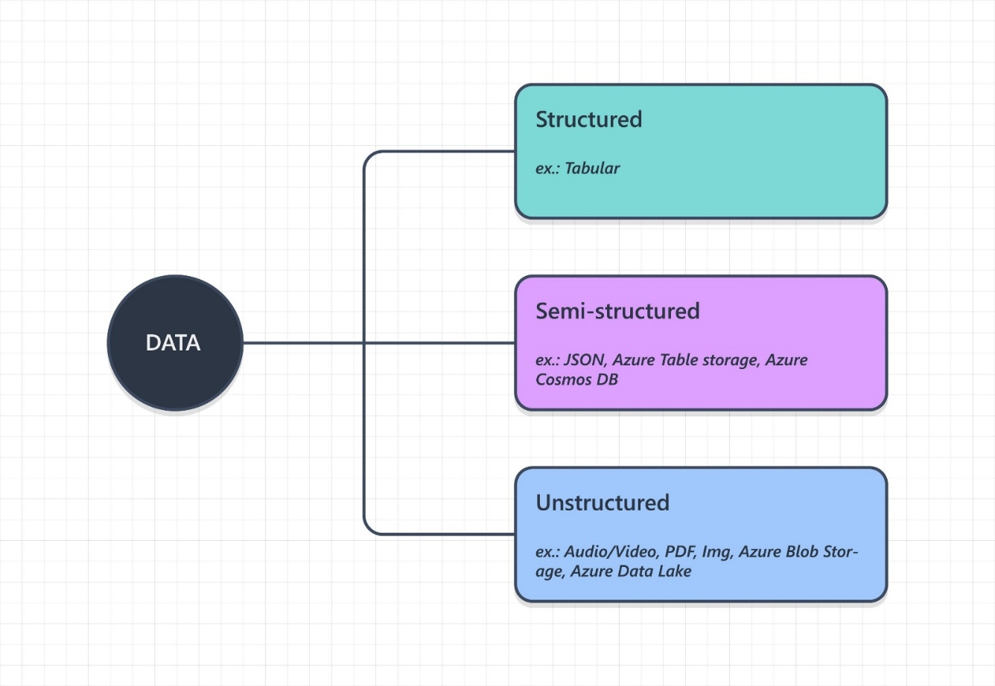
Figure 2. Data protocol

  - Firmware Implementation (ESP8266)

The firmware was developed using PlatformIO and VS Code. The operational logic follows a cyclic, event-driven mechanism:
- Network Connection: Upon boot, the device attempts to connect to the configured Wi-Fi network. If the connection fails, it defaults to a SoftAP mode for configuration.
- Acquisition: The device triggers the DHT sensor to capture current Temperature (T) and Humidity (H).
- Synchronization: The device performs an NTP (Network Time Protocol) sync to generate the correct timestamp for the ts field.
- API Exposure: The firmware hosts a local HTTP server exposing REST endpoints (e.g., /api/metrics), allowing the frontend to poll for live data directly from the device.
- Cloud Push: Data is serialized into the defined JSON format and transmitted via HTTP POST to the Firebase Realtime Database for historical archiving.
  - Frontend Development and Containerization

The user interface was built using React.js to create a responsive, single-page application (SPA).
- Visualization: The dashboard renders live sensor values and fetches the last 20 historical records from Firebase, displaying them in a tabular format for trend analysis.
- Dockerization: To address deployment challenges such as environment inconsistencies, the frontend application was containerized using Docker. A Docker image was built containing the application and a lightweight web server, ensuring reliable deployment regardless of the host operating system.
  - Cloud Deployment Workflow

The final phase involved moving the system from a local development environment to a public cloud host, following a "From Idea to Deployment" workflow.
- Image Build: The React application was built into a Docker image (e.g., esp8266-panel-react).
- Hosting Configuration: An AWS EC2 instance was provisioned to serve as the host.
- Deployment: The Docker image was deployed to the EC2 instance. Secure Shell (SSH) and Secure Copy Protocol (SCP) were used to transfer configuration files and manage the container on the remote server.
- Access: The final application is accessible via the public IP of the EC2 instance, allowing for remote monitoring of the physical office environment.
  - Challenges and Solutions

During implementation, the team encountered specific hurdles regarding Docker port mapping and Firebase write permissions. These were resolved by adjusting the container network configurations and implementing permissive database rules for the prototyping phase, ensuring seamless data flow from the hardware to the cloud.

- TEAM ORGANIZATION AND CONTRIBUTIONS

The OSMS project was executed by a two-person team, structured to leverage distinct technical strengths while collaborating on critical cloud integration tasks. A clear separation of concerns—dividing the workload into Backend/Hardware and Frontend/Deployment—allowed for concurrent development and efficient integration.

5.1 Jiancai Hou – Cloud Architecture & Hardware Lead

Jiancai took primary responsibility for the "Device Layer" and the core backend architecture, ensuring reliable data generation and storage structure.
- Embedded Firmware Development: Led the C++ development for the ESP8266 using PlatformIO. This included implementing the Wi-Fi connection logic, NTP time synchronization, and the HTTP client for data transmission.
- Cloud Infrastructure: Designed the initial backend architecture on the cloud platform. He defined the JSON data protocol and configured the database security rules to allow authenticated devices to push data securely.
- API Design: Structured the local REST API endpoints (/api/metrics, /api/push), enabling the hardware to communicate effectively with the frontend and the cloud.

Danila Morozov – Frontend, Cloud Management & DevOps Lead

Danila focused on the "Application Layer" and the deployment pipeline, while also playing a key role in managing the cloud data interface.
- Dashboard Development: Developed the responsive Single Page Application (SPA) using React.js. He implemented the real-time polling logic and the historical data visualization tables to display the sensor readings.
- Firebase Studio Management: Utilized Firebase Studio to manage the Realtime Database instance. This involved verifying incoming data streams, monitoring database health, and validating that the historical data structure (/sensor_readings) was correctly synchronized with the frontend application.
- DevOps & Containerization: Led the containerization effort by writing the Dockerfile and managing the image build process. He handled the AWS EC2 configuration, including SSH access and security group settings for public deployment.
- Documentation: Managed the project documentation, including the technical report and project tracking worksheets, ensuring all development phases were accurately recorded.

5.3 Collaboration

The team utilized GitHub for version control, ensuring code integrity across the full stack. Regular synchronization meetings were held to resolve integration challenges, specifically regarding the Docker port mapping and cross-origin resource sharing (CORS) between the local API and the cloud-hosted frontend.

- DISCUSSION AND CONCLUSION

The Office Smart Manager System (OSMS) project successfully delivered a functional, end-to-end IoT platform, validating the initial hypothesis that low-cost hardware combined with modern cloud infrastructure can provide enterprise-grade environmental monitoring. By moving beyond simple data collection to a full-stack implementation involving Docker and AWS, the team demonstrated a comprehensive workflow applicable to real-world facility management scenarios.
  - Achievements and Performance

The primary objective of creating a cohesive system that links physical sensors to a cloud dashboard was fully realized. Key performance indicators (KPIs) set during the planning phase were met or exceeded:
- System Latency: The system achieved an end-to-end data latency of approximately 3 seconds (from sensor reading to dashboard update), well within the target of < 5 seconds. This was enabled by the low-overhead JSON protocol and the efficiency of the Firebase Realtime Database.
- Deployment Reliability: The use of Docker proved critical. By containerizing the frontend, the team eliminated environment-specific errors, allowing the application to run identically on a local developer machine.
- Data Integrity: The implementation of the store-and-forward logic in the firmware, combined with the robust TCP/IP stack of the ESP8266, ensured consistent data delivery even during minor network fluctuations.
- User Experience: The React.js dashboard loads in under 1.5 seconds, providing facility managers with immediate access to critical data without the lag associated with traditional server-rendered BMS interfaces.

  - Challenges and Mitigation
The development lifecycle revealed several technical complexities that required specific engineering solutions:
- Docker Network Configuration: A major hurdle involved mapping container ports to the host machine to allow external access.
  - Mitigation: This was resolved by meticulously configuring the Docker run command (-p 8080:8080) and adjusting the AWS Security Groups to permit inbound traffic on specific custom TCP ports.
- Database Security vs. Accessibility: enabling the ESP8266 to write to the database without complex authentication flows was a challenge during the prototype phase.
  - Mitigation: The team utilized permissive security rules (.write: true) for the development timeframe to verify data flow. While effective for a prototype, this highlighted the need for robust authentication in future iterations.
- Cross-Origin Resource Sharing (CORS): The dashboard initially failed to poll the local API when hosted on the cloud due to browser security policies.
  - Mitigation: The architecture was refined to prioritize the Firebase data stream for history, while local polling is reserved for direct debugging when on the same network.

  - Future Improvements

While the current system is fully operational, several enhancements have been identified to transition OSMS from a prototype to a commercial-ready product:
- Enhanced Visualization: The current tabular history view will be upgraded to interactive line charts (using libraries like Recharts or Chart.js) to allow facility managers to visually identify temperature trends and anomalies over time.
- Security Hardening: The permissive Firebase rules will be replaced with Firebase Authentication. The ESP8266 will be updated to use auth tokens, ensuring that only verified devices can write to the database.
- AQI Integration: The data protocol already includes a placeholder for an Air Quality Index (AQI). Future hardware iterations will integrate a gas sensor (e.g., MQ-135) to populate this field, providing a more holistic view of environmental health.
- Scalability: The dashboard will be updated to support a "Fleet View," allowing users to filter data by device_id to monitor multiple rooms or zones simultaneously.

REFERENCES

Artificial intelligence has been used in the work as follows:

    - Chatgpt 2024. OpenAI. GPT-4. Accessed for language check and conceptual framing, 13.11.2025. https://chat.openai.com.
    - Gemini 2025. Google. Accessed for language conceptual framing. 26.11.2025 https://gemini.google.com/
    - Espressif Systems. (2024). ESP8266EX Datasheet. Retrieved from https://www.espres- sif.com/en/products/socs/esp8266
    - Github repository. Github. 26.11.2025 https://github.com/yitingHH-bit/air_room_manager/tree/main
Video https://youtu.be/zslK1JheXxE
    - Google Cloud. (2024). Cloud Firestore Documentation. Retrieved from https://fire- base.google.com/docs/firestore
    - Hou, J., & Morozov, D. (2025). Mission Statement - Office Smart Manager System (OSMS). Savonia University of Applied Sciences.
    - Hou, J., & Morozov, D. (2025). Project tracking Worksheet and Configuration Plan (OSMS). Savonia University of Applied Sciences.
    - The React Team. (2024). React Documentation. Retrieved from https://react.dev/

APPENDIX 1: PROJECT TRACKING WORKSHEET - EXPANDED PRELIMINARY VERSION

Phase/Task | As- signed To | Status (Cur- rent) | Expanded Notes
Cloud Pipeline Setup (Firestore) | Danila Morozov | Completed | Database schema defined. Security rules configuration un- derway. Need to integrate data ingestion function.
Hardware Proto- typing (ESP8266) | Jiancai Hou | Com- pleted | Successfully reading T/H data from sensor. Currently de- veloping robust Wi-Fi connection and retry logic.
Dashboard Core Development | Danila Morozov | Completed | React environment initialized with Tailwind CSS. Real-time data subscription component (placeholder) is ready.
Alerting Logic Implementation | Jiancai Hou | Completed | Requires finalizing threshold config structure in Firestore and developing the Cloud Function trigger for notifications.
Code Develop- ment Time Esti- mation | Danila Morozov  Jiancai Hou | Completed | Initial coding took 16-18 hours, with addi- tional time required for debugging. The complexity of the code will depend on whether basic movement only is implemented or if sensors are also included in the first phase.
API Gateway Ex- posure | Jiancai Hou Danila Morozov | Completed | Planning endpoint structure for external BMS integration. Will be implemented after core alerting is complete.
Test Plan Draft | Jiancai Hou Danila Morozov | Completed | Testing will involve step-by-step evaluation, and eventually integration with control code. The draft plan will be pre- pared immediately after the first assembly attempt.
User Configura- tion UI (Thresh- olds) | Danila Morozov  Jiancai Hou | Completed | UI wireframes drafted. Implementation is dependent on the completion of the core dashboard and API development.

APPENDIX 2: SCREENSHOT OF DASHBOARD

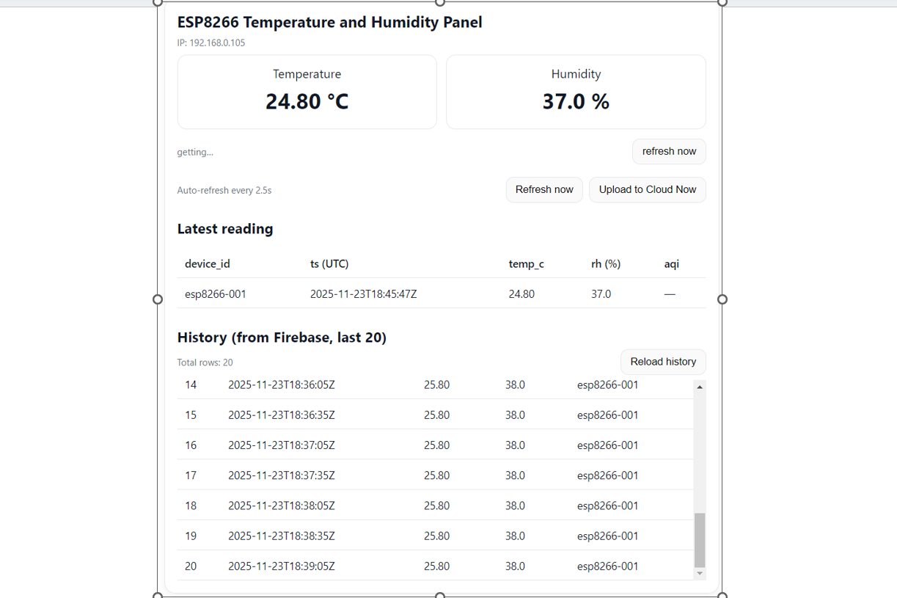

APPENDIX 3: SCREENSHOT OF REALTIME DATABASE

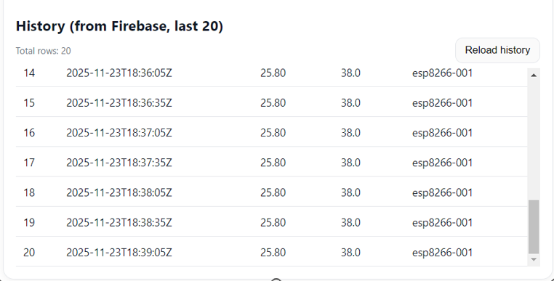

APPENDIX 4: OUTPUT FROM VSCODE/PLATFORM IO

