Last Name:   wang                   First Name:     yiting                       Student ID: 13853462

1. [10pts] Find the text of all tweets that were posted by the tweeter with the handle ‘patgotweet’.

a) [6pts] Relational Algebra

π tweet_text σ handle='patgotweet' ((Tweeter) ⨝ (Tweet))

b) [1pt] Parse Tree

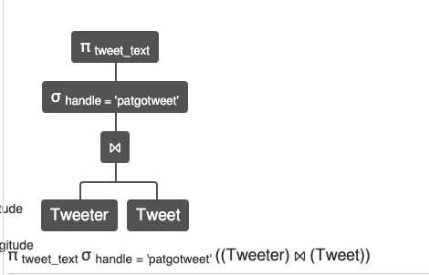

c) [3pts] Result

@TheValuesVoter @MrsPerrin I’m in one of those states. It’s a big Trump state so Covid is all a hoax here and masks don’t work. It’s a strange place to live right now.... and a bit scary and frustrating.

2. [10pts] List the domains of expertise for checkers who have verified tweets that have the hashtag “*COVID19*”.  (**Note: The hashtag value is all in capital letters.)**

a) [6pts] Relational AlgebQ

π domain σ hashtag='COVID19' (((Expertise) ⨝ (Checker)⨝ (Verification))⨝(Hashtag))

b) [1pt] Parse Tree

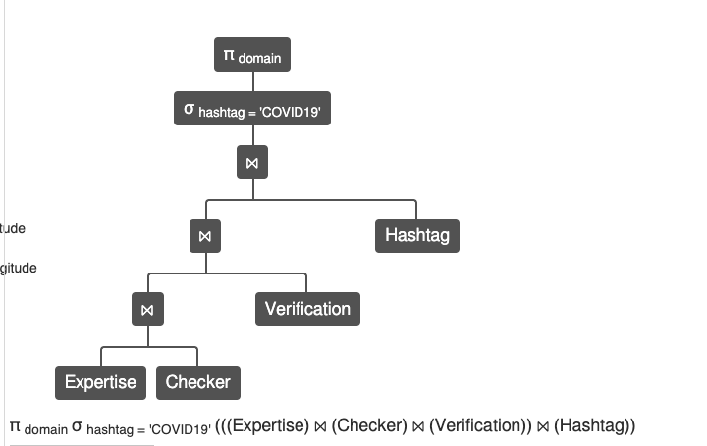

c) [3pts] Result

|  |
| --- |
| Health Service Quality |
| Public Health |

3. [10pts] List the handles of Tweeters who have posted a tweet that has been verified by a Checker who has been a checker since “2020-01-31 03:41:49”.

a) 6pts] Relational Algebra

π handle σ checker_since≥'2020-01-31 03:41:49' (Checker⨝Verification⨝Tweet⨝Tweeter)

b) [1pt] Parse Tree

c) [3pts] Result

4. [15pts]  List the evidence-providing users’ ids and the associated checkers’ ids where the users live in the state of CA and the checkers used evidence submitted by users who are not checkers themselves.

Example:

Let’s say that we have the following evidence and info about who submitted it:

|  |  |  |
| --- | --- | --- |
| **ev_id** | **url** | **Submitted by** |
| 0 | “http://foo.com” | checker0 |
| 1 | “http://baz.org” | user1 |
| 2 | “http://baz.org” | user2 |

In your query (relational algebra), you need to consider only the evidence submitted by user1 and user2 (i.e., ev_id =1 and ev_id = 2, respectively) if they live in California. Your result should not include ev_id = 0 as it was submitted by a checker (namely checker0).

a) [9pts] Relational Algebra

CANotChecker = π user_id (σ address_state = 'CA' (User)) - π user_id (Checker)

Submitter=π from_user_id←user_id, ev_id (EvidenceFrom ⨝ CANotChecker)

π from_user_id, user_id (Submitter ⨝ Evidence ⨝ VerifiedUsing ⨝ Verification)

b) [3pt] Parse Tree

c) [3pts] Result

| **from_user_id** | **Verification.user_id** |
| --- | --- |
| 44 | 0 |
| 44 | 3 |
| 44 | 6 |
| 44 | 15 |
| 44 | 22 |
| 44 | 21 |

5. [15pts] Find the evidence URLs, verification comments, and checkers’ first and last names for checkers who verified tweets that contain the hashtag “COVID19”. (**Again: “COVID19” is in all caps**.)

a) [9pts] Relational Algebra

π url, comment,name_first,name_last σ hashtag='COVID19' ((Evidence)⨝(VerifiedUsing)⨝(Verification)⨝(Hashtag)⨝(User))

b) [3pt] Parse Tree

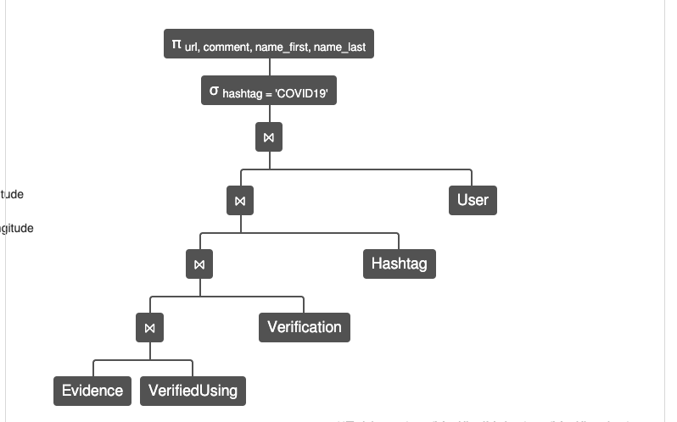

c) [3pts] Result

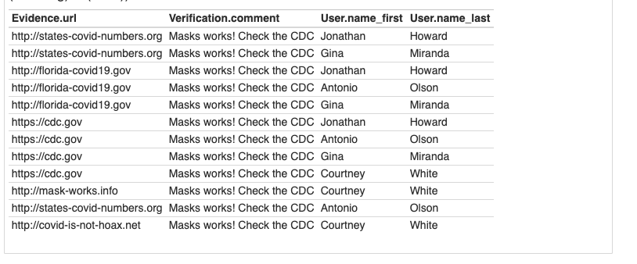

6. [15pts] Find the email addresses of all users who have submitted evidence about tweets that have either the hashtag “MaskUp” or the hashtag “COVID19”. **(Note: Hashtags are case-sensitive.)**

a) [9pts] Relational Algebra

π email σ hashtag='MaskUp'∨ hashtag='COVID_19' (Verification⨝Hashtag⨝User)

π email σ hashtag='MaskUp'∨ hashtag='COVID_19' (About⨝ EvidenceFrom⨝ Hashtag⨝User)

b) [3pt] Parse Tree

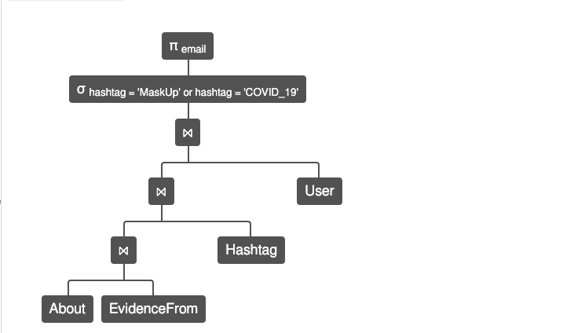

c) [3pts] Result

7. [15pts] Find the user IDs, first names, and last names of checkers that have **all** the domains of expertise from the user with ID = 68. (Note: Your answer will include the “ID = 68” checker as well, of course.)

a) [9pts] Relational Algebra

Che=π user_id,domain (Checker⨝Expertise)

target=π domain σuser_id=68 (Expertise)

result=Che÷target

π user_id, name_first, name_last (result⨝User)

b) [3pt] Parse Tree

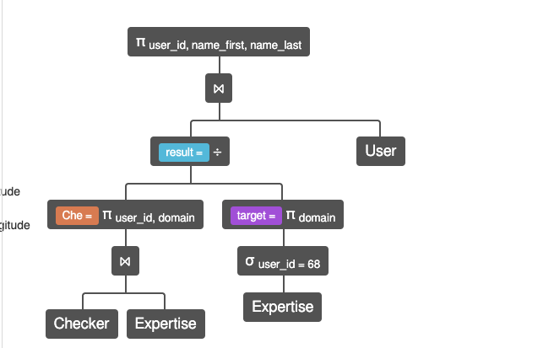

c) [3pts] Result

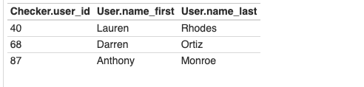

8. [10pts] List the phone numbers of checkers who have either verified the tweet with the id “1321211561046933514” or who are experts in “Infectious Diseases”.

1. [6pts] Relational Algebra

π number σ tweet_id='1321211561046933514'∨ domain='Infectious Diseases' ((Checker⨝Phone⨝Expertise)⨝Verification)

b) [1pt] Parse Tree

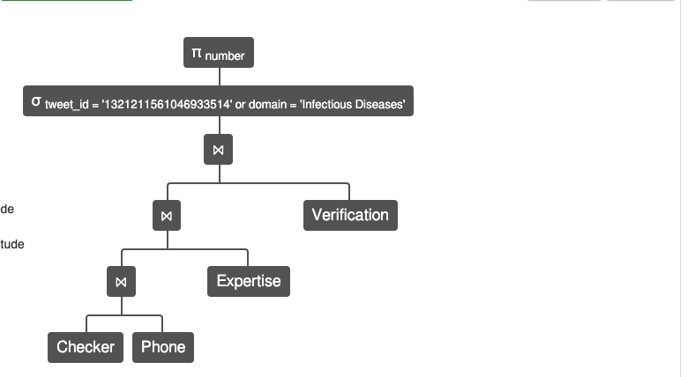

c) [3pts] Result

| **Phone.number** |
| --- |
| 001-070-249-0204 |
| 001-337-445-5627x321 |
| 193-407-5790x179 |
| 524.899.8641 |
| 164.768.4712x8904 |
| 403-156-1446 |