Basic
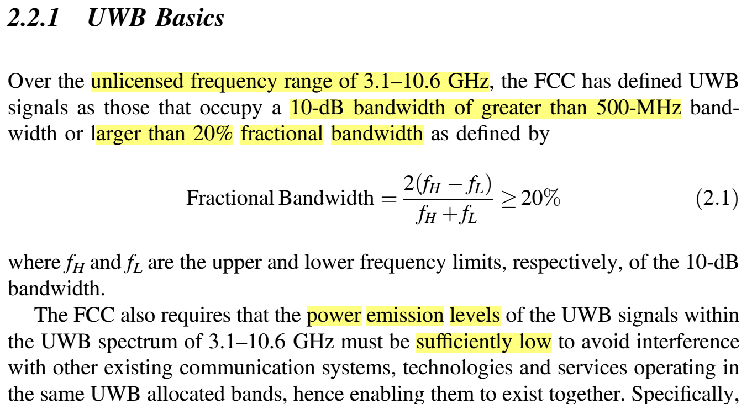

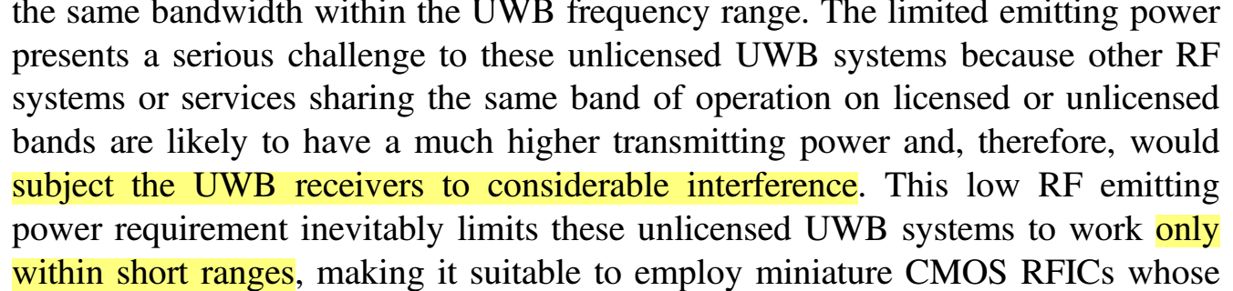

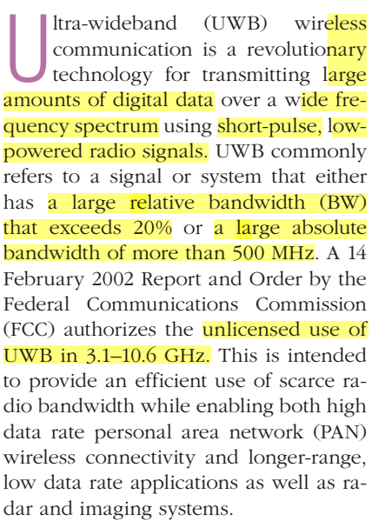----------------

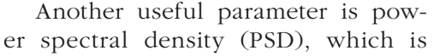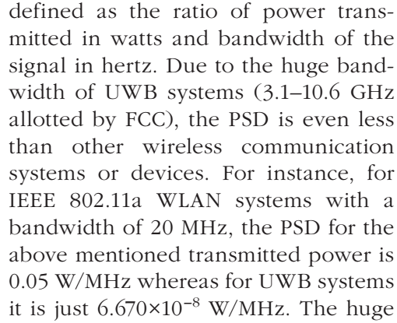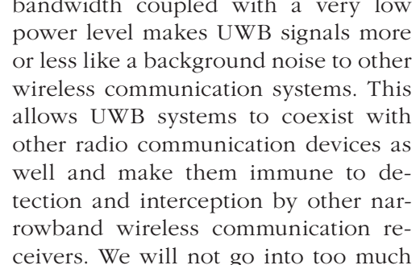

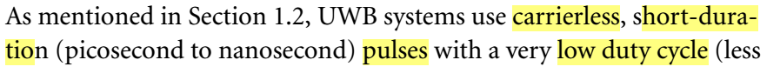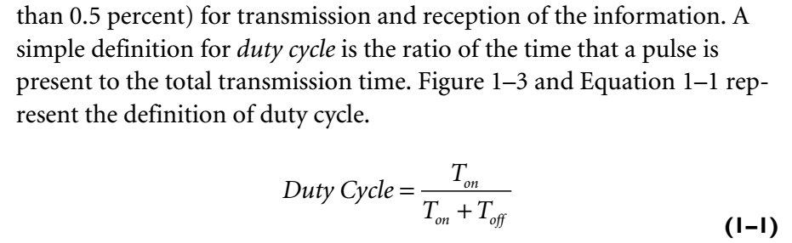
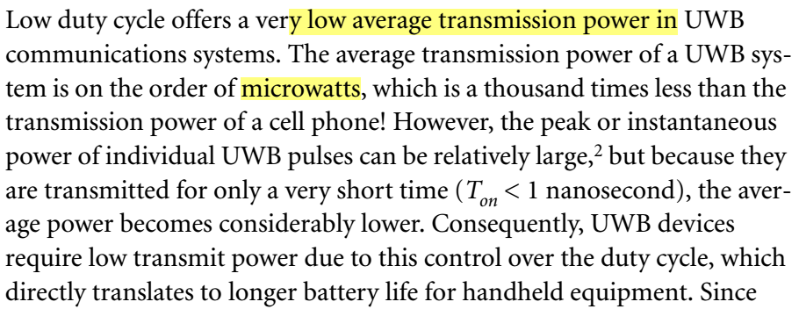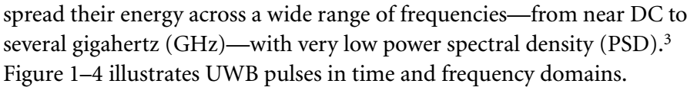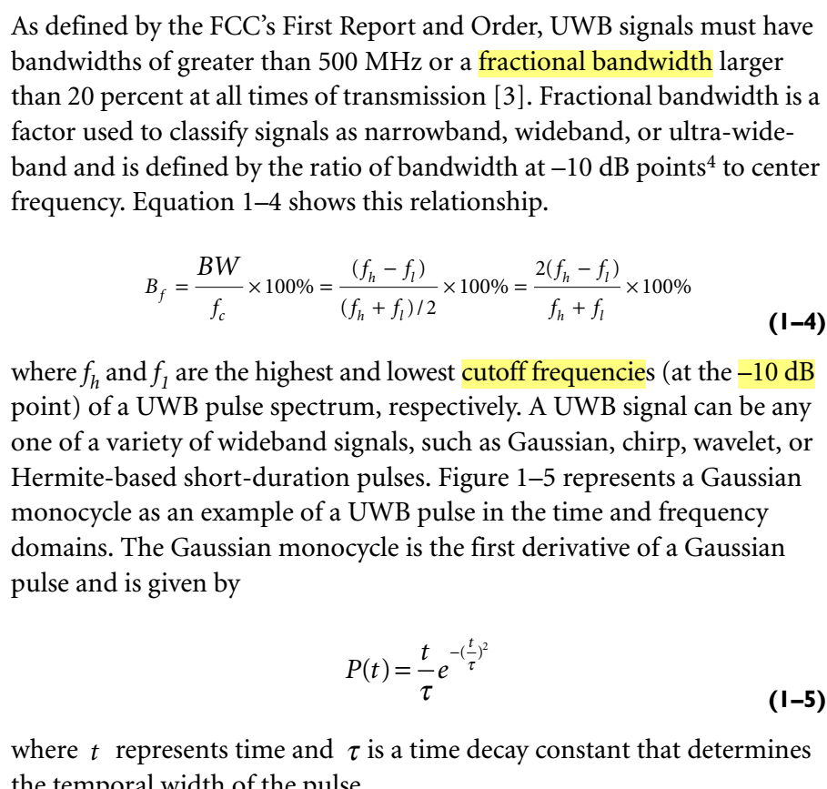

>>>>>>>>>>>>>>>>>>>>>>>>>>>>>>>>>>>>>>>>>>>>>>>
>>>>>>>>>>>>>>>>>>>>>>>>>>>>>>>>>>>>>>>>>>>>>>>
>>>>>>>>>>>>>>>>>>>>>>>>>>>>>>>>>>>>>>>>>>>>>>>
Advantages and disadvantages

