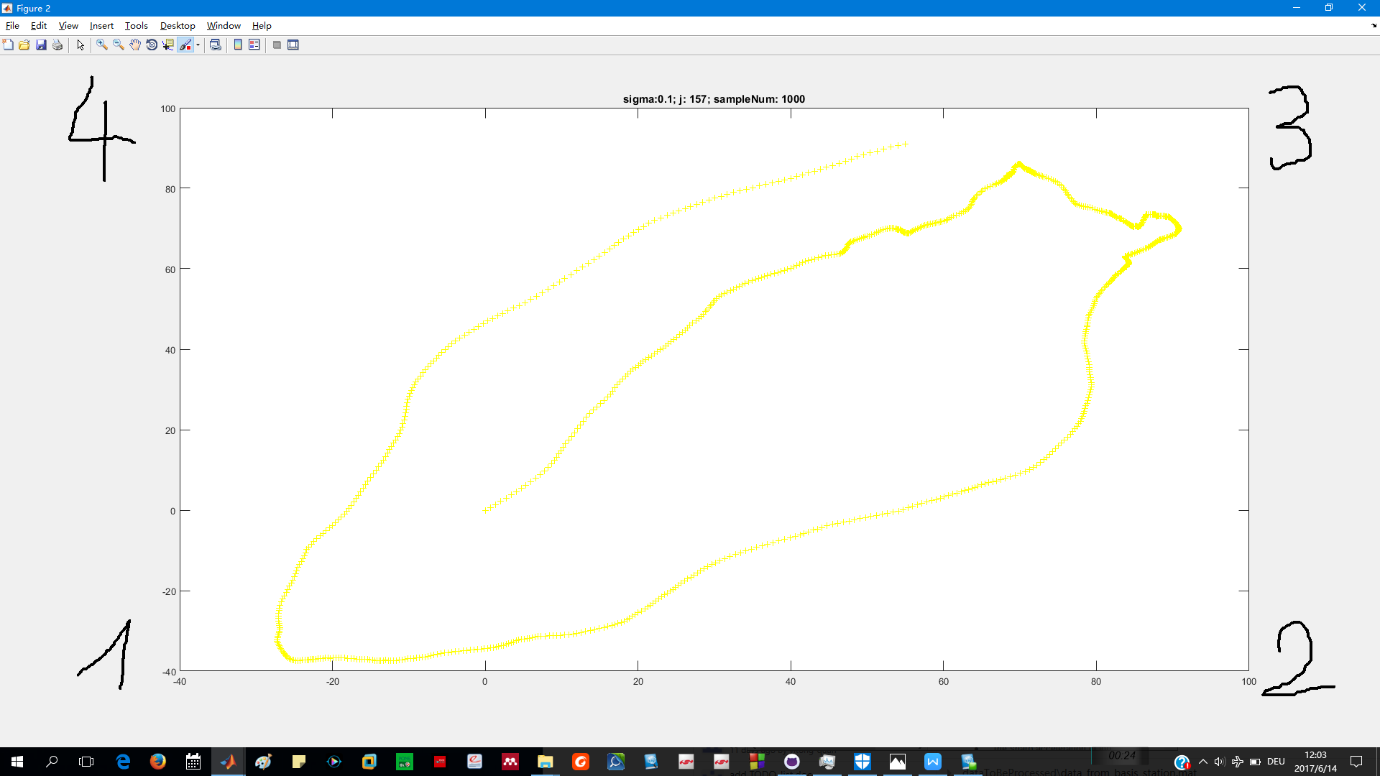
Nodes positions
++++++++++++++++++++++++++++++++++++++++++++++++++++++++++++++++++++++++++++++
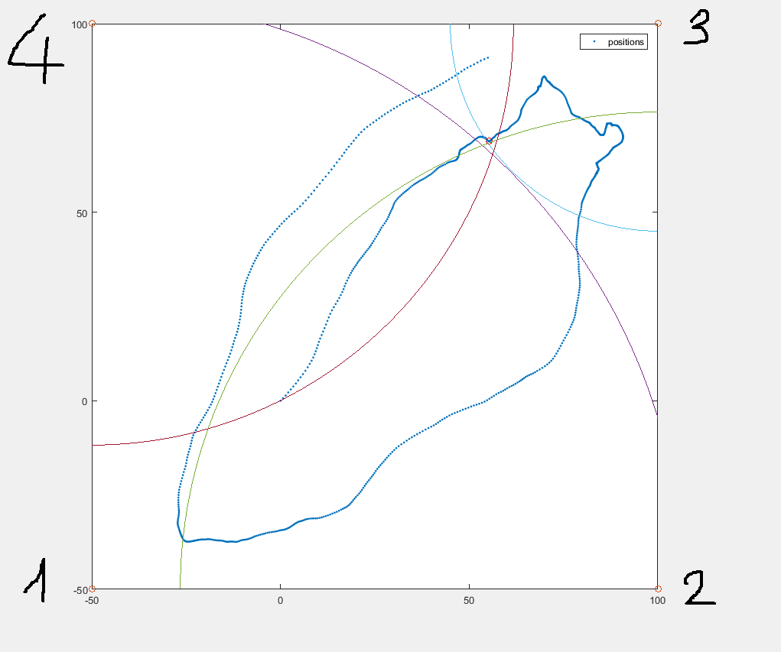

============================================
Nodes position in experiments(position2 is not so correct) see below
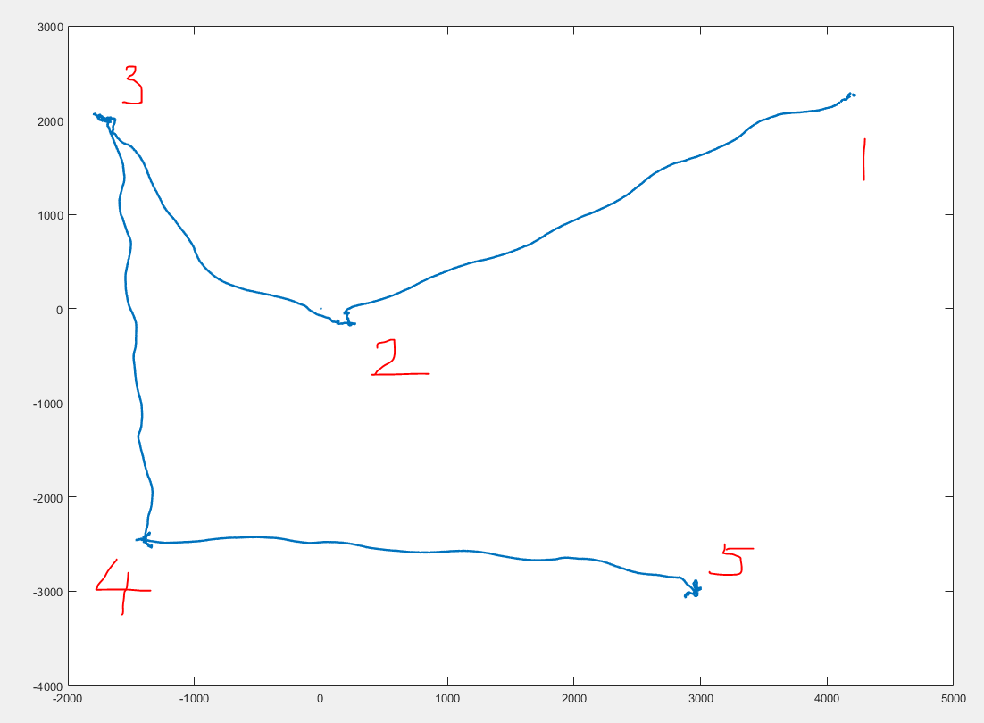
c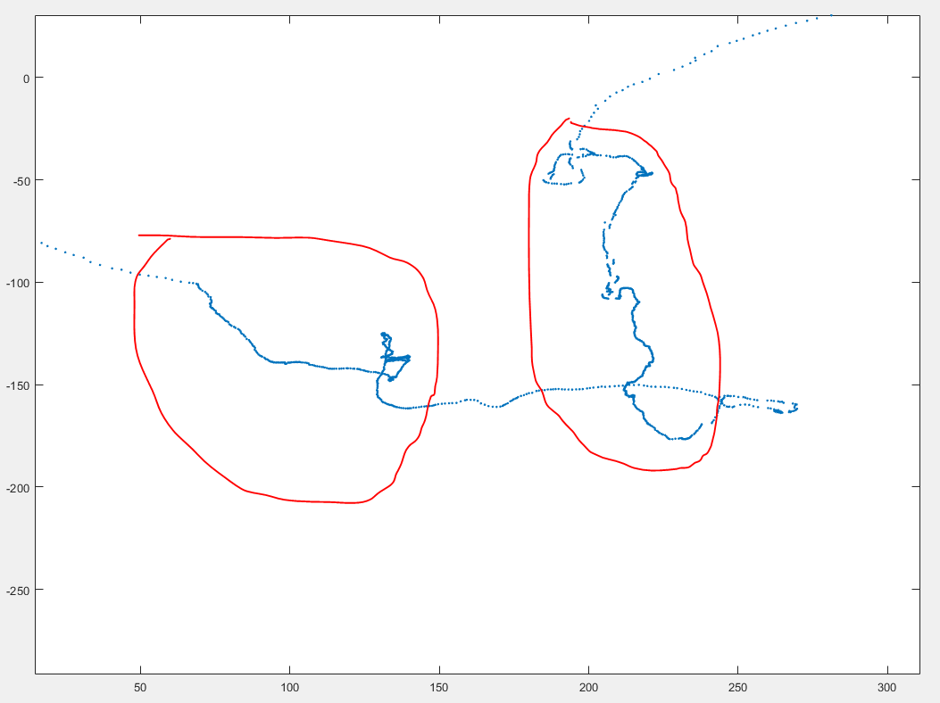
c