Main() << Basis_V1_24bit :

/********
* Command received:
********/
if (length > 0)
{
length = 0; // Reset the command length
>>>>>>
Change to Reset the command length at the end of the if{} case
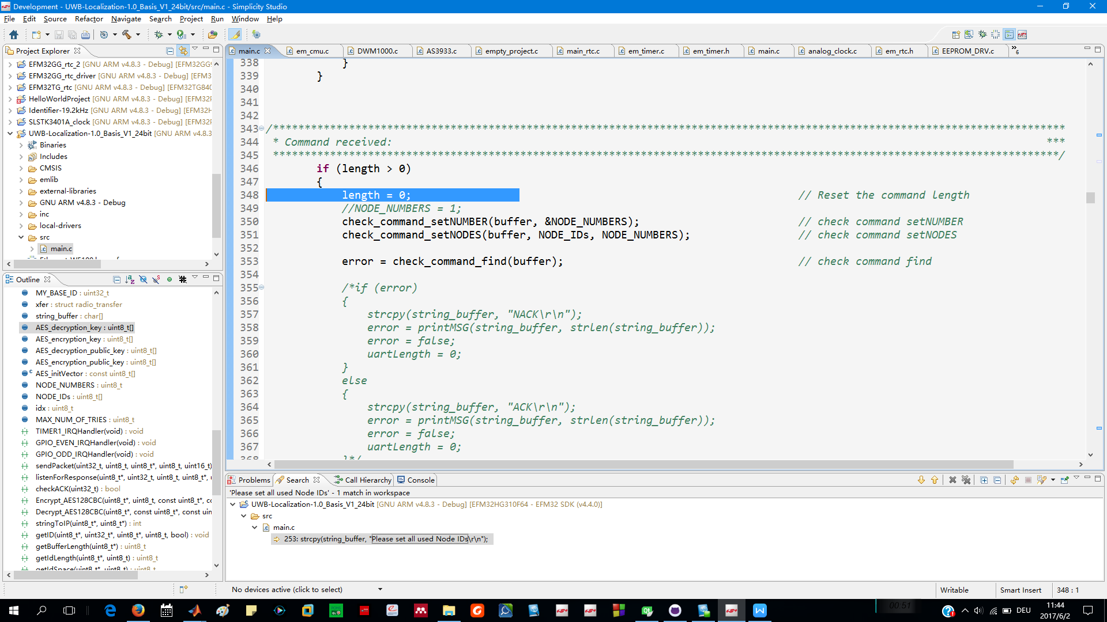

++++++++++++++++++++++++++++++++++++++++++++++++++++++++++++++++++++++++++++++
DATA_READING
File : try_to_communicate_with_basis_station_in_matlab.m
Use: X = str2double(str)
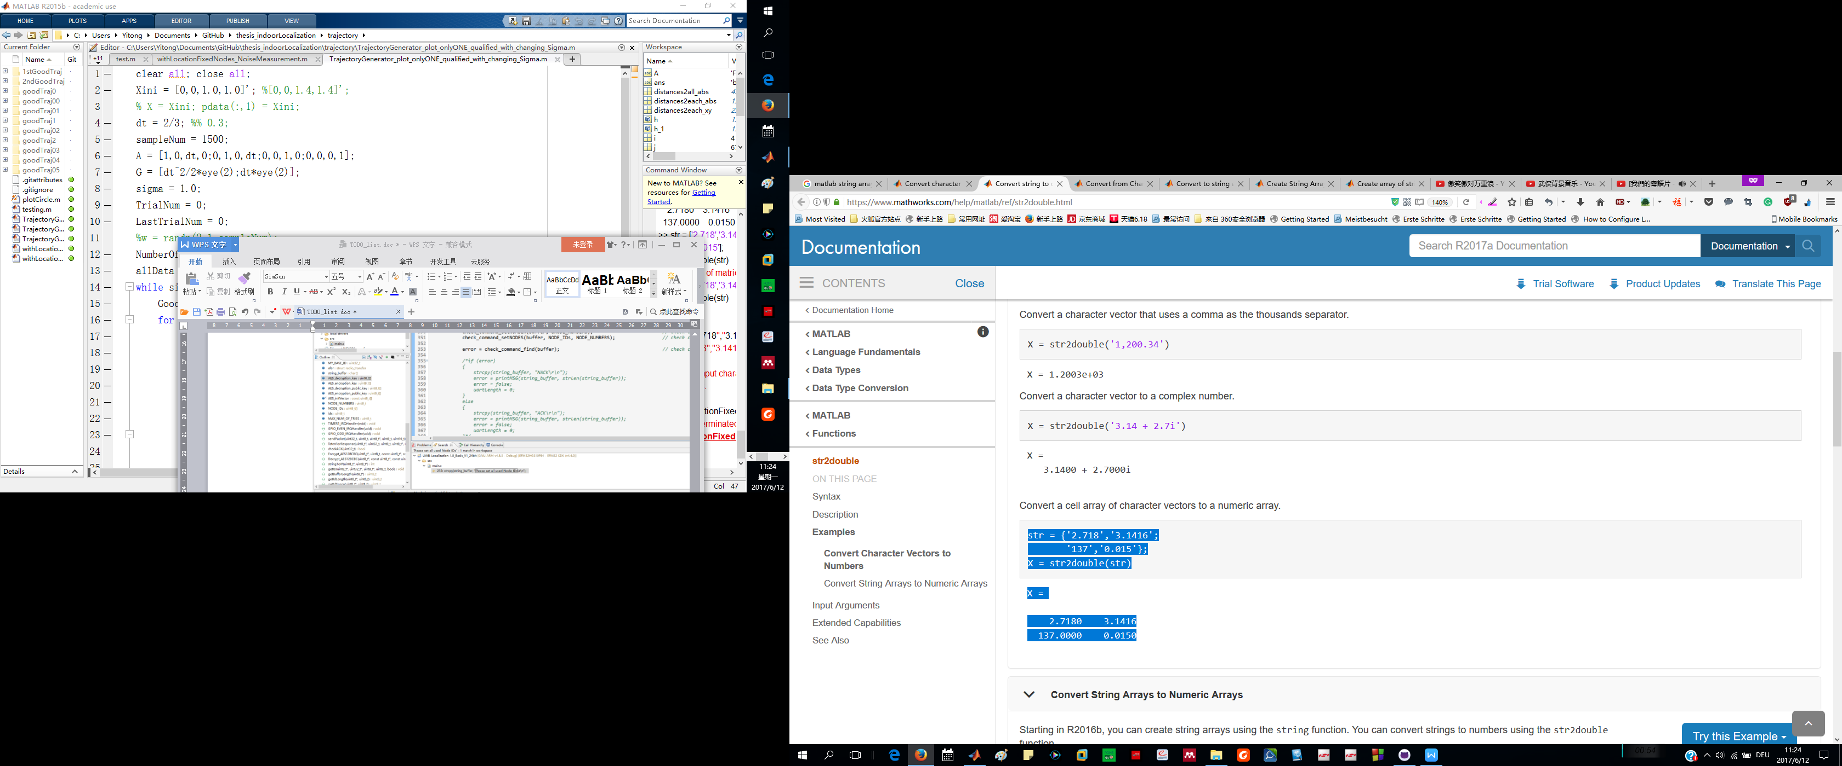
https://www.mathworks.com/help/matlab/ref/str2double.html

++++++++++++++++++++++++++++++++++++++++++++++++++++++++++++++++++++++++++++++
KALMAN FILTER
goodTraj01:
1, Use noisey_measurements with 3 nodes to realize localization
2, with 4 nodes
3, replace some measurements with 0, repeat 1st and 2nd steps

++++++++++++++++++++++++++++++++++++++++++++++++++++++++++++++++++++++++++++++

++++++++++++++++++++++++++++++++++++++++++++++++++++++++++++++++++++++++++++++

++++++++++++++++++++++++++++++++++++++++++++++++++++++++++++++++++++++++++++++

