8,16,2017

Try to disable the enter SLEEP mode of the MCU, disable ‘EMU_EnterEM2’

Try to disable the enter SLEEP mode of the DWM1000, disable ‘DWM1000_enter_sleepmode()’,’DWM1000_SPI_Wake_Up (wakeup_buffer, 50)’, ‘DWM1000_enter_sleepmode()’

Try to disable cc1101_power_down, ‘cc1101_power_down()’

Don’t work

0a070bf8edb68461c50ed8a8d61ac901bf76a690 modified AS3933.c in node making it more reliable, namely less chance to return 0 data; 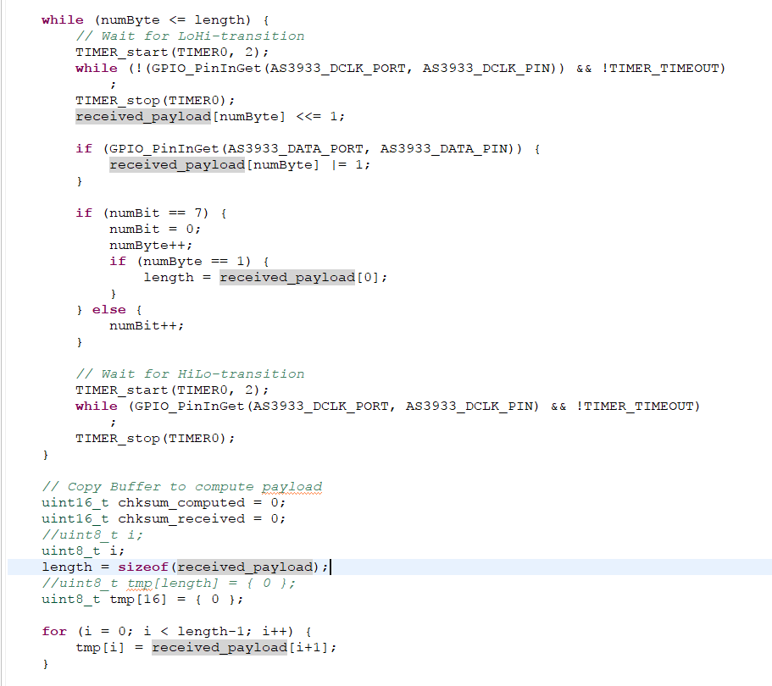

Trying to do the same to the tag

Besides the command send from the base looks like thereis problem, since sometime false returned here in AS3933.c

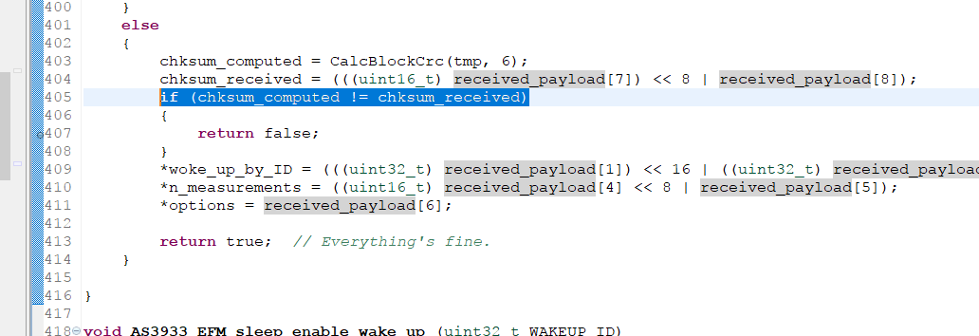

Above are the same problem as followed

Normal case

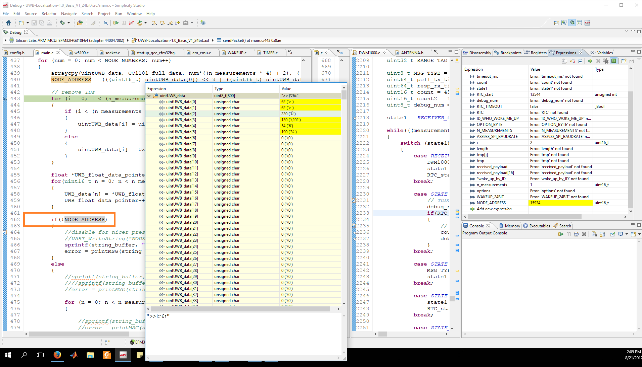

When problem comes

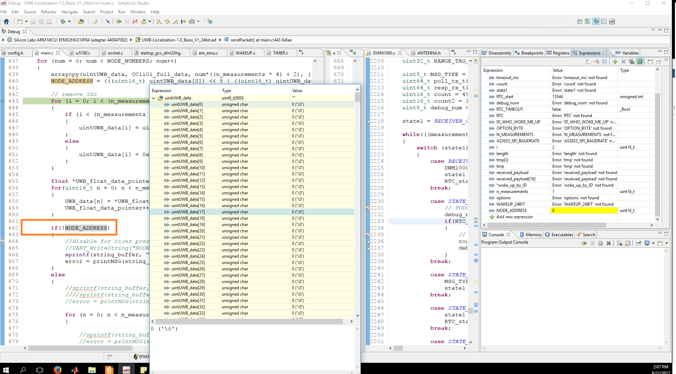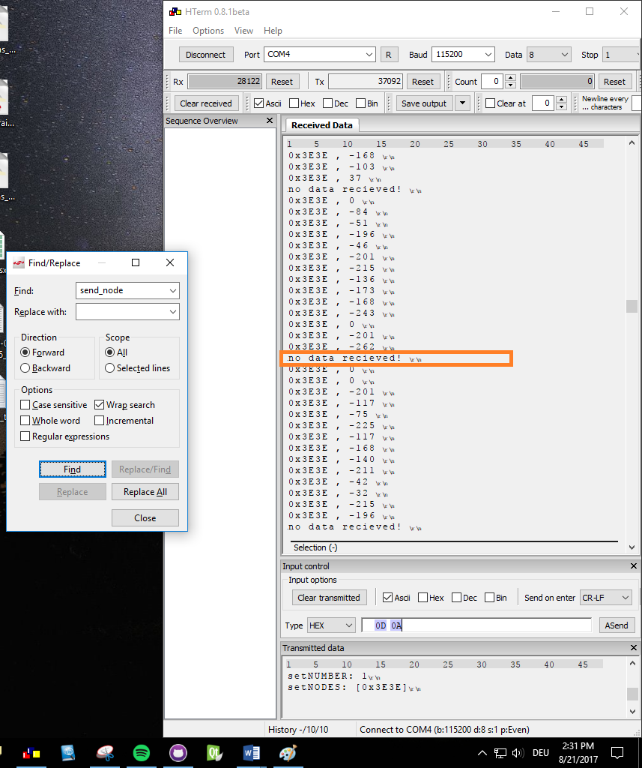

Solve it by adding the code idx = 17, to solve the over float problem ( ‘idx’ is uint8_t format).

