Contents

1 Introduction

2 Theoretical Background

2.1 localization with distances

In Geometry, the position of a point can be determine by several methods, such as Trilateration and Triangulation. In this thesis, Trilateration is used for location determination. Followed is a brief introduction about Trilateration:

In a two dimensional space, to determine the position of a point, at least 3 distances to 3 different fixed positions are required(these 3 fixed positions should not lie in a same line).

When the exact distances from a mobile Tag to 3 anchor Nodes are known, the position of this mobile Tag can be determined by the intersection point of circles around the Nodes with corresponding radius.

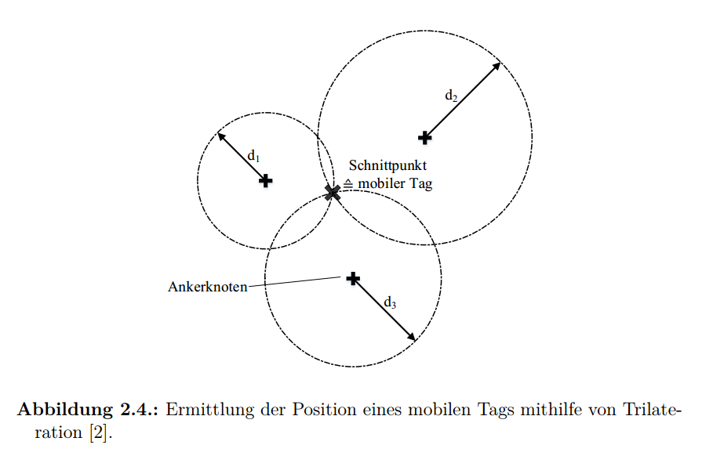

(pic from ‘Patrick thesis P11’)

When the distances from a mobile Tag to 3 anchor Nodes are added with noise due to the inherent error of hardware, the position of this mobile Tag lies within the intersection area of circles.

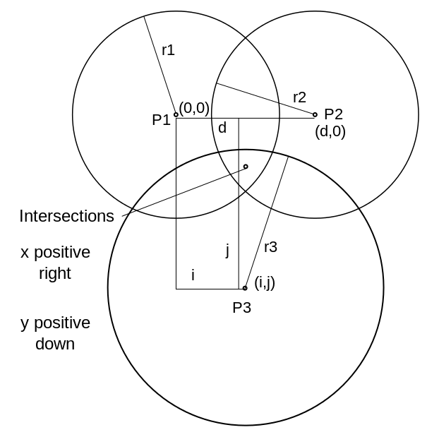

(pic from ‘https://en.wikipedia.org/wiki/Trilateration’)

2.2 distance measurements base on UWB signal

2.2.1 UWB

2.2.2 distance measurements

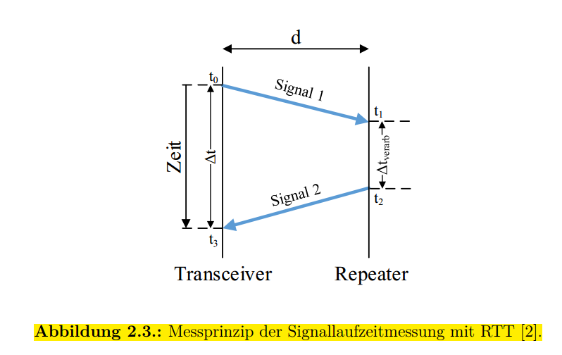

(pic from ‘Patrick thesis P10’)

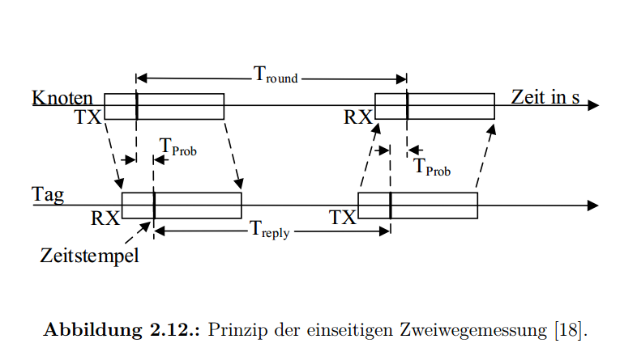

(pic from ‘Patrick thesis P24’)

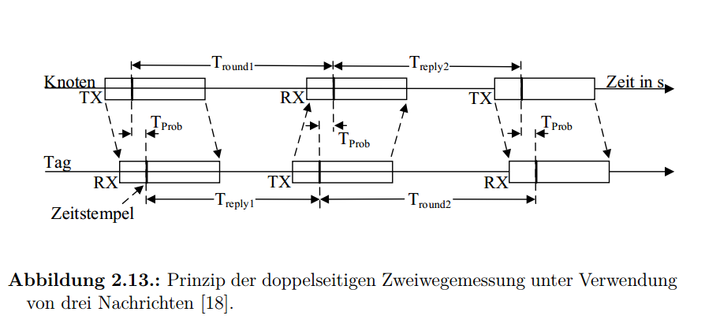

(pic from ‘Patrick thesis P25’)

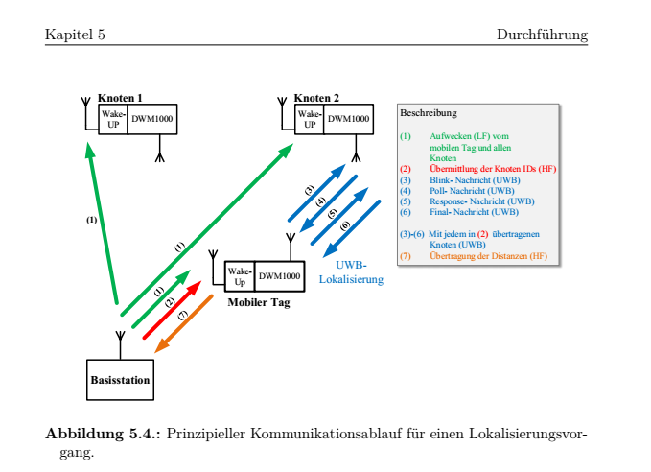

(pic from ‘Patrick thesis P50’)

2.3 KF

2.4 EKF

2.5 Self-Calibrations for Anchor-Nodes

2.6 State of the Art

1. Improvement of hardware

Loop jumper(tag), timing, state machine(loop between nodes)

Sampling rate

Before and after

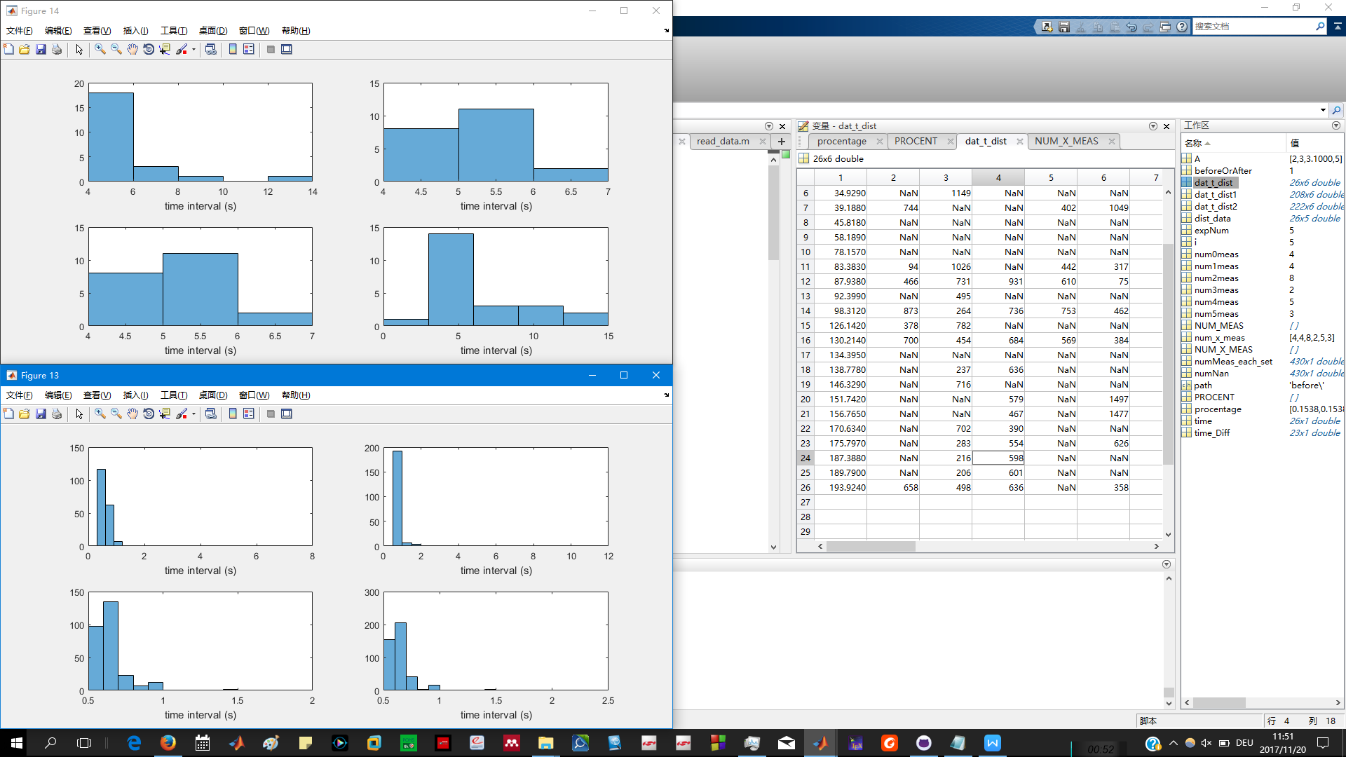

Before

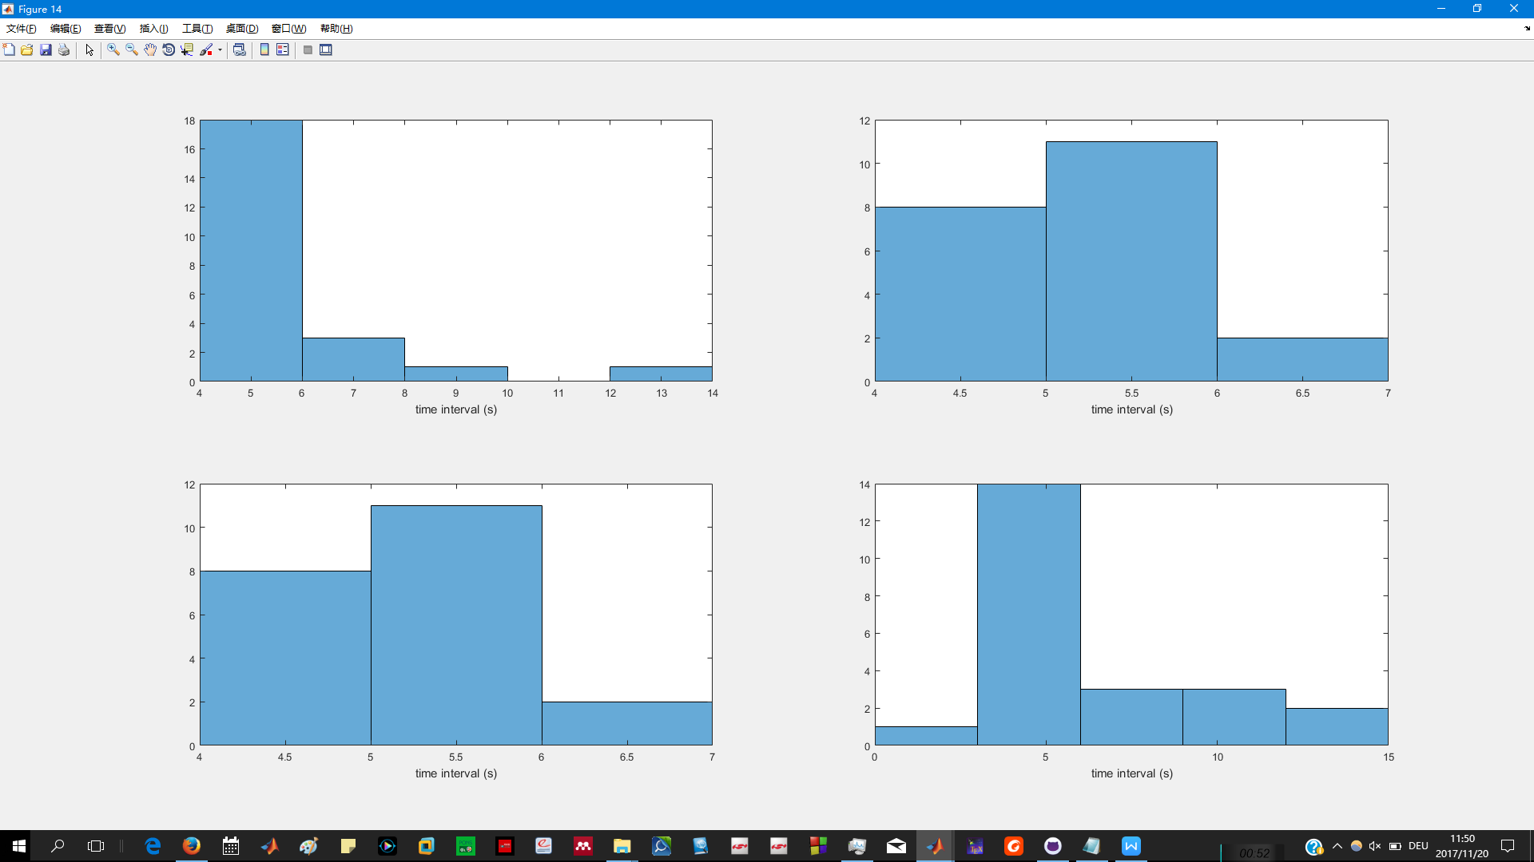

After

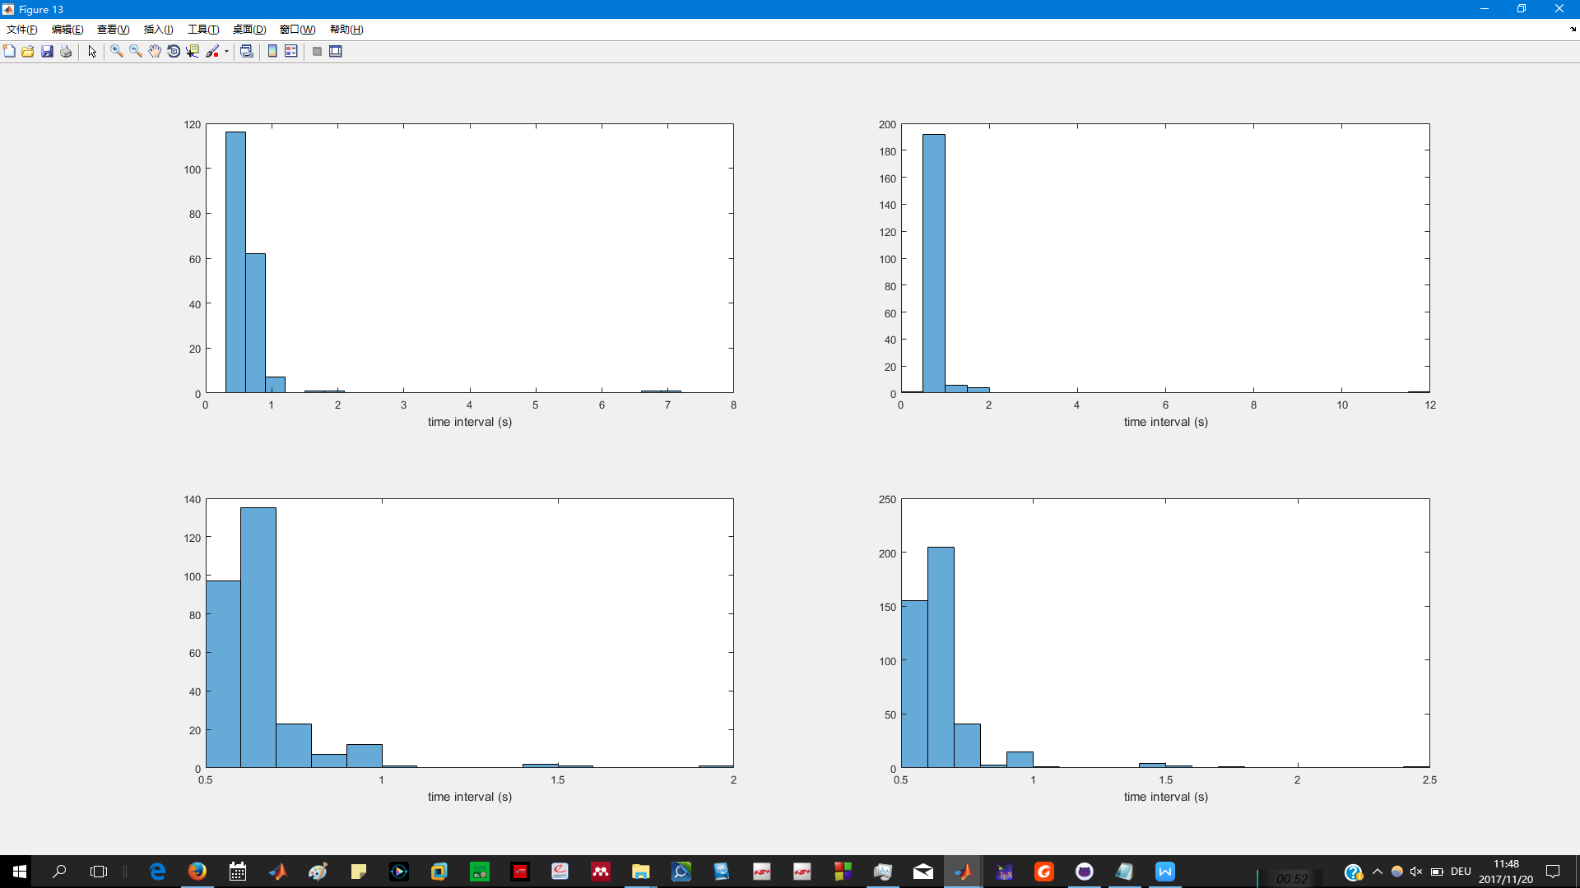

Mat file ‘C:\Users\Yitong\Documents\GitHub\thesis_indoorLocalization\improvment in hareware’ *hist(time_Diff,100);*

Sampling measurement #

Before and after

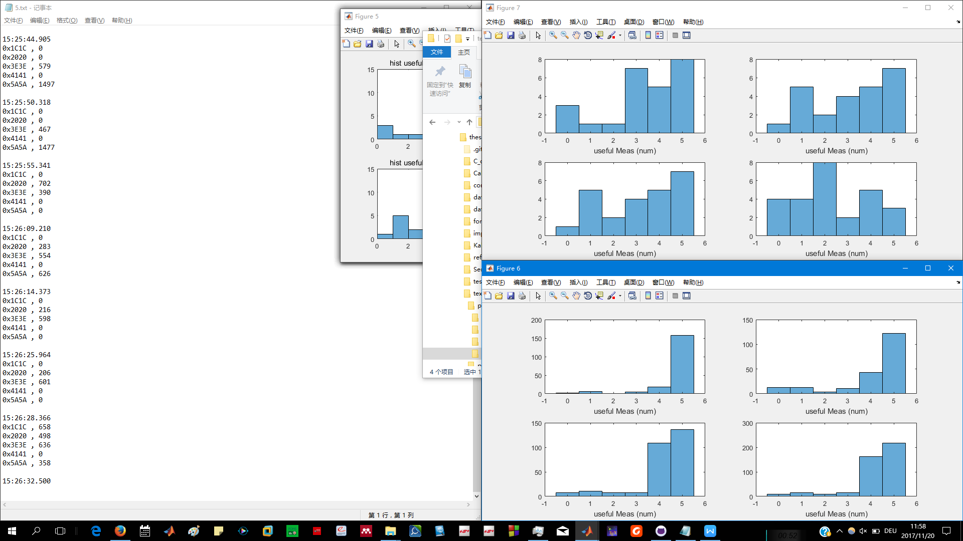

Before

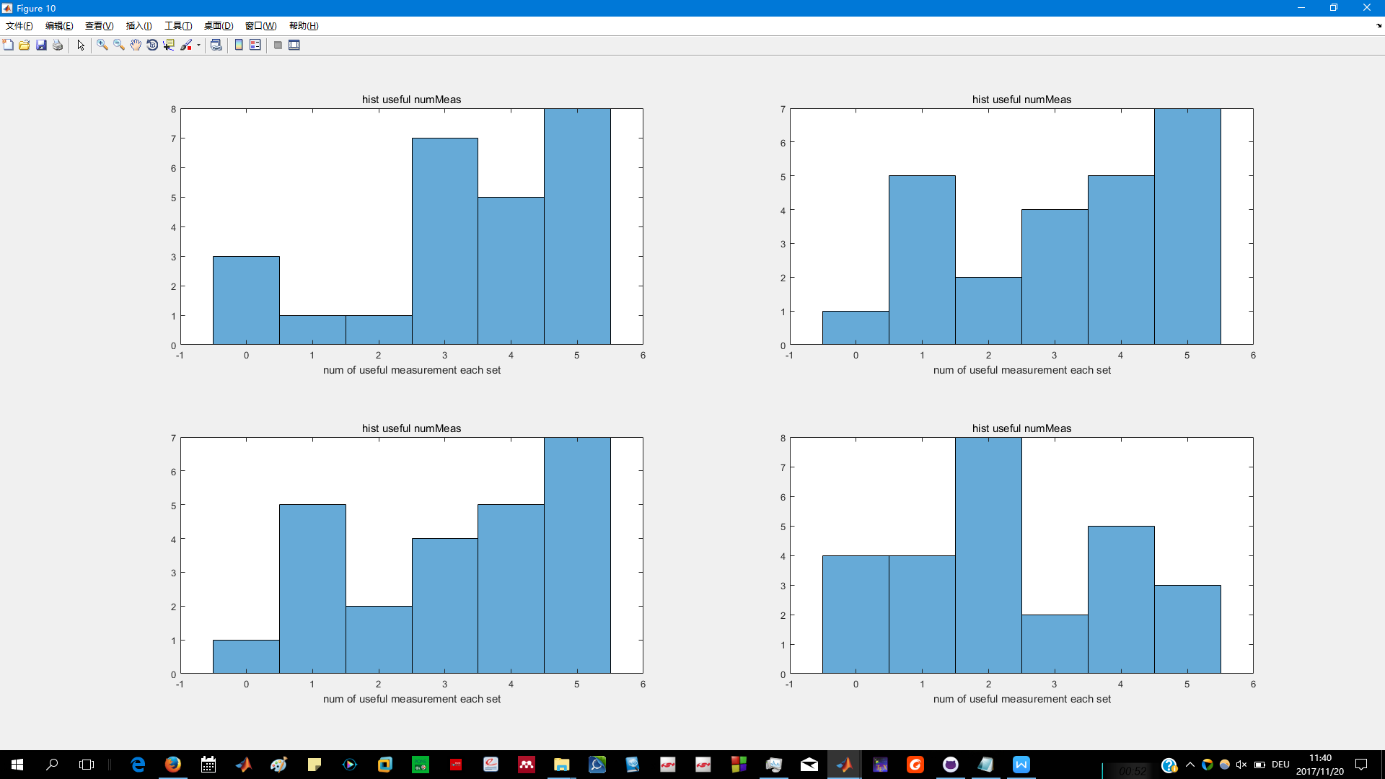

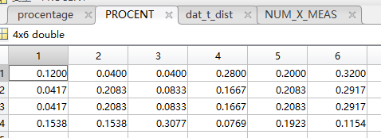

After

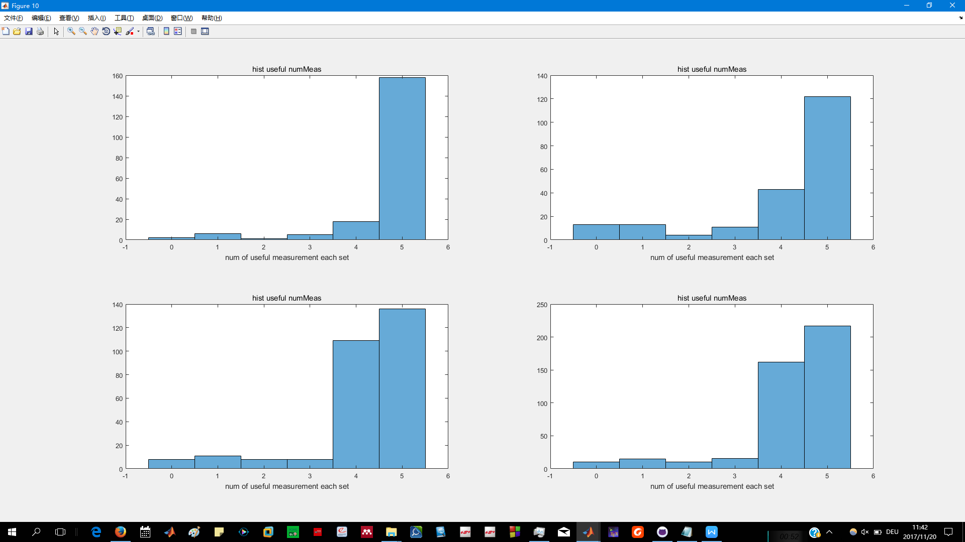

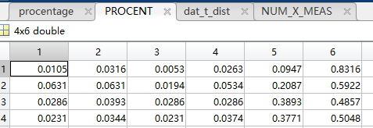

Location’C:\Users\Yitong\Documents\GitHub\thesis_indoorLocalization\improvment in hareware\after’

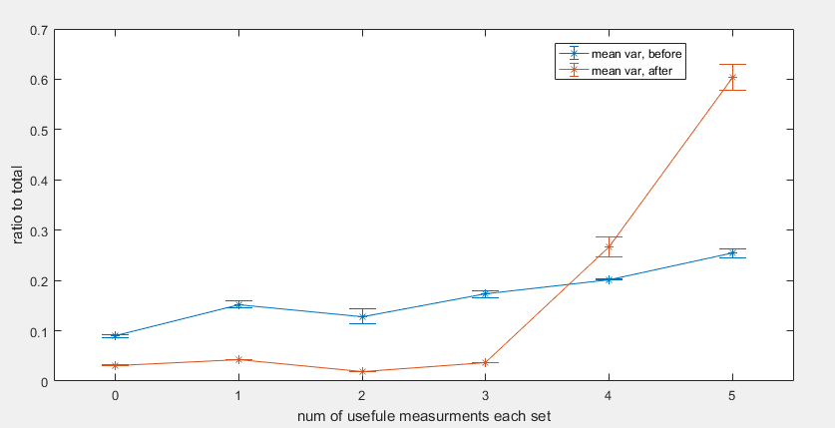

(‘C:\Users\Yitong\Documents\GitHub\thesis_indoorLocalization\improvment in hareware\compare in numUsafule meas.fig’)

4 Measurements

4.1.1 Calibration

Set up (3,4,5,6,7,8,9m)

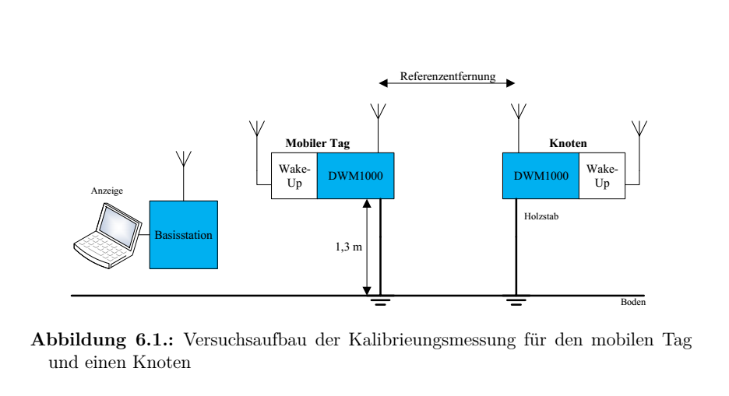

(pic from ‘Patrick thesis P64’)

Measurements Distributions

.................................. heavy tail in front

34568m

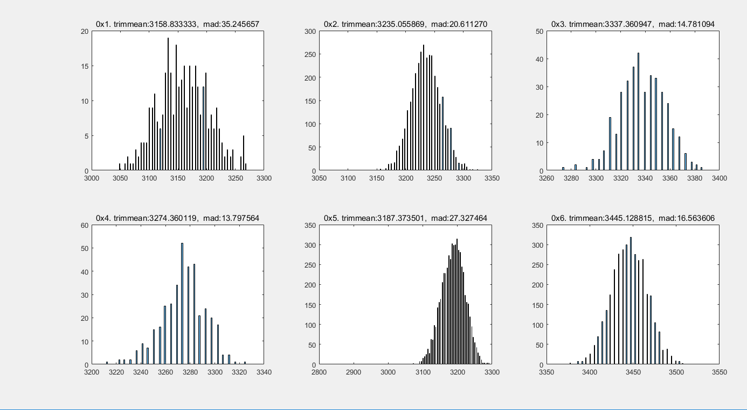

...

‘thesis_indoorLocalization\communicate_with_basis_station_in_matlab\calibrations\outdoor\OUTDOOR_MEASUREMENT_07_27_2017\histogram’

Trimmean and mad useage.

Trimmean for calibration

Mad for R

Calibration results

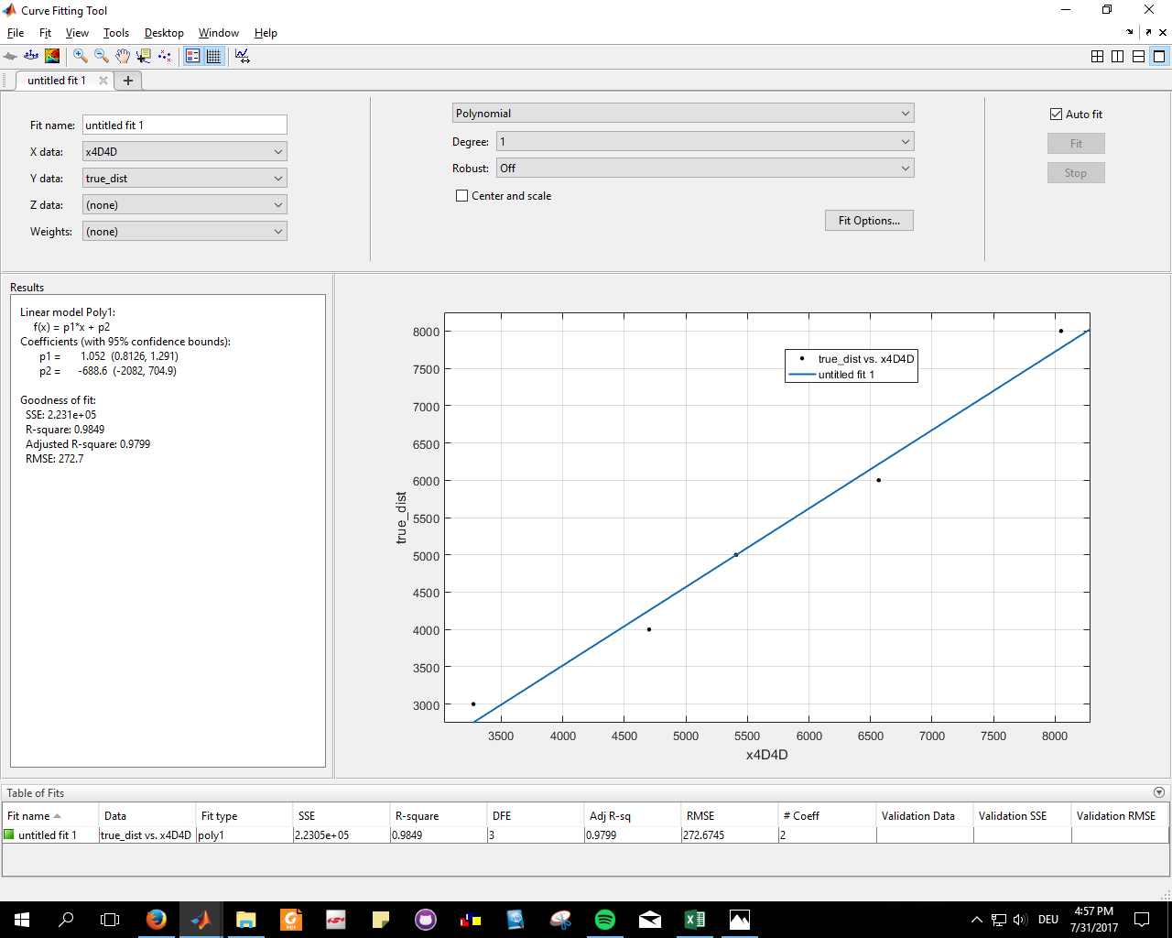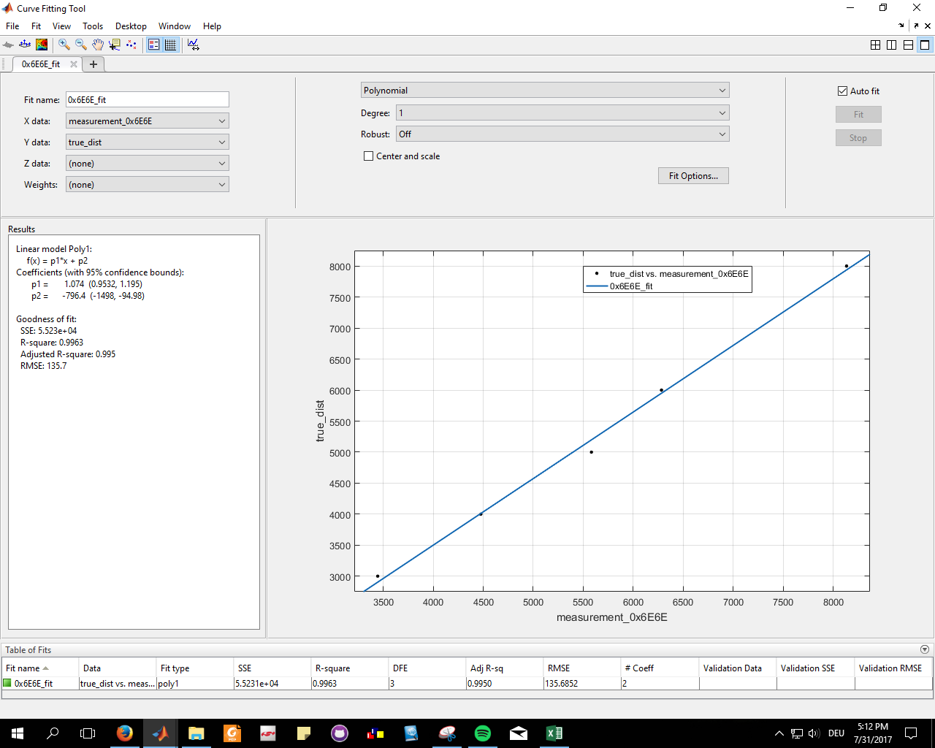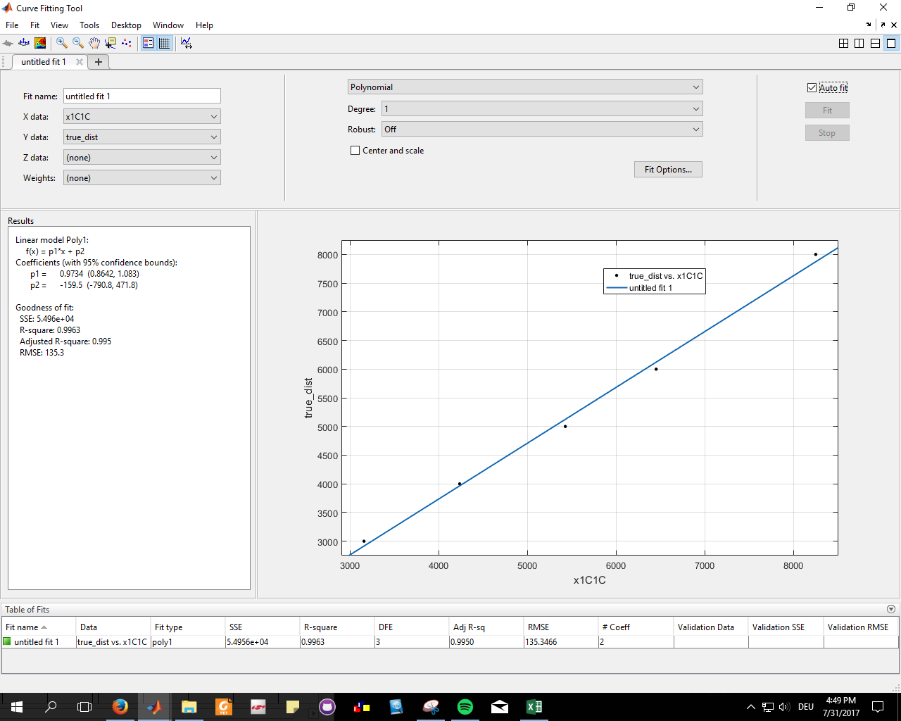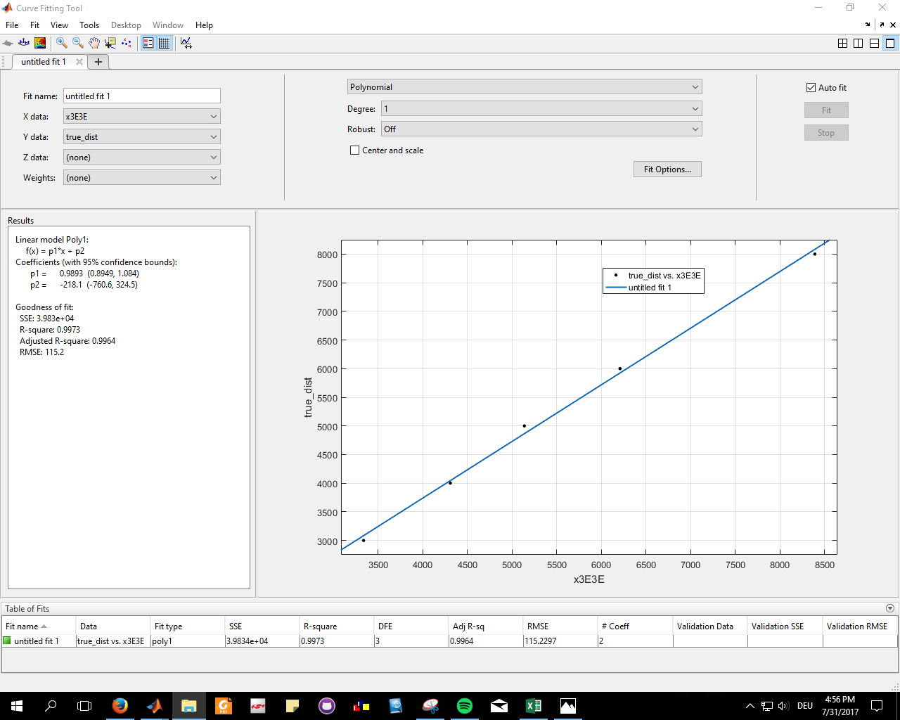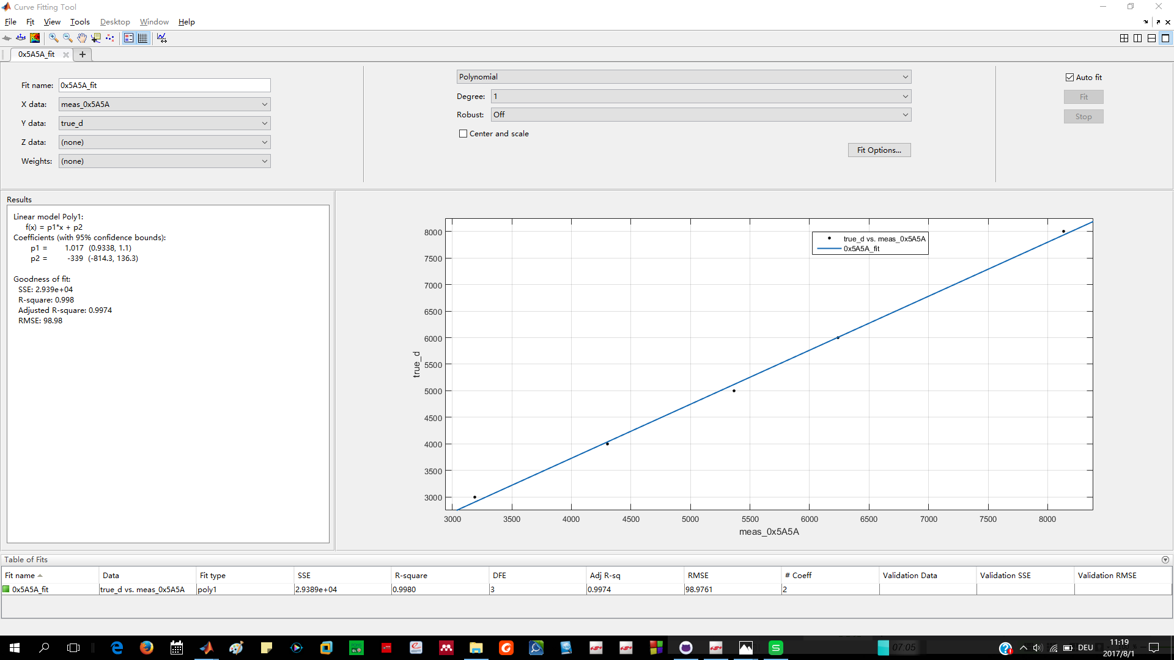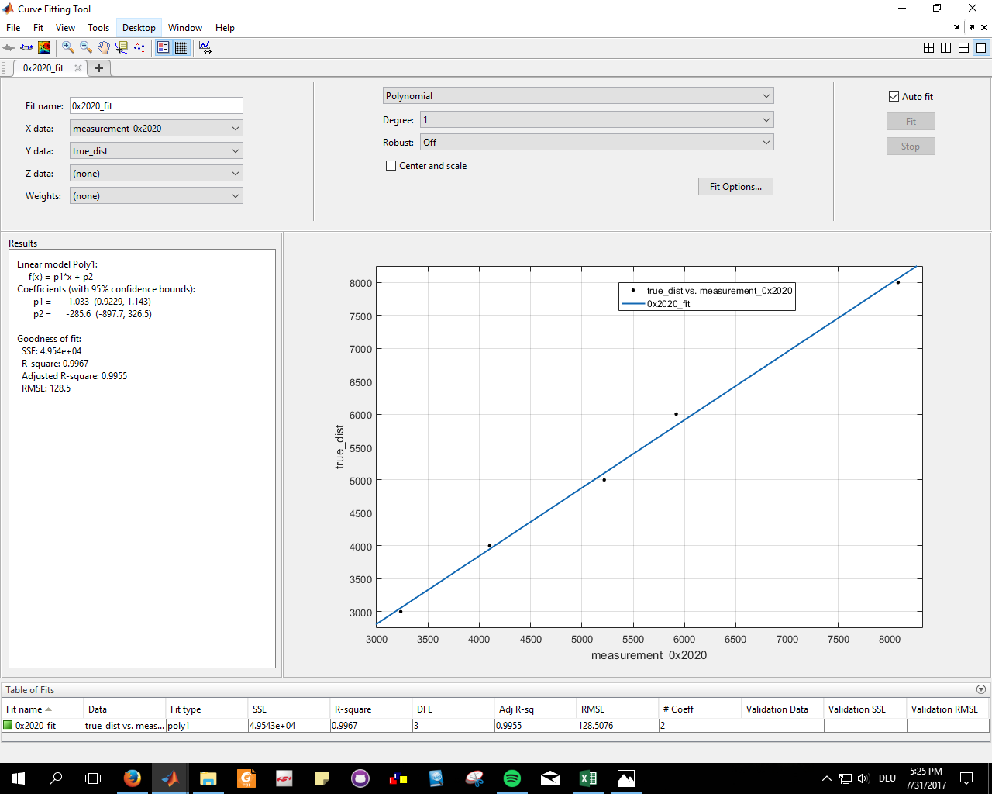

‘thesis_indoorLocalization\communicate_with_basis_station_in_matlab\calibrations\outdoor\OUTDOOR_MEASUREMENT_07_27_2017\fitting_0x1C1C.PNG’

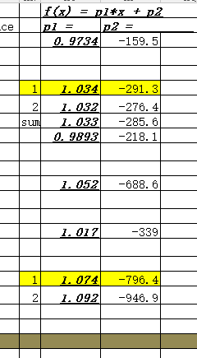

**(mad, trimmean)**

‘thesis_indoorLocalization\communicate_with_basis_station_in_matlab\calibrations\outdoor\OUTDOOR_MEASUREMENT_07_27_2017\outdoor_calibration_results.xlsx’

4.1.2 Data Collections

5 Experiments Base on Simulations data

5.1 generating moving trajectories

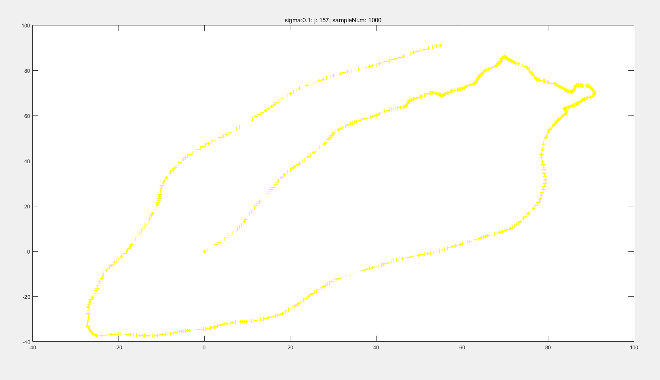(unit cm)

(‘\thesis_indoorLocalization\trajectory\goodTraj01’)

Algo::Code:(\thesis_indoorLocalization\trajectory\TrajectoryGenerator_plot_onlyONE_qualified_with_changing_Sigma.m)

5.2 choosing Positions of Anchor-Nodes

>2m

Cover the traj in the acceptable range, which the signal still can be reached to most of the nodes

5.3 EKF without noisy distance data

5.3.1 choosing the right parameter for EKF

Q/R big trusts more on measurements, vercise wise...the motion model is randon, not so well simlated , so try to make the Q big.

Q/R big or small results

5.3.2 different strategies of processing incoming data

5.3.2.1 evenly distributed sampling in time domain

5.3.2.2 uneven distributed sampling in time domain

5.3.3 Results

**root-mean-square error (RMSE)** is a frequently used measure of the differences between values (sample and population values) predicted by a model or an estimator and the values actually observed.(wikipedia)

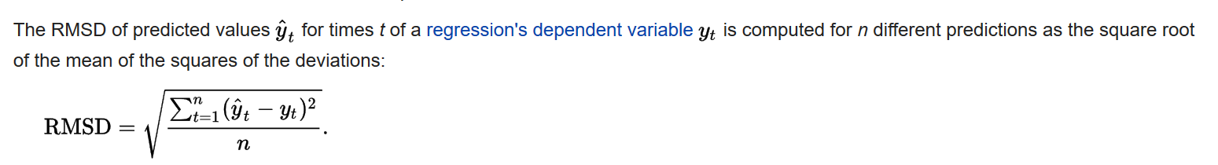(wiki)

**RMSE v.s. ratio of Q/R**

(C:\Users\Yitong\Documents\GitHub\thesis_indoorLocalization\KalmanFilter\KF_traj\results\same R to generate noise\data not missing) (results are not calculated by RMSE, but )

*When data is not enough , this set can be use’differ R to generate noise’*

(C:\Users\Yitong\Documents\GitHub\thesis_indoorLocalization\KalmanFilter\KF_traj\results\differ R to generate noise\fig_goodTraj01)

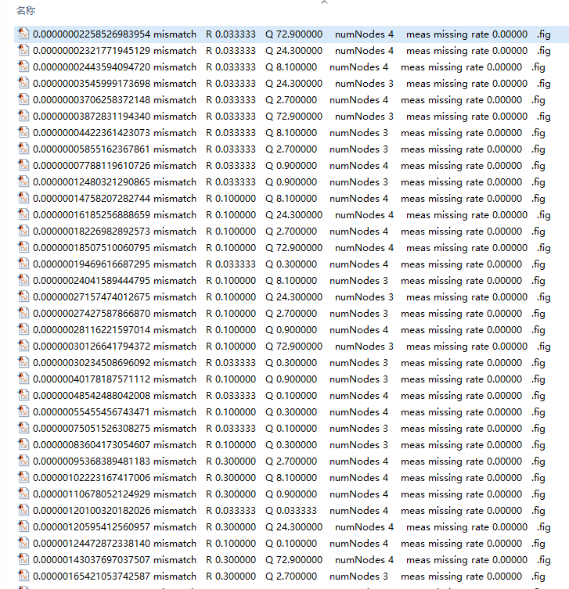

5.4 EKF with noisy distance data

5.4.1 noisy data generatation(add noise / delete data)

(add noise according to the R from mad)

delete data (randon delete; in a specific order to reproduce the cinario of 25ms40Hz case)

5.4.1 choosing the right parameter for EKF (XXX)

5.4.2 Results

**RMSE v.s. ratio of Q/R**

**RMSE v.s. number of missing meas**

**RMSE (noisy free vs noisy)**

5.5 Self-Calibrations for Anchor-Nodes

5.5.1 performance effected factors

5.5.1.1 number of trajectory points and Anchor-Nodes

5.5.1.2 distributions of the Anchor-Nodes and the trajectory

6 Experiments based on measurement data

6.1 EKF with Measurement data

6.1.1 choosing the right parameter for EKF

6.1.2 Results

6.2 Self-Calibrations for Anchor-Nodes

6.2.1 Results

6.3 25ms40Hz

6.3.1 data mitigation