**Data Repository**

This Data Perspective examines the progression of educational performance in children aged 3 to 5 years, focusing on how these abilities evolve month by month. The analysis covers both general education and specific subjects, including literacy, math, and physical education, aiming to provide insights into critical developmental milestones during these formative years.

1. **Key Findings:**

**Developmental Index:** An index was created by calculating the arithmetic average of 10 child development items across four key domains:

**Literacy & Math:** EC6, EC7, EC8

**Physical Development:** EC9, EC10

**Learning Abilities:** EC11, EC12

**Socio-emotional Development:** EC13, EC14, EC15

The Cronbach’s Alpha for this index was found to be 0.4465, indicating moderate internal consistency. This suggests that while the index captures relevant developmental aspects, there may be room for refinement to improve its reliability.

|  |  |  |
| --- | --- | --- |
|  | 3 year old | 4 year old |
| ec6 | 0.06 | 0.14 |
| ec7 | 0.08 | 0.13 |
| ec8 | 0.11 | 0.25 |
| ec9 | 0.91 | 0.93 |
| ec10 | 0.40 | 0.38 |
| ec11 | 0.84 | 0.89 |
| ec12 | 0.71 | 0.77 |
| ec13 | 0.96 | 0.96 |
| ec14 | 0.51 | 0.47 |
| ec15 | 0.38 | 0.37 |

**Table 1 Average of Key Development Indicators**

1. **Evolution of Performance with Age:** The graph above shows the conditional mean of the index plotted against the child’s age in months. It demonstrates a generally upward trend in educational performance as children age, with some fluctuations. Notably, there are significant jumps around the ages of 44 to 48 months and from 53 to 56 months, indicating rapid developmental changes during this period.

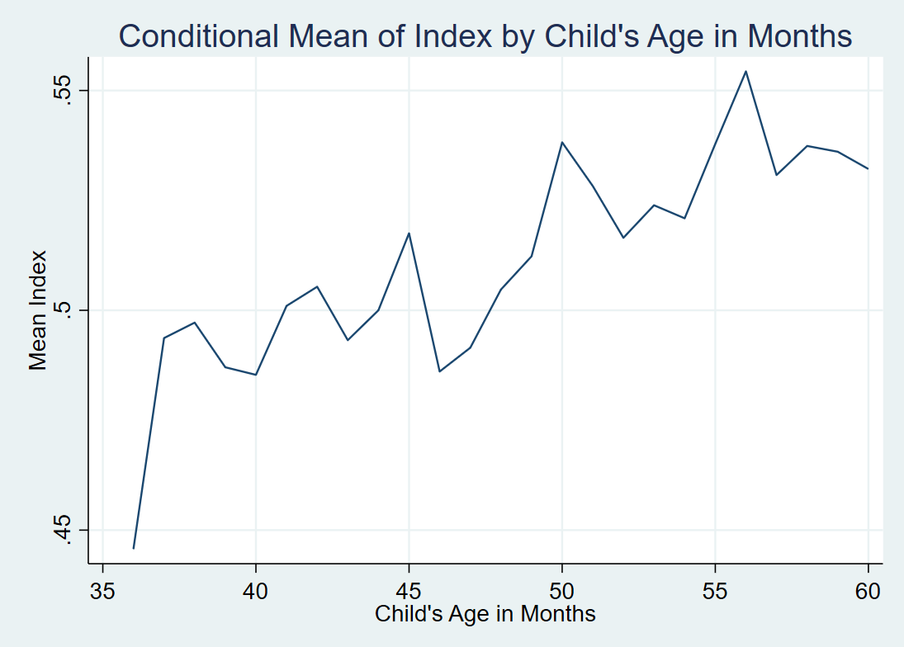

1. **Regression Analysis:** The regression results, summarized in the table, show a positive and statistically significant relationship between age (measured in months) and the development index calculated using methods mentioned above. Specifically, each additional month corresponds to an increase of 0.00258 in the index (p < 0.05). The model explains about 1.7% of the variance in the index (R-squared = 0.017), suggesting that while age is a contributing factor, other variables may also play significant roles.

**Table 2 Regression results between age in month and development index**

|  |  |  |  |  |  |
| --- | --- | --- | --- | --- | --- |
| **Variable** | **Coefficient** | **Standard Error** | **Observations** | **R-squared** | **Adjusted R-squared** |
| month_gap | 0.00258 | -0.0004 |  |  |  |
| Constant | 0.388 | -0.0194 |  |  |  |
|  |  |  | 2491 | 0.017 | 0.016 |
| *Standard errors in parentheses * p<0.05, ** p<0.01, *** p<0.001 | | | | | |