<https://codecanyon.net/item/asilify-auto-garage-management-software/34368442>

**Vehicle Repair and Maintenance Management System Free Template Source code**

**Login Form**

**Dashboard**

* Number of customers
* Number of tasks
* Number of team members
* Income of the day

**Customer Information - crud**

* Full name
* Complete Address
* Email Address
* Contact Number
* Avatar
* Username
* Password
* Account Status

**Task Information - crud**

* Transaction Code
* Task name
* Description
* Vehicle Type
* Customer name
* Amount
* Task Status – pending, completed, paid
* Completion Date
* Create Invoice button
* View Task details button

**Task Details - crud**

* Transaction Code
* Parts
* Quantity
* Amount
* Total Amount
* Remarks

**Invoice Information - crud**

* Invoice Number
* Customer Name
* Transaction code
* Total Parts
* Total Amount
* Invoice Date
* Action Buttons

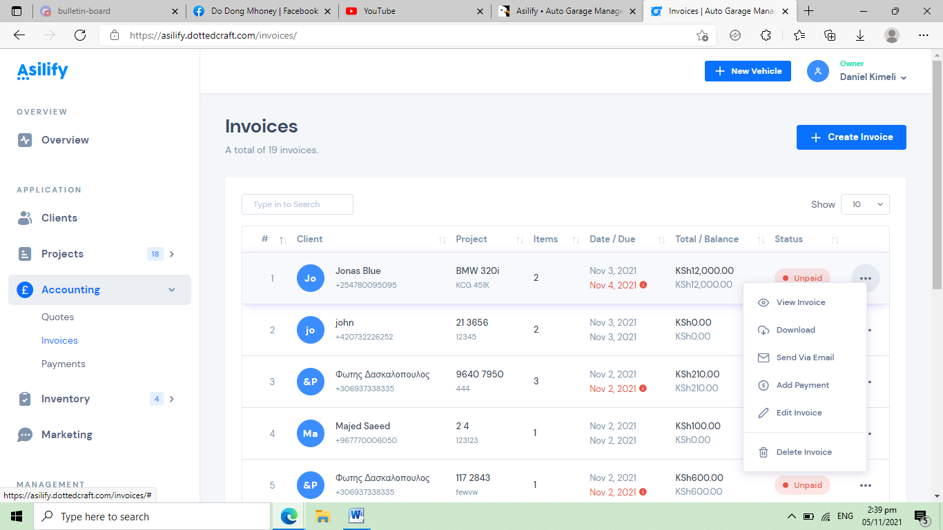

**Team Members - crud**

* Full name
* Designation
* Complete Address
* Email Address
* Username
* Password
* Account Status

**Payment Records - crud**

* Invoice Number
* Payment Date
* Amount
* Balance
* Status – paid, partially paid

**Company Settings – update settings**

* Company name
* Address
* TIN Number
* Contact Number
* Logo

**SMS and Email Settings – update settings**

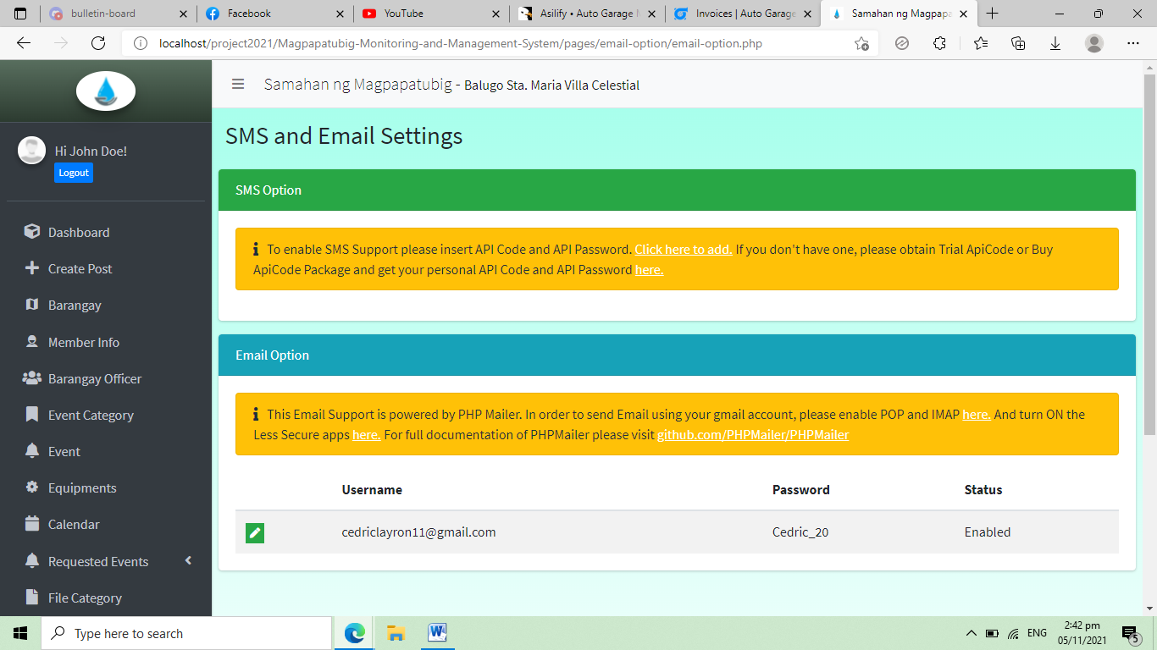

**Income** **Report – print and export button**

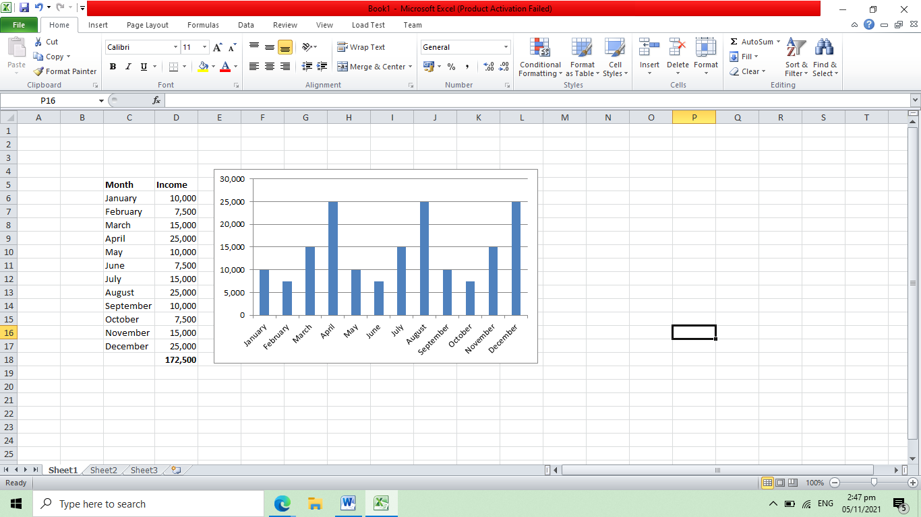

**Customer Account**

**Customer Dashboard**

* Number of invoice
* Total Payment
* Balance
* Number of transactions

**New Task**

* Task name
* Description
* Vehicle Type

**Task List Information**

* Transaction Code
* Task name
* Description
* Vehicle Type
* Amount
* Task Status – pending, completed, paid
* Completion Date
* View Task details button

**Task Details**

* Transaction Code
* Parts
* Quantity
* Amount
* Total Amount
* Remarks

**My Invoice**

* Invoice Number
* Transaction code
* Total Parts
* Total Amount

**My Payment**

* Invoice Number
* Payment Date
* Amount
* Balance

**My Profile**

* Full name
* Complete Address
* Email Address
* Contact Number
* Avatar
* Username
* Password