**Original Graphs:**

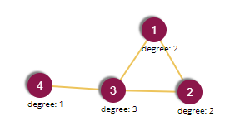 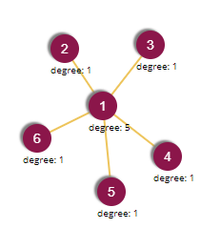 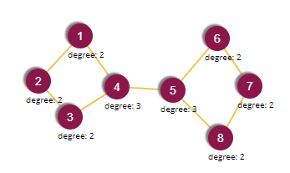

TriangleWithLeg StarWithFiveSpokes TwoConnectedSquares

**After AttachNewVerticesToTestGraphs():**

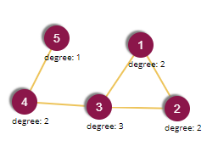 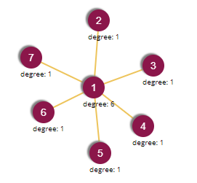 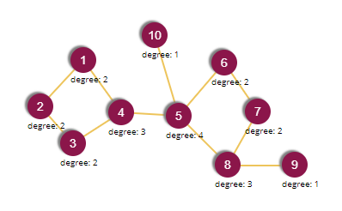

TriangleWithLeg StarWithFiveSpokes TwoConnectedSquares

**After RemoveExistingVerticesInTestGraphs():**

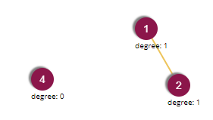 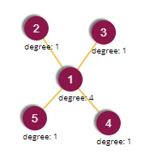 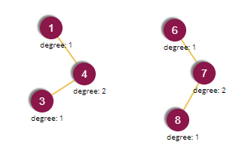

TriangleWithLeg StarWithFiveSpokes TwoConnectedSquares

**After AddAndRemoveVerticesInTestGraphs():**

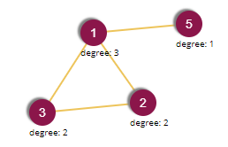 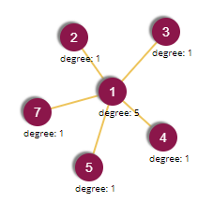 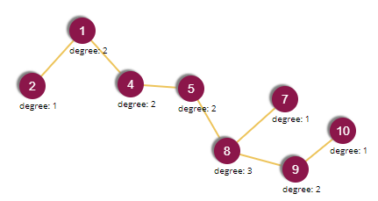

TriangleWithLeg StarWithFiveSpokes TwoConnectedSquares

**After AddEdgesBetweenExistingVerticesInTestGraphs():**

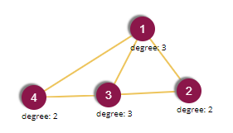 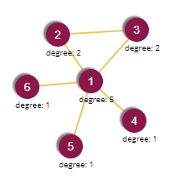 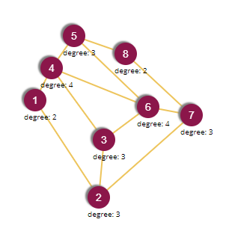

**After RemoveEdgesBetweenExistingVerticesInTestGraphs():**

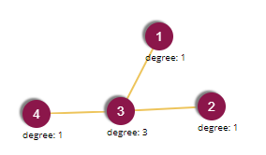 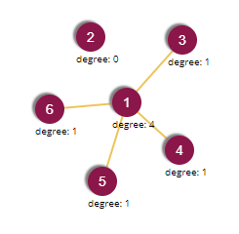 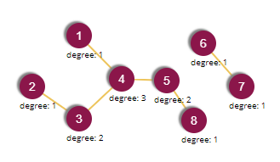

TriangleWithLeg StarWithFiveSpokes TwoConnectedSquares

**After AddAndRemoveEdgesBetweenExistingVerticesInTestGraphs ():**

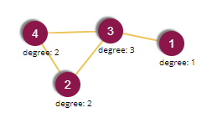 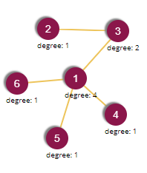 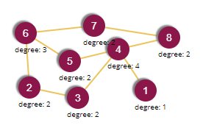

TriangleWithLeg StarWithFiveSpokes TwoConnectedSquares