Zein-Caseinate NP Colloidal Stability
DLVO Analysis of the 08/12/2026 DLS Dataset
Preliminary -- single replicate per condition (n=1); no error bars available

Summary
Zein-caseinate nanoparticles were characterized by DLS/ELS across a pH 3-7 x ionic strength 25-100 mM grid (12 conditions, one replicate each) and modeled with classical DLVO theory (electrostatic double-layer repulsion + van der Waals attraction) to predict colloidal stability. Under this dataset, every measured grid condition and all three food-relevant target conditions (whole milk, yogurt, bread-release) fall well below the 10 kT marginal-stability threshold -- the model predicts no meaningful energy barrier anywhere in the tested space, i.e. fast aggregation is expected across the board. The main driver is that measured zeta potentials are modest in magnitude (|zeta| <= ~14 mV) compared to the ~30+ mV typically associated with well-stabilized protein colloids; because the electrostatic repulsion term scales with zeta-squared, even this relatively small reduction removes most of the stabilizing barrier.

Key result: stability across all tested and target conditions
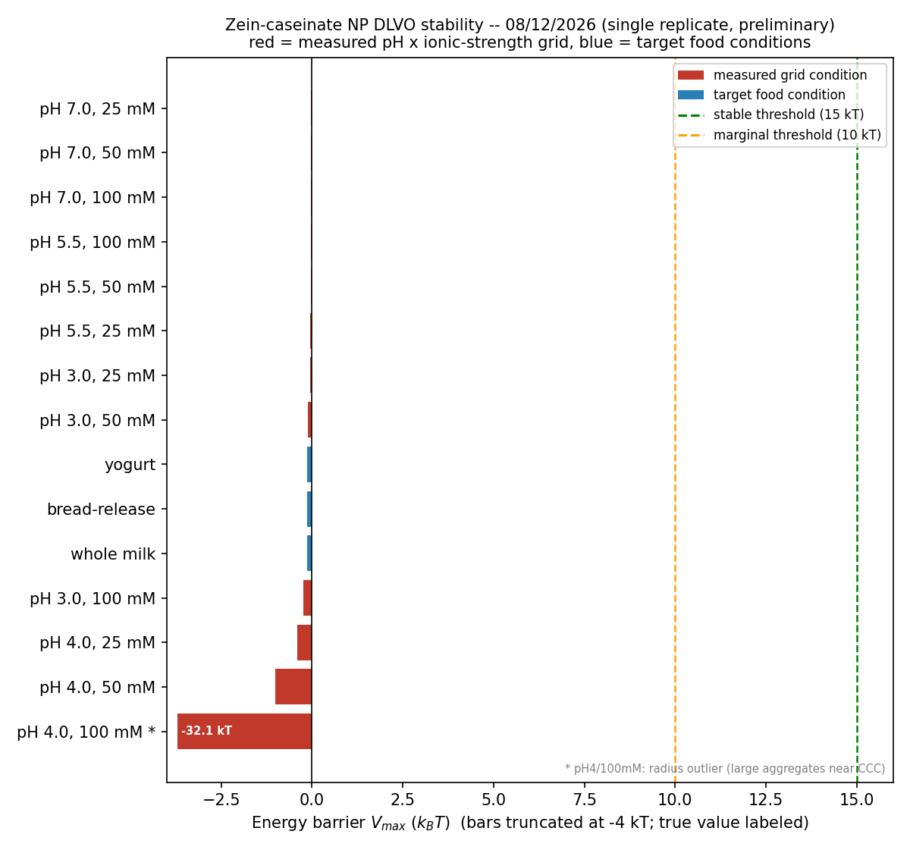
Figure 1. DLVO energy barrier (V_max) for every measured (pH, ionic strength) condition (red) and the three food-relevant target conditions (blue), sorted low to high. Green/orange dashed lines mark the stable (15 kT) and marginal (10 kT) thresholds used throughout this analysis. The pH 4 / 100 mM bar is truncated at -4 kT (true value -32.1 kT) to keep the rest of the chart readable -- see note below.
No bar reaches even the marginal threshold, let alone the stable one. This is the single plot that answers the practical question directly: as currently formulated (no dialysis / ion removal, single replicate), zein-caseinate NPs are not predicted to be colloidally stable in any of the three tested food-relevant environments, nor across the pH/ionic-strength ranges tested in the lab grid.

Measured grid results
pH | I (mM) | zeta (mV) | radius (nm) | V_max (kT) | Call
3.0 | 25 | 8.80 | 83 | -0.05 | unstable
3.0 | 50 | 12.35 | 116 | -0.10 | unstable
3.0 | 100 | 13.35 | 175 | -0.23 | unstable
4.0 | 25 | 4.69 | 246 | -0.41 | unstable
4.0 | 50 | 6.56 | 441 | -1.00 | unstable
4.0 | 100 | 9.05 | 8404* | -32.10 | unstable
5.5 | 25 | -14.16 | 77 | -0.04 | unstable
5.5 | 50 | -12.71 | 73 | -0.04 | unstable
5.5 | 100 | -11.40 | 68 | -0.03 | unstable
7.0 | 25 | -11.08 | 60 | -0.02 | unstable
7.0 | 50 | -10.83 | 65 | -0.03 | unstable
7.0 | 100 | -12.47 | 65 | -0.03 | unstable
* pH 4 / 100 mM: DLS z-average radius (8404 nm) is far outside the range of every other condition (60-480 nm) and is most likely a real signature of large aggregates forming near the critical coagulation concentration (CCC) for pH 4, not an instrument artifact (zeta was still measurable at 9.05 mV). Excluded from the representative radius used in the continuous sweep; retained here with its own (real) barrier calculation.

Food-relevant target condition predictions
Using the fitted zeta(pH, I) interpolation model, DLVO was evaluated at three food-relevant conditions from the broader project (whole milk, yogurt, bread-release):
Food condition | pH | I (mM) | zeta predicted (mV) | V_max (kT) | Call
Whole milk | 6.6 | 80 | -11.87 | -0.14 | Unstable
Yogurt | 4.5 | 20 | -12.61 | -0.14 | Unstable
Bread-release | 5.3 | 50 | -11.83 | -0.14 | Unstable

All three fall in the same range as the general grid (V_max approx -0.14 kT) -- effectively no barrier. None of the three food environments is predicted to be a stable environment for these NPs under this formulation.

Supporting figures

Energy profiles, all measured conditions
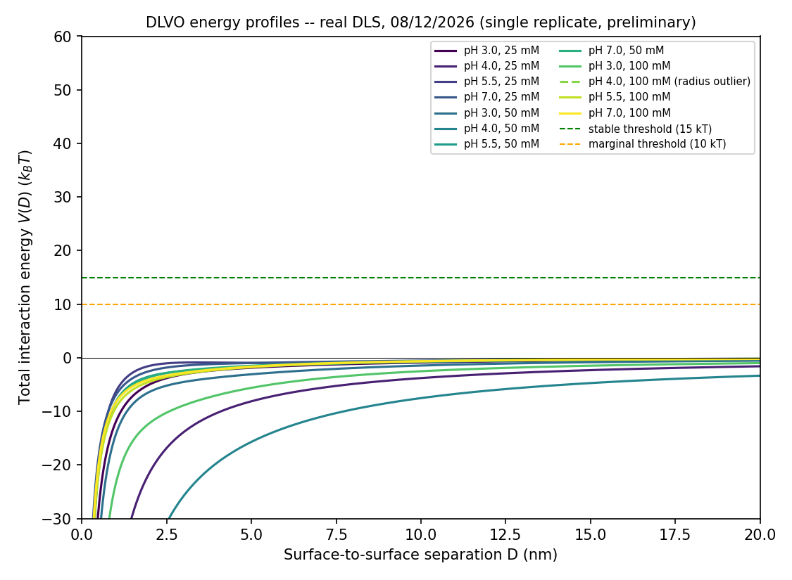
Figure 2. V(D) interaction energy curves for every measured condition. None crosses the marginal (orange) or stable (green) threshold lines.

Continuous pH x ionic-strength stability map
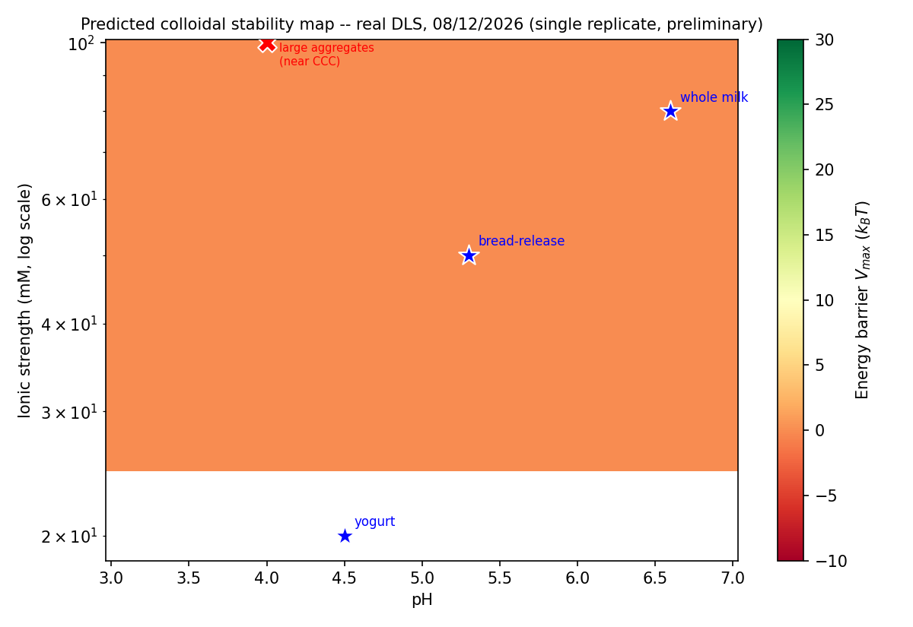
Figure 3. Interpolated stability map across the measured pH/ionic-strength envelope. The map is uniformly in the unstable (red/orange) range with no contour reaching the 10 kT marginal line -- included for completeness, but Figure 1 is the more direct/decision-relevant view of this same result.

Notable findings beyond stability
- Isoelectric point located: with the addition of pH 3 data, the fitted sigmoid places the true isoelectric point at pH ~4.06 -- markedly lower than the ~5.8 reported in the literature for bare zein, consistent with the caseinate coating changing the particle's intrinsic surface chemistry rather than simply screening bare-zein charge.
- CCC signature at pH 4: particle size grew sharply with ionic strength at pH 4 specifically (246 -> 441 -> 8404 nm across 25/50/100 mM), pointing to a critical coagulation concentration somewhere in the 50-100 mM window at this pH -- a useful target for a finer follow-up ionic-strength scan.
- Zeta magnitudes are lower than typically reported for well-stabilized protein colloids; whether this reflects residual, non-dialyzed sodium (from sodium caseinate) screening the double layer, or an intrinsic property of the zein-caseinate surface, is unresolved with the current data (see Recommendations).

Limitations
- Single replicate (n=1) for every condition -- none of the numbers above have error bars, and single noisy points cannot yet be distinguished from real trends.
- The pH 4 / 100 mM radius (8404 nm) is a single DLS z-average reading of what is likely a broad/bimodal aggregate population; treat as qualitative evidence of aggregation rather than a precise size.
- Hamaker constant (1.0e-20 J) is taken from literature (bare zein, Su et al. 2024), not fit to this system; results are the single largest source of unquantified uncertainty in the absolute kT values (though the qualitative "no barrier anywhere" conclusion is robust to this choice, since the required increase in zeta to reach 10-15 kT is large).

Recommendations
- Prioritize replicates (n>=3) at pH 4, 25/50/100 mM first -- this is where both the isoelectric point and the CCC estimate live, and where the single-point data is most decision-critical.
- Run a quick conductivity check on the current (non-dialyzed) NP suspension against a DI water blank; if conductivity is well above the DI water baseline, that supports the residual-sodium hypothesis and motivates a dialysis trial before committing to a full repeat of the DLVO grid.
- If conductivity confirms excess background ions, run one dialyzed vs. non-dialyzed zeta comparison at a single representative condition before repeating the full matrix -- this isolates whether higher zeta (and therefore a real stability barrier) is achievable with the current zein:caseinate formulation, or whether the formulation itself needs to change.

