Application and Prospect of Sensors with Real-time Monitoring Function in Agricultural Intelligent Irrigation Systems
HUANG Zhaowei¹
(1.College of Mechanical and Electronic Engineering, Northwest Agriculture and Forestry University, Yang Ling, Shaanxi, China 712000)
Abstract：Irrigation is an extremely important operation link in agricultural production. With the continuous development of agricultural intelligence, the agricultural intelligent irrigation system has introduced multiple sensors to improve monitoring performance in response to problems such as low monitoring accuracy, high monitoring difficulty, and inability to conduct real-time monitoring. The advent of sensors has provided us with more accurate and convenient monitoring methods, and also offered important technical support for the development of precision agriculture. This article mainly introduces the application of several sensors in the intelligent irrigation system and the practical effect of multi-sensor information fusion. Firstly, a brief introduction to the working principles of various sensors mentioned in the text is provided. Secondly, the relevant application scenarios and functions of the corresponding sensors are discussed. Finally, summarize the current application status of sensors and further analyze the future development direction and prospects of the sensor industry.
Keywords：Sensor technology; Intelligent irrigation system; Real-time monitoring; Precision agriculture

0 Introduction
Agriculture, as the cornerstone of global food security, is confronted with multiple challenges for its sustainable development, including water shortages, climate change and rising labor costs. ^{[1]} Irrigation, as a core link in agricultural production, has long relied on empirical management models, resulting in frequent problems such as low water resource utilization rate, soil degradation and non-point source pollution ^{[2]}. With the deepening of the concept of precision agriculture and the innovation of Internet of Things technology, the intelligent irrigation system based on sensors has become the key path to solve the above-mentioned problems.
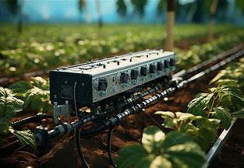
Figure1. Intelligent irrigation system
Soil, as the foundation for crop growth, its physical and chemical properties directly determine the balance of water supply and demand. In traditional irrigation, the mode of irrigation according to the schedule ignores the spatial heterogeneity of soil texture, moisture content and nutrients. For instance, the water-holding capacity of clay and sandy loam varies significantly. A single irrigation strategy is prone to cause waterlogging and root rot in the former and drought and reduced yield in the latter. ^{[3]} Soil parameter monitoring sensors construct models of soil moisture movement and solute migration by precisely measuring indicators such as soil moisture, temperature, electrical conductivity and pH value. Soil temperature sensors monitor temperature changes in the root system layer to predict the water absorption capacity of crop roots and the intensity of soil evaporation, thereby avoiding the physiological stress on crops caused by low-temperature irrigation.
The physiological state of crops is a direct manifestation of water demand. The traditional method relying on manual observation is difficult to capture subtle stress signals. The crop physiological state monitoring sensor can sense indicators such as leaf water deficiency, spectral characteristic changes and micro-scale deformation of stems in real time through non-contact or contact means. ^{[4]} The existing sensors have achieved precise identification of the turning point of crop water balance through micron-level deformation monitoring, which can trigger irrigation instructions in advance compared with the traditional soil moisture threshold method.
This article mainly discusses the soil parameter monitoring sensors and crop physiological state monitoring sensors, which play important roles in the intelligent irrigation system.

1 Sensors used for monitoring parameters of soil
This chapter mainly describes three types of soil parameter sensors commonly used in intelligent irrigation systems, namely soil temperature sensors, soil moisture sensors, and soil pH monitoring sensors.

Soil temperature sensor
Soil temperature indirectly regulates the water absorption and growth process of crops by influencing the root respiration rate, enzyme activity and microbial metabolism. During the process of wheat cultivation, the water absorption efficiency of the root system is the highest at 15-20℃. When the temperature is below 10℃, it significantly inhibits the development of the root system. ^{[5]} Therefore, monitoring soil temperature is of great significance for agricultural production and also helps to make irrigation decisions based on real-time temperature. Soil temperature sensors achieve real-time monitoring of root layer temperature by sensing the heat conduction characteristics of the soil.
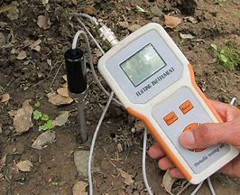
Figure2. Soil temperature sensor diagram
1.1.1 Principle of temperature sensing
The most common forms of temperature sensors are thermistor sensors, thermocouple sensors and optical fiber temperature sensors. Thermistor sensors take advantage of the characteristic that the resistance value of semiconductor materials changes with temperature. They convert it into a voltage signal through a Wheatstone bridge circuit and process the real-time monitored signal to perceive temperature changes. ^{[6]} Thermocouple sensors are based on the Seebeck effect. When a temperature difference is formed at the two ends of two different metal conductors, a thermoelectric potential is generated. By measuring the potential difference and converting it into temperature, they are suitable for long-term buried monitoring. ^{[7]} The optical fiber temperature sensor is based on the backscattering principle of optical fibers. It calculates the temperature through the frequency offset of the optical signal and has the advantages of anti-electromagnetic interference and long-distance transmission. It is suitable for distributed monitoring in large fields.
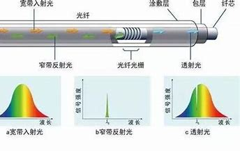
Figure3. Schematic diagram of optical fiber temperature sensor
1.1.2 Scenarios of production application
In terms of field crop management, during the apple-growing process in Xinjiang region, the low temperature in spring often leads to poor and uneven fruit quality. The temperature monitoring system based on thermistor sensors can trigger temperature compensation instructions when the temperature in the orchard remains below the threshold for too long. ^{[8]}
In terms of temperature control in greenhouse seedling raising, in tomato tray seedling raising, the temperature is monitored in real time by thermocouple sensors buried in the substrate layer, and the flow of geothermal pipelines is regulated by a PID controller, which can effectively control the temperature fluctuations in the root zone. ^{[9]}

Soil moisture sensor
Soil moisture is the most direct control variable of the intelligent irrigation system. According to data from the Food and Agriculture Organization of the United Nations, approximately 60% of global irrigation water is wasted due to the lack of precise monitoring. ^{[10]} Soil moisture sensors provide a scientific basis for setting irrigation thresholds by quantifying soil moisture content.
1.2.1 Principle of Humidity Monitoring
Commonly used humidity sensors include resistive type, capacitive type, time-domain reflection type and frequency-domain reflection type. Resistive humidity sensors reflect humidity changes by utilizing the correlation between the resistance value of materials such as gypsum blocks or ceramics and the moisture content. Capacitive sensors measure the moisture content through the change of dielectric constant between electrodes. The time-domain reflectometry sensor calculates the dielectric constant and moisture content by measuring the propagation time of electromagnetic pulses in the soil. The frequency-domain reflective sensor calculates the dielectric constant based on the phase shift of high-frequency signals in the soil to infer the moisture content. ^{[11]}
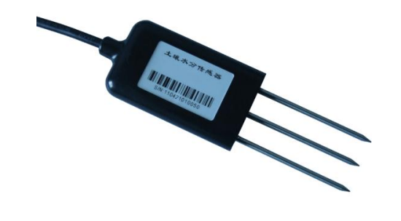
Figure4. Soil moisture sensor
1.2.2 Development direction in future
Due to the complexity of soil composition, the moisture content also varies in different parts of a field. Even at the same moisture content, there are significant differences in the dielectric constants between clay and sandy soil, and a calibration algorithm based on the composition of soil particles needs to be developed.
The electrical components of the most common resistive sensors are highly susceptible to corrosion by soil microorganisms, leading to measurement drift and affecting the accuracy of real-time monitoring and the stability of long-term use. In addition, frequent replacements significantly increase the cost of the intelligent irrigation system. It is necessary to optimize the surface material of the sensors or add anti-corrosion layers to reduce maintenance and replacement costs.

Soil pH monitoring sensor
1.3.1 The principle of pH measurement
The traditional pH sensor uses the glass electrode method to measure the pH value based on the membrane potential generated by the concentration difference of H + on both sides of the glass membrane, which has a relatively high accuracy ^{[12]}. The drawback is that it requires regular calibration and is not suitable for large-scale use.
In response to the shortcomings of traditional sensors, the solid-state ion-selective electrode (ISE) emerged ^{[13]}. It adopts all-solid-state membrane technology such as polymer membranes, significantly enhancing its shock resistance and anti-pollution capabilities. With a short response time, it can be buried in the field for long-term monitoring.
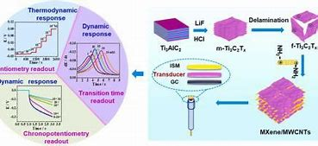
Figure5. The principle of solid-state ion-selective electrodes
In addition, in recent years, spectral pH inversion has provided a new idea for determination. Through the correlation modeling of near-infrared spectroscopy and soil pH, non-contact monitoring can be achieved. ^{[14]}
1.3.2 Real application scenarios
In southern tea gardens, when the soil pH is less than 4.5, lime water is injected through the drip irrigation system. By integrating the feedback from the pH sensor based on spectral analysis to form a closed-loop control, the pH of the root layer can be increased to 5.5-6.0, thereby enhancing the content of tea polyphenols in the tea. ^{[15]}
In greenhouse applications, pH sensors are often used in conjunction with conductivity (EC) sensors, which have a significant regulatory effect on the coupling of water and fertilizer. In greenhouse tomato cultivation, EC sensors are used to monitor root layer salt content in real time. The intelligent irrigation system can automatically switch between clear water irrigation and salt water irrigation based on the feedback salt index, and can dynamically adjust the salt content while monitoring in real time.
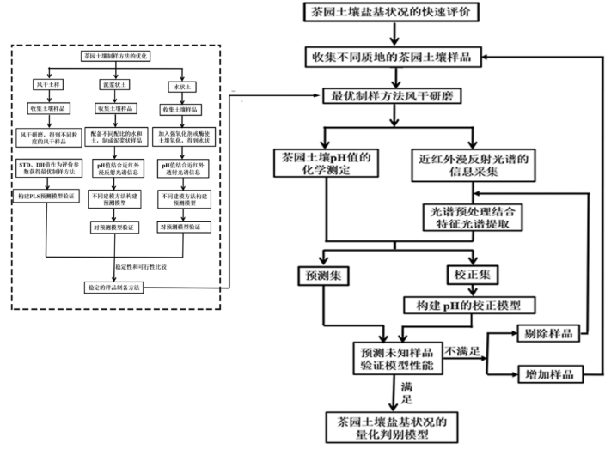
Figure6. Real-time pH monitoring system for tea gardens
1.3.3 Approaches of Technological innovation
Like other soil parameter monitoring sensors, pH sensors also have the issue of stability in use. Organic matter and metal ions in the soil are prone to adsorb on the electrode surface, affecting measurement feedback. Therefore, it is necessary to develop self-cleaning technologies such as ultrasonic cleaning modules and adaptive calibration algorithms based on online calibration using differential pulse voltammetry as an example.
In order to improve the integration degree of the intelligent irrigation system and reduce the control difficulty, highly integrated real-time monitoring sensors can be developed. Currently, there are composite parameter detectors integrating pH, EC and temperature. The Horiba LAQUA twin series pH meters on the market can monitor multiple parameters simultaneously. In the future, structural improvements can be made to reduce the volume of the detector. Make it possible to be buried and used in the soil.
To enhance the intelligence of the intelligent irrigation system, by storing sensor data on the chain, the authority of soil parameters is ensured, laying a credibility foundation for scenarios such as pollution source tracing in agricultural production.

Sensor used for monitoring crop physiological state
The physiological state of crops is a direct manifestation of the water demand in farmland. Traditional irrigation relies on the single-dimensional monitoring of soil moisture, making it difficult to capture the water stress signals of crops themselves in real time. The crop physiological state monitoring sensor builds a three-dimensional monitoring system from the micro-scale of leaves to the macroscopic scale of the canopy through a combination of non-contact perception and contact measurement, providing decision-making basis driven by crop demands for intelligent irrigation. ^{[16]} This chapter focuses on the discussion of non-contact crop water stress detection technology and leaf surface humidity-disease early warning sensors.

Non-contact monitoring of crop water stress
Non-contact technology remotely inverts the physiological state of crops through physical signals such as optics and thermology, avoiding the interference of contact measurement on crops. It is suitable for various scenarios such as fields and greenhouses. At present, there are detection methods for perception from multiple dimensions. This section takes common spectral analysis and thermal imaging analysis as examples, and looks forward to more advanced technological updates and iterations in the future.
2.1.1 Multispectral and hyperspectral remote sensing
The spectral reflectance of crop leaves is closely related to water content and chlorophyll concentration. Water stress can lead to a decrease in the swelling pressure of leaf cells and changes in the mesophyll structure, thereby increasing the reflectivity in the near-infrared band. Based on the above principles, calculating two vegetation indices, namely the normalized moisture index and the photochemical reflection index, can quantify the degree of stress.
The application of spectral analysis in agricultural production is mainly reflected in unmanned aerial vehicle (UAV) hyperspectral monitoring and satellite remote sensing. Unmanned aerial vehicle (UAV) monitoring can obtain canopy spectral data weekly by carrying the Micasense Rededg-P camera and trigger irrigation instructions through the NDWI threshold. ^{[17]} Calculating the crop water stress index through the multispectral imager (MSI) sensor and adjusting the intelligent irrigation system in real time is a common method of satellite remote sensing.
2.1.2 Thermal infrared imaging sensor
From the principle analysis, when there is sufficient water, crops reduce the leaf surface temperature to below the air temperature through transpiration. Under stress, transpiration weakens and the leaf surface temperature rises. The thermal infrared sensor assesses the moisture condition by measuring the difference between the canopy temperature (Tc) and the air temperature (Ta), in combination with the stomatal conductance model.
$$ΔT=T_{c}-Ta （1）$$
Thermal infrared sensors play a significant role in greenhouses. By periodically scanning the canopy with thermal imagers, when the ΔT calculated by Formula (1) exceeds the threshold and remains so for a certain period of time, the intelligent irrigation system triggers the drip irrigation system to replenish water. ^{[18]}
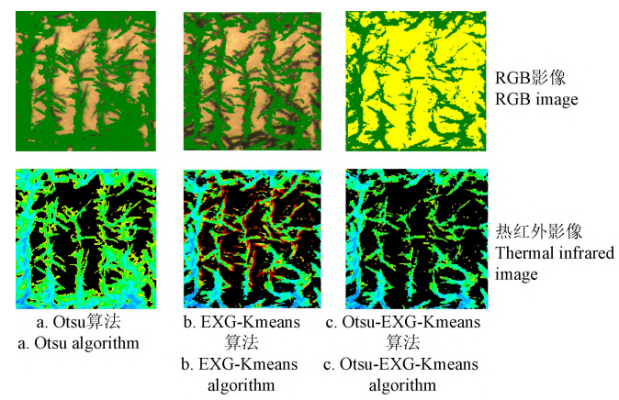
Figure7. Thermal infrared imaging scan of the canopy
In addition, thermal infrared imaging can also play a role in weather warning. The monitoring system based on ground thermal imagers can issue early warnings a few days before soil moisture drops too low, shifting the lead time of irrigation decisions from passive response to active prevention.
2.1.3 Stem micro-change monitoring sensor
The diurnal variation of the stem diameter can reflect the balance of water supply and demand, which is manifested in the contraction of the stem when transpiration is vigorous during the day and its recovery at night. Therefore, by using high-precision sensors to monitor the variation amplitude and phase changes, the degree of moisture stress can be determined. ^{[19]}
In practical applications, to ensure sensing accuracy and economy, differential transformer sensors and fiber Bragg grating (FBG) sensors are usually used. The differential transformer sensor calculates the radial deformation of the stem through the voltage change between nodes and is suitable for the measurement of woody plants. The FBG sensor utilizes the linear relationship between the wavelength drift of the fiber Bragg grating and strain, enabling simultaneous monitoring of stem deformation and temperature, and is suitable for long-term burial.
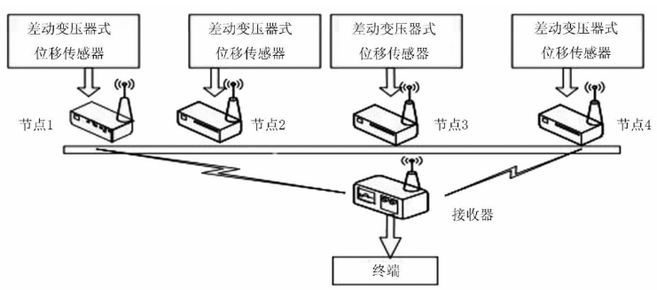
Figure8. Flowchart of differential transformer sensor
At present, the applicability of the stem micro-change monitoring methods still needs to be improved. The stems of herbaceous plants are slender and may cause mechanical damage. Therefore, miniaturized fixtures need to be developed for use in combination.

Leaf surface humidity - Disease early warning sensor
2.2.1 Leaf surface humidity sensor
There are two different types of sensors for leaf surface humidity. One is the capacitive sensor, which uses the water film on the leaf surface as the dielectric and determines the humidity by measuring the capacitance change between the electrodes ^{[20].} Its characteristics are fast response speed and strong anti-interference ability. There are also resistive sensors, which, based on the conductivity of water, determine humidity or weather by measuring the resistance value of the liquid film on the blade surface. They are low-cost but are easily affected by the waxy substance on the blade surface.

The main function of the leaf surface humidity sensor is to prevent diseases. By adding a leaf surface humidity feedback module to the intelligent irrigation system for large fields, when the leaf surface humidity exceeds the predetermined threshold for a certain period of time after irrigation, it will trigger micro-sprinkler supplementary irrigation to reduce the occurrence of diseases.
2.2.2 Fluorescence spectroscopy sensor
Fluorescence spectra can be divided into chlorophyll fluorescence and ultraviolet fluorescence. The principle of chlorophyll fluorescence is to measure the maximum quantum efficiency of light system II through a pulse-modulate fluorescence meter. When crops are under water stress, the obvious changes in parameters can serve as a warning of leaf wilting. Ultraviolet fluorescence is utilized because after leaves are excited by ultraviolet light, the intensity of their autofluorescence is positively correlated with the content of secondary metabolites, indirectly reflecting the crop's stress resistance.
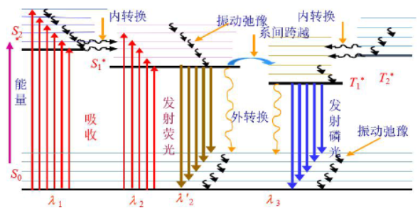
Figure9. The principle of ultraviolet fluorescence
Fluorescence spectroscopy sensors are used for active prevention. During the cultivation of greenhouse cucumbers, the use of a drone monitoring system based on chlorophyll fluorescence spectroscopy analysis can identify plants affected by aphids at an early stage. ^{[21]}
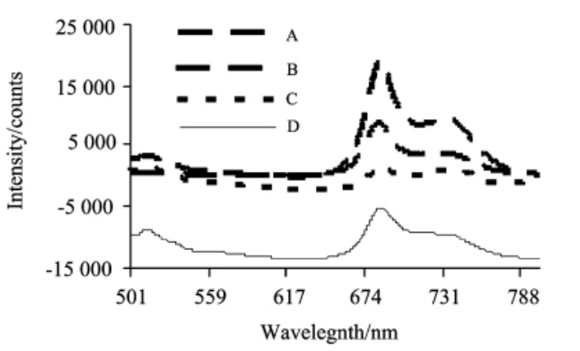
Figure10. Chlorophyll spectrum analysis
With the development of artificial intelligence, AI can drive spectral analysis and assist in the optimization of intelligent irrigation systems. In the future, fluorescence spectroscopy sensors will be cross-integrated with deep learning. Using convolutional neural networks (CNNS) to extract features from fluorescence spectroscopy data can achieve early disease detection and disease prevention more quickly and efficiently. ^{[22]}

Conclusion
The innovation of agricultural intelligent irrigation systems relies on the precise capture of the farmland environment and crop conditions by real-time monitoring sensors. The soil temperature, humidity and pH/EC sensors have achieved precise characterization of the root zone environment through multi-dimensional data fusion. In terms of crop physiological monitoring, multispectral remote sensing, thermal infrared imaging and stem micro-change sensors have constructed a complete chain from canopy stress early warning to microscale moisture monitoring of stems. Real-time technology effectively reduces data transmission delay through the combination of wireless sensor networks and edge computing.
However, the current technology still faces bottlenecks such as insufficient environmental adaptability, poor spatio-temporal coordination of multi-source data, high cost and energy consumption, which restrict large-scale application. The future development will be driven by technological integration and innovation as the core force. Breakthroughs in materials science can significantly extend the lifespan of soil parameter sensors, and flexible bionic leaf surface sensors can reduce crop damage. Spectral technology is evolving towards miniaturization. Intelligent system integration builds a spatio-temporal collaborative irrigation decision-making system through an "air-ground-space" integrated network and AI models based on the Transformer architecture, thereby enhancing the accuracy of decision-making. ^{[23]}
In conclusion, real-time monitoring sensors are the core support of intelligent irrigation systems, and their technological evolution will drive agriculture to transform from experience-driven to data-driven. By breaking through performance bottlenecks through interdisciplinary innovation and building a low-cost and highly reliable monitoring system, and deepening its application in combination with the "Digital Village" strategy, real-time monitoring technology will provide key solutions for global food security, sustainable water resource utilization, and the goal of carbon neutrality in agriculture, leading precision agriculture towards full-process intelligence and greenization.

References
[1] Liu Tao. Challenges and Countermeasures of Farmland Irrigation Water Resources Management [J]. Agricultural Industrialization,2025,(01):137-139.
[2] Ma Xuezhi. The Current Development Status and Suggestions of Water-saving Irrigation Technology in Agriculture in China [J]. Hebei Agriculture,2025,(04):25-27.
[3] Zhang Zhijun. Research on Prevention and Control Technology of Soil Salinization in Farmland Water Conservancy and Optimization of Irrigation Mode[J]. New Farmer,2025,(12):54-56.
[4] Sun Guoxiang, Li Yongbo, Wang Xiaochan, et al. Research on Water-saving Irrigation Model of Summer Greenhouse Cucumbers Based on Crop Physiological Information [J]. Journal of Irrigation and Drainage,2014,33(02):1-5+68.
[5] Li Quanyi, LAN Deshun. Experimental Study on the Effects of Temperature Changes on the Germination Rate and Seedling Growth of Wheat [J]. Seed Science and Technology, 25,43(05):78-80.
[6] Cai Xiuyu, Li Jianyun. NTC thermistor sensing head of the best features of [J]. Journal of physics test, 1990, (6) : 33-36 DOI: 10.13228 / j.boyuan. Issn1001-0777.1990.06.012.
[7] Deng Yue. Verification and Calibration Method of Thermocouple Temperature Sensor Based on Improved Gray Wolf Algorithm [J] Shanghai Metrology & Testing,2024,51(04):68-70+73.
[8] Han Ning. Monitoring Methods and Visualization Research on Key Indicators of Apple Growth Process in Sandy Land of Southern Xinjiang [D] Xi 'an University of Technology,2024.
[9] Huang Jiaxi Greenhouse Temperature and Humidity Control System Based on Particle Swarm -BP Neural Network PID Algorithm [D] South China agricultural university, 2020. DOI: 10.27152 /, dc nki. Ghanu. 2020.000702.
[10] Tao Shaoming Research on Technology for Increasing Water Use Rate in Agricultural Irrigation under the Background of Water Resources Shortage [J]. Water Conservancy Science and Technology & Economy,2025,31(04):47-53.
[11] Bao Qiuxi Research on the Design Method of Soil Moisture Sensor Based on Capacitance Method [D]. Shenyang Agricultural University,2024.
[12] Lu Haifeng, Chen Lu, Shen Ru. Discussion on Measuring pH Value by Glass Electrode Method [J]. Shandong Environment,2000,(05):55-56.
[13] Zhang Linan Research on Rapid Detection Technology of Main Available Nutrients in Soil Based on Ion-Selective Electrodes [D]. China Agricultural University,2015.
[14] Huang Huayu, Ding Qidong, Zhang Junhua, et al. Inversion of soil salinity and pH in farmland by ground hyperspectral coupling interpretable Integrated Machine Learning [J/OL] Environmental Science,1-17[2025-05-25].
[15] Ai Rui, Yao Fengjuan, Xu Pan, et al. Application and Design of Smart Tea Garden Monitoring and Control System [C]. 2022:83-88.
[16] Zhang Xiaodong, Li Pengfei, MAO Hanping, et al. Greenhouse grow more than information and environmental information sensing detection system design [J]. Journal of jiangsu agricultural science, 2021,49(24):209-215.
[17] Zhang Zhitao, Yu Guangduo, Wu Tiankui, et al. Extraction of Corn Canopy Temperature and Monitoring of Crop Water Stress Based on Unmanned Aerial Vehicle Remote Sensing Images [J] Transactions of the Chinese Society of Agricultural Engineering,2021,37(23):82-89.
[18] Gao Yang, Miao Yanlong, Li Han, et al. Monitoring of Potato water Stress Based on thermal infrared and visible light Images [C], 2018:88.
[19] Wang Yue, Liu Jianfei, Luo Bin, et al. Design and Implementation of Wireless Monitoring System for Micro-Changes of Crop Stems [J]. Agricultural Mechanization Research,2014,36(09):124-129.
[20] Zhang Bing, Huang Wensheng, Han Xia, et al. Maize Irrigation decision-making System Based on Leaf physiological Capacitance and Soil Moisture [J]. China Rural Water Conservancy and Hydropower,2011,(10):24-25.
[21] Sui Yuanyuan, Yu Haiye, Zhang Lei, et al. Fluorescence spectroscopy Monitoring and Early Warning of Aphid damage in greenhouse cucumbers [J]. Spectroscopy and Spectral Analysis,2012,32(07):1834-1837.
[22] Hou Maoze, Ma Yanqiong, Tian Senlin, et al. Research on Water Pollution Source Tracing Based on Convolutional Neural Network Recognition of Three-dimensional Fluorescence Spectra [J]. China Environmental Monitoring,2022,38(05):188-195.
[23] Fu Donghui, Liu Yuanda, Liu Yanfeng, et al. The Application of Sensors in Modern Agriculture [J]. Heilongjiang Science and Technology Information,2011,(06):56-57.

