Explanation:

When I try to reproduce the sincNet in Linux system, because of my pc is windows only. So I try to use virtual machine to run the project3 in Linux system. Everything is good except when I run speaker id.py, there is error occupied on the line: cnnNet.cuda() and I found out I need to gpu to accelerate process using pytorch and I try to do the pytorch using cpu only, but it failed. Then I do the research online to find the way I can access gpu when I run the program in virtual machine, however unfortunately it seems no way for windows system to access gpu. So I turned to try download Linux system as subsystem as windows. However, I am not familiar with subsystem and try to do research on how to run program on that. So far, I could not reproduce the result of project 3 based on the gpu trouble. I hope I can fix it later and create my own database to train using sincNet.

10/26/2020

I fix all the trouble running in the windows system. And the reproduce result is shown below:

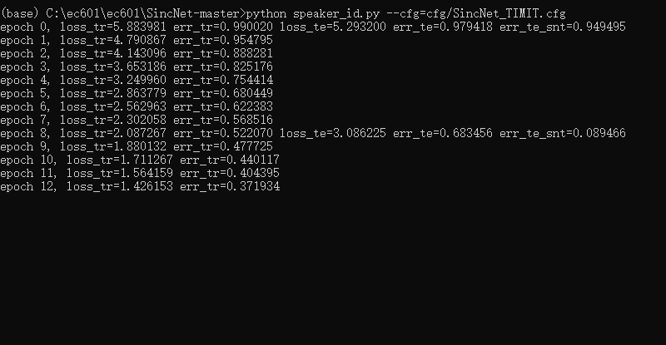

This is about one hour testing result. It will take long time testing all 360 epoch so maybe I could not test all database. However we can see that the loss_tr and error_tr is decreasing, which is good and prove our machine learning system is working.