**Global Temperature Changes (1880–2020)**

By Yi Xie

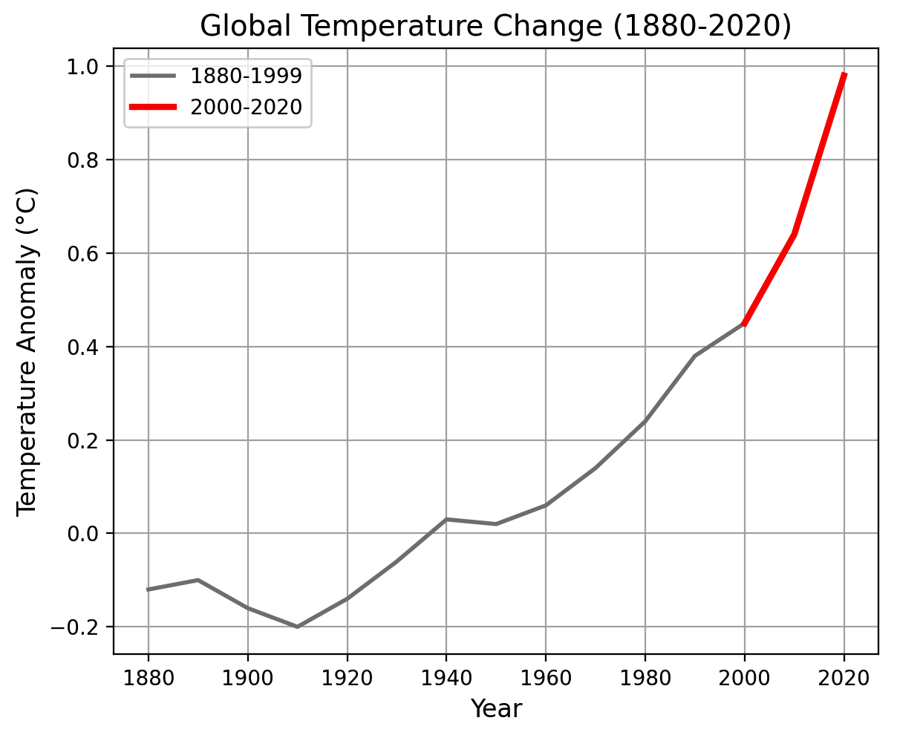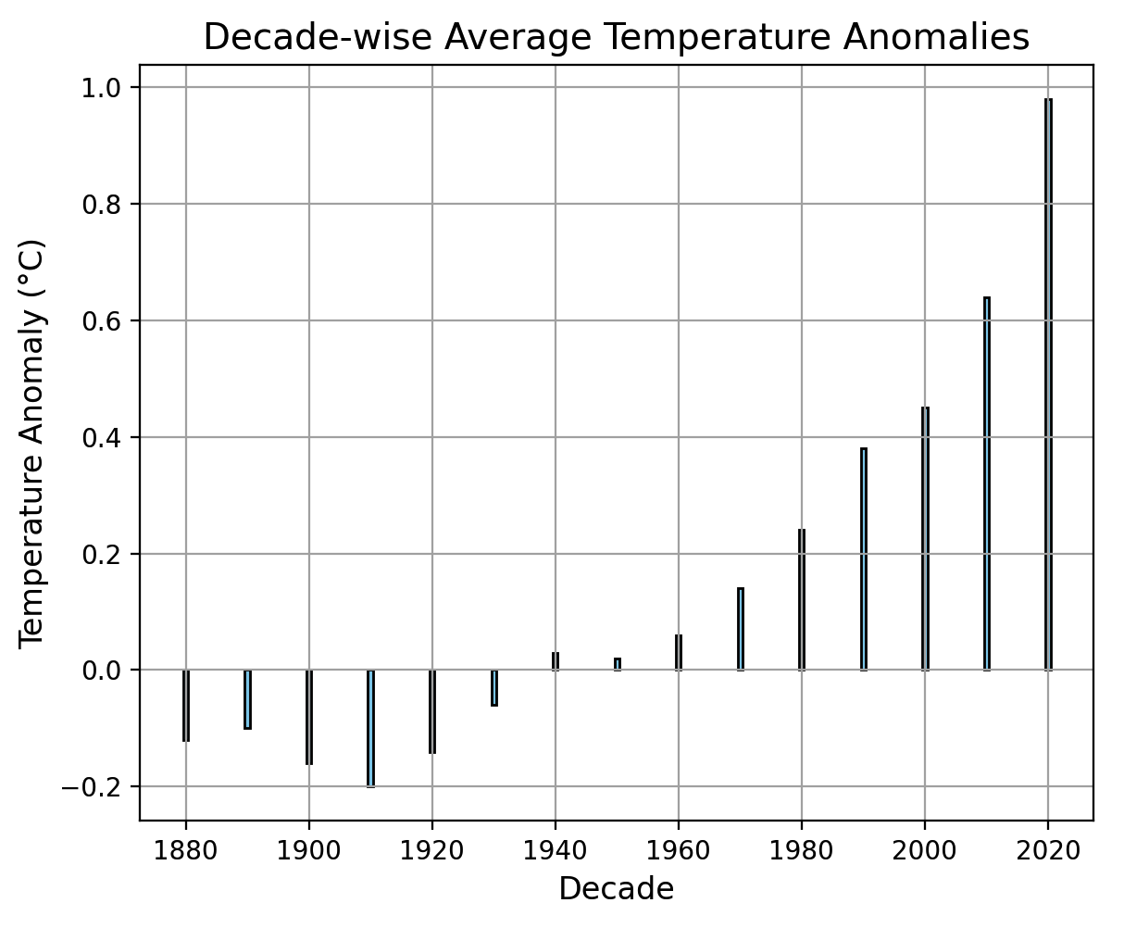

Figure 1 Global Temperature Changes (1880–2020)

Figure one illustrates the historical trends in global temperature anomalies from 1880 to 2020. The **grey line** represents anomalies from 1880 to 1999, while the **red line** highlights the accelerated warming observed between 2000 and 2020.

Key observations include:

* A consistent rise in global temperatures, particularly after 1980.
* A steep increase during the most recent decades (2000-2020), with 2020 being one of the warmest years recorded.

Legend:

* Grey Line: Represents global temperature anomalies from 1880 to 1999.
* Red Line: Highlights temperature anomalies from 2000 to 2020.

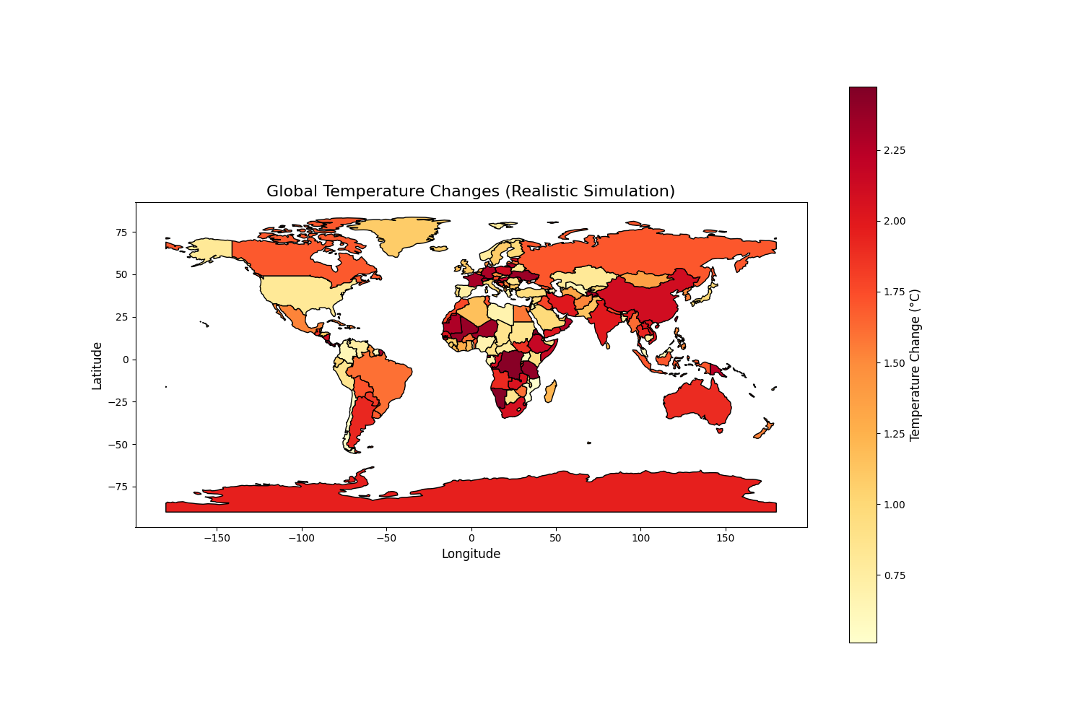

Figure 2 Heatmap of Global Temperature Changes

**Figure 2** displays temperature changes across the world using country-level data. The **color gradient** indicates the magnitude of temperature anomalies:

* **Darker red areas** signify regions with the highest temperature increases, such as the Arctic and parts of Africa.
* Polar regions exhibit the most significant changes, reflecting the severe impact of climate change on ice caps and surrounding ecosystems.

Legend:

* Heatmap: Darker colors indicate higher temperature anomalies (in °C).

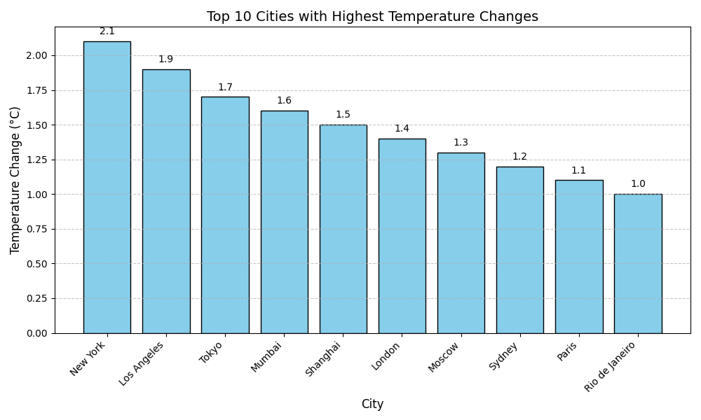

Figure 3 Top 10 Cities with Highest Temperature Changes

This bar chart ranks the top 10 cities that have experienced the most significant temperature increases over time. Key insights:

* Cities like **New York**, **Los Angeles**, and **Tokyo** show the largest changes, driven by urbanization and industrial activities.
* The variation in temperature increases across cities highlights the localized impacts of climate change on urban areas.

Legend:

* Bar Chart: Displays the magnitude of temperature changes for the top 10 cities.

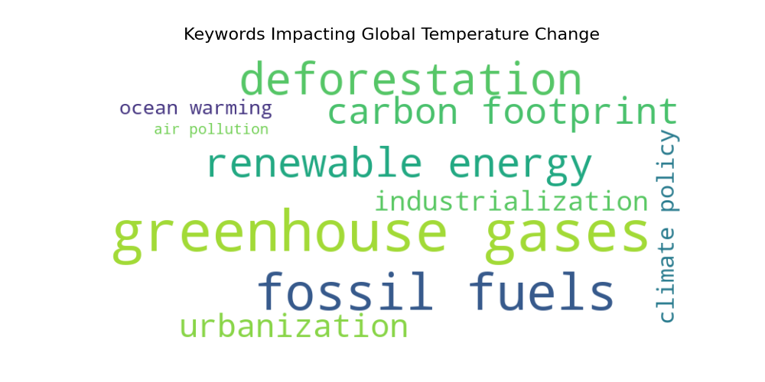

Figure 4 Keywords Impacting Global Temperature Change

This word cloud visualizes key factors contributing to global temperature changes. Larger words indicate a higher frequency and importance:

* **Greenhouse gases** and **fossil fuels** are the most significant contributors.
* Other factors, such as **deforestation**, **carbon footprint**, and **urbanization**, underline human-induced drivers of climate change.

Legend:

* Word Cloud: Larger words represent more impactful climate change contributors.

#### ****Findings****

* **Global Perspective**:
  + Significant warming trends are observed across all continents, with polar regions experiencing the largest changes.
* **Key Factors**:
  + Greenhouse gases, fossil fuels, and deforestation are major contributors to global warming, as highlighted in the word cloud.
* **Urban Areas**:
  + Cities like New York, Los Angeles, and Tokyo show the highest temperature changes due to urbanization and industrial activities.
* **Recent Trends**:
  + A steep rise in global temperatures is evident from 2000-2020, with 2020 being among the warmest years on record.

#### ****Data and Methods****

* **Data Sources**:
  + Global temperature anomalies: Berkeley Earth and NASA GISS datasets.
  + City-specific temperature changes: NOAA Global Historical Climatology Network (GHCN).
  + Keywords for word cloud: Extracted from IPCC reports and climate literature.
* **Methods**:
  + Heatmap: Visualized using geopandas and country-specific temperature changes.
  + Word Cloud: Generated with the wordcloud library based on keyword frequency.
  + Bar Chart: Top 10 cities identified and plotted using matplotlib.
  + Main figure: Combined multiple visualizations for integrated analysis.

#### ****Significance Statement****

This report underscores the global and regional impacts of climate change. By integrating multiple perspectives—spatial, temporal, and urban—the analysis highlights the urgency of addressing the climate crisis. The findings serve as a critical resource for policymakers, urban planners, and environmentalists in their efforts to mitigate climate change.

#### ****Github Link****

https://github.com/yix138/-INFSCI2415-Final-Report