**Documentation**

1. **User input**

First, user will be asked to enter some input and make some choices, including what text to be displayed, the x-coordinate and y-coordinate to display the text, the choice of direction to move the text, the time step to display the text and lastly the speed to display the text.

* 1. **Text to be displayed**



Figure 1.1.1: Users are asked to input text to be displayed

Users can enter any alphabets or numbers or space to be display later in the display board, notice that small letter or capital letter of alphabets will all be accepted but the output will be in capital letter.



Figure 1.1.2: Error message if texts are more than 25 characters

But users can only enter a maximum of 25 characters, a message will be displayed to inform the user that the text that exceeds 25 characters will not be accepted and user will be asked to re-enter the text again.



Figure 1.1.3: Error message if symbols are entered

If users enter any symbol, the text will not be accepted too, and a warning message will pop out.

* 1. **Coordinate to start displaying the text**



Figure 1.2.1: Users are asked to input coordinate to start displaying the text

Next, users need to enter the coordinate to start printing out the text. It is the same as the Cartesian plane in Mathematics, x-coordinate starts from 0 (left) to 39 (right) and y-coordinate starts from 0 (bottom) to 19 (top).

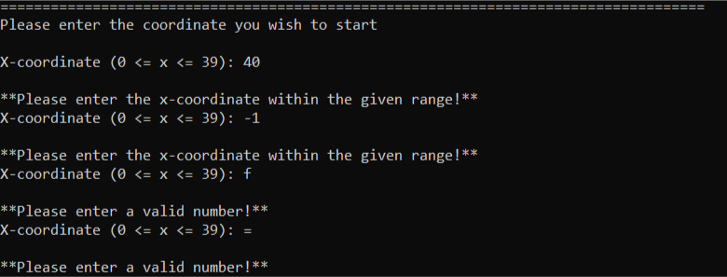

Figure 1.2.2: Error message when numbers entered out of range or alphabets and symbols are entered

Numbers that out of the given range or any alphabets and symbols entered will be rejected and a warning message will be displayed to inform the users and ask for re-enter of data.

* 1. 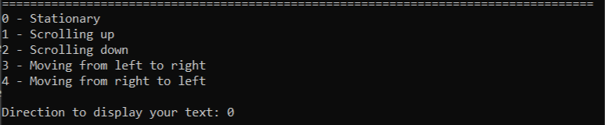**The direction to move the text**

Figure 1.3.1: Users are asked to select a direction

Then, users need to enter the 5 given choices of directions to display the text.

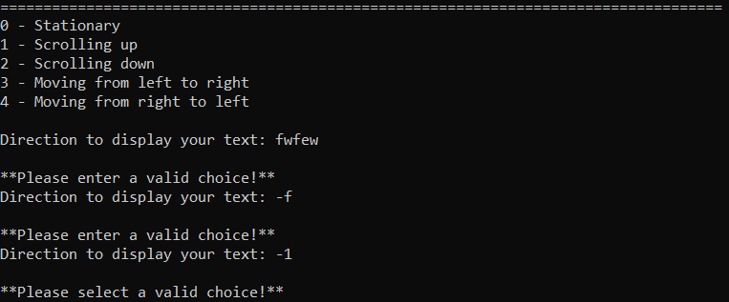

Figure 1.3.2: Error message is displayed when input is not from 0 to 4

Note that anything other than these 5 choices will be rejected and users need to enter his choice again.

* 1. **Time steps**

Figure 1.4.1: Users are asked to enter time step

Then, users need to enter how many time steps he wants to display the text.

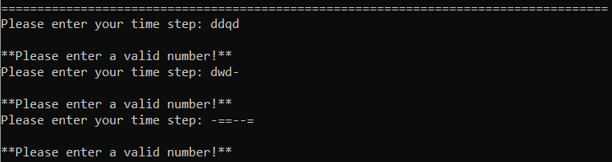

Figure 1.4.2: Error message when input is not positive integer

Alphabet and symbol input will not be accepted in this section.

* 1. **Speed**



Figure 1.5.1: Users are asked to enter the speed

Lastly, users will be asked to select the speed that he wants to move the text from slowest (1) to fastest (10).

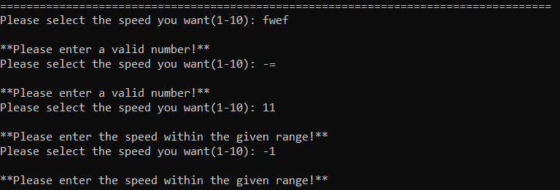

Any numbers that our of range or alphabets will not be accepted by the program.

Figure 1.5.2: Error messages when number other than from 1 to 10 is entered

Same as the above, any symbols and alphabets or numbers that out of range will not be accepted.

1. **Display Board Output**
   1. **Stationary**

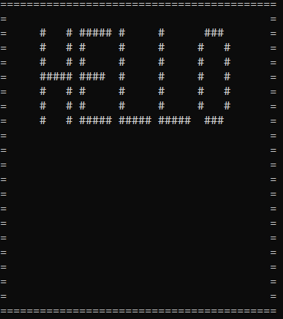

Figure 2.1.1: Text displayed

Figure 2.1.1 shows the display board output if the user entered hello, enter the coordinate (5, 18) and chose to display his text stationary. In this case, time step and speed will not be asked since there is no movement of text.

* 1. **Scrolling up**

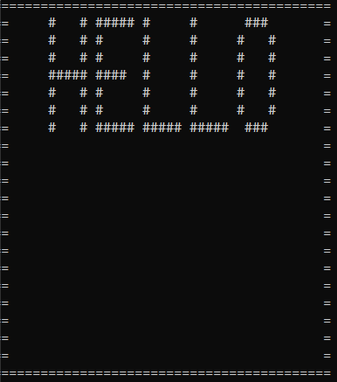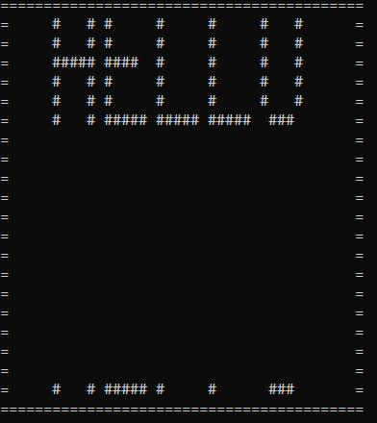

Figure 2.2.1: When text is being scrolled up

Figure 2.2.1 shows a 3-time steps of scrolling text upwards. When the first row of the text exceeds the upper border of the display board, it will disappear and appear at the bottom which shows a wrap effect.

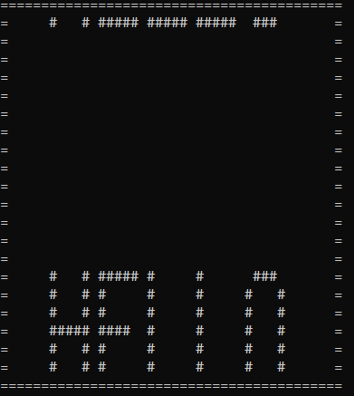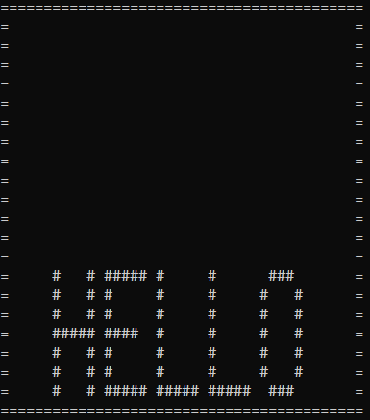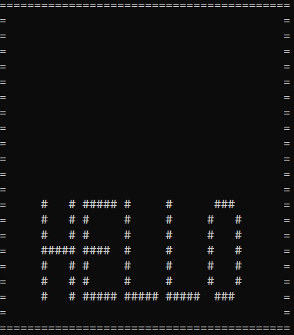

Figure 2.2.2: Texts finish printing from the bottom and start to move upwards

After the texts finish printing from the bottom, it will start to move upwards as a whole, and this process will continue until the time steps end.

* 1. **Scrolling down**

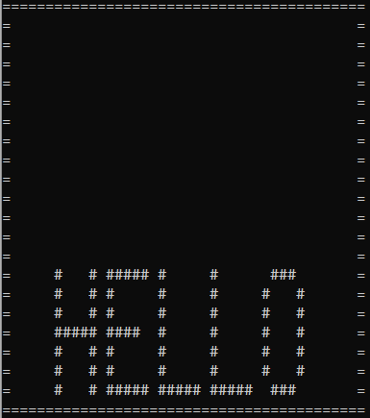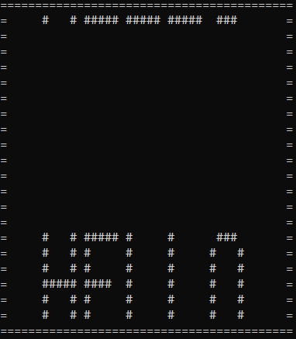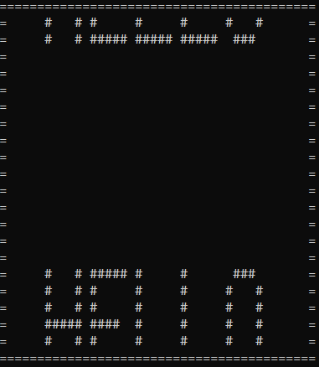

Figure 2.3.1: When text is being scrolled down

Figure 2.3.1 shows that when a text is located at the bottom of the display board, the last row will appear at the top of the display board while the rest remain at the bottom of the display board in the next time step. This shows a wrap effect and this effect will continue until all rows of the text is printed at the top of the display board.

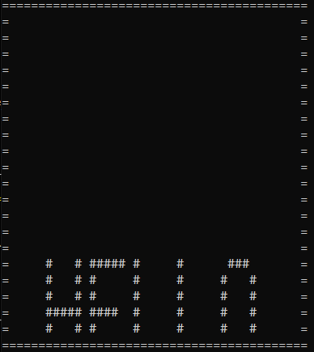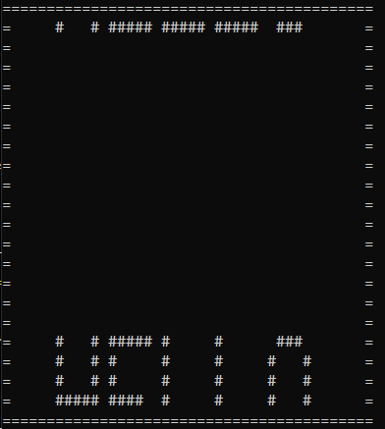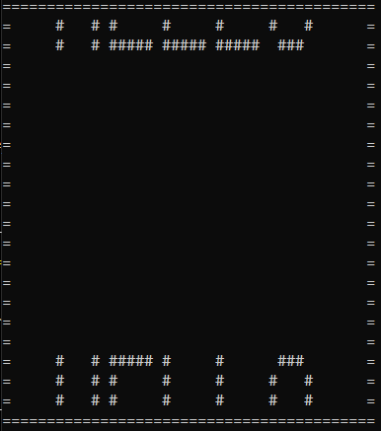

Figure 2.3.2: When the text is not fully shown

If the user entered a coordinate that makes the text cannot be shown completely, the wrap effect will only show the last row at the top of the display board in the second time step while the remaining part will keep scrolling at the bottom of the display board.

* 1. **Moving from left to right**

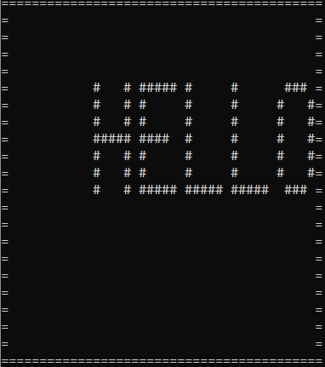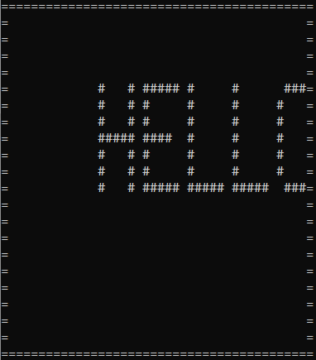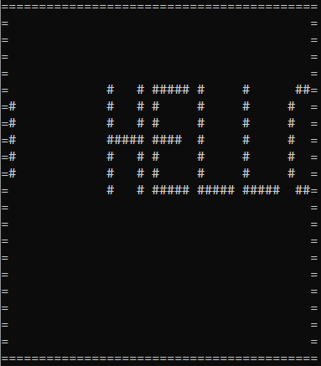

Figure 2.4.1: Text wrapping effect when text moves from left to right side

When the user wants the text to move from left to right, the text will start the wrapping effect in the next time step if it reaches the right border at the current time step. Note that the last column of every character is an empty column, so in the second time step it actually prints the last column of the “O” which is an empty column. Only in the third time step, the second-last column of “O” is printed.

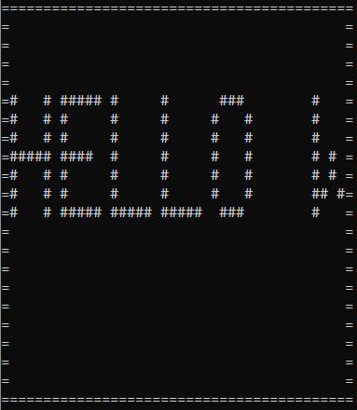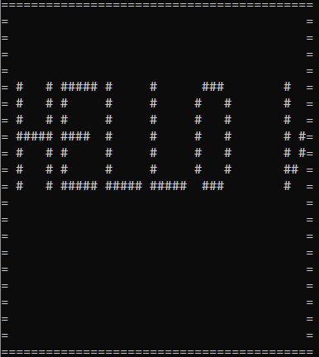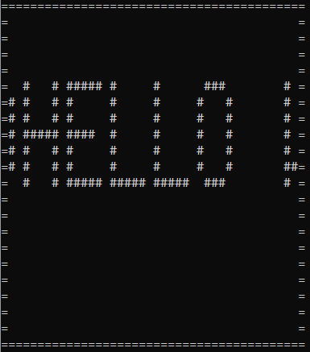

Figure 2.4.2: A long text is moved from left to right side

If a long text is entered by the user, for example in Figure 2.4.2, the text user entered is “Hello world”, the program will also print the last column of the last character in the second time step and continue to print the whole long text from the left side.

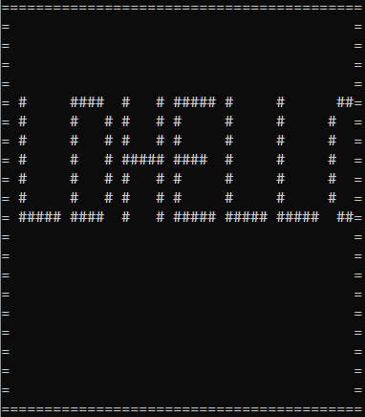

Figure 2.4.3: The text “world” connected to the “Hello”

Note that if the last text has no space behind it, when the wrap effect takes place, the last text will connect to first text as the program will automatically start to print the last column of the last text. To separate the last text from the first text, a space needs to be entered after the last text.

* 1. **Moving from right to left**

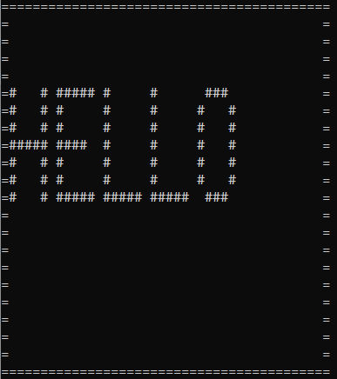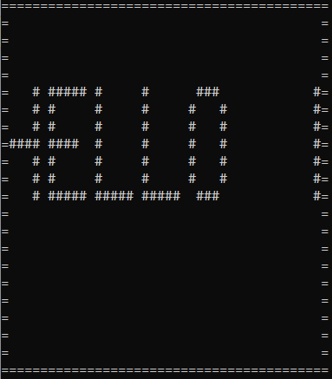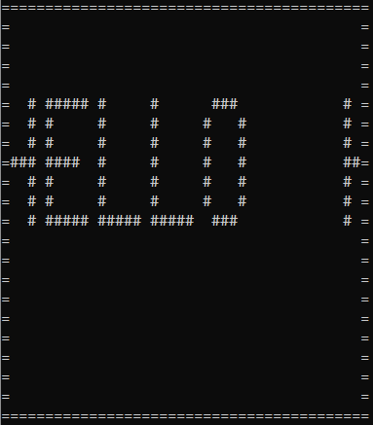

Figure 2.5.1: Text wrapping effect when text moves from left to right side

When the user entered a short text and it reaches the left border, the first column of the first character will disappear and pop out at the opposite side in the second time step. The text will continue to disappear and appear at the opposite side until the whole text is located at the right side, then it will start to move to the left again.

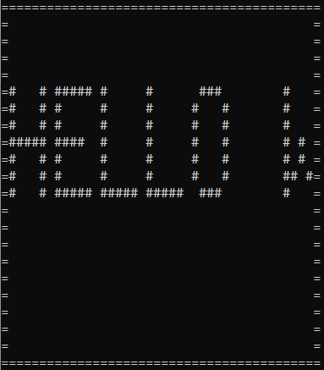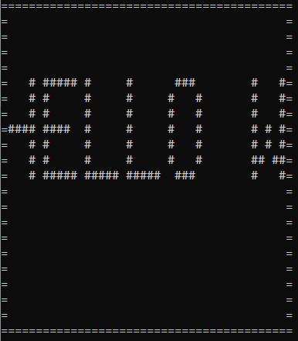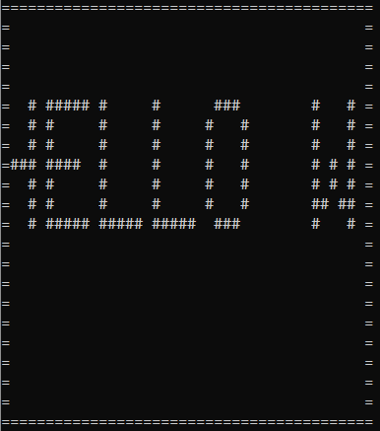

Figure 2.5.2: A long text is moved from right to left side

If a long text is entered, even though the first character reaches the border and disappear, the program will first display the remaining text. As shown in Figure 2.5.3, after all the text is shown, only then the program will display the first column of the first character at the right side.

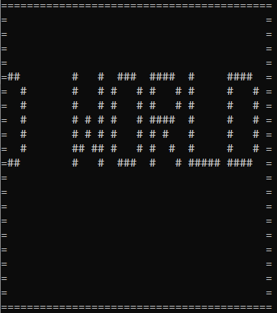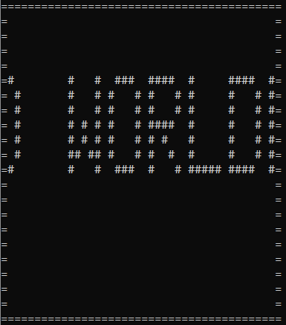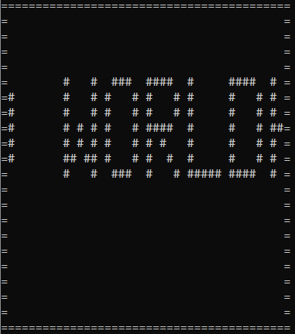

Figure 2.5.3: The first column of the first character is printed out

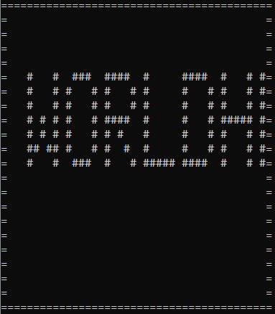

Figure 2.5.4: The text “world” connected to “Hello”

Note that if the user did not enter a space at the end of the text, when the text start moving, the first character will connect to the last character. To separate it, kindly add a space after the whole text.