1. **Format of Input File**

|  |  |
| --- | --- |
| **Input Data** | **Description** |
| 1 | Speed |
| Selamat Hari Merdeka | Input phrase |
| 80 40 | Board size (optional, default is 40 20) |
| 10 20 | Anchor point |
| * | *Drawing character (optional, default is #) |
| st | Direction |
| 100 | Time step (optional, default is 1) |
| wr | Wrap-around choice (optional, default is no wrap-around) |
| mr | Rotation (optional, default is up right) |

* Input needs to follow the order except for the last three input data
* Format for board size is (column row)
* Format for anchor point is (x-coordinate y-coordinate)
* Choices for rotation is mr (mirror), rot90 (clockwise 90 degree) and rot-90 (anticlockwise 90 degree)
* Only drawing character is case sensitive
* *Drawing character can be any character or “inc” if inception feature needed
* **Kindly enable C++ 11 (-std=c++11) when compiling**

1. **Sample Show Case**
   1. Sample input 1

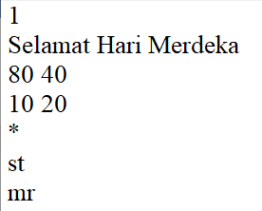

Speed: 1

Input phrase: Selamat Hari Merdeka

Board size (x, y): (80, 40)

Anchor point (x, y): (10, 20)

Drawing character: *

Direction: Stationary

Rotation: Mirror

Wrap effect: Disable (default)

Time step: 1 (default)

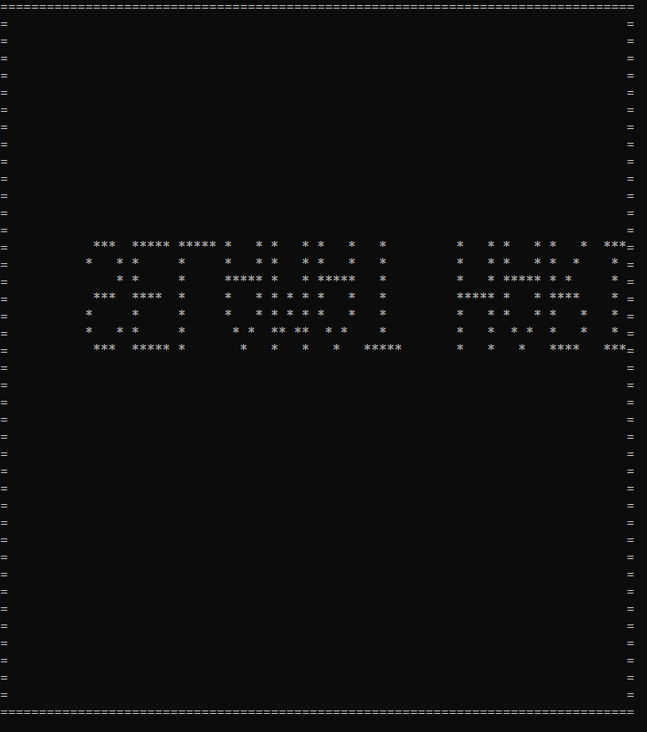

* 1. Sample2

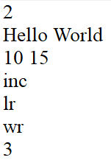

Speed: 2

Input phrase: Hello World

Board size (x, y): (40, 20) (default)

Anchor point (x, y): (10, 15)

Drawing character: Inception

Direction: Left to right

Wrap effect: Enable

Rotation: Up right (default)

Time step: 3

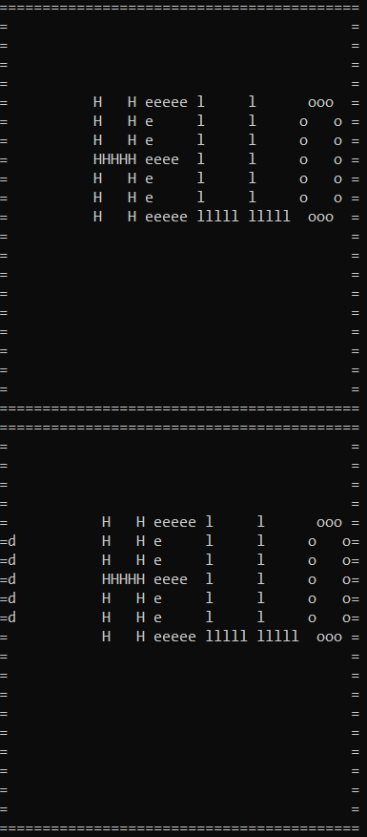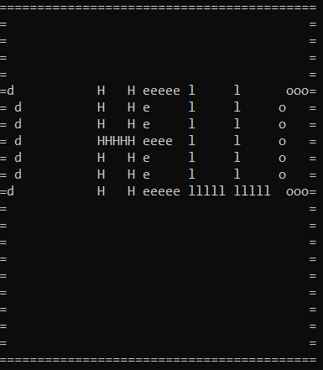

* 1. Sample3

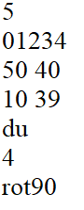

Speed: 5

Input phrase: 01234

Board size (x, y): (50, 40)

Anchor point (x, y): (10, 39)

Drawing character: # (default)

Direction: Down to up

Time step: 4

Rotation: Clockwise 90 degree

Wrap effect: Disable (default)

