

Faculty of Computing and Informatics (FCI)

Multimedia University, Cyberjaya

TMA1301

Computational Methods

**Monte Carlo Method Simulation**

**Trimester 2, Session 2019/2020**

**Prepared by:**

|  |  |  |
| --- | --- | --- |
| Lim Yixen | 1171103542 | 1171103542@student.mmu.edu.my |
| Lee Guang Shen | 1171103543 | 1171103543@student.mmu.edu.my |
| Wong Jit Chow | 1171103534 | 1171103534@student.mmu.edu.my |
| Wong Phang Wei | 1171103580 | 1171103580@student.mmu.edu.my |
| Chan Wai Jun | 1171103397 | 1171103397@student.mmu.edu.my |

**Table of Contents**

|  |  |
| --- | --- |
| **Contents** | **Page** |
| Probability tables | 1 |
| Flowchart | 3 |
| Output of simulation | 4 |

**Probability tables**

Table of tickets’ information

|  |  |  |  |
| --- | --- | --- | --- |
| Day / Slot | Total ticket type 1 | Total ticket type 2 | Total ticket type 3 |
| 1 | 60 | 60 | 60 |
| 2 | 70 | 75 | 80 |
| 3 | 60 | 75 | 70 |
| 4 | 50 | 50 | 50 |
| 5 | 70 | 70 | 65 |
| 6 | 40 | 40 | 40 |

Table of ticket slot/day

|  |  |  |  |  |
| --- | --- | --- | --- | --- |
| Ticket slot/day | Probability | CDF | Range (MIN) | Range (MAX) |
| 1 | 0.2 | 0.2 | 1 | 20 |
| 2 | 0.1 | 0.3 | 21 | 30 |
| 3 | 0.05 | 0.35 | 31 | 35 |
| 4 | 0.15 | 0.5 | 36 | 50 |
| 5 | 0.2 | 0.7 | 51 | 70 |
| 6 | 0.3 | 1 | 71 | 100 |

Table of ticket type

|  |  |  |  |  |  |
| --- | --- | --- | --- | --- | --- |
| Ticket slot/day | Probability | CDF | Range (MIN) | Range (MAX) | Price |
| Ticket type 1 | 0.3 | 0.3 | 1 | 30 | 15 |
| Ticket type 2 | 0.5 | 0.8 | 31 | 80 | 25 |
| Ticket type 3 | 0.2 | 1 | 81 | 100 | 35 |

1

Table of inter-arrival time

|  |  |  |  |  |
| --- | --- | --- | --- | --- |
| Inter-arrival | Probability | CDF | Range (MIN) | Range (MAX) |
| 2 | 0.15 | 0.15 | 1 | 15 |
| 3 | 0.2 | 0.35 | 16 | 35 |
| 4 | 0.25 | 0.6 | 36 | 60 |
| 5 | 0.1 | 0.7 | 61 | 70 |
| 6 | 0.3 | 1 | 71 | 100 |

Table of service time for counter(s)

|  |  |  |  |  |
| --- | --- | --- | --- | --- |
| Service time | Probability | CDF | Range (MIN) | Range (MAX) |
| 6 | 0.2 | 0.2 | 1 | 20 |
| 7 | 0.25 | 0.45 | 21 | 45 |
| 8 | 0.25 | 0.7 | 46 | 70 |
| 9 | 0.15 | 0.85 | 71 | 85 |
| 10 | 0.15 | 1 | 86 | 100 |

2

**Flowchart**

3

**Output of simulation**

1. At first, some information and probability tables are displayed.

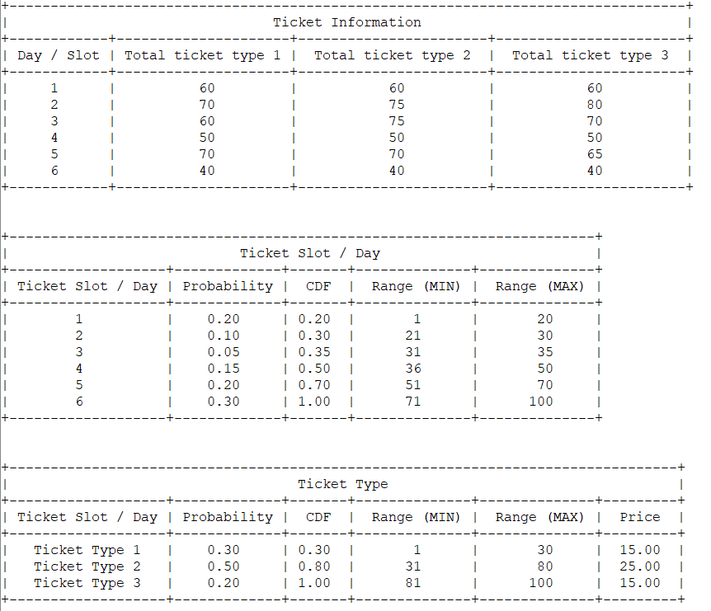

Figure 1: Number of tickets that are available for sale for six days



Figure 2: Probability, CDF and random number range to determine ticket of which day will be bought by the customers



Figure 3: Probability, CDF and random number range to determine the type of ticket that will be bought by the customers, price of each ticket is also shown

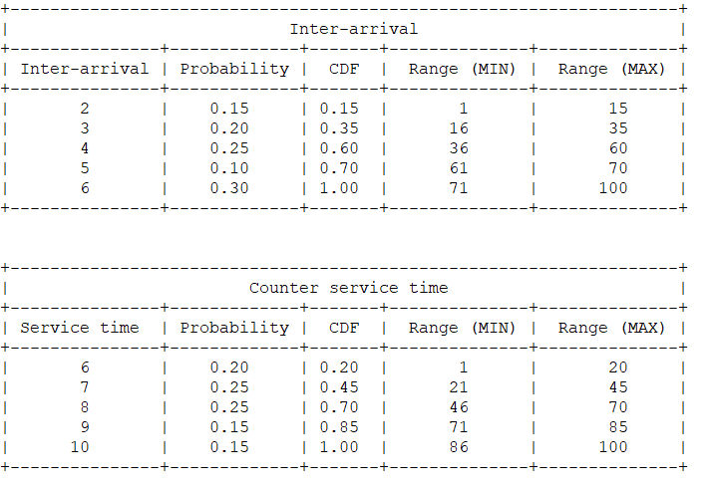

Figure 4: Probability, CDF and random number range to determine the inter-arrival time of the customers

4



Figure 5: Probability, CDF and random number range to determine the service time of the customers

1. Next, the user will be asked to select which counter to be put in operation for the simulation.

Note:

1. A total of three counters are provided
2. Only the lowercase “y” will be considered as the answer “Yes”, others input will be considered as “No”
3. At least one counter is needed to be put in operation
4. Closed counter(s) might be opened if any customer has to wait for service

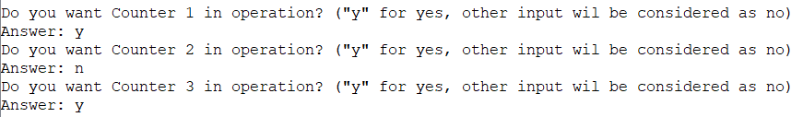

Figure 6: The prompt for user to select counter(s) in operation

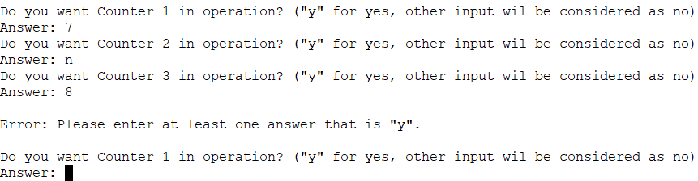

Figure 7: Error message will be displayed if no counter is set to be in operation

5

1. Next, the user will be asked to input the number of customers for the simulation.

Note:

1. Number of tickets will be generated randomly from 1 to 10 for each customer



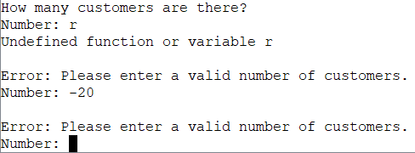Figure 8: The prompt for user to enter the number of customers

Figure 9: Error message will be displayed if invalid number of customers is entered

1. Then, user will be asked to choose one calculation method for the random number’s generation.

Note:

1. The value “a” and “c” will be asked for choice 2
2. The value “a” will be asked for choice 3
3. The value “c” will be asked for choice 4
4. 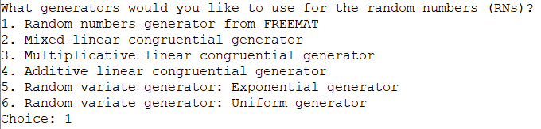The value lambda will be asked for choice 5

Figure 10: The prompt for user to select the calculation method for random numbers

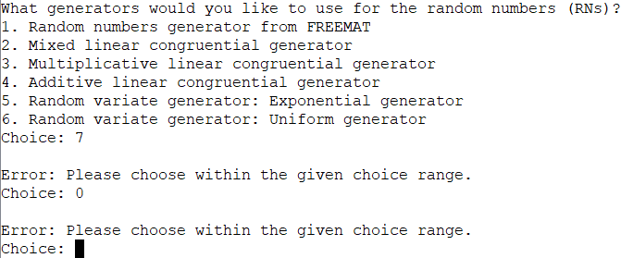

Figure 11: Error message will be displayed if invalid choice is entered

6

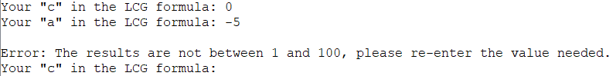

Figure 12: If RNs generated are not within the range, user is required to re-enter the input.

1. The messages will be generated such as the number of counters that are in operation, arrival time and service time of customers, serving counter, number, type and slot of tickets purchased and the amount need to be paid.

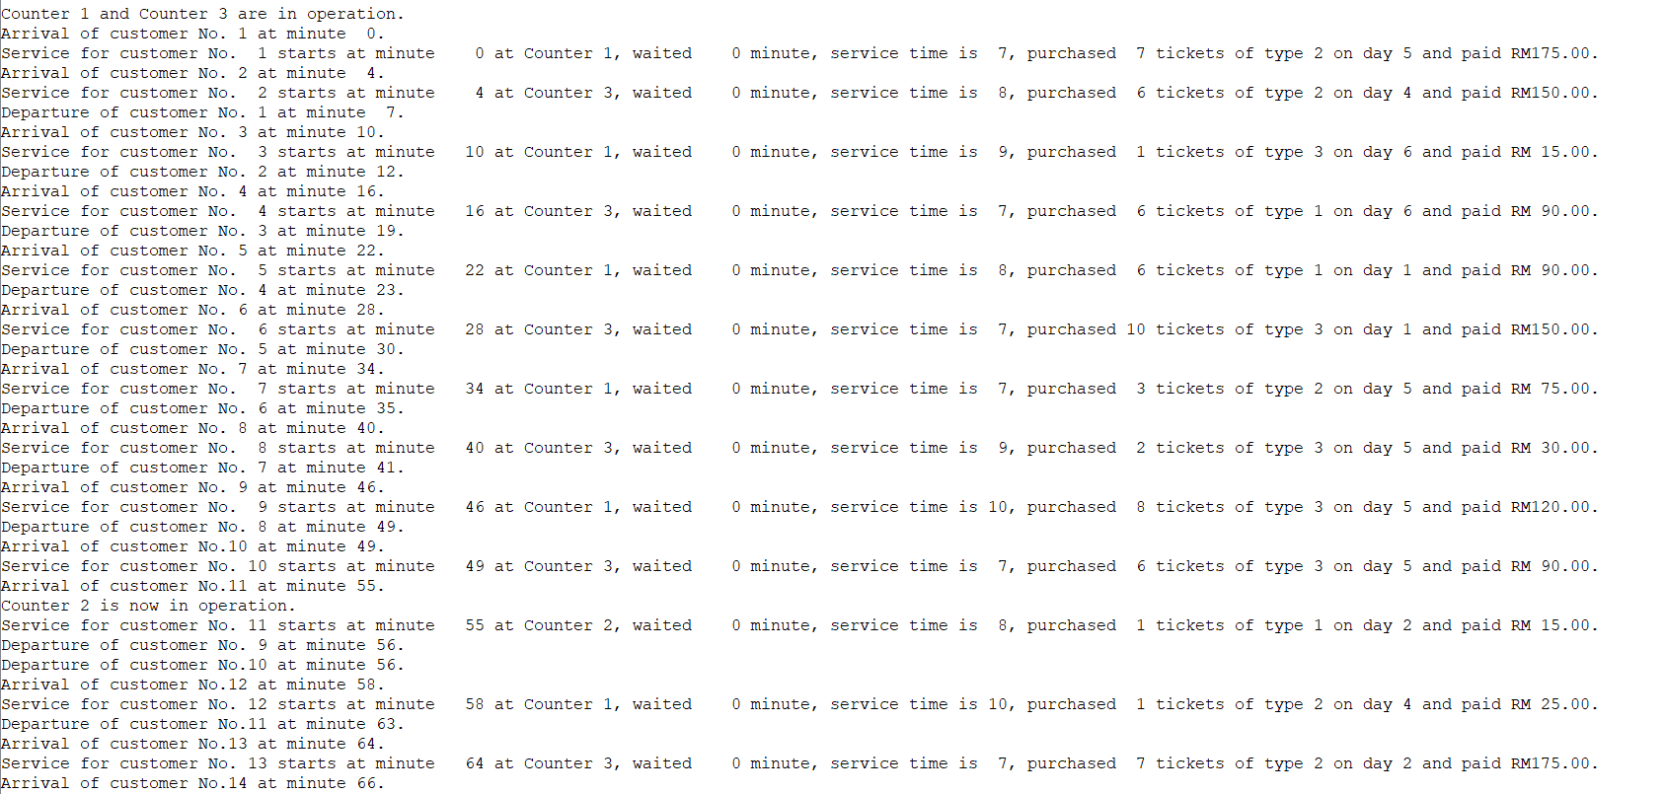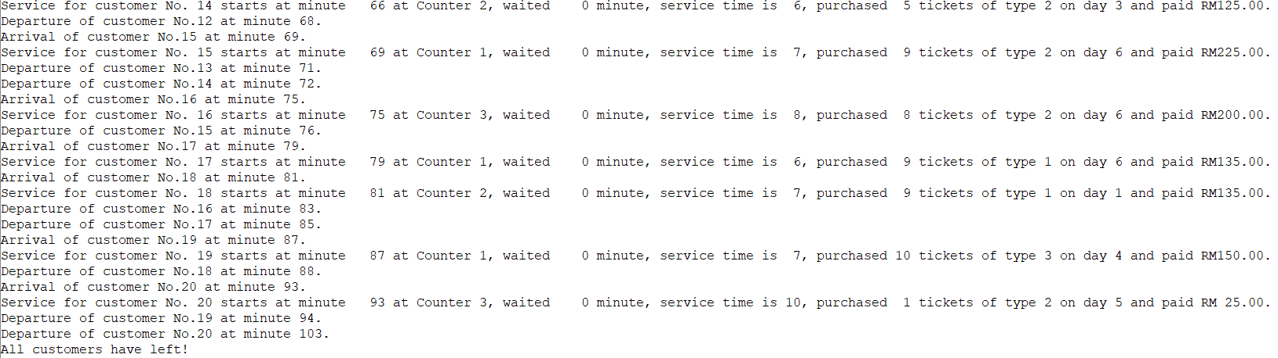

Figure 13: Generated messages

7

1. A table that shows the inter-arrival time, ticket slot and ticket type based on the random numbers generated from the calculation method and probability tables above. It also shows the number of tickets purchased and amount need to be paid.

Note:

1. Amount need to be paid is obtained from the multiplication of ticket price in the ticket type table above and the number of tickets purchased

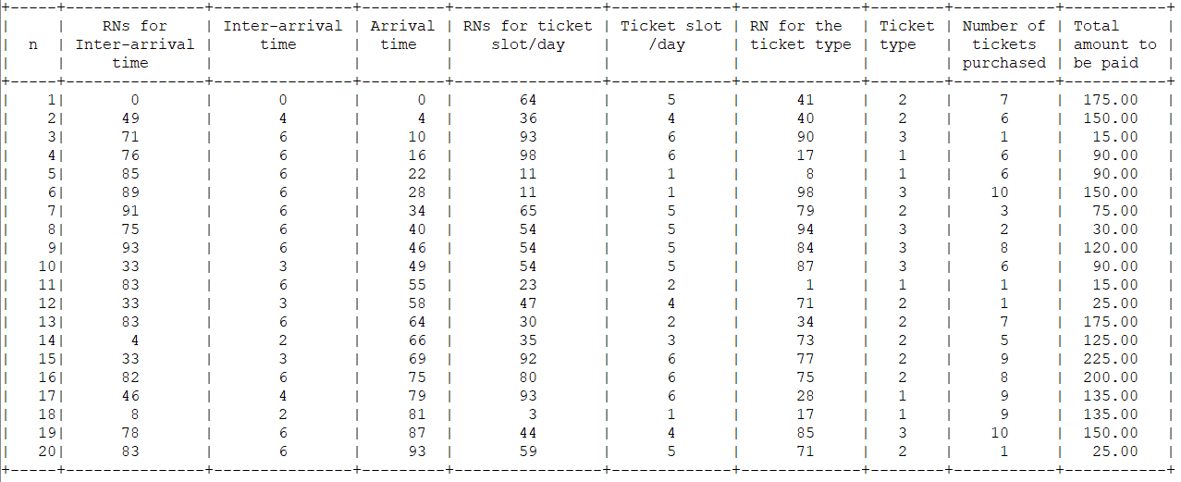

Figure 14: Random numbers information table

1. Then, the tables and information of counter(s) will be shown.

Note:

1. 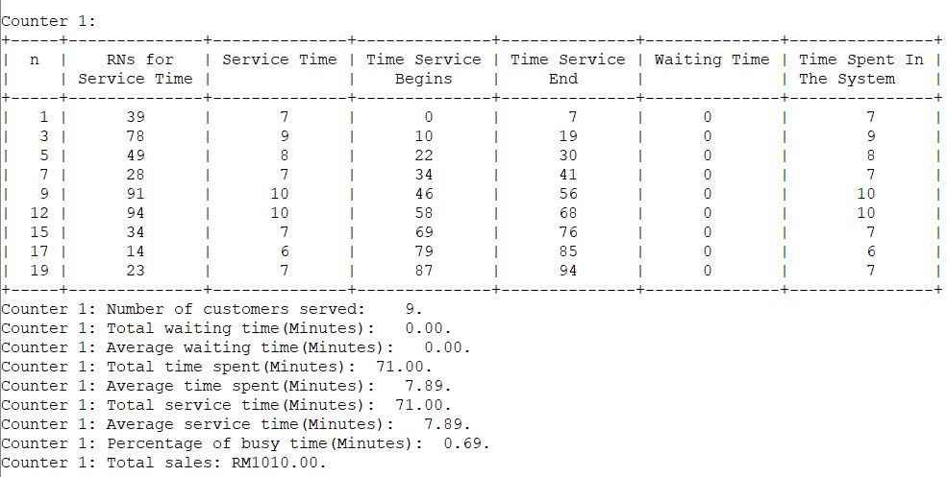n is the number of customers

Figure 15: Table and information of Counter 1

8

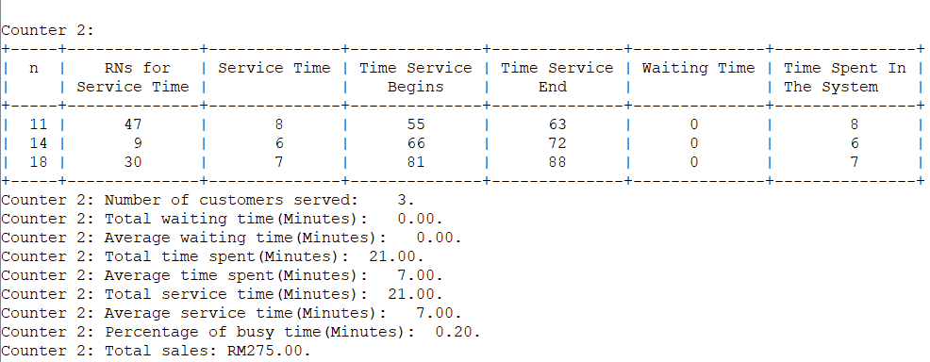

Figure 16: Table and information of Counter 2

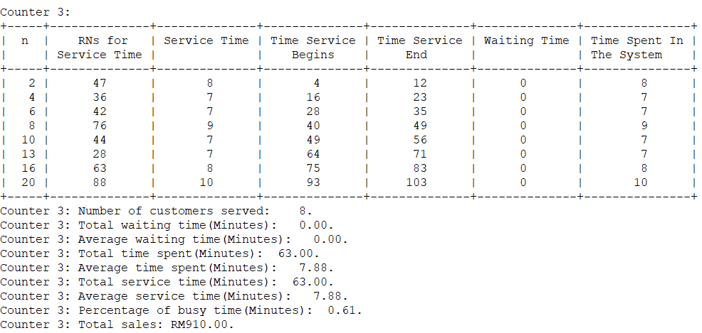

Figure 17: Table and information of Counter 3

1. Then, the remaining tickets of each slot will be shown.

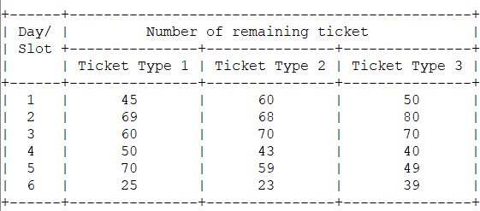

Figure 18: Table of remaining tickets

9

1. Some analysis will be calculated and displayed.

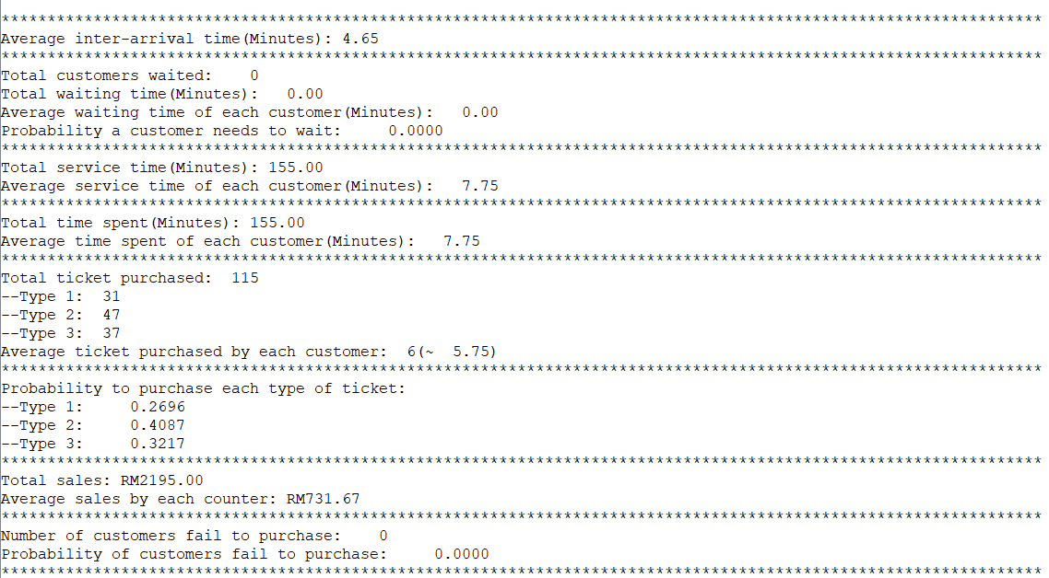

Figure 19: Analysis of the simulation

10