**Restaurant Project**

**1.Introduction**

This project is aimed to help UBC students planning out their diet, by examining the data records of the restaurant in BC. 373 restaurants are presented in the raw data where we will carefully filter out restaurants that are relatively close to UBC (Kumar, 2020).

How to eat well on a tight budget is always a problem for university students. Due to the outbreak of covid-19, many restaurants experienced high levels of pressure. According to news, up to 24 percent were breaking during this special time (Lazaruk, 2021). As the circumstance becomes better recently, many reopened restaurants start to increase their price in order to recover from the loss due to covid-19. According to Canada's Food Price Report 11th annual edition, there is a 5% overall food price increase in 2021(Canada's food price report, 2021). As meat and vegetables were predicted to have a growth of 4.5 to 6.5 percent (Canada's food price report, 2021). Since university students often tend to experience high volumes of coursework, cooking by themself is at a high time expense. Getting a food delivery could be a solution to this problem. However, delivery fees, as well as tips, are not cheap for students in general, especially most students don't have a steady job. What's more, reports have also shown that due to the increase in fuel costs, the shipping price is also growing (Lazaruk, 2021). Thus, it is important to construct a way to help UBC students to eat well at an affordable cost.

Consequently, we aimed to use this project to help students in UBC plan out their eating diet. Restaurant rating, prices, and locations were used to construct a linear programming problem that best design the recommended frequency to eat in each restaurant.

**2. Developing the model**

**2.1Terminology and Definitions**

$x_{n}$: The number of times should the nth restaurant in the filtered table be visited per week

$r_{n}$: The rating of the nth restaurant computed by R($x_{n}$)

$a_{n}$: The transit time from the nth restaurant to UBC, estimated by their address according to the “landmark” column

$b_{n}$: The average cost of the nth restaurant, according to the “cost” column in the database

t: The upper bound of the sum of the time spending on transit to the restaurants per week (min)

c: The upper bound of the sum of the eating cost per week

m: The upper bound of sum of the meal a student wish to have in the restaurant per week

n: The upper bound of the student to visit the same restaurant per week (never visit one restaurant for more than times per week)

**2.2Assumptions**

* Since the delivery fee can be expensive, we assume the student would reach the restaurant through transit, and not order the delivery. Therefore, we filter out the rows where both of the “Diner in ability” and “Take away ability” are false or missing.
* We trust the rating of each restaurant in the database. However, considering other factors such as the numbers of reviews are different and people might lower their expectations on cheap restaurant, we are not using the “rating” column in the database alone for the final rating. We developed a function to estimate the final rating when treating the raw data.

* This project assumes the travel time each day does not varies much at the same time and the traffic condition would stay the same at each mealtime. Thus, we used 6:00 pm on Monday as the leaving time for conducting the research.

**2.3Linear Programing Model**

**Objective function: max $\sum_{i=1}^{n}{r_{i}·x_{i}}$**

The objective function computes the sum of scheduled visiting times at each restaurant multiplied by the corresponding rating. Because we want to maximize the eating experience under all the constraints, we would like to maximize the objective.

**Subject to:**

$\sum_{i=1}^{n}{a_{i}·x_{i}}≤t$

The first constraint ensures that the sum of time cost on transit to each restaurant per week does not succeed the upper bound t.

$\sum_{i=1}^{n}{b_{i}·x_{i}}≤$**c**

The second constrain ensures that the sum of cost on each restaurant does not succeed the upper bound on cost c.

$\sum_{i=1}^{n}{x_{i}}≤$**m**

The third constrain ensures that the total meal eaten per week does not succeed the upper bound m.

**0 $≤$ $x_{1}, x_{2},… , x_{n} ≤$ n**

Because the student would not want to eat at the same restaurant for a whole week, the last constraint ensures that the time eating at the same store does not succeed n. Since students can't eat negative times at a restaurant xi should all be greater than zero.

**Additional Information**

We want to develop a program that allows users to schedule their dining individually. Therefore, for variables such as t, c, m, n, users are free to decide whatever they want and input them into the program.

**3.Procedures**

**3.1Treating of Data**

We used python for treating our data.

**choosing of data**

We utilize the database “Vancouver Restaurant Dataset” posted on Kaggle for our study. The data contains 373 rows of restaurants and 17 columns of their information such as “costs” and “ratings”(Kumar, 2020).

**filtering**

Columns containing missing data were filtered. Restaurants with low rating numbers (below 20 in our case) were also removed, which eliminates the data that isn't persuasive enough. As we are only looking at data that was rated out of 5, restaurants with a rating that is above 5 were also dropped.

**setting up transit time**

The raw data does not contain the travel time nor the distance from UBC to each restaurant, so we computed the time ourselves. Since most university students commute using public transportation, we compute the travel time from UBC Bus Loop to each restaurant by using Google Map under the Transit section. The leaving time was set at 6:00 pm on Monday, a common time for dinner on weekdays. Travel time was recorded in minutes.

**revaluate the rating**

Since the more expensive restaurants might offer higher quality food, and when people rate more expensive restaurants they might have higher expectations, the price level of the restaurant should be considered as a factor in the evaluation. The raw data categorized the price of each restaurant into 4 levels: Not Expensive, Average Cost, Expensive, and Too Expensive. In order to evaluate, we assigned a corresponding number to each level: "Not Expensive": 2, "Average Cost": 3, "Expensive": 4, "Too Expensive": 5. However, the consideration of price is also the user's choice, for they can input the value of the “price_expectation” variable at the beginning of the program, which is a decimal between 0 and 1 that stands for the weight of the price on the final self-rating value. For example, if the user defines price expectation as 0.3, when calculating the self-rating value of the restaurant x with raw rating 4.6 and with price level as “average cost”, R(x) = 4.6*0.7 + 3*0.3 = 4.12; if the user inputs the price expectation as 0.2 when calculating the self-rating value of the restaurant y with raw rating 4.3 and with price level as “too expensive”, R(y) = 4.3*0.8 + 5*0.2 = 4.44.

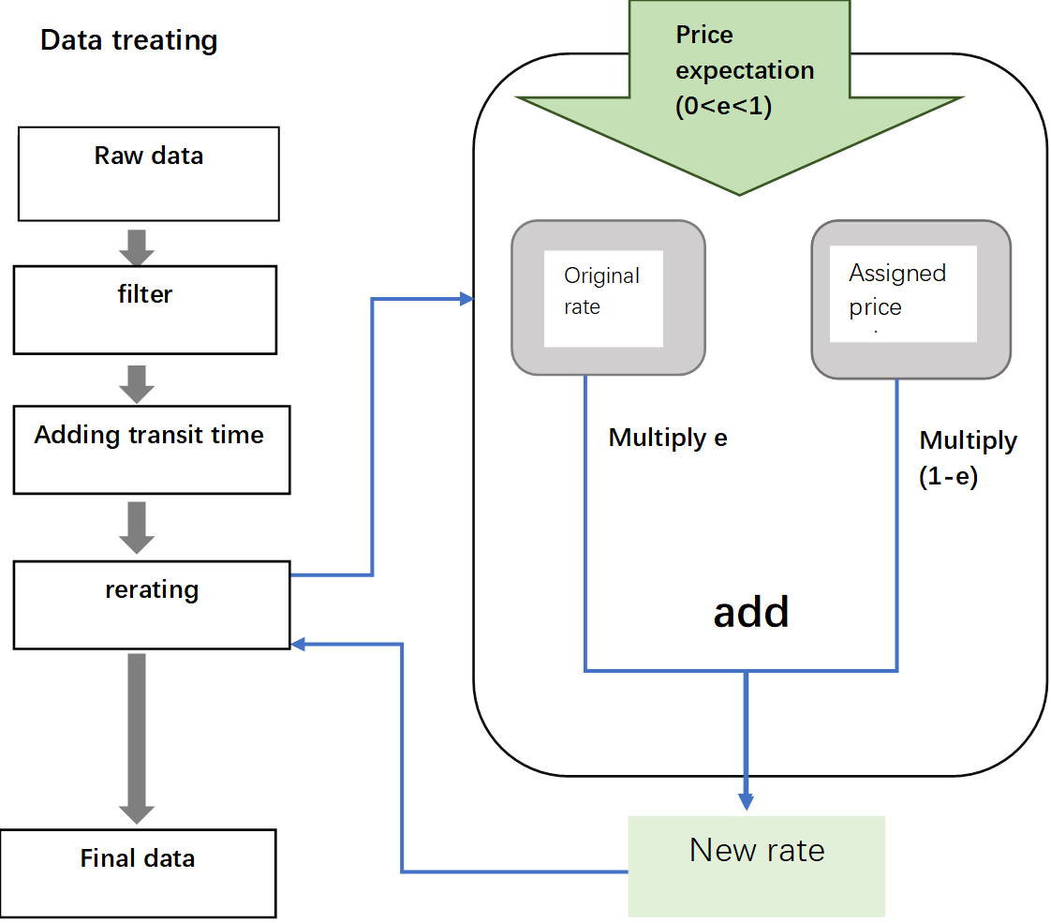

**3.2programing of the model**

Python PuLP pack was used to solve the Linear programming model.

LPMaximize was used to construct our LPproblem. A dictionary that contains the referenced variables was set for each restaurant. Since one is unable to go to a restaurant 0.5 times. The restaurant variables are constrained as integers with a lower bound of 0.

**4.Conclusion**

the result of our programming model suggests that

**5.Further improvement**

There are no specific figures of cost in the original database and they only provided the level of costs such as “average”, “expensive”, and “very expensive”, we might have to quantify them as coefficients or find other methods to calculate the index of costs.

The program could be improved by inputting more constraints by the user.

**References**

Lazaruk, S. (2021, July 6). *Why prices at your favourite B.C. restaurants may be going up*. vancouversun. Retrieved October 9, 2021, from https://vancouversun.com/business/local-business/expect-higher-prices-on-menus-restaurateur-warns-as-operating-costs-mount.

*Canada's food price report 2021*. Dalhousie University. (n.d.). Retrieved October 9, 2021, from https://www.dal.ca/sites/agri-food/research/canada-s-food-price-report-2021.html.

Edwards, D. (2021, June 20). *Restaurateurs grapple with rising menu prices, food costs amid covid-19 pandemic - national*. Global News. Retrieved October 9, 2021, from https://globalnews.ca/news/7965723/restaurant-food-costs-covid/.

Naveen Kumar, (2020). Vancouver restaurant Dataset, Version1. Retriveved October 7, 2020 from https://www.kaggle.com/banaveenkumar/vancouver-restaurent-dataset