CSC343 Assignment 1 Part 1 Report

# Experiment 1: optimal block size

The optimal block size according to our experiment on *write_blocks_seq* is 2MB. It does not correspond to the system disk block size which is 4096. Block size of 4MB did not perform better than 2MB. The performance increases as block size increases from 512B to 2MB (except for 8KB), and decreases as block size increases from 2MB to 4MB. This is because the larger the block size, the fewer I/Os are needed to write the file. The reason why 2MB block size has better performance than 4MB block size is probably the time to write larger buffer size increases more than the time of reduced I/Os.

*write_blocks_seq* is more efficient than *write_lines*, because *write_lines* are doing disk I/Os for each line whereas write_blocks_seq are doing disk I/Os for each block. Therefore, *write_blocks_seq* has less disk I/Os and has better performance.

Please see the plot below.

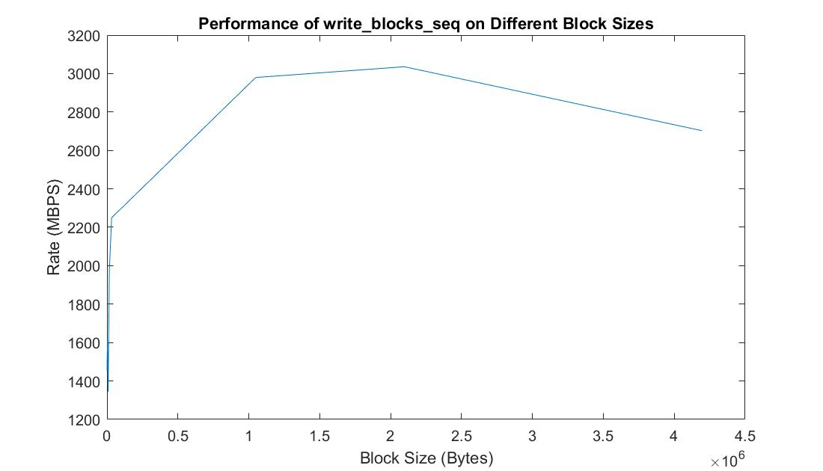

# Experiment 2: sequential vs. random read rate

*Note: We performed the following experiments using SSD on CDF with block size 2MB.*

We used Solid State Disk as the secondary storage, it has a sequential read rate of 1930 MB/s. The RAM has a sequential read rate of 2520 MB/s. The ratio rate between SSD and RAM in our experiment is 1930/2520 = 0.766, but the ratio discussed in class is 42/358 = 0.11. Our test result does not correspond to the ratio discussed in class. They both showed RAM having a faster read rate than SSD, but the discussed ratio is much lower than ours. We think that query is one of the reason caused the difference. We implemented a query in the program of testing RAM and SSD to read records from buffer, so the running time of query was an overhead while testing reading speed. The other problem is that we only tested 5 times for each experiment. We may need more tests to get a more accurate result.

The random read program for RAM (*read_ram_rand*) has the highest read rate around 2803 MB/s, while average for sequential read for RAM (*read_ram_seq*) is about 2521 MB/s. The query program in read_ram_seq takes more time because of extra executing time of query. Therefore, the read_ram_seq should have the highest read rate without query. *read_blocks_seq* and *read_blocks_ram* have a rate of 1927 MB/s and 513 MB/s separately. In SSD, sequential read take much less time than random read. In Addition, read_ram_seq has lower read rate than read_ram_rand because of query execution. RAM always takes less time to read both randomly and sequentially than SSD. In summary, we say RAM should have faster read speed than SSD, and also sequential read take less time than random read.

Please see the performance results on all different types of reads and writes below:

# Experiment 3: sequential vs. random write rate

In conclusion, we have learned that comparing to RAM, disk I/O operations are more expensive. Sequential reads and writes are more efficient than random reads and writes. In order to improve performance, we should consider fewer disk I/Os, reduce seek and rotation delays using sequential disk access instead of random disk access.