7.1.2 Product Related Artefacts

**Software Design**

**Software Architecture: Model-View-Controller Frame**

Model: data transfer between view and controller. For example, a customer object will be serialized into database and retrieved from database. It is the logic of database.

View: UI logical interface of the application. For example, users can view and interact with it.

Controller: an intermediate between Model and View. Process the incoming request and send back response.

**Developed Platform and language:**

Front-end: HTML, CSS, Javascript

Back-end: Node.js.

Database: MongoDB.

**User Interface Design: Bootstrap 3**

A free and open-source front-end library.

**Back-end Design: Express.js**

A web application framework for Node.js

**Implementation**

**Front-end Implementation checklist:**

|  |  |
| --- | --- |
| Features | Status |
| Client login interface(email, password) | Completed |
| Add Client information interface(email, password , name, home address, multiple contact numbers) | Completed |
| Edit Client information interface((email, password , name, home address, multiple contact numbers) | Completed |
| Add Pet interface(name, breed, birth of date) | Completed |
| Edit pet information(name, breed, birth of date) | Completed |
| Client personal homepage interface   * Buttons for Appointments (Upcoming Appointments, Appointment History, make Appointment) * Buttons for User Setting (Registry info and Pet info) * Reminder * Log out | Completed |
| Client make Appointments interface:   * Select a pet form list of dogs * Select from a list of available appointment times * Select one grooming option * Add a description | Completed |
| Client edit Appointments interface | Completed |
| Client view Appointments list (edit, cancel) | Completed |
| Groomer view a list of bookings interface | Completed |

All the code uploaded online.

**GitHub repository: https://github.com/yixiongchen/SWENProject.git**

**Interface Demo**

1. **Client login and register (username and password)**

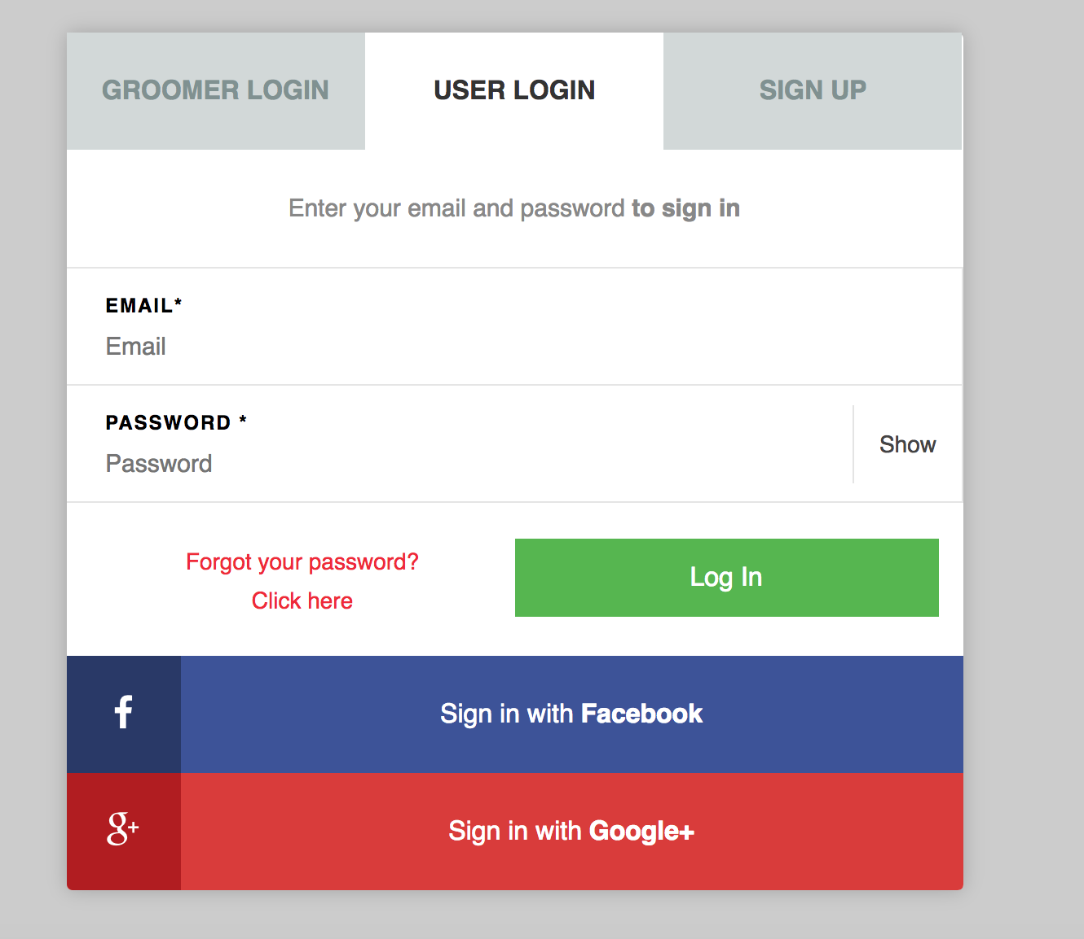

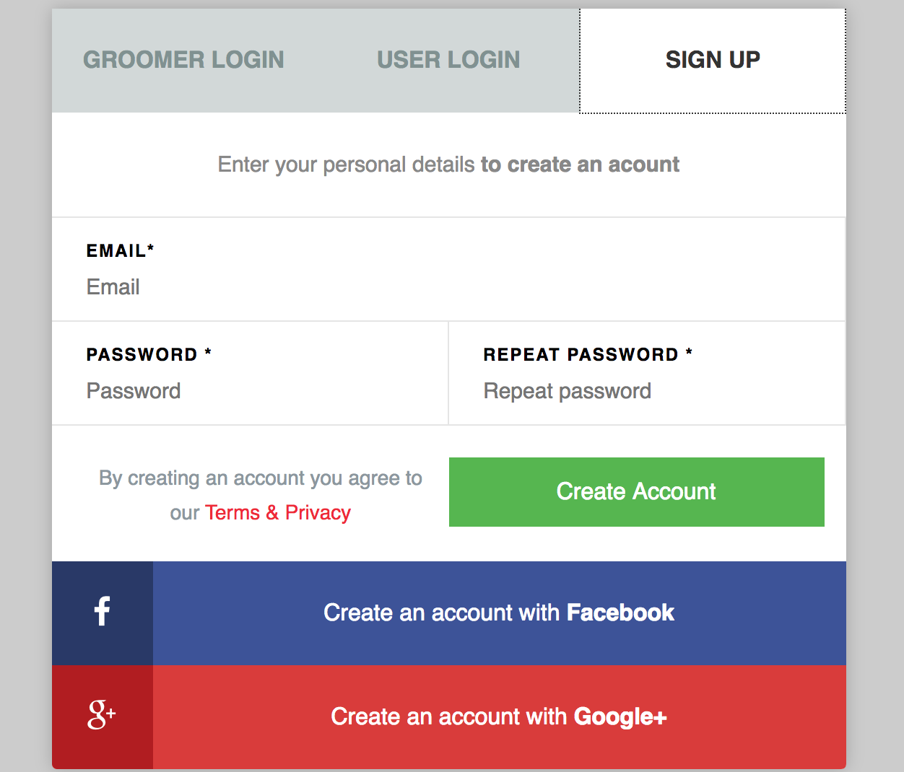

1. 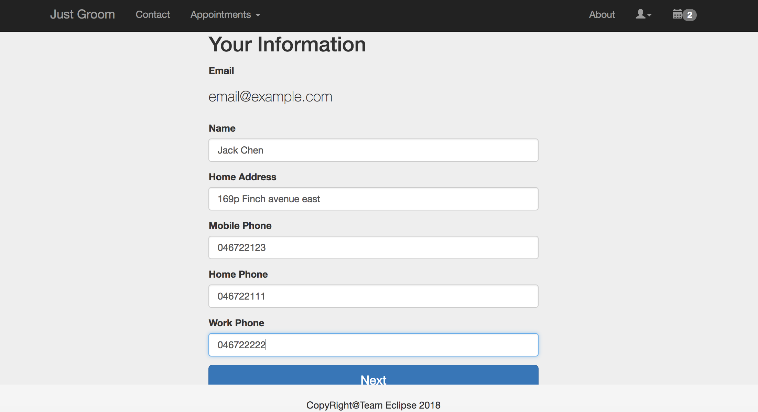**Add Client information**
2. **Add Pet information**

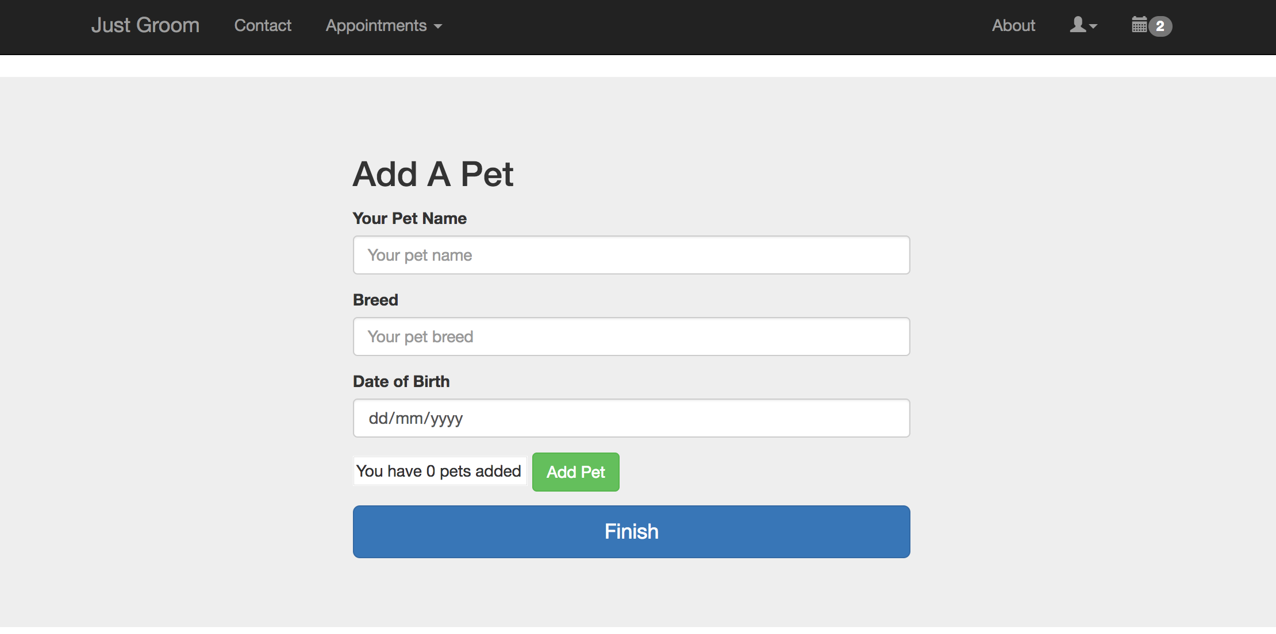

1. **Client make an Appointment**

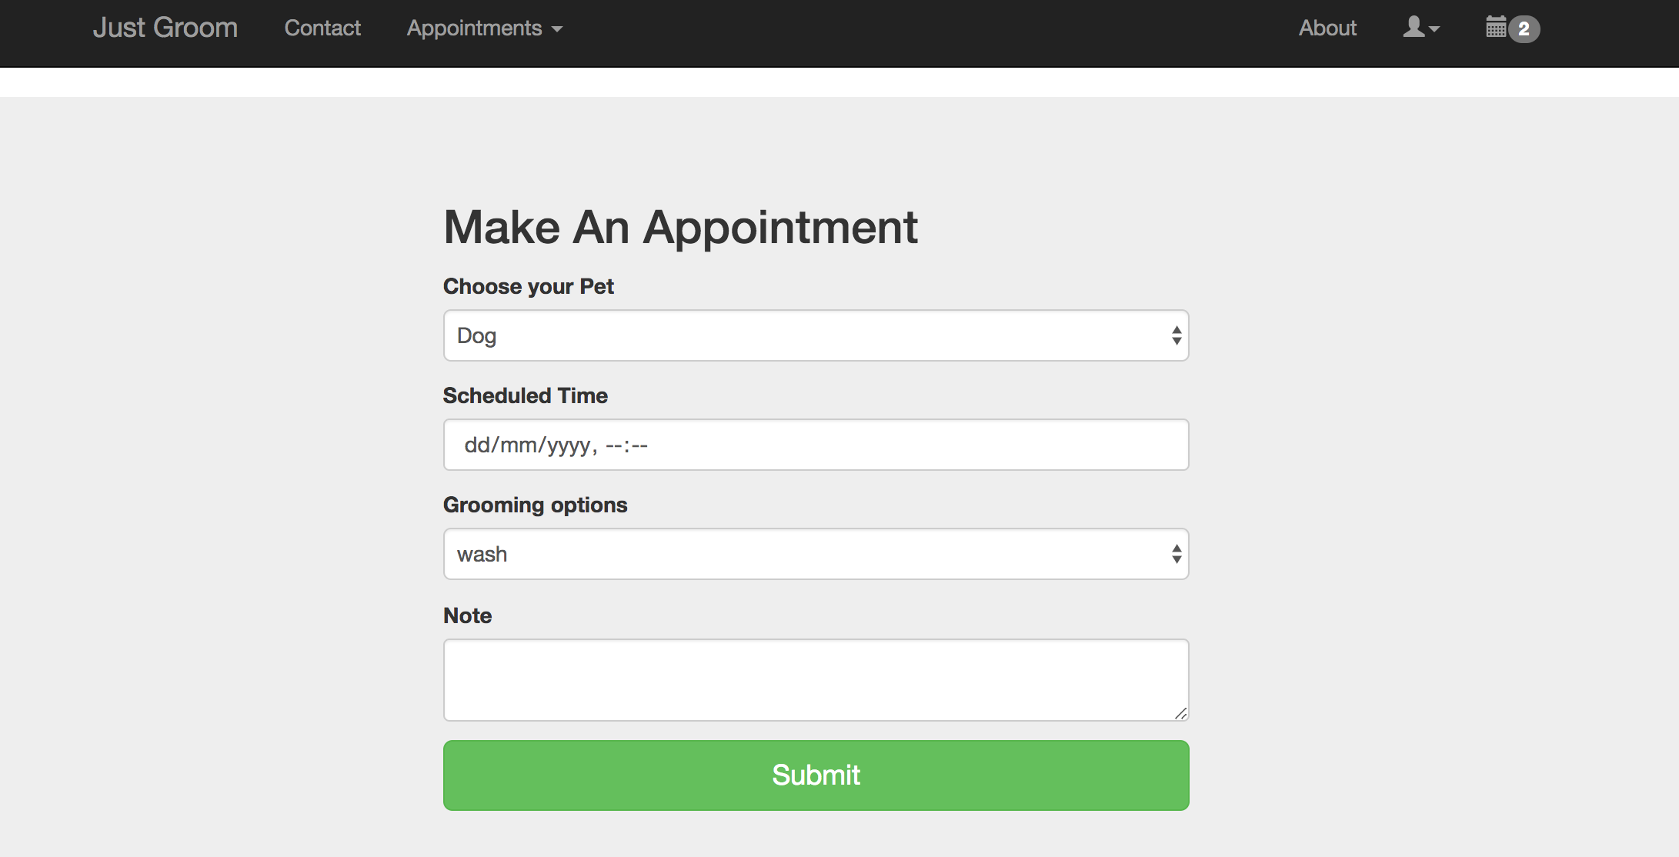

1. **Client edit and cancel appointments**

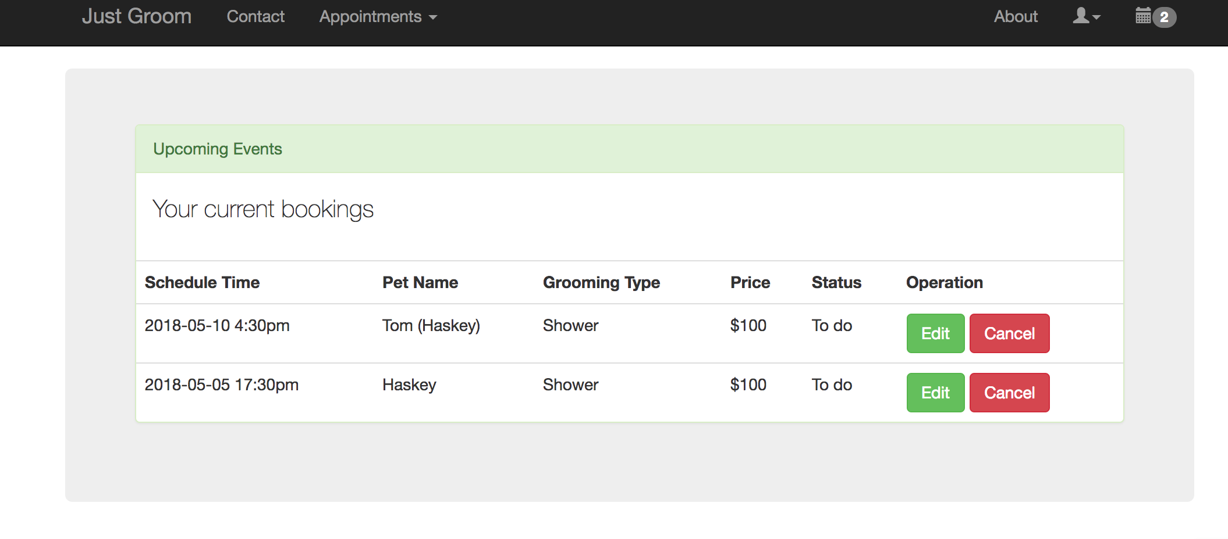

1. **Groomer view a list of bookings**

