FINS5545 · FINANCIAL MARKET DATA LITERACY
AtlasSignal
Funds, Sentiment and an Evidence-First Investment App
Project B: Data Factory Floor Stations 3–4
Student ID · z5646061
UNSW Business School · August 2026

Executive Summary
AtlasSignal is a prototype investment platform that integrates systematic portfolio construction, financial news sentiment analysis and a Streamlit app for investors. The project compares twelve funds, rather than assuming that one optimisation method will work best for every asset family. One main result is that Combined Risk Parity has the strongest risk-adjusted return performance within the combined family, although this result is based on a shorter historical sample so I would not treat the ranking as a forecast.
The twelve funds cover three asset families: equity-only, crypto-only and combined equity–crypto portfolios. Each asset family is tested using four construction methods: Equal Weight, Minimum Variance, Maximum Sharpe and Risk Parity. Performance is evaluated using a monthly walk-forward out-of-sample (OOS) design: target weights are only determined from information available before each rebalance date. After that, the holdings are allowed to drift with realized asset returns until the next monthly rebalance. Equity and combined funds use 252 observations and trading days per year, while cryptocurrency funds follow their original seven-day calendar and use 365 observations per year.
Within the equity family, Equal Weight has the highest realised Sharpe ratio at 0.819. Crypto Minimum Variance has the highest Sharpe ratio within the crypto family at 1.075, but this result is not low risk in the absolute sense: the annualised volatility is 76.9%, and the maximum drawdown is -72.8%. Combined Risk Parity has the highest Sharpe ratio within the combined family, at 0.888, with a 14.39% annualised return and 16.20% volatility. So, I think return should be considered together with volatility and drawdown, rather than ranking funds only by historical return.
Sentiment results are more mixed. VADER provides a transparent description of the tone of sector news, but adding the signal to Risk Parity has not improved the out-of-sample Sharpe ratio. The coverage-adjusted version performs better than the naive sentiment tilt strategy and produces less turnover, but it is still lower than the benchmark level based on price alone. Therefore, I regard coverage adjustment as a way to reduce the impact of under-representative news, rather than evidence that sentiment signals can create excess returns.
The Streamlit application transforms these results into a simple investor journey: compare fund product lines, open fund data tables, test historical fund allocations, and explore the sentiment experiment. Combined Risk Parity is a reasonable diversified reference portfolio in this prototype because it has the strongest risk-adjusted result within the combined family. This does not mean it will always outperform the other funds. The sentiment analysis function is still in the experimental stage. Before supporting investors' decision-making, real products also need to be checked for suitability, more accurate cost modelling and live-forward monitoring.
The evidence covers daily walk-forward OOS results from January 2021 to December 2023. The comparison of major funds assumes that the risk-free interest rate is 0% and the main fund comparison assumes 0 bps transaction costs. Turnover is still reported, and the fusion experiment also includes a 10 bps cost robustness check. These choices make prototypes easy to compare, but also limit the scope of promotion of historical results.

1. Fund design and walk-forward testing
Part B uses the cleaned equity, crypto and headline data prepared earlier to build a series of fund prototypes. The purpose is to compare the performance of different portfolio rules in the face of the same investment environment, rather than treating one optimiser as automatically correct. The final product includes twelve funds: equity-only, crypto-only and combined equity-crypto funds. Each asset family contains four funds constructed using Equal Weight, Minimum Variance, Maximum Sharpe ratio and Risk Parity.
These four methods rely on different information. The equal weighting method is the simplest benchmark, and does not use the estimated mean or covariance. The minimum variance method uses the covariance matrix to seek the lowest estimated portfolio variance. The maximum Sharpe ratio method also uses the estimated mean rate of return, so its weight depends more on the estimated value of the historical rate of return. Risk Parity focuses on the contribution of each asset to portfolio risk. These differences make it possible to produce different asset allocations and different out-of-sample performance even if the underlying assets are the same (Markowitz 1952; Maillard, Roncalli & Teiletche 2010).
Minimum Variance: min_w w' Sigma w
Maximum Sharpe: max_w [w'(mu - r_f)] / sqrt(w' Sigma w)
Risk contribution: RC_i = w_i (Sigma w)_i / (w' Sigma w)
Portfolio performance is evaluated using a monthly fixed-window walk-forward OOS backtest. On the first available date of each month, each model will generate a new target weight based on the estimation window before rebalancing. Subsequently, the portfolio holds these target weights and allows the weights to drift with the actual asset return until the next rebalancing. This schedule prevents future information from affecting decision-making and also avoids the assumption of daily rebalancing. All portfolios are long-only and fully invested. Equity and combined portfolios have a 10% maximum individual asset weight. Crypto-only portfolios use a 25% individual asset cap, while combined funds also have a 20% aggregate crypto-sleeve cap. These constraints reduce extreme concentration, although they do not remove estimation risk from the optimisation process.
Table 1. Walk-forward design by asset family. Windows and annualisation use observations on each family's stated calendar.
Family | Assets | Window | Periods/year | Live OOS period | Weight cap
Equity | 50 | 252 | 252 | 2021-01-04 to 2023-12-29 | 10%
Crypto | 10 | 365 | 365 | 2021-01-01 to 2023-12-31 | 25%
Combined | 60 | 252 | 252 | 2021-01-04 to 2023-12-29 | 10%; crypto sleeve 20%

Source: Author calculations from results/tables/backtest_design.csv; price inputs supplied through the course data-access helper.
Calendar processing is also very important. Equity and combined portfolios follow the U.S. stock trading calendar and use 252 trading days per year; while crypto-only funds retain all seven days and use 365 trading days. For the combined universe, crypto returns are first calculated based on the native seven-day calendar and are only then aligned to the equity trading date. If weekends were removed before calculating crypto returns, several days of crypto price movement would be combined into a single Monday return. In this project, the Sharpe ratio is reported with an annual risk-free interest rate of 0% as a modelling hypothesis (Sharpe 1966).

2. Portfolio results differ by asset family
Within the equity family, the equal weighted strategy has achieved the highest out-of-sample Sharpe ratio of 0.819, with an annualised return of 13.21% and a volatility of 16.12%. This result is important because in this sample, the simplest strategy produced a higher realised risk-adjusted return than the three optimisation methods. The Risk Parity strategy reduced the volatility to 14.53%, with a maximum drawdown of -18.49%, but its annualised return was only 10.51%, resulting in the Sharpe ratio of only 0.723. A reasonable explanation is that the equal weighting strategy is less sensitive to estimated errors because it does not depend on the estimated expected rate of return. This does not mean that optimisation is useless. Instead, it shows that a more complex model does not necessarily lead to better OOS performance.
Crypto needs to be evaluated on a different risk scale. The annualised arithmetic rate of return of Crypto Minimum Variance is 82.66%, the volatility rate is 76.91%, the Sharpe ratio is 1.075, and the maximum drawdown is -72.82%. The label “minimum variance” only indicates that its variance is lower than that of other cryptocurrency portfolios in the crypto opportunity set, which is not a low-risk investment in the traditional sense. Crypto Equal Weight and Crypto Risk Parity also lost about four-fifths of their previous peak value at the worst point, so the high growth path in the Exhibit A2 must be considered together with the drawdown in the Exhibit A3.
Table 2. Highest realised out-of-sample Sharpe fund within each family, January 2021–December 2023.
Family | Fund | Ann. return | Ann. vol. | Sharpe | Max DD
Equity | Equity Equal Weight | 13.21% | 16.12% | 0.819 | -20.25%
Crypto | Crypto Minimum Variance | 82.66% | 76.91% | 1.075 | -72.82%
Combined | Combined Risk Parity | 14.39% | 16.20% | 0.888 | -19.47%

Source: Author calculations from results/tables/performance_metrics.csv. Arithmetic annualised returns; risk-free rate 0%; 252/365 annualisation by family.
Within the combined equity–crypto family, Risk Parity produced the highest realised Sharpe ratio, at 0.888. Its annualised rate of return is 14.39%, slightly lower than the 16.43% of the equal weight strategy, but the volatility is lower. The annualised volatility is only 16.20%, while the equal weight strategy is 21.60%; the maximum drawdown is also smaller, -19.47% and -27.87% respectively. The Minimum Variance strategy further reduces volatility to 12.52%. It also has the shallowest maximum drawdown, which is -15.78%, but the annualised rate of return drops to 6.48%. So there is no simple “best” fund based on one number. The choice depends on how much return, volatility and drawdown the investor is willing to accept.
For this prototype, I would use Combined Risk Parity as the main diversified reference portfolio. The reason is that it achieves a balance between return, volatility and drawdown in the combined family, not because it wins all indicators. It still fell by about one-fifth from the previous high, so the results should be presented in the form of a historical risk-adjusted comparison, rather than a commitment to future performance.

3. Construction method changes risk, exposure and turnover
Exhibit A4 helps explain why funds built with the same assets take different paths. Combined Equal Weight is mechanically stable because each of the 60 assets receives the same target weight, so that the crypto sleeve accounts for about 16.7%, which is lower than the upper limit of 20%. The combined Risk Parity strategy is also relatively stable. Healthcare is its largest average equity sector exposure at about 14.0%, and the annualised turnover is 44.3%. This stability is very important because adjusting the target weight will generate trading activities, and the main fund comparison assumes zero transaction costs.
Although the minimum variance strategy reduces overall volatility, it may still lead to concentrated sector exposure. In the comprehensive historical data, its largest average sector weights are Healthcare (27.8%), Consumer (18.6%) and Communication Services (17.9%). This is consistent with the model's goal of finding a low-covariance portfolio under the set constraints, and also explains why a single risk indicator should not be used to describe a low-volatility portfolio. Therefore, the application shows the latest OOS target weights as of December 1, 2023, including sector composition and cryptocurrency configuration, rather than live holdings.
Maximum Sharpe is the least stable construction method in the sample. It has not reached the highest realised Sharpe ratio in any family. Annualised turnover for equity is 292.9%, the crypto is 236.4%, and the combined fund is 299.9%. One possible reason is that it is difficult to estimate the expected rate of return reliably. Small changes in the historical average rate of return may lead to significant fluctuations in the tangency portfolio, especially when assets are close to their weight limit. Therefore, the optimisation can still be mathematically correct while the estimated inputs remain noisy. For more realistic products, I suggest testing the mean shrinkage effect and turnover penalty mechanism before adopting this method.
Each of the twelve fact sheets summarises the required indicators: growth of $1, annualised rate of return, volatility, Sharpe ratio, maximum drawdown and the latest OOS target configuration. In addition, it also contains additional information such as Sortino ratio, historical 95% Value at Risk (VaR), Expected Shortfall (ES) and portfolio turnover. The latest target comes from OOS rebalancing on December 1, 2023, which is a backtest model target, not a real-time recommendation.

4. What the sector sentiment index shows
The independent sentiment index uses VADER to score 146,830 mapped headlines. VADER is a transparent dictionary-and-rule method that can use lexical polarity together with casing, punctuation, intensifiers and negation (Hutto & Gilbert 2014). Therefore, the original title text was retained instead of being forcibly cleaned up. This makes the model easy to audit, but also leaves an important limitation: the general-language lexicon may misread financial terms, irony or market-specific contexts.
The aggregation aims to prevent heavily covered companies from dominating a sector. Headlines are first averaged within each ticker-day. The available ticker-day scores are then averaged equally within each sector-day. This prevents a company with many headlines from dominating the sector index. The complete sector-date grid keeps 228 no-news sector-days as missing rather than treating them as neutral. For the use of the portfolio, the signal comes from the previous stock trading day, so weekend or Monday-aligned news cannot affect the Monday decision. It first becomes available to the portfolio signal on the next equity trading day.
Sector sentiment_s,t = (1 / N_s,t) sum_i Sentiment_i,t
Exhibit A6 draws the ten sector series from 2020 to 2023 as the average value of 21 trading days. The average original sentiment of each sector is positive. Materials has an average raw sentiment of about 0.096, while Utilities is about 0.184, but these levels cannot be directly compared without considering the coverage rate. Utilities has average ticker coverage of 59.3%, and there are 44 trading days without news, while Technology has average ticker coverage of 86.5%. Therefore, the high sentiment reading based on weak or concentrated news should be lower than the same interpretation based on extensive reports.
Even without profitable trading rules, the index is still very useful as a descriptive feature. It transforms unstructured headlines into auditable sector-level time series and makes different contents of news reports visible to users. Its weakness is also obvious: the data is headlines rather than complete articles, publisher information is limited, syndicated headlines may be repeated, and VADER does not measure whether the news is economically surprising. These restrictions are the reason for treating the index as a context rather than a direct return forecast.

5. Coverage adjustment helps control a weak signal
The main innovation is based on the news-concentration measure developed in Part A. When most headlines come from only a few tickers, or when there is very little news in the sector, the sector sentiment score is less representative. Therefore, AtlasSignal adjusts the lagged relative-sector sentiment signal using a confidence term, which combines the normalised headline HHI of the previous three completed months with the ticker coverage of the past 21 trading days. Only the information available before the portfolio decision enters this adjustment stage.
Confidence_s,t = (1 - mean HHI_s,t over 3 completed months) × sqrt(Coverage_s,t over prior 21 trading days)
At each monthly rebalance, the lagged 21-trading-day sector sentiment mean is standardised across sectors, clipped, and scaled to a maximum 25% relative tilt. This tilt only applies to the equity side of risk parity; the crypto targets in the combined fund remain unchanged. This gives three directly comparable situations: price-only Risk Parity, naive sentiment tilt and coverage-adjusted sentiment tilt. The 25% setting is the main design, and the 10%, 25% and 40% tilt strength and the 0 or 10 basis point cost are used as robustness checks, not selected after observing the best results.
Table 3. Base Risk Parity versus 25% sentiment tilts at zero transaction cost, January 2021–December 2023.
Family | Variant | Ann. return | Ann. vol. | Sharpe | Ann. turnover
Equity | Base Risk Parity | 10.51% | 14.53% | 0.723 | 37.3%
Equity | Baseline Sentiment | 9.90% | 14.50% | 0.683 | 58.8%
Equity | AtlasSignal Coverage-Adjusted | 10.04% | 14.52% | 0.692 | 53.1%
Combined | Base Risk Parity | 14.39% | 16.20% | 0.888 | 44.3%
Combined | Baseline Sentiment | 13.83% | 16.16% | 0.856 | 63.7%
Combined | AtlasSignal Coverage-Adjusted | 13.95% | 16.18% | 0.862 | 58.3%

Source: Author calculations from results/tables/fusion_comparison.csv; all portfolio decisions use lagged information.
The main result is that adding sentiment did not improve risk-adjusted performance. Equity Sharpe fell from 0.723 under price-only Risk Parity to 0.683 under the naive sentiment tilt and 0.692 after coverage adjustment. Within the combined fund, the Sharpe ratio dropped from 0.888 to 0.856 and 0.862. Turnover also increases after adding sentiment. For equity, annualised turnover is 58.8% under the naive tilt and 53.1% after coverage adjustment. For the combined fund, the figures are 63.7% and 58.3% respectively.
The robust results point in the same direction. All 24 non-base strength-and-cost cases have a negative change in Sharpe, so there is no evidence that sentiment rules create alpha. However, every coverage-adjusted case loses less Sharpe and produces less turnover than its matched naive case. I think this is mainly a problem of data quality: when news coverage is weak or concentrated, reducing the confidence level can mitigate the impact of weak signals, but it cannot make the underlying sentiment signals stronger. There are several possible reasons. Headlines may already be incorporated into prices quickly, while sector aggregation can remove firm-level information. VADER also has limited financial vocabulary, and monthly rebalancing may be too slow for a short-lived signal.
For products, the coverage index can serve as a warning of signal quality rather than a source of market return. I suggest that after testing on longer prospective samples, real costs and alternative text models, the sentiment portfolio function should remain experimental.

6. How the app presents the evidence
AtlasSignal is aimed at users with financial knowledge who can understand return, volatility, drawdown and diversification, but do not want to use the underlying Python pipeline in depth. Therefore, the design of this application focuses more on decision analysis than model development. It allows users to compare different funds, view a certain fund in detail, test a historical allocation scenario, and then explore the sentiment evidence. The purpose is to make assumptions and risks clearly visible, rather than providing intraday trading signals or personalized advice.
- Compare Funds: Twelve products are compared by product category and construction method, while showing the return, volatility, Sharpe ratio and maximum drawdown. You can also download the exact comparison table.
- Fund Fact Sheet: You can open any fund to view its performance path, drawdown, required statistics, the latest OOS target holdings and sector or cryptocurrency composition. In addition, other downside risk and turnover indicators are available for reference.
- Allocation Lab: Users can combine up to four fund sleeves in a historical allocation scenario. The allocation inputs are normalised to 100%, and each combination is allowed to drift after initial allocation. When a native crypto fund is included, weekend crypto returns are retained. This scenario does not rebalance the fund sleeves every day. Their weights are allowed to drift after the initial allocation.
- News & Innovation: users can inspect sector sentiment and news coverage, then compare price-only Risk Parity with the naive and coverage-adjusted sentiment variants.
The deployed application reads the precomputed CSV artifacts from the results/ directory instead of running VADER on the server or rebuilding the portfolio backtest. This maintains the responsiveness of the interface and separates model production from display. In addition to using colors, the visual design also adopts method shapes and line styles, and no horizontal page overflow problems were found in desktop and 390-pixel-wide browser tests.
The app also includes several basic guardrails. Crypto drawdowns remain visible in the app. The latest OOS target has been marked with the date of December 1, 2023. The allocation input is normalised transparently, and the negative sentiment results will not be hidden. These designs reduce the possibility of users confusing high historical returns with low risk. However, these measures cannot replace suitability assessment, legal disclosure, liquidity and custody analysis, or real-time operational records.

7. Reflection and recommendations
Some parts of the project worked better than I expected. Reusing the Part A data foundation meant I did not need to copy raw data into Part B. Timing and calendar tests also caught several small implementation choices that could affect the return series. The construction of all twelve funds also makes it easier to compare the behaviors of different methods. In the integrated data set, Combined Risk Parity produced the strongest combined-family Sharpe in this sample, and the application associates summary statistics with growth, drawdown and target configuration views instead of presenting a single indicator number alone.
Other parts did not work as well. The maximum Sharpe ratio is unstable and the turnover is high, which further highlights the sensitivity of Maximum Sharpe to noisy mean-return estimates. More importantly, the sentiment tilt reduced the Sharpe ratio in all tested tilt strengths and cost assumptions. Although the coverage adjustment alleviated this deteriorating trend, it failed to reverse it. I think it is more meaningful to keep this negative result than to choose the least negative setting and present it as a success. For me, the result supports using coverage as a data-quality control rather than claiming predictive alpha.
The evidence is also limited by the sample. The OOS period only covers 2021 to 2023 and includes unusually volatile crypto market conditions. Since the same OOS period is used to compare multiple funds, the ranking depends on the sample, not the results found independently. The performance of major funds assumes zero transaction costs and a 0% risk-free rate. When returns are highly volatile, the arithmetic annualised return may be significantly different from compound investor growth. Sharpe also uses volatility as its risk measurement indicator, so maximum drawdown, Value at Risk (VaR) and Expected Shortfall are still important.

Recommendation 1 — Use Combined Risk Parity as the prototype reference portfolio
I suggest setting Combined Risk Parity as the default diversified reference portfolio in the prototype, because it has the strongest combined family Sharpe ratio (0.888), and its maximum drawdown is -19.47%, which is materially lower than Combined Equal Weight’s -27.87%. The 20% aggregate crypto-sleeve cap should be retained, and the loss path should be displayed before the user allocates funds. Minimum Variance can sit beside it as a more defensive option. This does not mean Risk Parity will always be the best fund.

Recommendation 2 — Treat sentiment as an experiment, not a product claim
I would not present the sentiment tilt as an alpha strategy. A better next test is to freeze the current coverage-adjusted rule at a 25% maximum relative tilt and test it prospectively for at least another twelve months, adopt a realistic transaction-cost assumption, and add a preset finance-specific or supervised text model as a comparison. The main measures should be the change in the Sharpe ratio, turnover, the sector coverage, and the drawdown relative to the price-only Risk Parity base. Even if the sentiment tilt remains disabled, the coverage confidence indicator can still be used as a warning about whether the available news is representative.

Recommendation 3 — Add suitability and operating controls before any launch
Before the prototype can support real investors, I will add a short risk questionnaire and convert the answers into asset allocation limits. The application should show severe crypto drawdown and liquidity-stress scenarios, display transaction costs before confirmation, and mark configurations beyond the crypto allocation guardrail. The result artifacts should also be rebuilt through a scheduled and versioned process, including versioned input data, data-failure alerts, and audit logs to ensure that outdated targets cannot be displayed without notice.

8. Limits of the evidence and next questions
• If the sample time is longer and covers different interest-rate, equity and crypto regimes, will the fund ranking remain similar? Would the result also hold in a true live-forward sample?
• After applying mean shrinkage, turnover penalty and explicit transaction costs to the entire fund pool, how much of Maximum Sharpe's instability would remain?
• Would a finance-specific sentiment model, event classification, or firm-level timing capture information that the sector-level VADER signal misses without introducing look-ahead bias or retrospective parameter selection?
• How will custody, liquidity, taxation, management fees and investor suitability affect product design and the 20% crypto-sleeve cap used in portfolio funds?
The current results support an educational prototype and a series of clear follow-up tests, but do not support personal investment advice, a causal claim that news sentiment drives future returns, or a guarantee that the fund with the highest Sharpe ratio in this OOS sample will still be the best choice in the future.

References
Hutto, C.J. & Gilbert, E. 2014, 'VADER: A parsimonious rule-based model for sentiment analysis of social media text', Proceedings of the Eighth International AAAI Conference on Weblogs and Social Media, pp. 216–225, https://eegilbert.org/papers/icwsm14.vader.hutto.pdf.
Maillard, S., Roncalli, T. & Teiletche, J. 2010, 'The properties of equally weighted risk contribution portfolios', The Journal of Portfolio Management, vol. 36, no. 4, pp. 60–70, https://doi.org/10.3905/jpm.2010.36.4.060.
Markowitz, H. 1952, 'Portfolio selection', The Journal of Finance, vol. 7, no. 1, pp. 77–91, https://doi.org/10.1111/j.1540-6261.1952.tb01525.x.
Sharpe, W.F. 1966, 'Mutual fund performance', The Journal of Business, vol. 39, no. 1, pp. 119–138, https://doi.org/10.1086/294846.
UNSW Business School 2026a, FINS5545 Financial Market Data Literacy: FinTech Project 2026 – Systematic Multi-Asset Funds with News-Sentiment Analytics, course project brief, UNSW Sydney.
UNSW Business School 2026b, FINS5545 Financial Market Data Literacy: Data Guide, course handout, UNSW Sydney.

Appendix A — Required Exhibits
The exhibits below are derived from precomputed Part B outputs. Each is referenced and interpreted in the main report. The sample period, units and principal limitation are repeated so each exhibit can be read independently.
Exhibit A1. Walk-forward out-of-sample performance across twelve AtlasSignal funds, January 2021–December 2023.
Fund | Ann. return | Ann. volatility | Sharpe | Max drawdown
Equity Equal Weight | 13.21% | 16.12% | 0.819 | -20.25%
Equity Minimum Variance | 6.47% | 12.50% | 0.518 | -15.66%
Equity Maximum Sharpe | 11.09% | 16.63% | 0.667 | -19.13%
Equity Risk Parity | 10.51% | 14.53% | 0.723 | -18.49%
Crypto Equal Weight | 67.87% | 81.89% | 0.829 | -81.57%
Crypto Minimum Variance | 82.66% | 76.91% | 1.075 | -72.82%
Crypto Maximum Sharpe | 43.46% | 76.35% | 0.569 | -82.56%
Crypto Risk Parity | 68.90% | 79.89% | 0.862 | -79.87%
Combined Equal Weight | 16.43% | 21.60% | 0.761 | -27.87%
Combined Minimum Variance | 6.48% | 12.52% | 0.518 | -15.78%
Combined Maximum Sharpe | 14.24% | 19.34% | 0.736 | -19.33%
Combined Risk Parity | 14.39% | 16.20% | 0.888 | -19.47%

Source: Author calculations from results/tables/performance_metrics.csv. Arithmetic annualised return; 252 periods for equity/combined and 365 for crypto; risk-free rate 0%; baseline cost 0 bps.
Reading note: the highest Sharpe differs by family. Crypto returns are accompanied by 76–82% volatility and 73–83% drawdowns, so cross-family return rankings without risk are misleading. The three-year sample is descriptive, not a forecast.

Exhibit A2. Growth of an initial $1 across methods, by asset family, January 2021–December 2023.
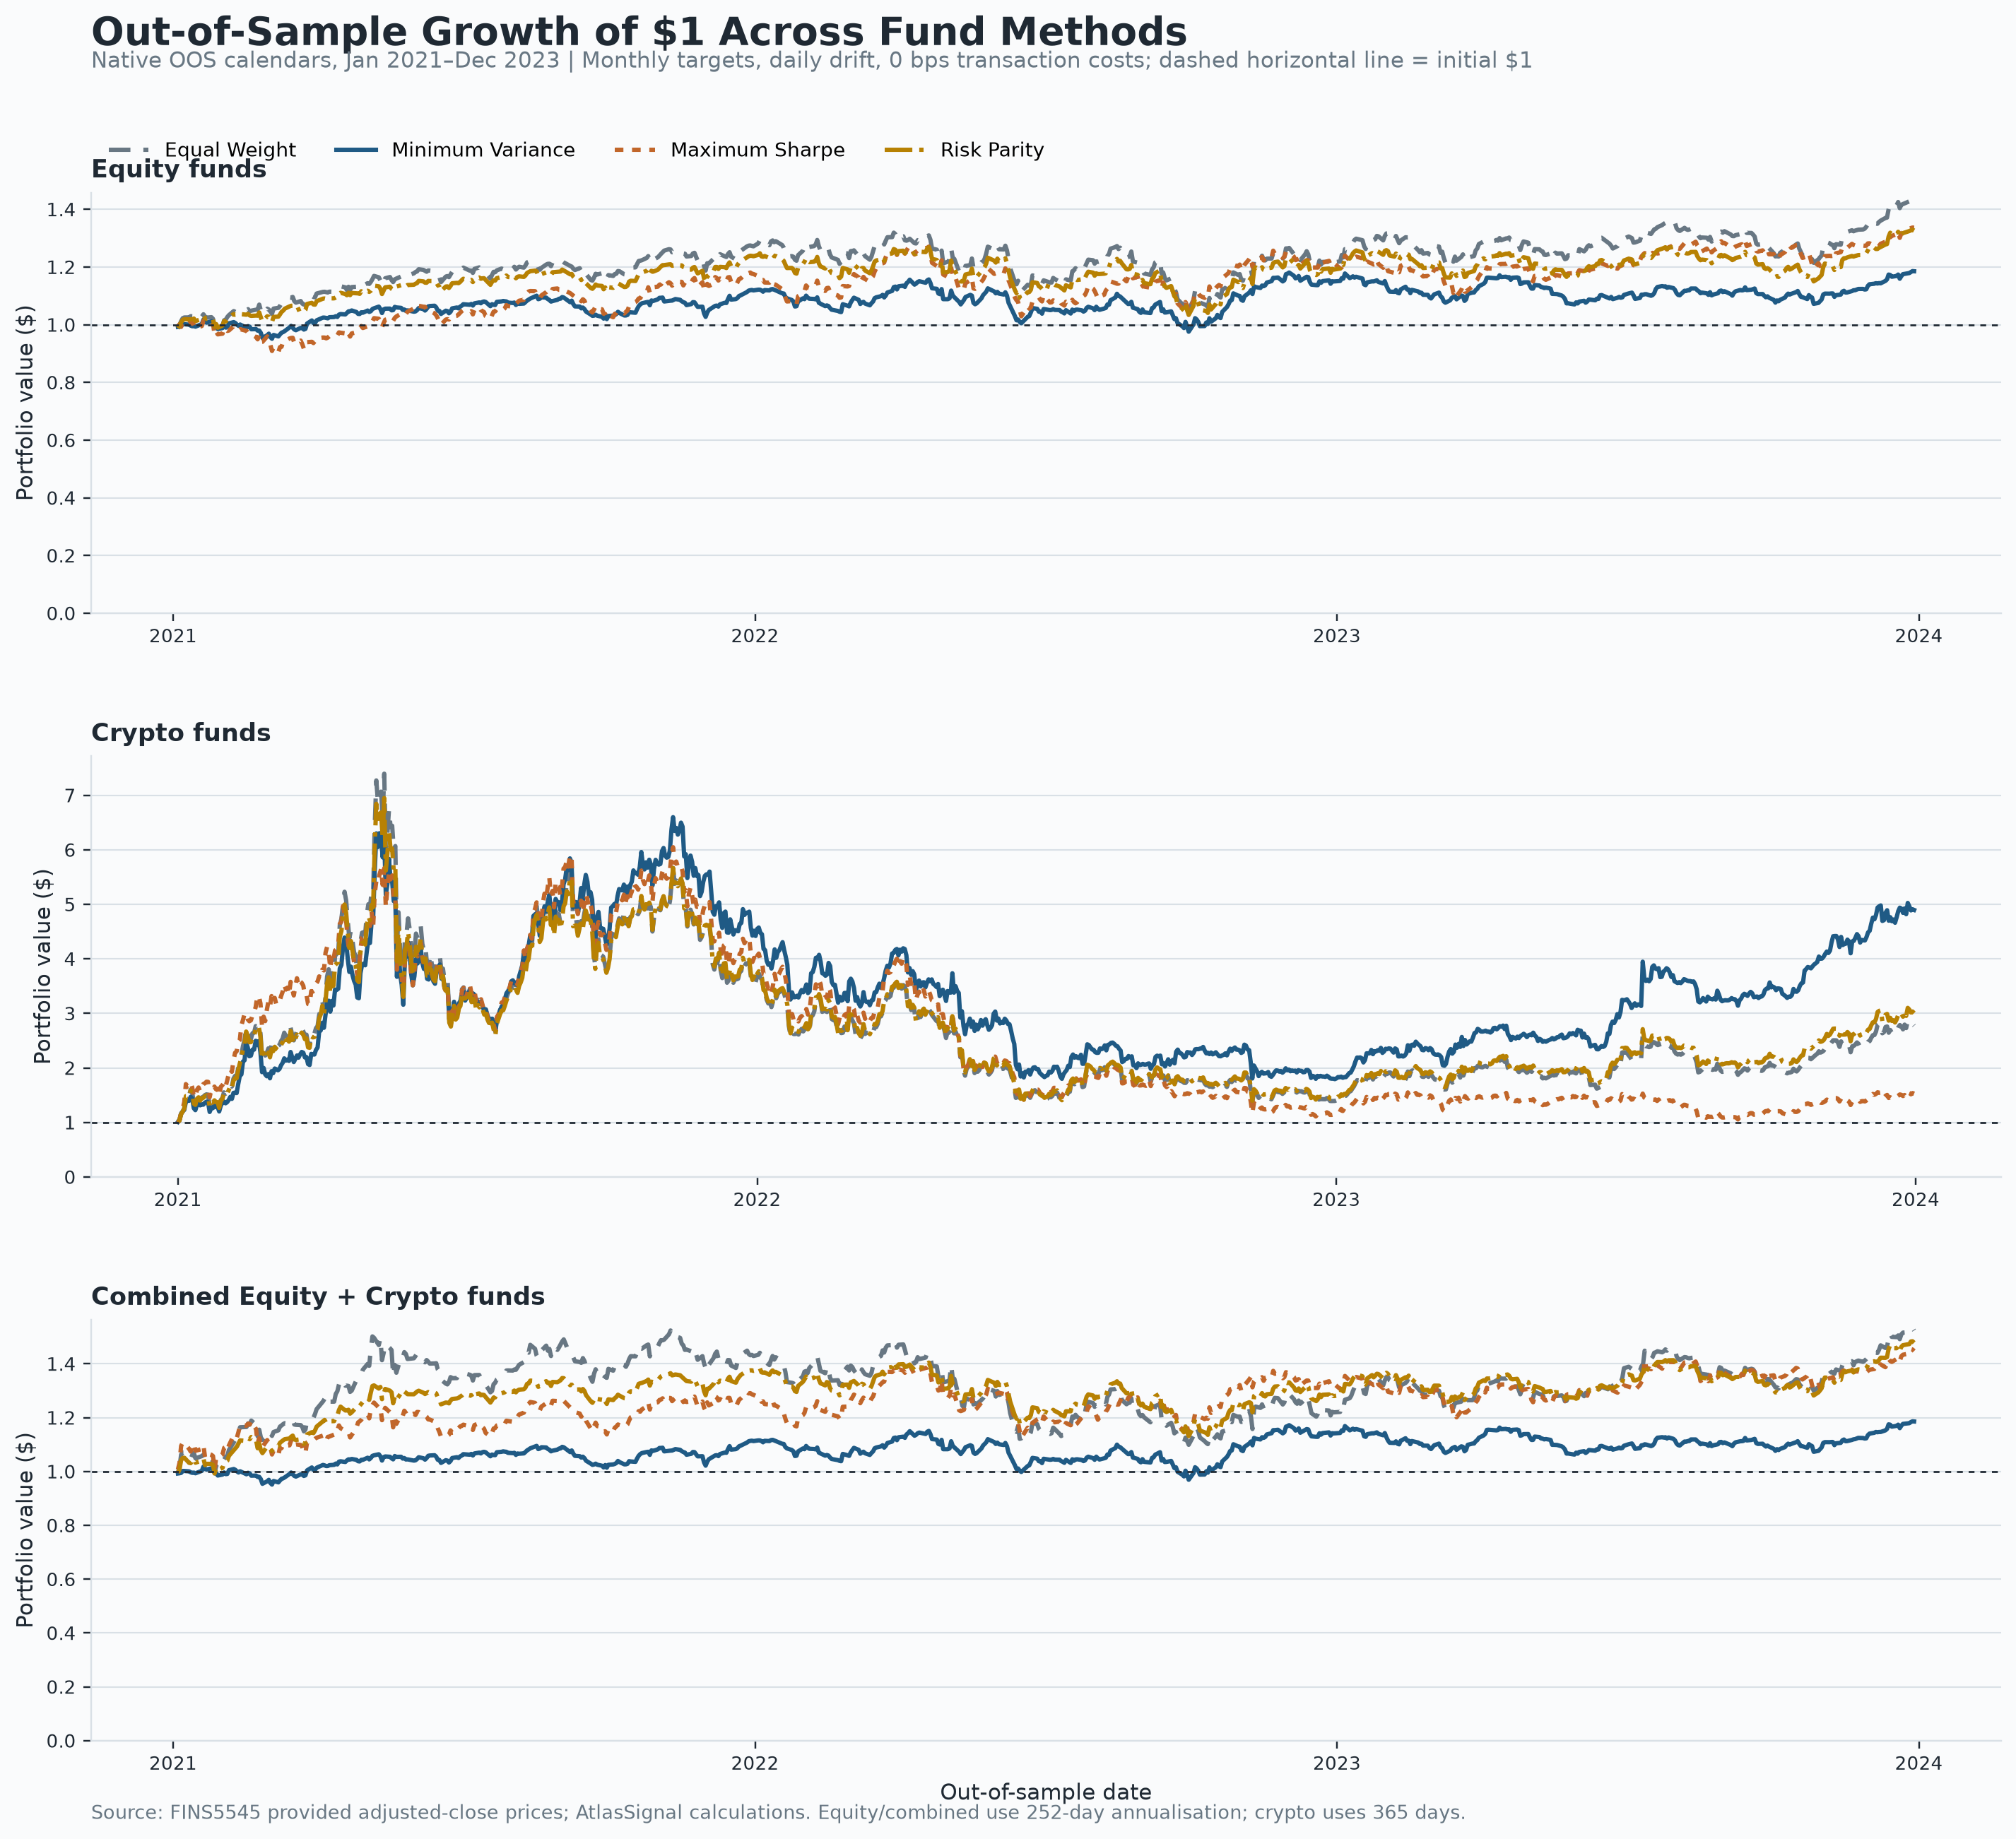
Source: Author calculations from the committed Part B result artifacts; market and headline inputs supplied through src/data_access.py.
Reading note: crypto reaches the highest ending wealth but follows a much more volatile path. Within the combined family, Risk Parity achieves a steadier path than Equal Weight; ending wealth alone does not measure repeatability or tail risk.

Exhibit A3. Drawdown from the running peak across methods, by asset family, January 2021–December 2023.
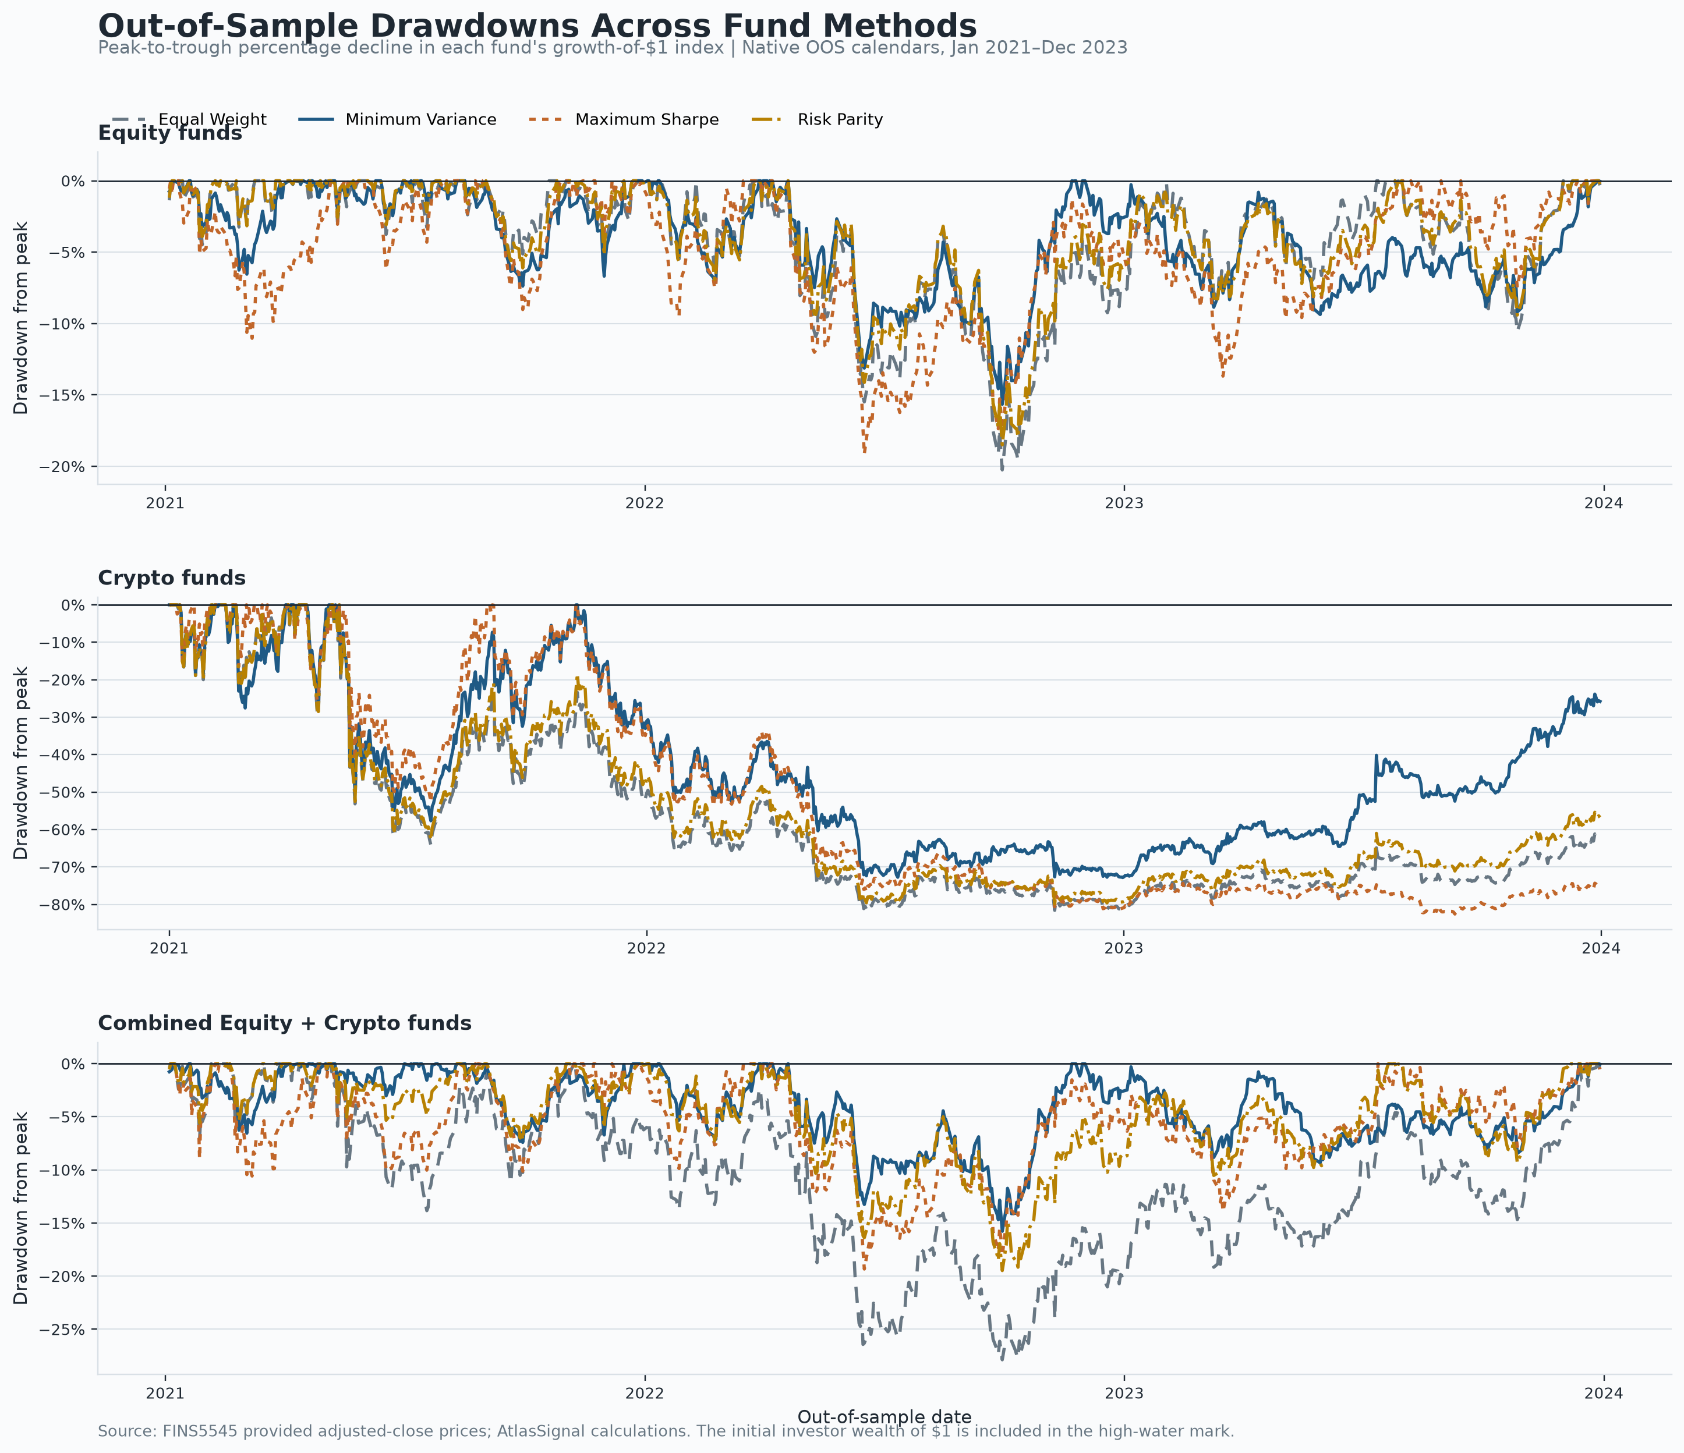
Source: Author calculations from the committed Part B result artifacts; market and headline inputs supplied through src/data_access.py.
Reading note: crypto funds lose roughly three-quarters to four-fifths from their running peaks, while combined funds remain materially less severe. Drawdown depends on the observed path and can be worse in future.

Exhibit A4. Combined-fund target allocation by sector or crypto sleeve and method, 36 monthly rebalances from January 2021 to December 2023.
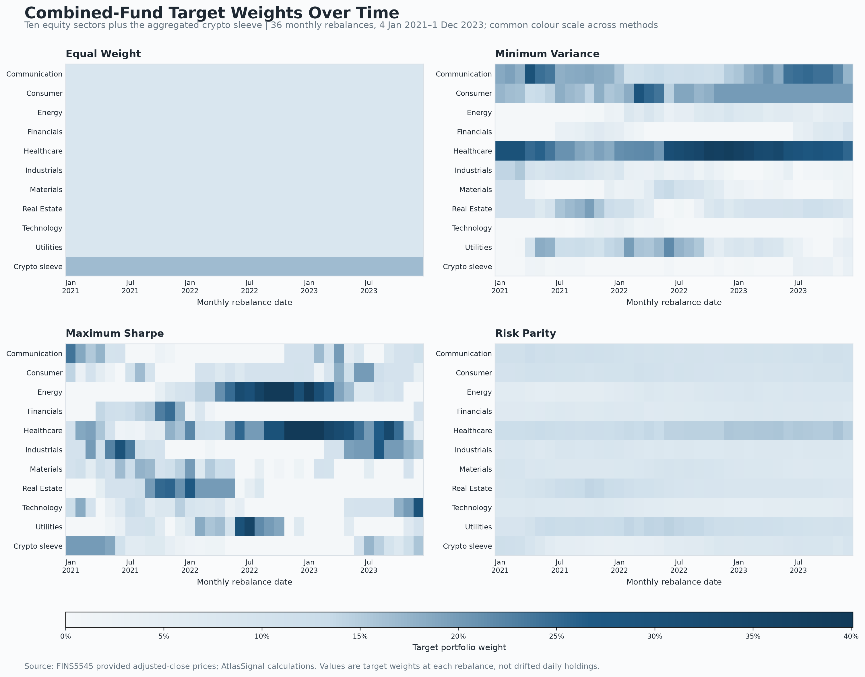
Source: Author calculations from the committed Part B result artifacts; market and headline inputs supplied through src/data_access.py.
Reading note: Equal Weight is stable, Maximum Sharpe shows the largest regime shifts, and Minimum Variance carries visible sector concentration. The colours are monthly target weights, not daily drifted holdings.

Exhibit A5. Realised out-of-sample Sharpe ratio across funds and methods, January 2021–December 2023.
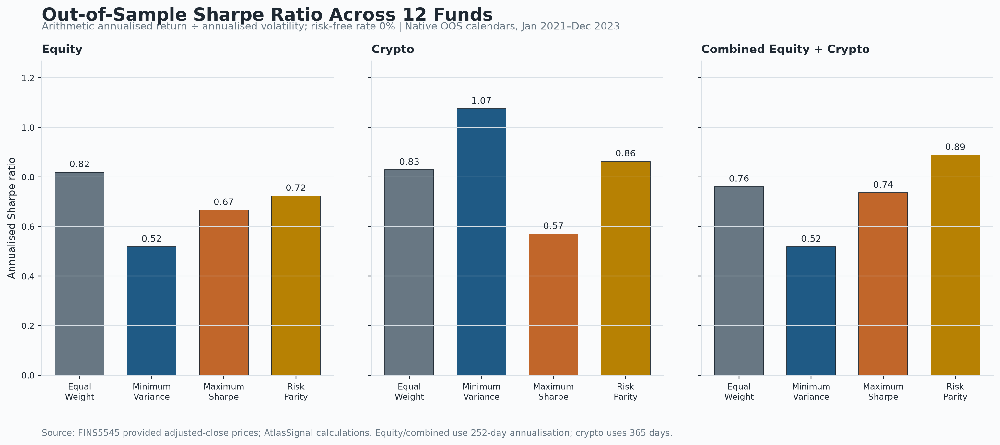
Source: Author calculations from the committed Part B result artifacts; market and headline inputs supplied through src/data_access.py.
Reading note: the leading method changes by family and Maximum Sharpe does not lead any family. Sharpe uses a zero risk-free rate and volatility as its risk denominator; it is not a guarantee.

Exhibit A6. Equal-ticker VADER sector sentiment index, shown as 21-trading-day means, January 2020–December 2023.
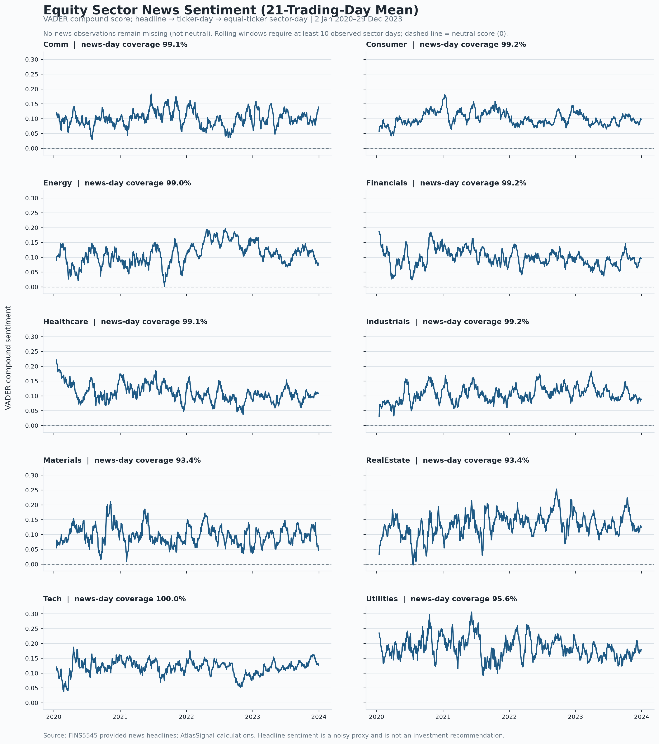
Source: Author calculations from the committed Part B result artifacts; market and headline inputs supplied through src/data_access.py.
Reading note: sector tone varies over time, but levels must be interpreted with coverage. No-news sector-days remain missing rather than being classified as neutral; the plotted series is descriptive, not a return forecast.

Exhibit A7. Risk Parity before and after sentiment tilts, with strength and transaction-cost robustness, January 2021–December 2023.
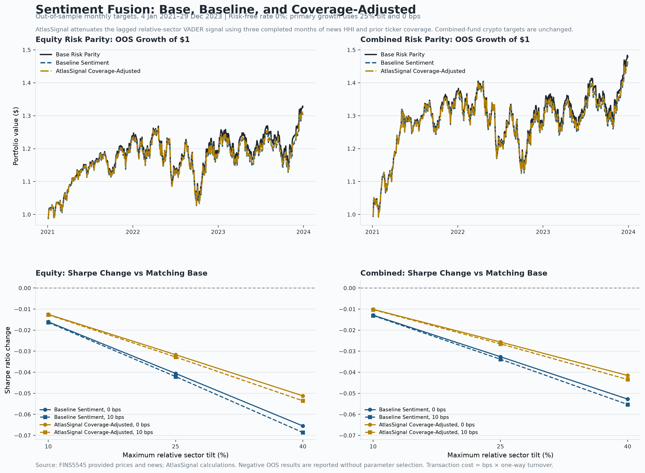
Source: Author calculations from results/data/fusion_returns.csv and results/tables/fusion_robustness.csv. Signals use only lagged information; strength grid 10%, 25% and 40%; costs 0 and 10 bps.
Reading note: every non-base robustness case has a negative Sharpe change. Coverage adjustment consistently loses less Sharpe and creates less turnover than the matched naive tilt, supporting a confidence-control interpretation rather than an alpha claim.

Appendix B — Reproducibility and AI Transparency
All raw data are accessed through src/data_access.py. The complete local reproduction command is python scripts/run_part_b.py; the deployed Streamlit app reads only the committed precomputed outputs under results/. Model, data and app tests are kept under tests/, while scripts/check_handin.py checks the final folder. The submitted ai/ directory records the prompts, proposed changes, validation evidence, identified weaknesses and student decisions.
AI assisted with code structure, debugging, validation, chart and app design, and preparation of an initial report draft. Numerical claims were checked against saved CSV outputs and automated tests. I reviewed and rewrote the assessed economic interpretation and critical reflection in my own words, and the submitted ai/ directory records the main AI-assisted workflow, corrections and final student decisions.

