**Exercise 1**

1. Average and dispersion in product characteristics

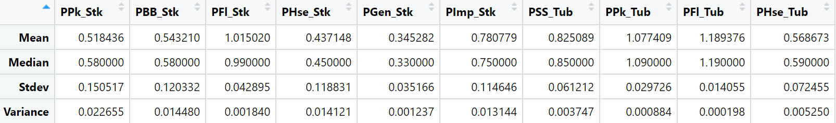

1. Market share
2. By product



1. By brand



1. By stk/tub



1. Mapping between observed attributes and choices

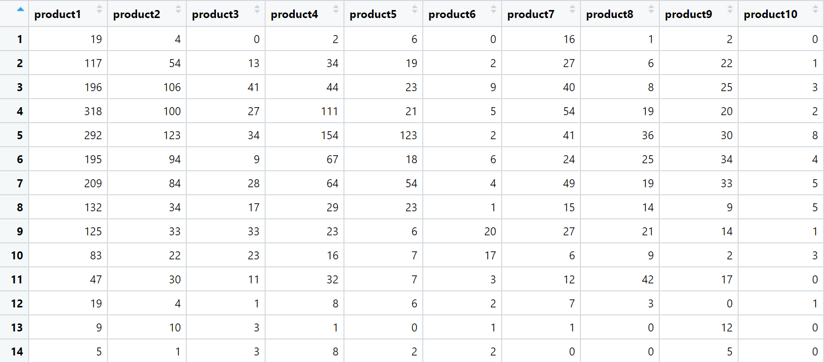

**Exercise 2**

Result:



Interpretation: here $β$ is negative, which means price and demand are negatively related. Holding all other variables constant, if the unit of price increases, the demand will decrease, and vice versa.

**Exercise 3**

Result:



Interpretation: for positive $β$’s mean that income has a positive relationship with demand; for negative $β$’s mean that income has a negative relationship with demand, and vice versa.

**Exercise 4**

1. Marginal effect of the first model

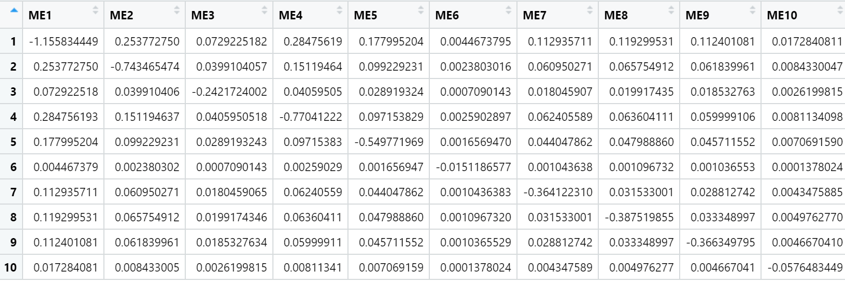

Interpretation: All elements on the diagonal are negative, which means if the price of the product increases, the demand of this product will decrease; all elements that are off-diagonal are positive, which means price and demand have a positive relationship.

1. Marginal effect of the second model



Interpretation: the marginal effects of the income are super small, which means income has very little almost no effect on demand.

**Exercise 5**

Mixed logit model of full set of choices



Mixed logit model of all the choices expect choice number 2



Conclusion on IIA:

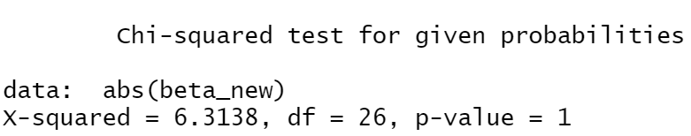

The Chi-squared equals to 6.3138 which is smaller than MTT, which means we have enough evidence to reject the IIA, so there is an IIA violation on this model.