Smart Pocket
User Manual
Step-by-step guide for everyday users
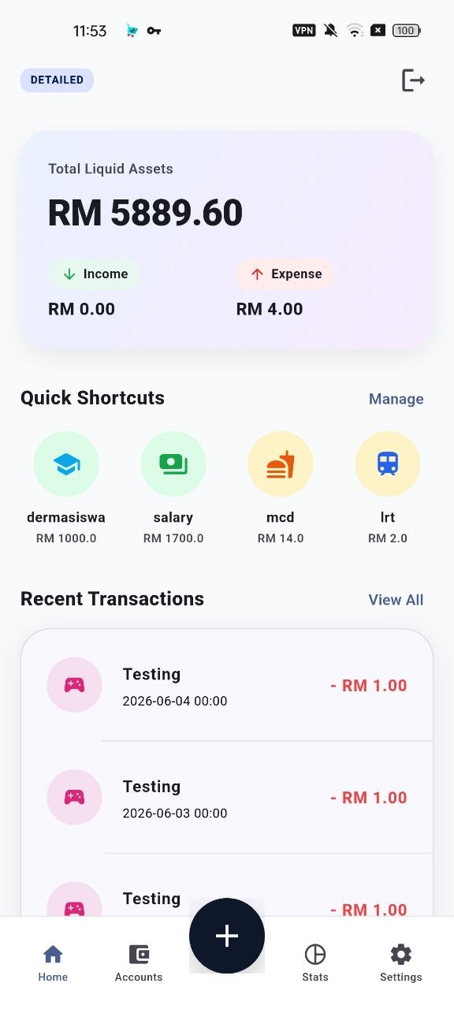
Main dashboard reference screen
System | Smart Pocket Personal Financial Management App
Platform | Android mobile application
Prepared for | PTA II / Final Year Project II evaluation
Version | User manual draft generated on 2026-06-23

How to Use This Manual
This manual explains how a normal user can use Smart Pocket from first login until daily financial tracking, reporting, backup, and settings management. The steps follow the current Smart Pocket implementation and the modules described in the thesis.
Recommended first-time order
Register or sign in, complete the Smart Survey, choose the operating mode, create accounts or set total assets, set a monthly budget, create categories or shortcuts if needed, then begin recording transactions.

Module Coverage Checklist
Module | Covered in this manual | Main user outcome
Authentication and profile | Sections 1 and 11 | Users can register, log in, recover account access, and update profile/security details.
Smart Survey and operating mode | Sections 1 and 8 | Users can complete the first survey and switch between Lazy Mode and Detailed Mode.
Dashboard | Section 2 | Users can view balances, shortcuts, and recent transactions from the main screen.
Account and asset management | Section 3 | Users can add accounts, manage balances, use provider presets, and maintain asset buckets.
Asset allocation goals | Section 3.4 | Users can set target percentages and review daily use, savings, and investment allocation.
Budget management | Section 4 | Users can set monthly budgets and understand budget warnings.
Category management | Section 4 | Users can add, edit, and delete income or expense categories.
Transaction recording | Section 5 | Users can record expense, income, and transfer transactions.
Transaction history and editing | Section 5.4 | Users can filter, edit, delete, and undo supported transaction changes.
Shortcuts and Lazy Mode | Section 6 | Users can create one-tap shortcuts and use simplified transaction entry.
Recurring transactions | Section 7 | Users can schedule repeated income, expense, or transfer records.
Analytics and visualization | Section 9 | Users can inspect monthly budget usage, category spending, cash flow, and investment P/L.
PDF report generation | Section 9.5 | Users can export monthly finance reports.
Backup and restore | Section 10 | Users can create cloud backup, export JSON backup, and restore saved data.
Settings, security, and theme | Section 11 | Users can manage biometric lock, dark mode, credential updates, and reset options.

1. First-Time Access

1.1 Open Smart Pocket
- Open the Smart Pocket app on the Android device.
- On the welcome screen, choose Login if you already have an account, or choose Create Account/Register if you are a new user.
- Use a stable internet connection for login, registration, password recovery, cloud sync, and backup actions.
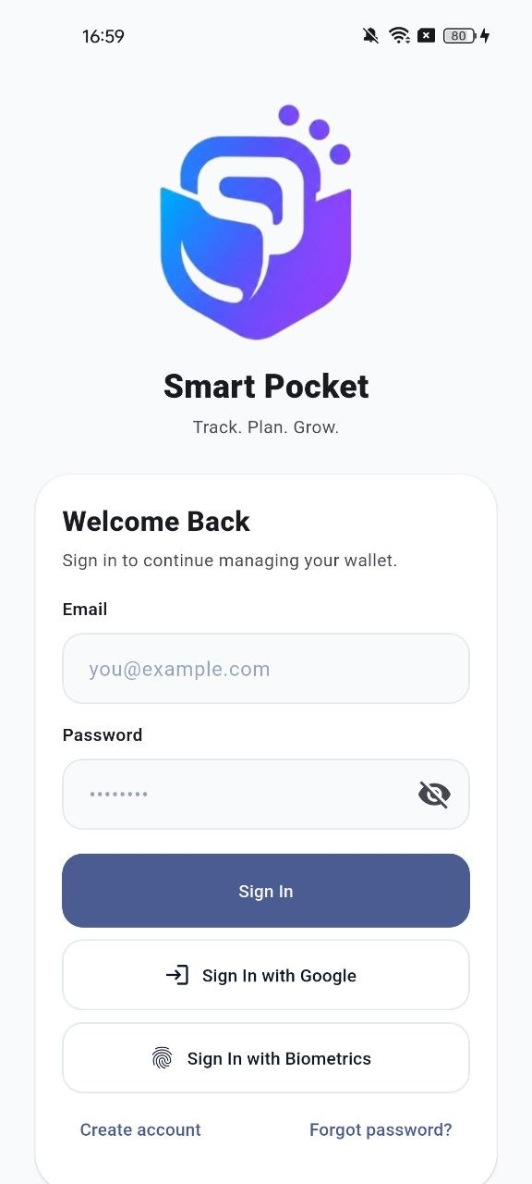  Welcome page | 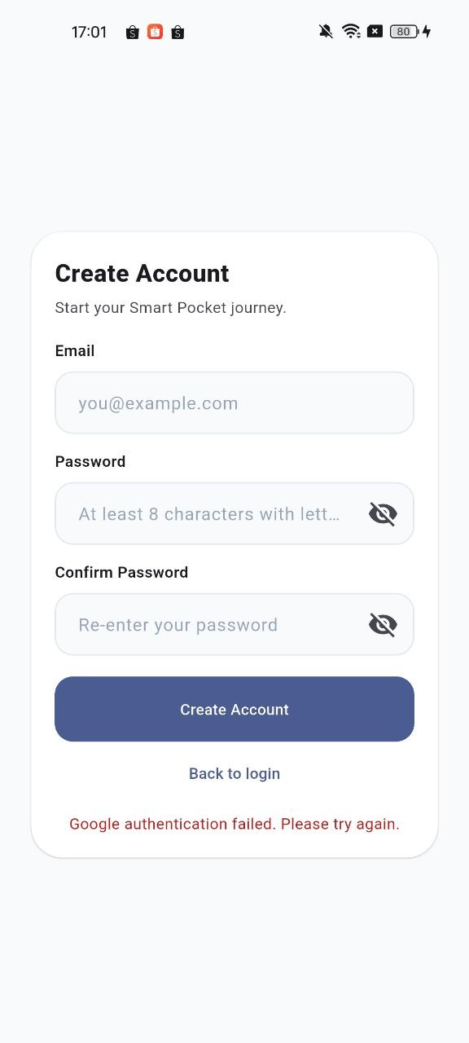  Create account page

1.2 Register a New Account
- Tap Create Account.
- Enter a valid email address.
- Enter a password and confirm the same password.
- Tap the register button and wait until the app creates your account.
- After successful registration, continue to the Smart Survey when it appears.
Important
If the password confirmation does not match, the app will stop the registration and ask you to correct it.

1.3 Log In
- Open the login page.
- Sign in using email and password, or use Sign In with Google if your account is linked to Google.
- If biometric login is enabled on the device and in Smart Pocket, tap Sign In with Biometrics.
- Wait for the app to load the dashboard or the required setup page.
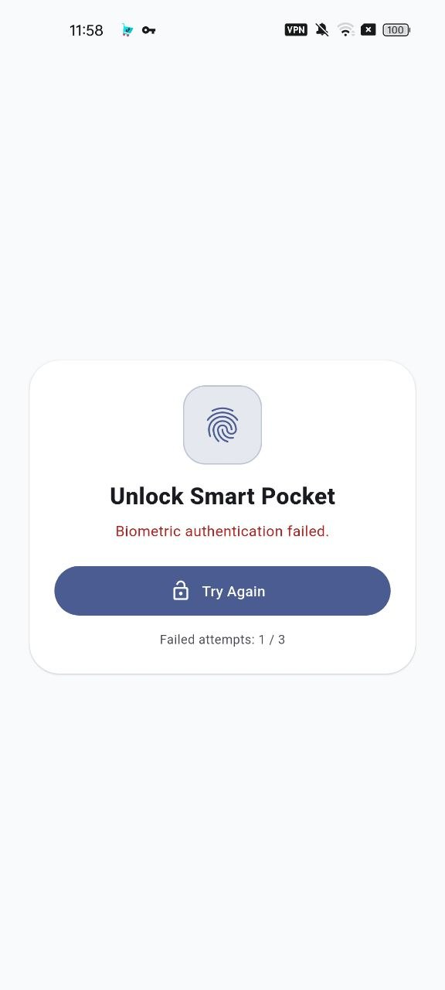
Biometric unlock page

1.4 Recover a Forgotten Password
- On the login page, tap Forgot password.
- Enter the registered email address.
- Tap the reset option and check the email inbox.
- Open the reset email and follow the password reset link.
- Return to Smart Pocket and log in again with the new password.
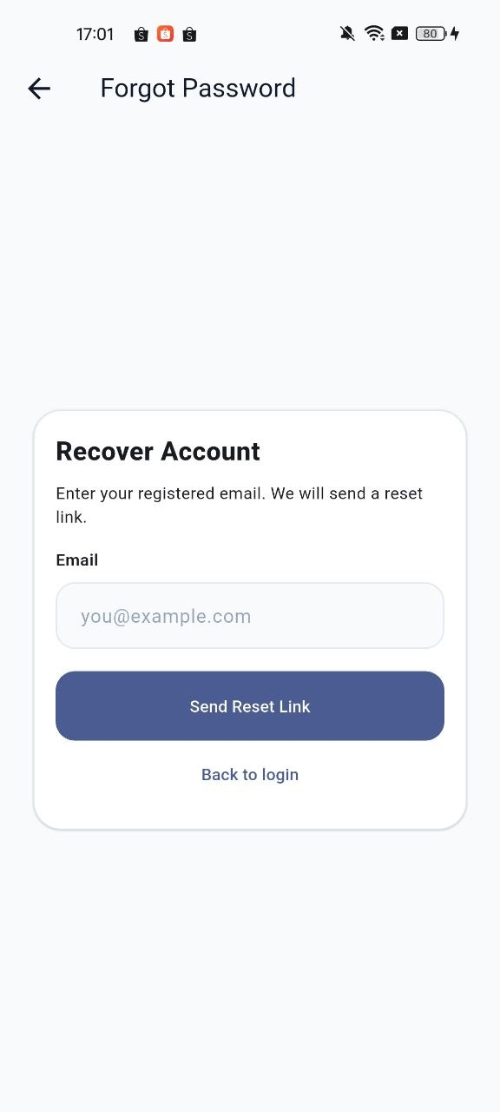
Forgot password page

1.5 Complete the Smart Survey
- After first login, answer the Smart Survey questions about spending awareness, saving ability, and budgeting confidence.
- Submit the survey.
- Smart Pocket uses the survey result to recommend an initial operating mode.
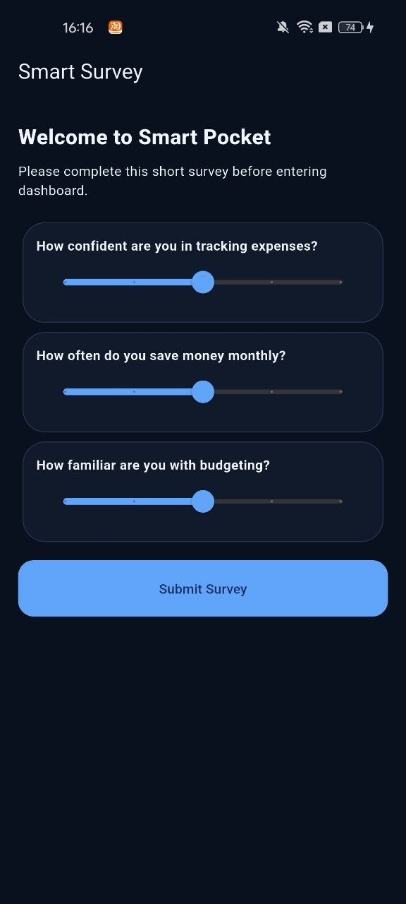
Smart Survey page

2. Dashboard
The dashboard is the main screen after login. It gives a quick view of the current financial position and provides fast access to common actions.
Dashboard page

2.1 Read the Dashboard
- Total Liquid Assets shows the available liquid amount based on account and asset settings.
- Recent transactions show the latest financial activities.
- Shortcuts allow faster recording of frequent transactions.
- The bottom navigation bar lets users move between major pages.

2.2 Use Dashboard Shortcuts
- Check the shortcuts area on the dashboard.
- Tap a saved shortcut for a common transaction.
- If a default account is already set, Smart Pocket records the transaction directly.
- If no default account is set, choose the source account or bucket when the selection dialog appears.
- Confirm the action and check the recent transaction list.

3. Account and Asset Management
The account and asset module helps users manage bank accounts, e-wallets, savings, investments, and total assets. It supports both detailed account tracking and simpler total asset tracking.
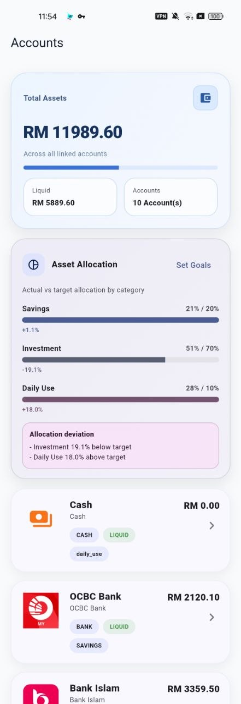  Accounts page | 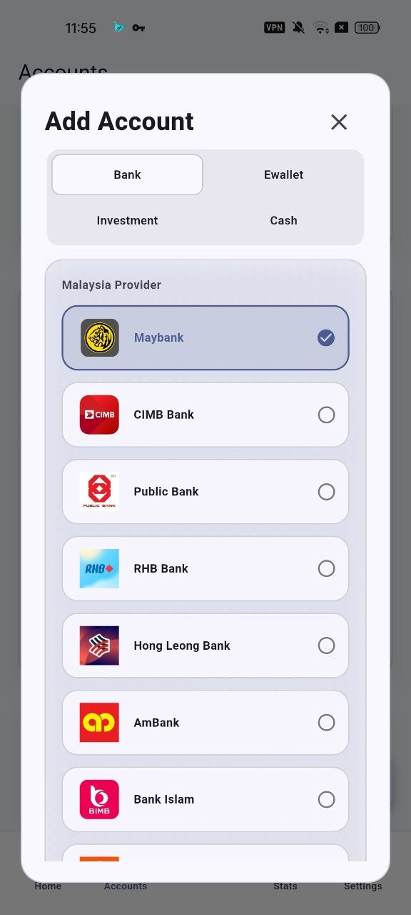  Account form

3.1 Add an Account
- Open the Accounts page.
- Choose the option to add or create an account.
- Select the account type, such as bank, e-wallet, saving, investment, or other supported account type.
- Choose a Malaysian provider preset when available, or enter a custom provider/name.
- Enter the opening balance or current balance.
- For investment accounts, decide whether the account should be included in liquid assets.
- Save the account and confirm that it appears in the account list.

3.2 Edit an Account or Balance
- Open the account details or edit form.
- Update the account name, provider, type, note, or balance.
- If updating an investment balance, review the profit/loss warning before saving.
- Save the change and check that the account summary is updated.

3.3 Delete an Account
- Open the account details page.
- Choose delete if the account is no longer needed.
- Read the confirmation message carefully.
- Confirm only if you are sure, because the balance and linked records may be affected.

3.4 Set Asset Allocation Goals
- Open Asset Allocation Goals from the account or asset area.
- Enable allocation goals.
- Choose a template such as Conservative, Balanced, or Aggressive, or enter custom percentages.
- Make sure Daily Use, Savings, and Investment percentages total exactly 100%.
- Save the goals.
- Use tag suggestions if Smart Pocket recommends account tags based on balances.
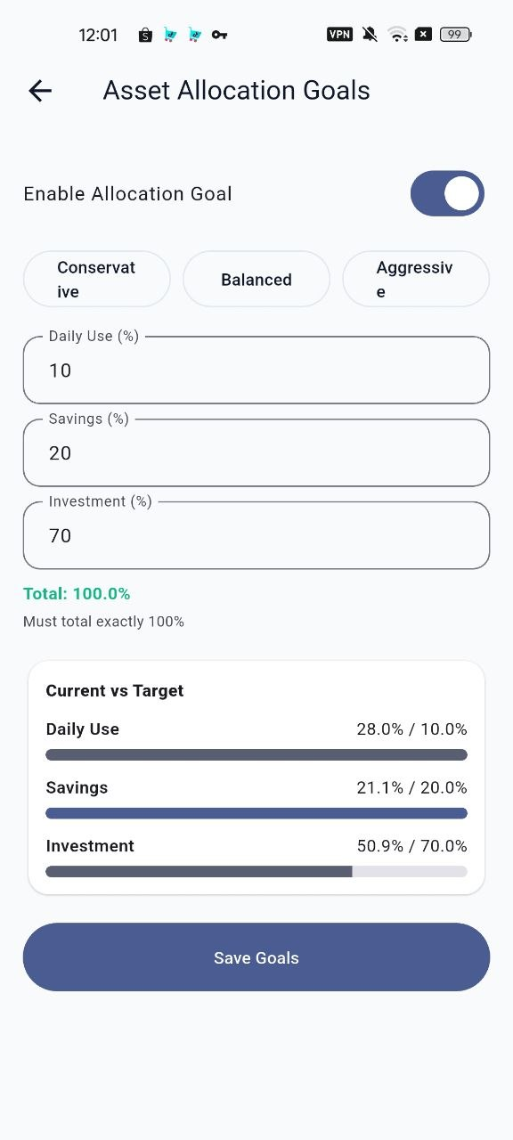
Asset allocation goals page

4. Budget and Category Management

4.1 Set or Update Monthly Budget
- Open Settings or the budget entry point.
- Open Monthly Budget.
- Select the target month if the month selector is available.
- Enter the budget amount in RM.
- Tap Save.
- Use the Analytics page to check how much of the budget has been used.
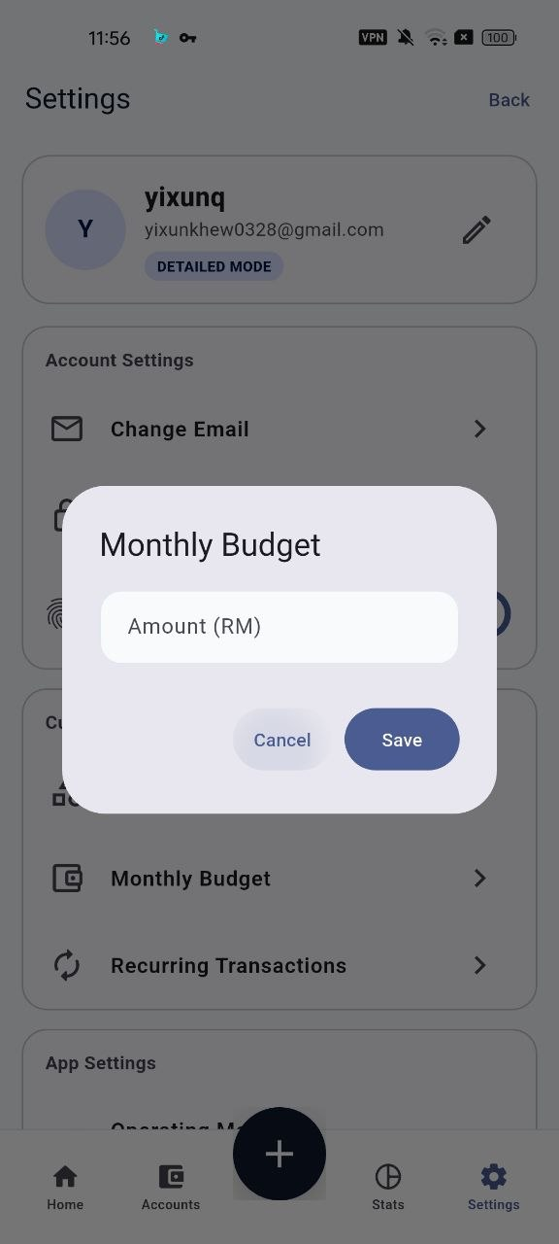
Monthly budget dialog
Budget warning behavior
If an expense causes monthly spending to exceed the budget, Smart Pocket displays a Budget Exceed warning. The user can still continue after reviewing the warning.

4.2 Manage Categories
- Open Manage Categories.
- Choose Expense or Income depending on the type of category needed.
- Enter the category name.
- Choose an icon. The same icon can be reused automatically by shortcuts.
- Save the category.
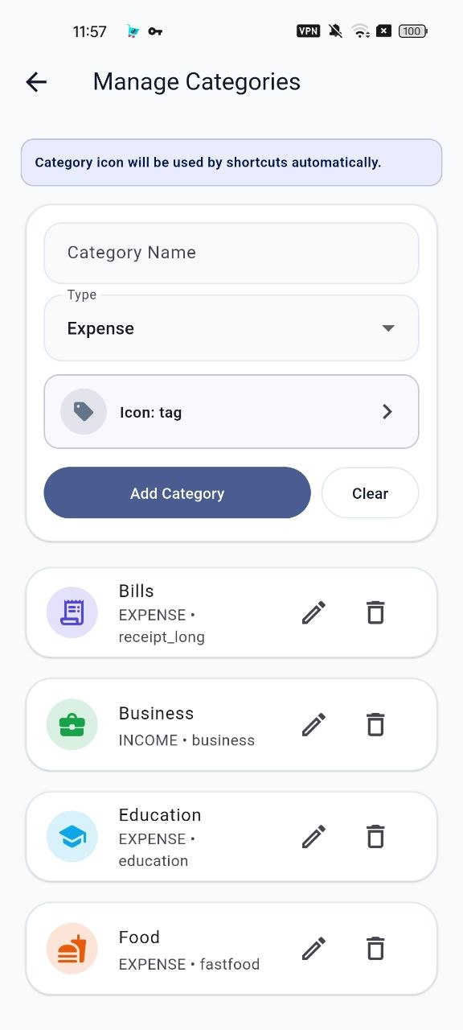
Manage categories page

4.3 Edit or Delete Categories
- Open Manage Categories and select the category.
- Update the name, type, or icon, then save.
- To delete a category, choose Delete Category.
- When asked, either reassign affected transactions to another category or delete the transactions linked to that category.

5. Transaction Management
Transactions are the main records in Smart Pocket. Users can record expenses, income, transfers, and simplified Lazy Mode entries.
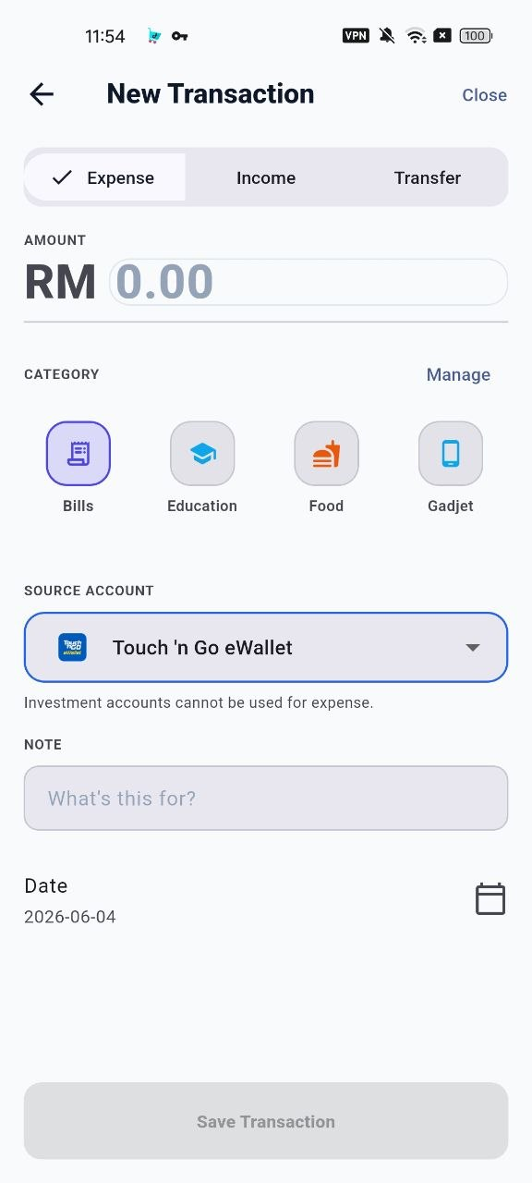  Expense entry | 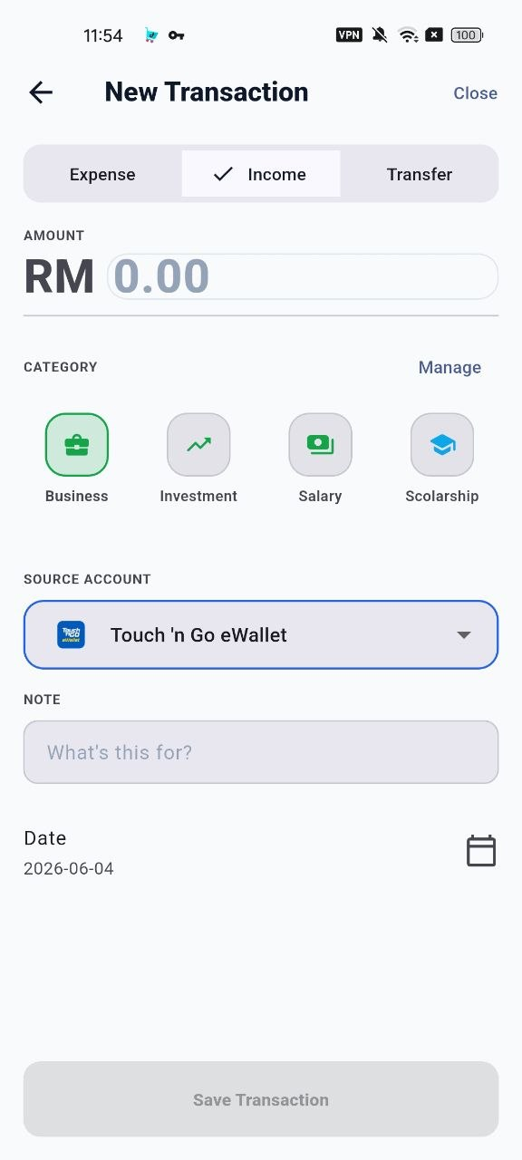  Income entry | 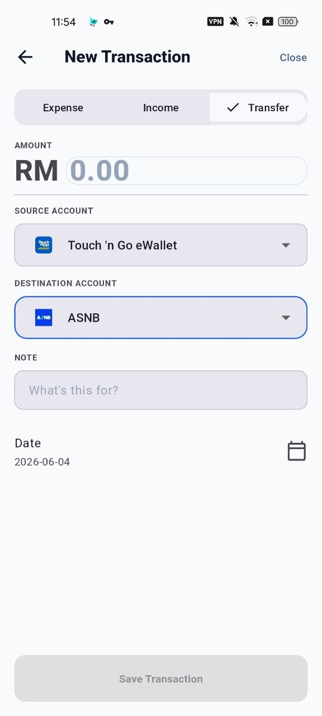  Transfer entry

5.1 Record an Expense
- Tap the add transaction button.
- Select Expense.
- Enter the amount.
- Choose an expense category.
- Choose the source account.
- Add a note if needed.
- Confirm the transaction date.
- Save the transaction.
Expense validation
Smart Pocket blocks invalid numbers, missing required fields, and insufficient funds. Investment accounts cannot be used as the source account for normal expenses.

5.2 Record Income
- Open New Transaction.
- Select Income.
- Enter the amount.
- Choose an income category.
- Choose the account that will receive the income.
- Add a note and date if needed.
- Save the income transaction.

5.3 Record a Transfer
- Open New Transaction.
- Select Transfer.
- Enter the amount.
- Choose the source account.
- Choose the destination account.
- Make sure the source and destination are not the same.
- Save the transfer.

5.4 Review, Filter, Edit, and Delete Transactions
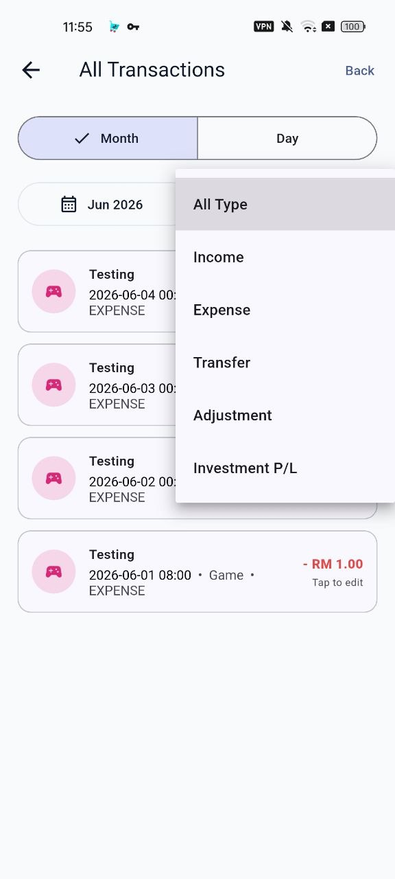  All transactions | 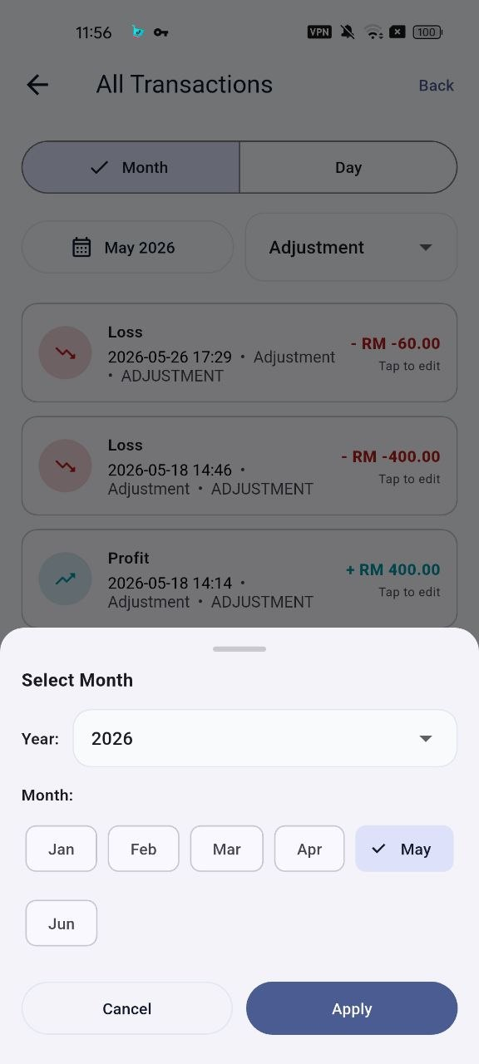  Month filter | 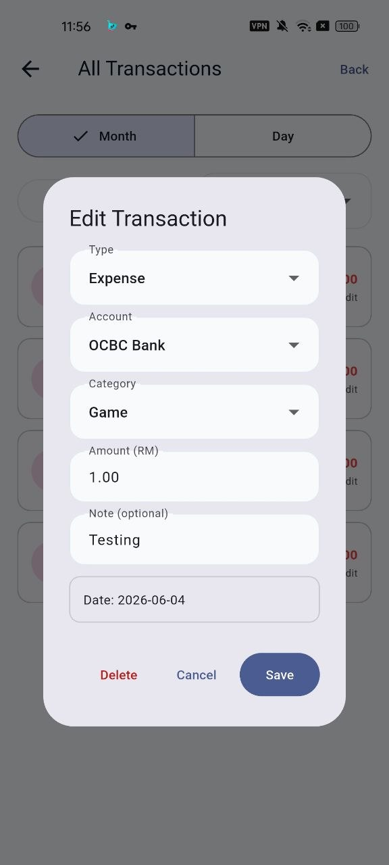  Edit transaction

- Open All Transactions.
- Use the month filter to view records for a specific year and month.
- Tap a transaction to review the details.
- Choose Edit to update supported transaction fields.
- Choose Delete if the record is incorrect and should be removed.
- Use Undo Last Edit when the app offers it after an edit.

6. Shortcuts and Lazy Mode
Shortcuts reduce repeated manual input. Lazy Mode further simplifies daily recording when a user wants speed over detailed account-level tracking.
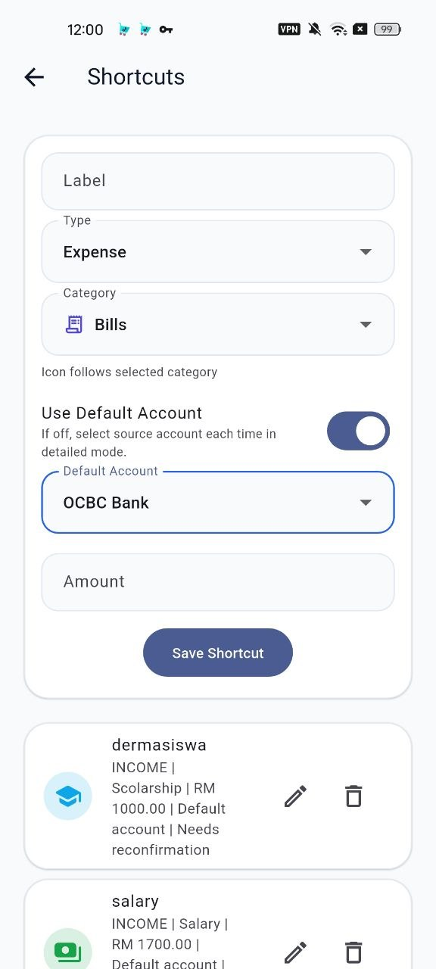  Shortcuts page | 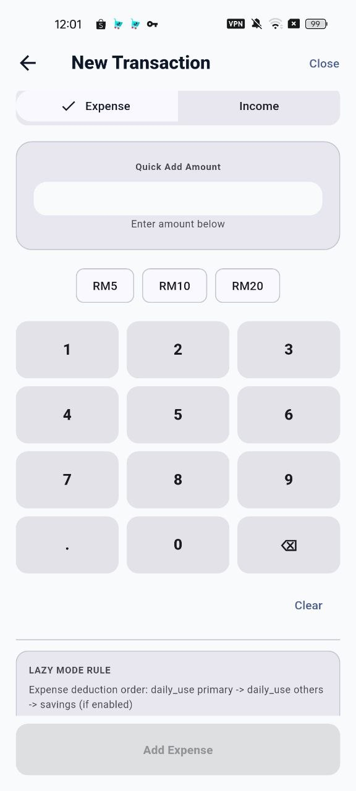  Lazy Mode entry

6.1 Create a Shortcut
- Open the Shortcuts page.
- Choose Expense or Income.
- Select the category.
- Enter the fixed amount.
- Choose whether the shortcut should use a default account.
- If using a default account, select the source account or bucket.
- Save the shortcut.

6.2 Use a Shortcut
- Go to the Dashboard or Shortcuts page.
- Tap the shortcut.
- If asked, select the source bucket or account.
- Confirm that the transaction is recorded.

6.3 Use Lazy Mode Entry
- Switch to Lazy Mode if you prefer faster daily tracking.
- Open the Lazy Mode transaction entry page.
- Enter the amount and basic transaction details.
- Save the record.
- Review the effect on assets and recent transactions.

7. Recurring Transactions
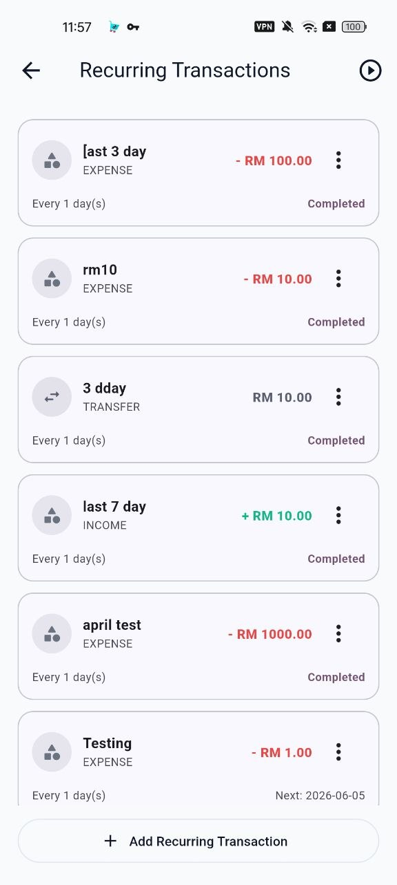  Recurring list | 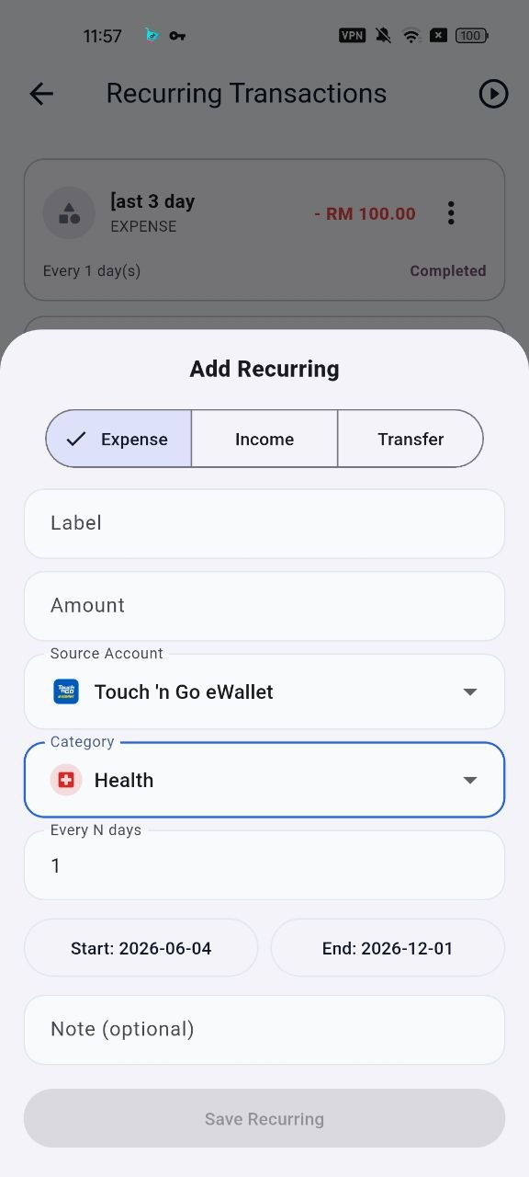  Recurring form

7.1 Add a Recurring Transaction
- Open Recurring Transactions.
- Tap Add Recurring Transaction.
- Choose Expense, Income, or Transfer.
- Enter the amount, account details, category where relevant, and note if needed.
- Set the start date.
- Choose the interval or frequency.
- Set an end date if the recurring plan should stop later.
- Save the plan.

7.2 Manage a Recurring Plan
- Open Recurring Transactions.
- Review each plan and its active/inactive status.
- Use Edit to change the plan details.
- Use the active toggle to pause or resume a plan.
- Use Delete only when the plan is no longer needed.

8. Operating Mode
Smart Pocket supports two operating modes. Detailed Mode is for users who want account-level tracking. Lazy Mode is for users who prefer faster and lighter daily entry.
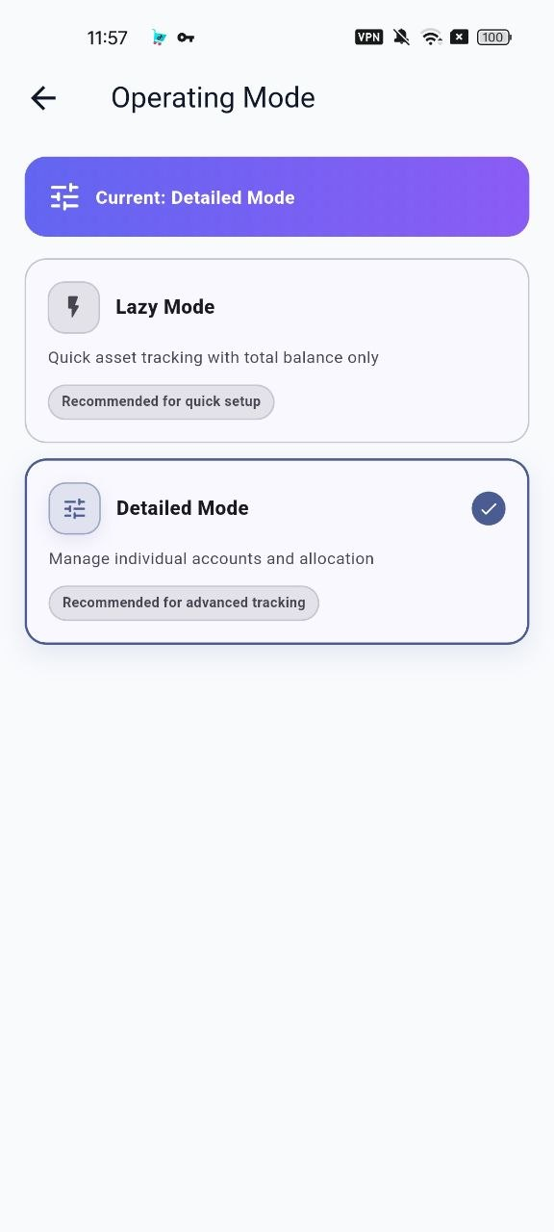
Operating mode page

8.1 Switch Mode
- Open Settings.
- Open Operating Mode.
- Review the current mode.
- Choose the target mode.
- Confirm the mode switch.
- If Smart Pocket asks to reconfirm shortcut accounts after switching, review the shortcut source account settings.

9. Analytics and PDF Reports

9.1 View Analytics
The Analytics page helps users understand spending, budget usage, cash flow, and investment performance.
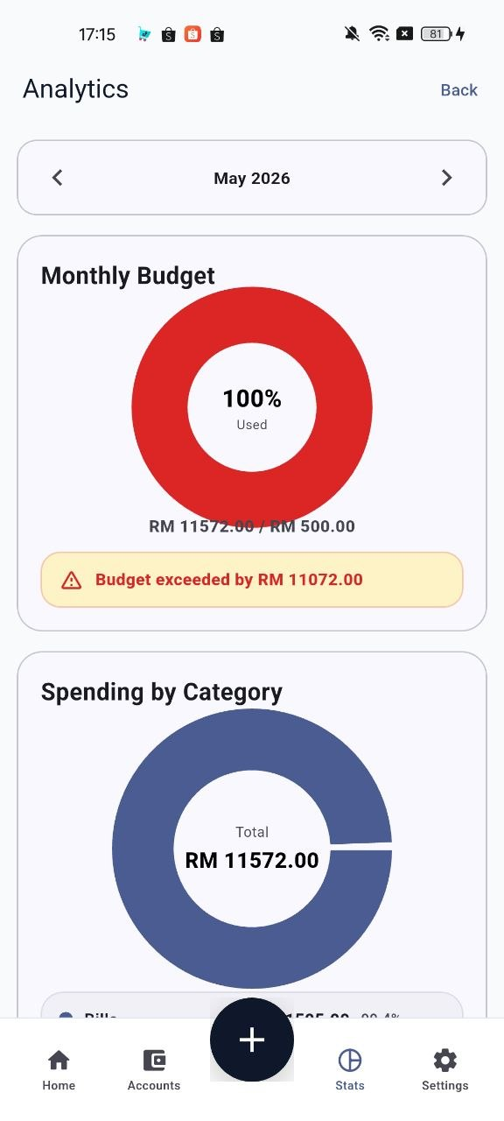  Budget view | 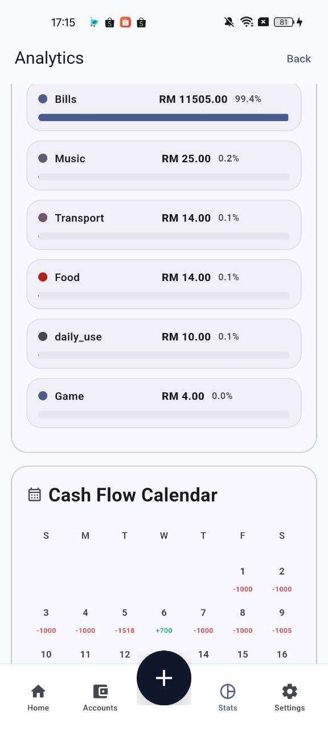  Category view | 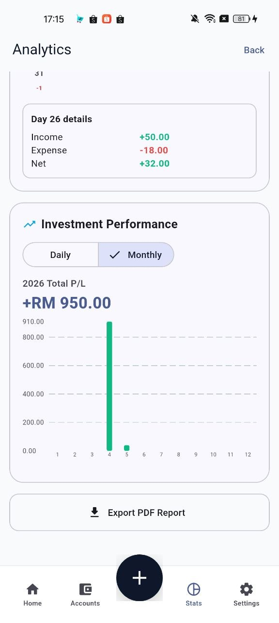  Cash flow / P/L

- Monthly Budget shows spending compared with the saved monthly budget.
- Spending by Category shows how expenses are distributed.
- Cash flow calendar uses daily indicators to help users review income and expense patterns.
- Investment Performance separates investment profit/loss from daily living expenses.

9.2 Export a PDF Report
- Open Analytics.
- Tap Export PDF Report.
- Select the report year and month.
- Generate the report.
- Open, share, or save the generated PDF using the device options.
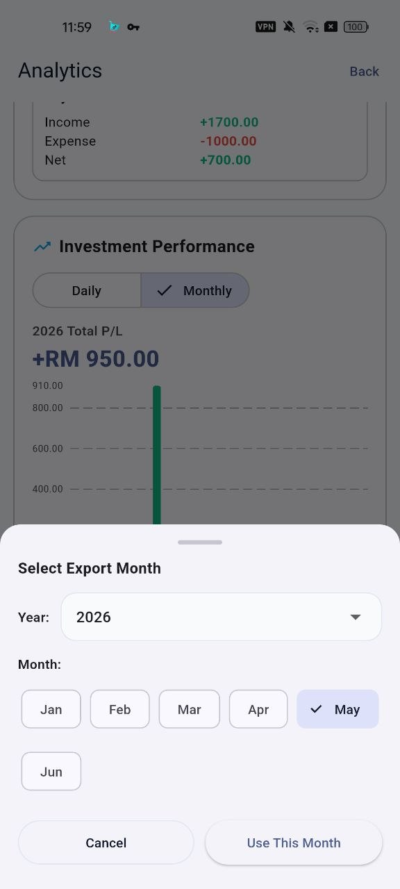  Select export month | 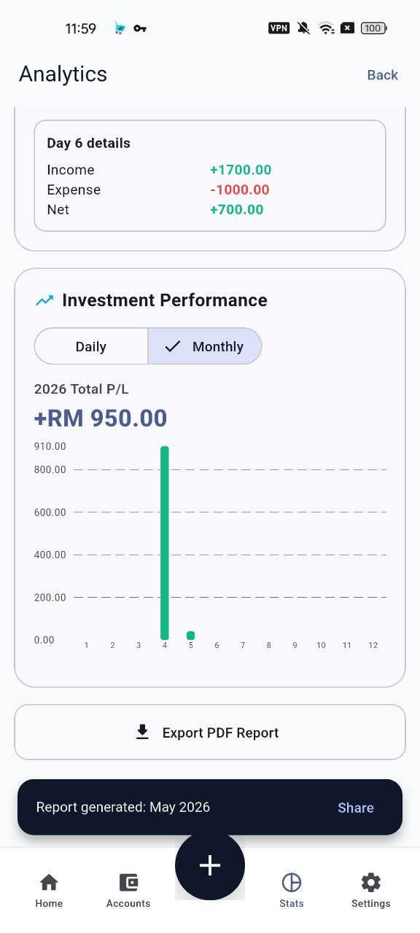  Generate report | 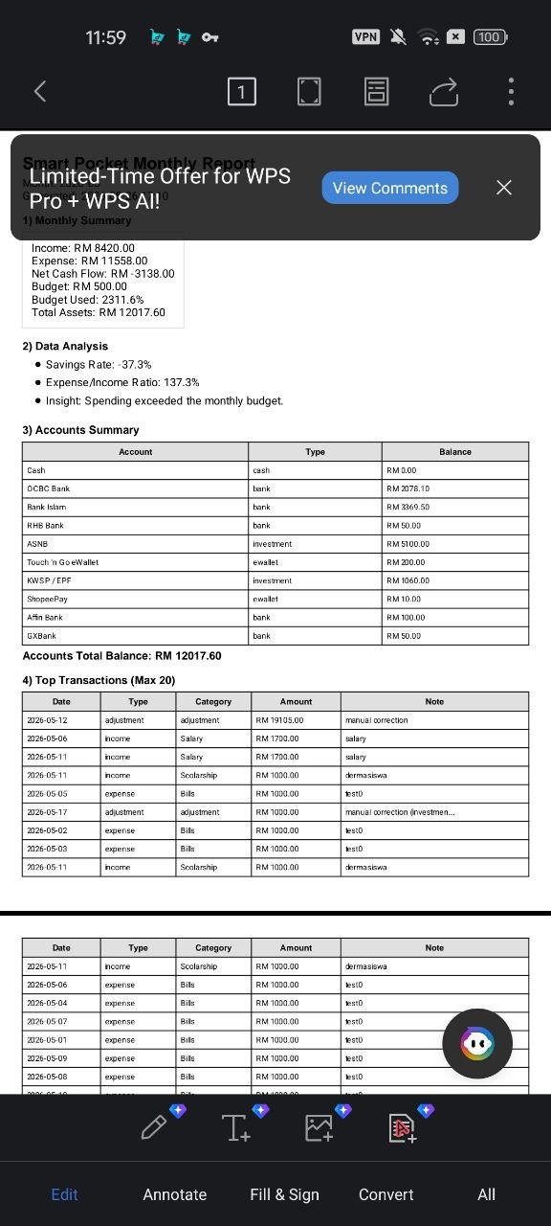  PDF report output

10. Backup and Restore
Backup and restore features help users protect financial records. Because backup files may contain sensitive financial data, users should store and share them carefully.
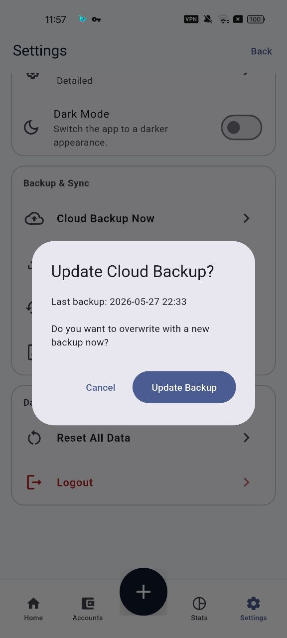  Cloud backup | 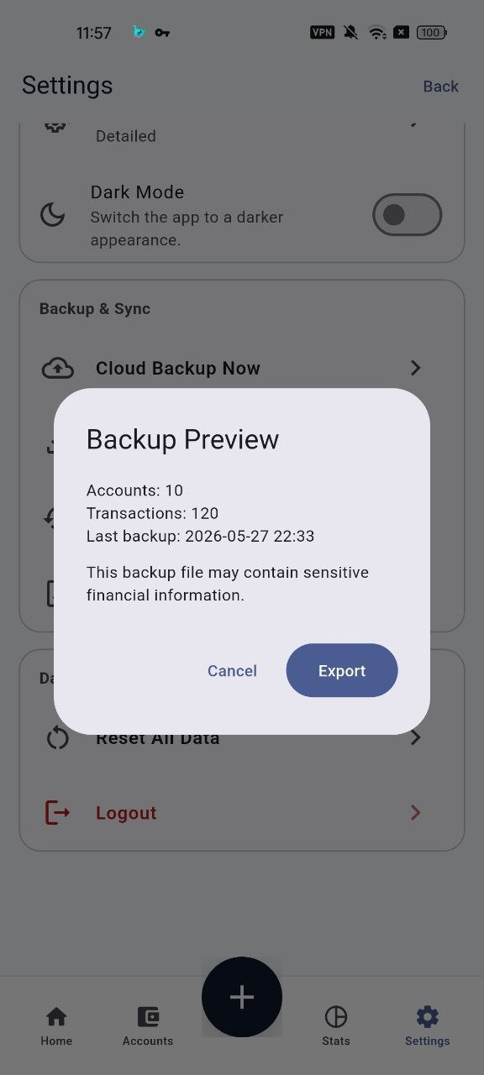  Backup preview | 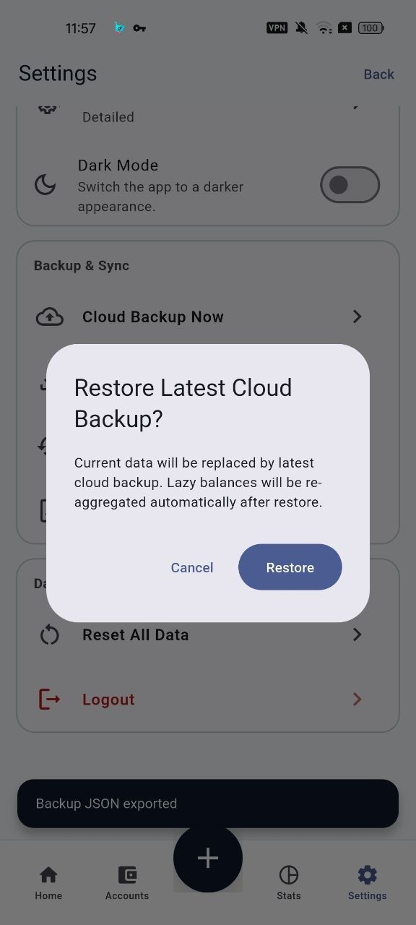  Restore backup

10.1 Create or Update Cloud Backup
- Open Settings.
- Choose the cloud backup option.
- Review the confirmation message and last backup information.
- Tap Update Backup.
- Wait for the success message before closing the app.

10.2 Export a JSON Backup
- Open Settings.
- Open Backup Preview or Export Backup.
- Review the number of accounts and transactions in the preview.
- Tap Export.
- Choose a safe app or location to share/save the backup file.
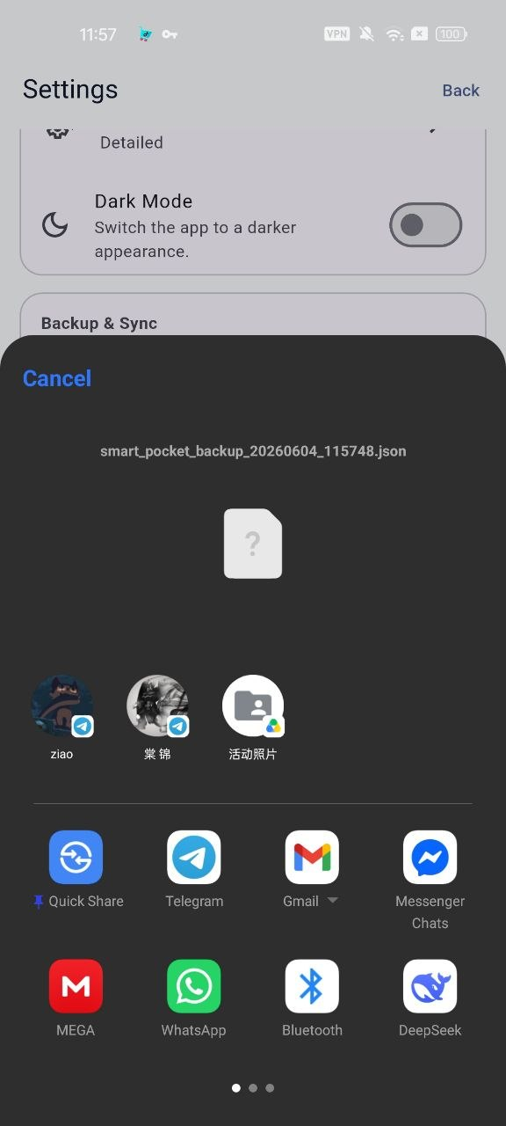
Backup sharing interface

10.3 Restore Backup
- Open Settings.
- Choose the restore option.
- Read the confirmation dialog carefully.
- Confirm only if you want the saved backup data to replace or restore current app data.
- Wait until the process completes, then review accounts and transactions.
Privacy reminder
Do not send backup files to public chats, public cloud folders, or unknown users. The backup can include sensitive financial information.

11. Settings, Security, and Theme

11.1 Manage Profile Details
- Open Settings.
- Choose Edit Profile to update the display name.
- Choose Change Email to update the login email. Enter the current password when requested.
- Choose Change Password to set a new password. Enter the current password and the new password confirmation.
- Save the change and wait for the success message.
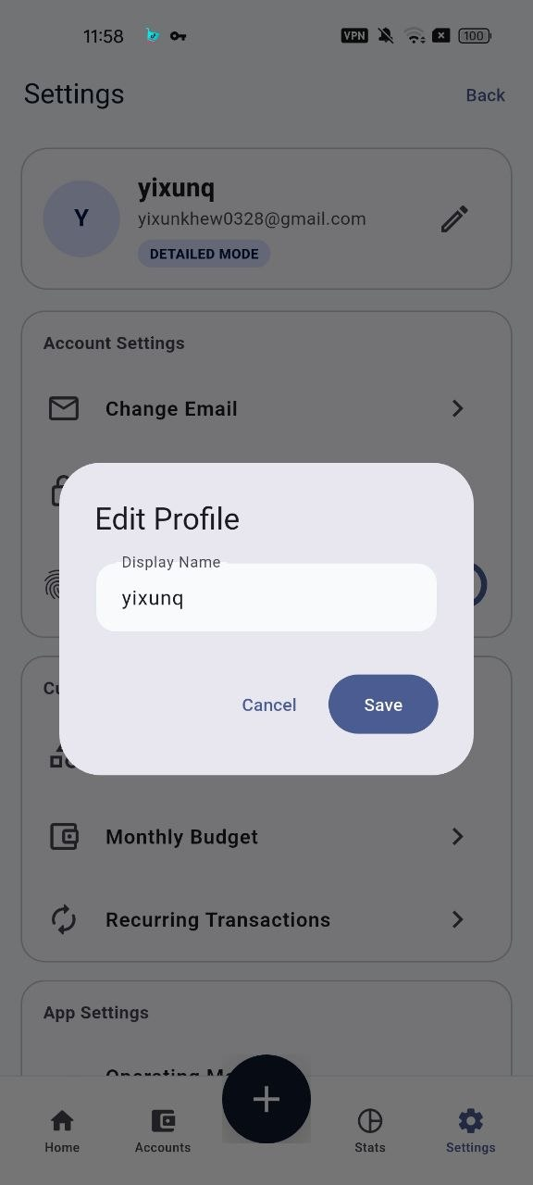  Edit profile | 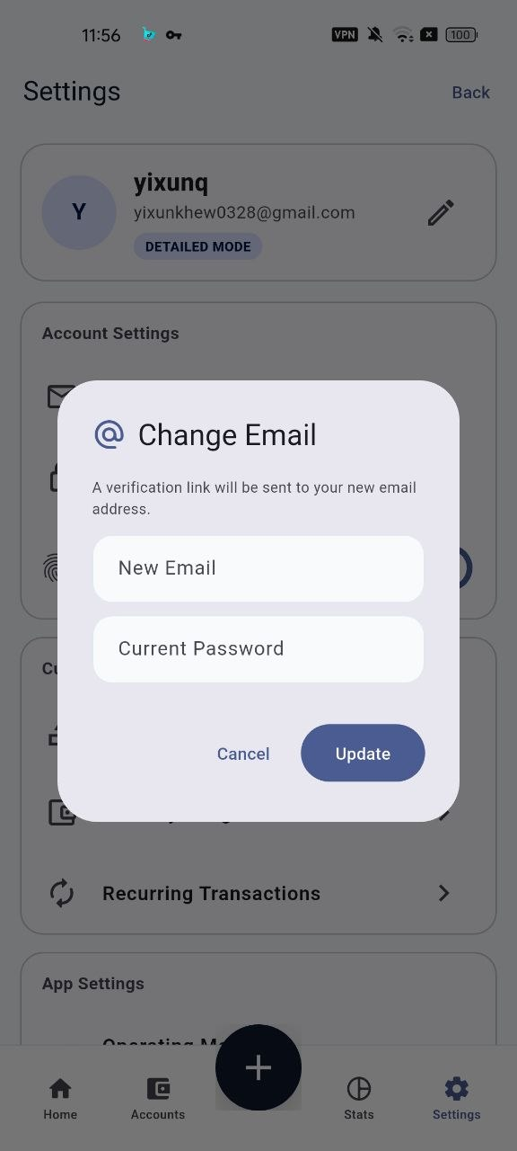  Change email | 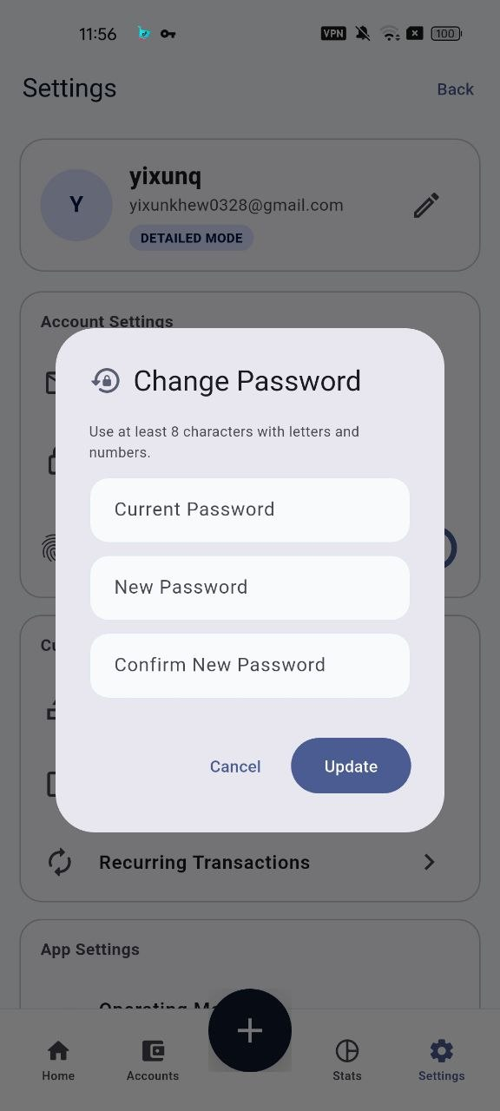  Change password

11.2 Enable Biometric Authentication
- Make sure fingerprint or face unlock is already set up in Android device settings.
- Open Smart Pocket Settings.
- Turn on Biometric Authentication.
- The next time the app is reopened, use fingerprint or face unlock when prompted.
Biometric scope
Smart Pocket uses device-level Android biometric authentication. The phone decides whether fingerprint, face unlock, or another supported biometric method is available.

11.3 Use Dark Mode
- Open Settings.
- Turn on Dark Mode.
- Return to the dashboard and confirm the interface changes to the dark theme.
- Turn it off again if you prefer the light theme.
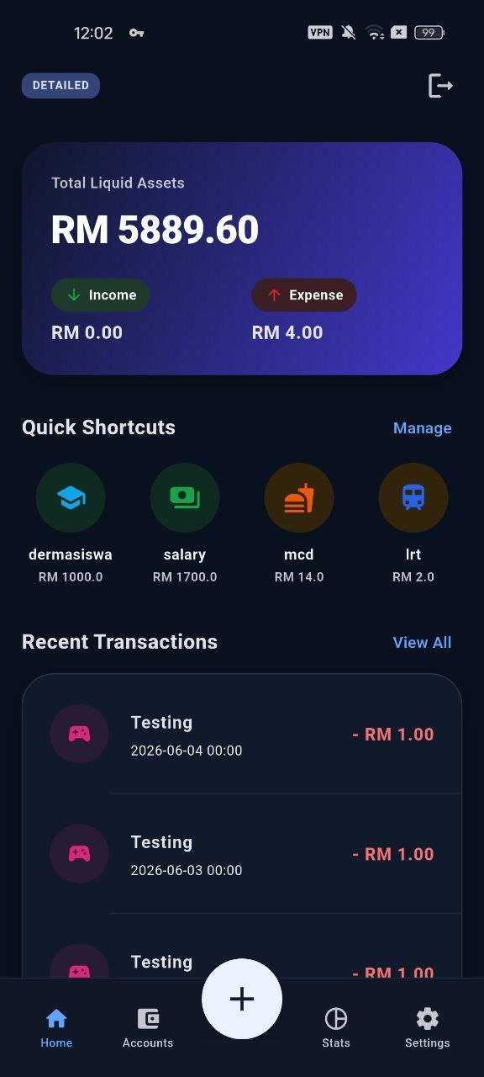
Dark mode dashboard

11.4 Reset All Data
- Open Settings.
- Choose Reset all data only when you want to clear Smart Pocket data.
- Read the warning message carefully.
- Confirm the reset only after creating a backup if you still need the records.

12. Troubleshooting Guide
Situation | What to check | Recommended action
Cannot log in | Email, password, network, Firebase account | Use Forgot Password, try Google sign-in if linked, and check internet connection.
Biometric login failed | Device biometric setup and Smart Pocket biometric setting | Use email/password or Google login. After 3 failed attempts, sign in normally and re-enable biometric if needed.
Cannot save transaction | Amount, category, source account, destination account, available balance | Complete required fields, use a valid number, and make sure funds are enough for expense or transfer.
Budget warning appears | Monthly spending exceeded budget | Review the warning. Continue only if the expense is intentional.
Allocation cannot save | Total percentage | Make Daily Use, Savings, and Investment total exactly 100%.
PDF report fails | Selected month, data volume, device permission | Retry export, select the correct month, and make sure file/open/share permissions are available.
Backup or restore failed | Network and backup source | Try again with stable internet. For JSON restore, confirm the correct backup file is selected.
Shortcut asks for account | Default account setting | Select a source account, or edit the shortcut and enable a default account.

13. Good Daily Practice
- Record small daily expenses as soon as possible, especially food, transport, subscriptions, and e-wallet spending.
- Use shortcuts for repeated purchases to reduce input time.
- Review the monthly budget page at least once per week.
- Check category spending before the end of the month.
- Update investment balances carefully so profit/loss is separated from daily income and expense.
- Create a backup before major changes, device changes, or data reset.

Appendix A: Rubric-Oriented Coverage Notes
The evaluator and supervisor rubrics both reward module coverage for the user manual. This manual therefore covers every module identified in the thesis functional requirements and the current Smart Pocket project structure.
Rubric concern | Manual response
All modules covered | Each core module is listed in the coverage checklist and explained with step-by-step use instructions.
Based on user requirements | The manual follows the thesis requirements for authentication, assets, transactions, validation, automation, analytics, categories, backup, and settings.
User can follow steps | Each major operation is written as numbered steps with warnings and troubleshooting notes.
Demonstrable system | Screenshots from the current thesis Chapter 4 are used as visual references for the implemented system.

