1.Please using the python IDLE to run the program

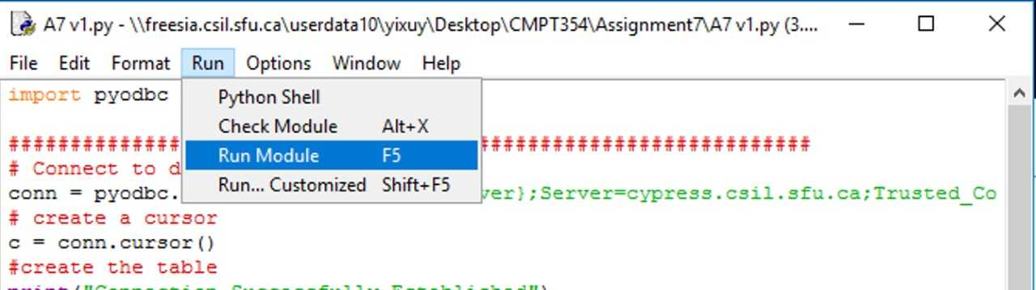

2.Follow the instruction on the screen and avoid the invalid input please

3. You need to search before you book the list.