Authorization and Affiliation Agreement
Agreement No.: LP-APP-AUTH-20260410
App: LE Paper App (Apple ID: 6761166271)
Parties
Party A: ZenPoint Solutions LLC
1765 Greensboro Station Pl Ste 900, McLean, VA 22102-3470, USA
Party B: BOISE INTERNATIONAL COMPANY LIMITED
Bank: JPMorgan Chase Bank, N.A. New York Branch
Address: 270 Park Ave. New York, NY 10017
Account: 20000045052199 | SWIFT: CHASUS33 (CHASUS33XXX)
Party C: RAMON LLC
2476 McCormick Blvd, Bullhead City, AZ 86429, USA
Purpose
To confirm legal affiliation and authorization for Apple App Store compliance (Section A-4).
Authorization
- Party A authorizes Party B to develop, operate, and maintain LE Paper App on the App Store.
- Party C authorizes Party A and Party B to operate the App and receive payments.
- All parties confirm they are legally affiliated for the App’s operation and settlement.
Payment Confirmation
The account of BOISE INTERNATIONAL COMPANY LIMITED at JPMorgan Chase Bank is the
sole authorized account for Apple payments of LE Paper App.
Warranties
All parties are legally registered; all information is true and accurate;
all authorizations are valid and comply with Apple’s terms.
Governing Law
United States law

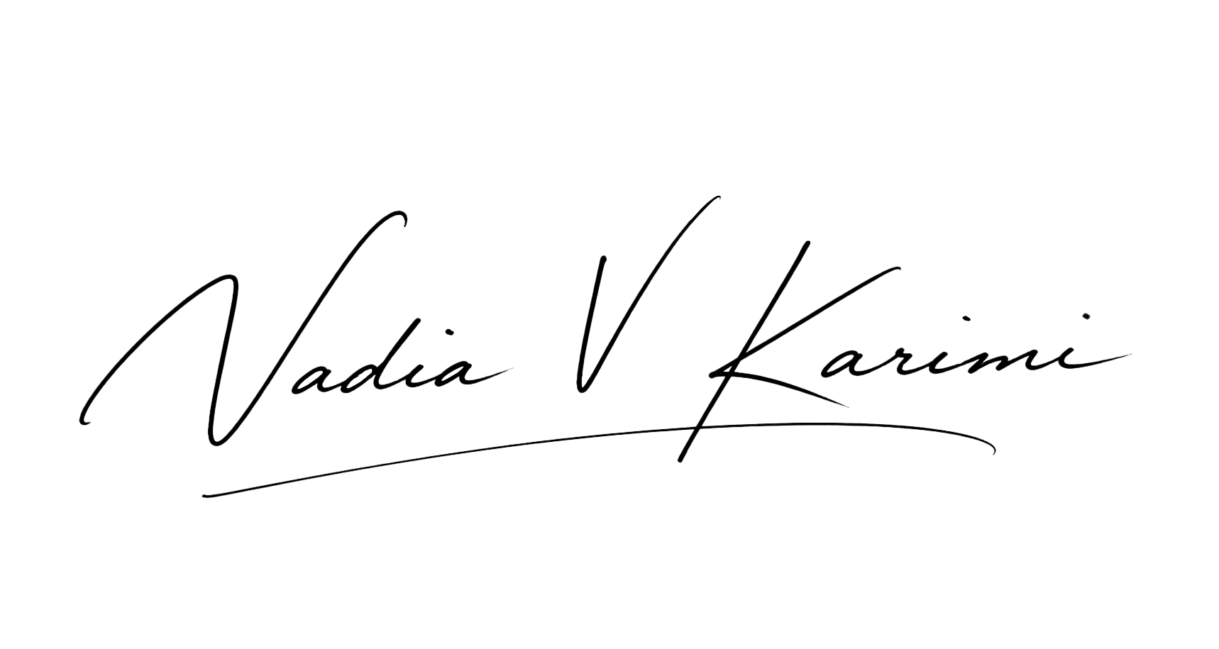

Party A: ZenPoint Solutions LLC

Signatory: _______________ Date: _______________

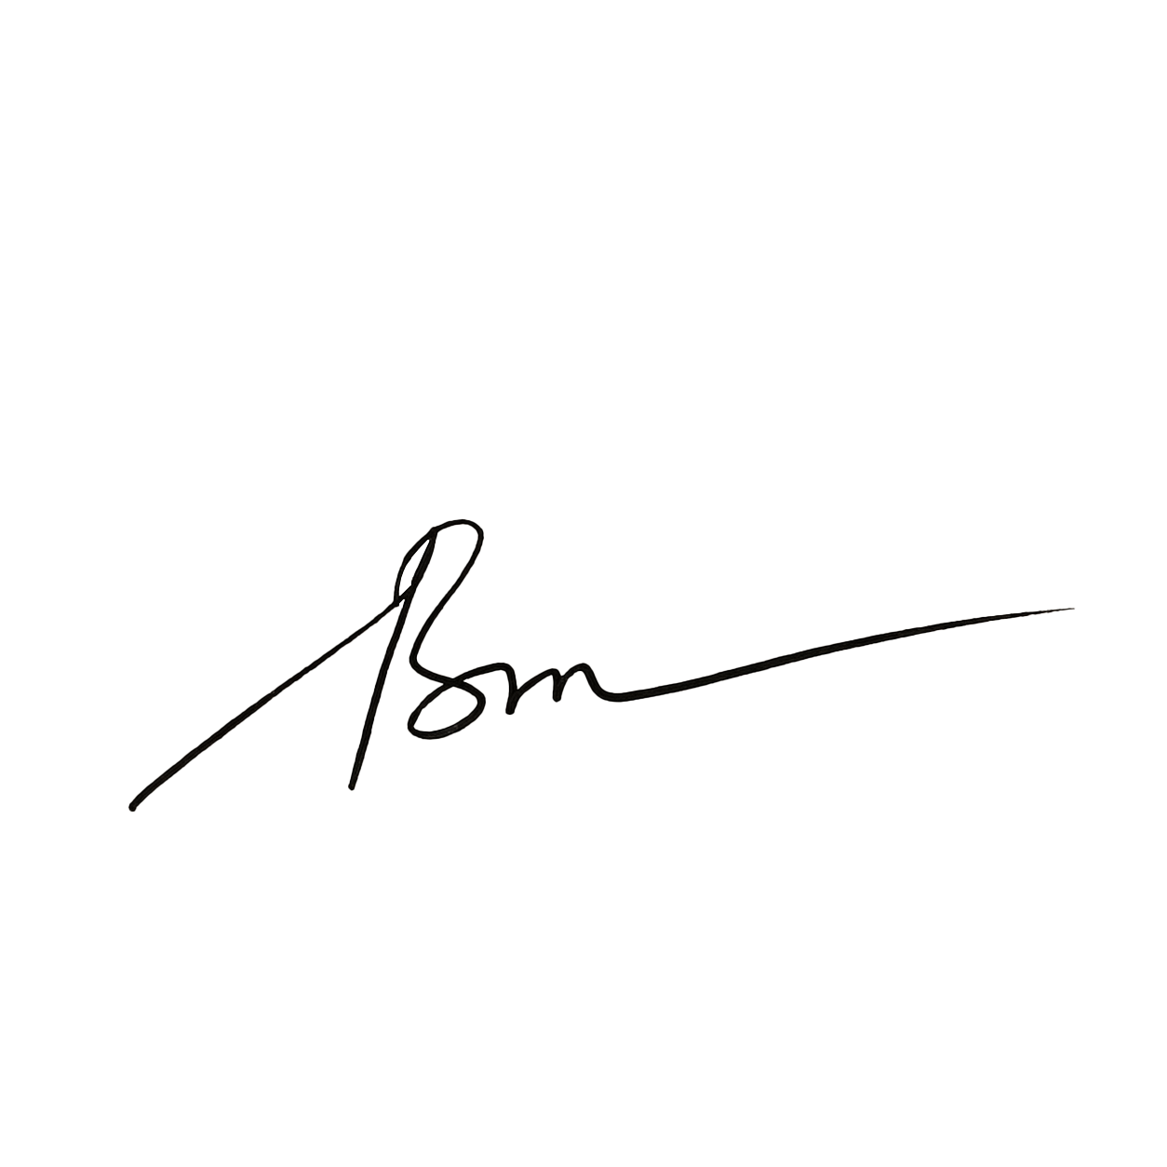

Party B: BOISE INTERNATIONAL COMPANY LIMITED

Signatory: _______________ Date: _______________


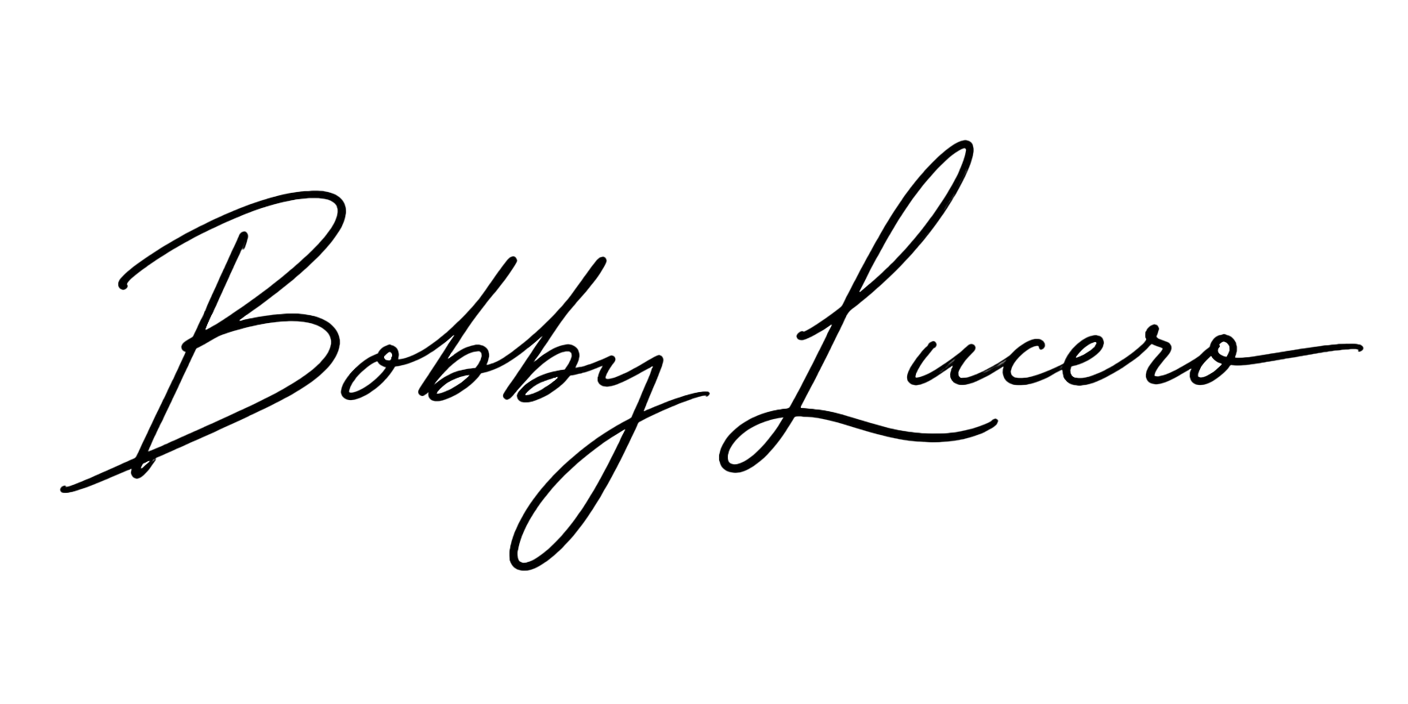
Party C: RAMON LLC

Signatory: _______________ Date: _______________

