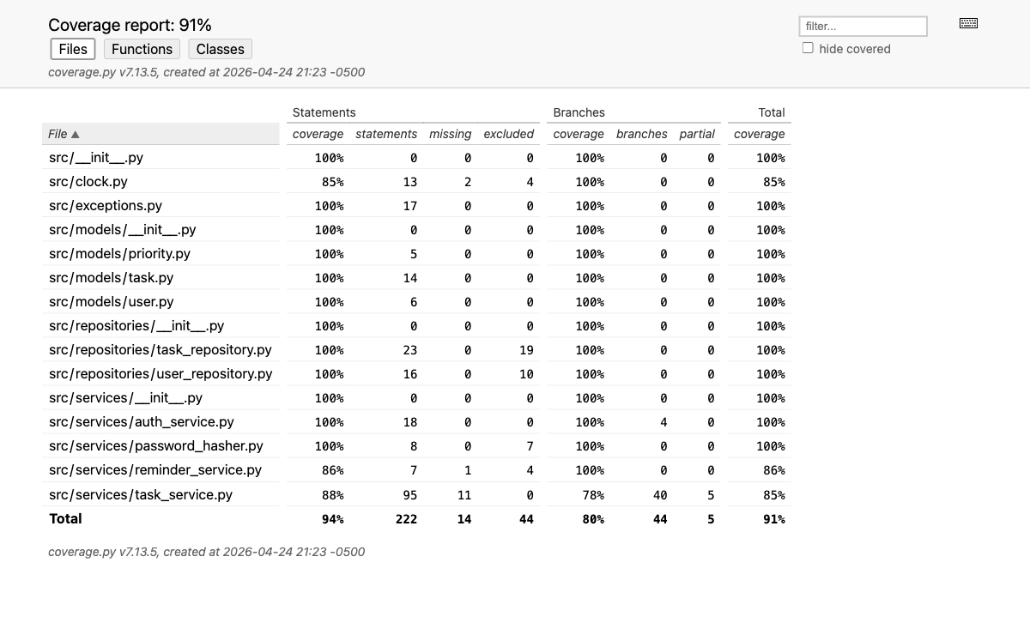
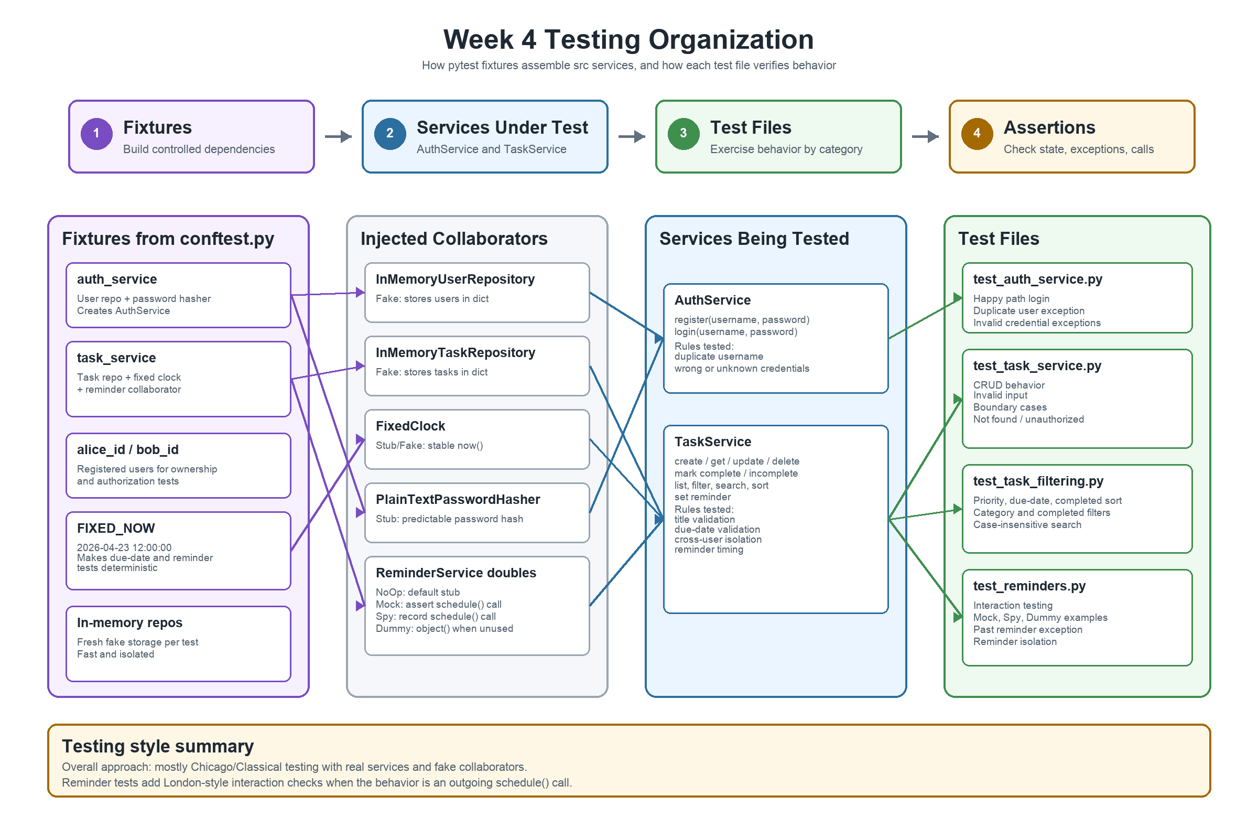
1. What you built

I built a small to-do list backend with two main parts, user authentication and task management. The authentication side handles registering users and logging them in, while the task side handles creating tasks, updating them, listing them, sorting them, marking them complete, and setting reminders. The main domain objects are users, tasks, and task priorities. I also separated the service logic from collaborators like storage, password hashing, time, and reminders. Those collaborators are injected into the services, which made the project easier to test because the tests could replace them with controlled versions.

2. Test strategy and coverage

The hardest tests to design were the interaction-style reminder tests in test_reminders.py. Most other tests check one clear final result, such as whether a task was created or whether an invalid title raises an error. The reminder tests were different because they needed to check whether the task service correctly worked with another collaborator. For example, the test using a mock reminder checks that the reminder service was actually called with the right task and time, generlly London style test are more difficlut to write as you have to think of how to interact with other modules.

The lowest meaningful gap was in task_service.py, especially the branches inside the update logic. To close that gap, I would need more tests for updating description, priority, due date, category, and the case where changing a due date clears an invalid reminder. I left some simple code, like parts of clock.py, less covered because it is mostly trivial wrapper behavior.

3. Test doubles and isolation

I used several kinds of test doubles. The in-memory task and user repositories work as fakes because they behave like real storage but only use dictionaries. The fixed clock is a controlled time source, which keeps due-date and reminder tests stable. The plain-text password hasher is a simple stub for predictable authentication tests. In test_reminders.py, I also used a mock to verify that the reminder service was called, a spy to record reminder calls, and a dummy object in a sorting test where the reminder collaborator was not used.

Overall, my approach was mostly Classical testing. I used real service objects and fake collaborators, then checked the final behavior. I did not mock every dependency. The exception is the reminder tests, where a more London-style approach made sense because the important behavior was the interaction with the reminder service.

4. The four pillars — your best and weakest test

The test I think most useful is test_list_tasks_does_not_return_other_users_tasks. I think it has strong regression protection because user isolation is one of the most important rules in the project, many websites nowsdays also encounter this kind of problem. If Bob can see Alice’s tasks, that is a serious privacy problem. It is also refactoring resistant because it does not care how tasks are stored internally; it only checks the visible behavior. It gives fast feedback because everything runs in memory, and it is maintainable because the setup is easy to understand.

The test I am least confident in is test_registering_the_same_username_twice_raises. It is useful, but it is small and only protects one narrow rule. Its regression protection is weaker than the user-isolation test because it does not cover a larger workflow. I kept it because duplicate usernames are still a basic authentication rule, and the test is simple enough that it does not add much maintenance cost.

5. Looking back

If I started over, I would make the task update behavior easier to test, maybe by splitting it into clearer smaller paths instead of handling many optional fields in one place. What surprised me most was how much the design of the backend affected the tests. Because the services used dependency injection, I could replace storage, time, and reminders in the tests. If the backend had created all of those dependencies internally, the tests would have been much harder to write.

