Relationship Between Green Spaces and Mental Health in Toronto, ON

Winter 2021

This paper reports our analysis of the correlation between green space and mental health within Toronto, ON, and its relationship with other socioeconomic factors. Data was collected from the Open Ontario, statistics Canada, and Toronto Community Health.

**Introduction**

When is the last time you enjoyed a stroll in the park, a casual game of catch, or simply took your dog for a walk by a green space down your street? Hopefully it hasn’t been too long! Undoubtedly, parks and green spaces have become absolutely essential areas in our cities (Shanahan et al., 2015), a place to disconnect from the stressors of everyday life and, perhaps, connect back to nature, with a neighbour, friends, or one’s inner peace. They provide fundamental services such as physical activity, meditation, social interaction, or simply a moment away from the hustle and bustle of modern cities such as Toronto, the focus of the present paper. Green spaces like Central Park in New York City (USA) or High Park in Toronto (ON) are millionaire investments that require careful planning and maintenance for the remainder from the moment they are inaugurated (and even prior to that). They must have a clear net positive effect on the population if they were deemed as feasible projects. As population rises and cities continue growing exponentially, public services such as city parks and other green spaces must be planned in ways that ensure equitable access to all inhabitants, if they are to be beneficial to the communities they serve (Nutsford et al., 2013).

The present paper aims to determine the relationship between green-space availability and mental health in Toronto, ON, Canada. The specific goal of our project is to investigate the relationship between the availability green space and mental health admission rates in Toronto neighbourhoods. Furthermore, we plan to determine which socioeconomic factors influenced mental health admissions in relation to green space, in hopes to identify more vulnerable neighbourhoods within Toronto.

To determine the existence (or lack thereof) of this relationship this project will firstly provide a comprehensive review of the available literature on links between green space and mental health, and walking distance trends in cities. Following the literature review, the data utilized in this study will be outlined, along with the methodology and statistical analysis used to accept or reject the null hypothesis. Our running hypothesis will expect there to be a clear negative correlation between green space availability and mental health hospital admissions per neighbourhoods in Toronto. Other aspects and relationships will be explored, such as the socioeconomic groups most affected by different availability of green spaces. Finally, the present paper will present final remarks, along with recommendations on future studies and urban planning, specifically in the city of Toronto, ON.

**Background**

Plenty of research is constantly being conducted to determine the effect of green spaces on population’s physical and mental health, as well as on the parameters that ensure equitable access to these areas. Are there certain socioeconomic groups more affected by their accessibility to parks? Does sex play a role in these relationships? Does the city of Toronto, widely regarded as one of the best places to live in worldwide, show correlation between green space accessibility and Torontonians’ mental health? Some of these questions have been answered by the existing literature, and some others, specific to Toronto (ON), we hope to shed light on with the present paper.

*Study area*

The affect of greenspace on mental health was conducted at the census tract level within Toronto. In order to analyze green space we overlayed a shapefile containing the census tracts with a shapefile containing the area in Km^2 of Toronto’ green spaces. Toronto was chosen as our study site due to the highly variable greenspace and its abundant open data sources. A high variability in green space was important for this study as it allows us to view results at the extremes (i.e. virtually no nearby green space -> alot of nearby greenspace) while still having enough census tracts to account for any significant deviations such as disproportionately massive parks.

*Greenspace and Mental Health*

Contact with natural environments including green spaces has been associated with improved perceived and objective health outcomes and wellbeing (Alcock et al., 2014 and James et al., 2015;). Science attributes many benefits to green spaces, including increased physical activity, reducing psychological stress, anxiety and depression, increasing social contacts and cohesion and reducing exposure to environmental hazards such as air pollution (Dadvand et al. 2015, 2016). Lopes et al. (2020) demonstrate the positive effects of walking in nature. As they suggest, a walk as short as 30 minutes in a setting with natural elements, such as a park, elicits a feeling of awe and consequently draws people away from themselves, preventing rumination and its negative health effects (related to stress and thus high cortisol levels). In this study, researchers compared the effects of walking in nature with the same type of walk (group and duration) except in an urban setting, through the city. This study adds to the scientific consensus that access to natural environments, especially within an urban environment, yields important benefits to the mental health capital of cities and countries. Dadvand et al. (206) suggest a more relevant effect of green spaces on mental health status in males under the age of 65. For the purpose of our study we will determine whether different sex or age groups experience different mental health outcomes with proximity or accessibility to green spaces in Toronto, as observed by Dadvand et al. (2016) in Barcelona. While science does not correlate living in a greener neighbourhood with any wellbeing outcomes, on the other hand it does suggest positive health outcomes for those who visited nature more than once a week (Martin et al., 2020). Martin et al. 2020 adds to the scientific consensus of positive health-nature relationships, suggesting that “detachment from the natural world may be a factor in poor mental and physical health”. In the present study we aim to determine whether parameters like distance and size of natural areas within Toronto (which affect accessibility) have an impact on the mental health of its population. Rigolon et al (2021) aim to determine the strength of associations between green-space and health of advantaged and disadvantaged groups. This research is relevant for the purpose of the present study on the associations between green-space and mental health in Toronto. The city has been a focus of this sort of science already, with papers such as Hassen (2016) pointing out the challenges of determining which characteristics of green spaces do affect Torontonians’ mental health, such as quality and accessibility of the parks. Determining which socioeconomic groups have a greater health dependency on accessibility to green-space can help in future urban planning and park allocation within cities. Rigolon et al. 2021 demonstrate that people of lower socioeconomic status show more beneficial effects to park accessibility than high-income households. The literature is clear, with multiple papers pointing out clear correlations between higher levels of green space and healthier populations (Richardson et al., 2013; van den Berg et al., 2016; Barton & Rogerson, 2017; Engeman et al., 2019; Callaghan et al., 2020 ). An important aspect of the analysis carried out for the purpose of our study on Toronto were buffers created around neighbourhoods’ centroids. These buffers would represent the walk time an average person would walk towards a park, within or outside their neighbourhood.

*People’s Willingness to Walk*

In order to decide the appropriate distance for each of the buffers representing walking distance, we did a brief literature review on the topic. A park that is far from one’s neighbourhood is expected to be considered less “accessible” to that particular neighborhood, since people are more likely to walk to their nearest, most accessible park. However, nothing is stopping Toronto residents from walking over to a park that might be located in a different neighbourhood from the one they reside in. Moore et al. (2010) studied the relationships existing between park use, age, social participation and neighbourhood age composition in the Canadian city of Montreal. Granted, Montreal and Toronto are very different cities, but we considered this research to be significant for the purpose of this paper. Research such as Moore et al. (2010) left it to the study’s subjects to indicate whether a park was (under their subjective opinion, often determined by their mobility status) within an accessible walking distance. Research such as this confirms the importance of park proximity in determining park use and accessibility, also demonstrating differential vulnerability of older adults to neighbourhood influences (average neighbourhood age and park use by age group). Bryan and Katzmarzyk (2009) provide insight into the walking patterns of Canadian adults, which is directly related to the purpose of our study. They found that leisure-walking time trends between canadian adults (2007 data) varied depending on different demographic subgroups. In 2007: 7% of respondents were willing to walk up to 15 minutes (per walk); 40% reported walking 16 to 30 minutes; around 37% walked 31-60 minutes; and less than 13% reported walking over an hour each time they went for a walk. These numbers report total walk time, whereas our buffer decisions are determining walk time towards a park. For that reason, the bracket of 0-30 minutes was deemed more significant for the purpose of this study, with an emphasis on the 5 minute mark which was found to be most significant in our analysis (see below). Finally, science agrees that someone’s willingness to walk can be determined by their age, health, time availability, quality of surroundings, safety, climate and other factors (Donahue, 2011). In New York, for example, commuters were most likely to walk to a station that was located within a quarter mile, a similar distance when compared to other big cities such as Los Angeles or the Bay Area (all U.S.A locations). Research supports both the quarter mile and half mile distances, since those dilute the issue of determining if the walk to the park is considered a chore, or rather part of the leisure experience. For these reasons, buffers of 5 minutes (410 meters), 10 minutes (826 m) and 15 minutes (1239 m) were determined to be most representative of residents’ trends (Donahue, 2011). Note these distances are measured around the centroid of each neighbourhood in ArcGIS Pro, then imported into R.

**Data and methods**

The project’s data comes from several sources. Neighbourhood boundaries and green space areas come from Open Toronto, a data portal containing publicly available information on Toronto, and Statistics Canada from 2011. The city is broken down into 140 distinct neighbourhoods, allowing us to analyze the relationship in great detail. Presuming residents are most likely to utilize green spaces that are easily accessible to them, a neighbourhood level spatial scale is appropriate. data Toronto Community Health profiles provide a neighbourhood-level breakdown of the annual rate of hospitalizations of Mental Health Conditions for those over 20. This data is averaged annually from 2012 to 2014. This is provided for males, females, and the overall population. As well, the data provided describes whether the hospitalizations for mental health conditions in a given neighbourhood are higher than, lower than, or not significantly different from the City of Toronto overall rate. This is done at a 95% confidence interval. Mental health is often a difficult topic to measure, so we decided that hospital admissions, a clear and quantifiable variable, was a good indicator of mental health within a neighbourhood. We plan to compare the numerical number of mental-health related hospital admissions to the percentage of a neighbourhood that is classified as green space. As well, we will compare the status of a neighbourhood (i.e. significantly higher than, significantly lower than, or not significantly different than Toronto’s average mental health admission rate) to the percentage of green spaces. Utilizing these datasets will help us determine if there is a relationship between the availability of green spaces and the mental health of Torontonians.

This study uses Rstudio to conduct a series of data processes to visualize and find a significant correlation in several variables including wealth, age, and distance to green space for Toronto, ON. Prior to loading data into R we created buffers using ESRI ArcPro, we then added buffers around neighbourhood boundaries based on our research. We then intercepted each of these buffers with the green space polygons. This gave us the green space area within each buffering distance for each neighbourhood. The independent variable in this study is the mental health data that measures annual hospitalization rates for the population of Toronto. This study conducts area data analysis using choropleth maps to visualize trends and patterns in the data, scatterplots, and regression analyses to determine relationships between mental health and the dependent variables. First we created choropleth maps to visualize the variables within Toronto’s neighbourhoods, we then created spatial moving average to determine if the neighbourhood level distribution of mental health cases was random or not random. We then use Moran’s I to determine if mental health cases were spatially autocorrelated. Finally we completed several linear models examining the correlation between mental health and the study variables focusing on green space availability.

**Results**

To begin this study we had to overlay a green space shapefile with the census shapefile. The green space data was originally in absolute km^2 but was changed to percentage within each census tract. Centroids were added to each census subdivision to determine the distance between each neighbourhood.

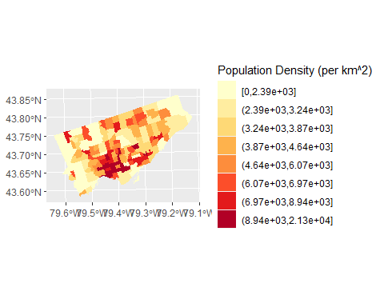

Population Density based on Total Population of 2615060 in Toronto, ON

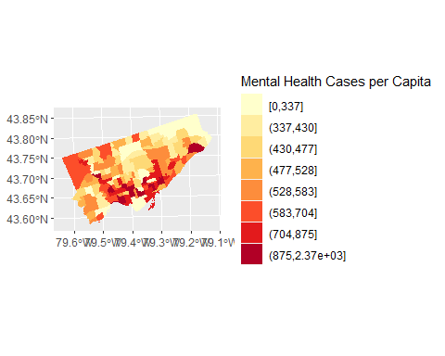

Mental Health Cases per Capita in Toronto, ON

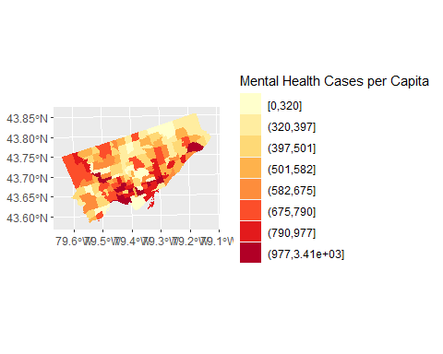

Male Mental Health Cases per Capita in Toronto, ON

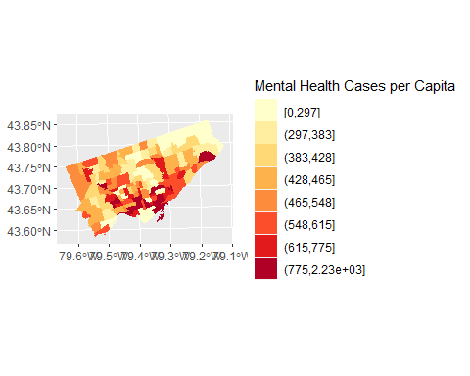

Female Mental Health Cases per Capita in Toronto, ON

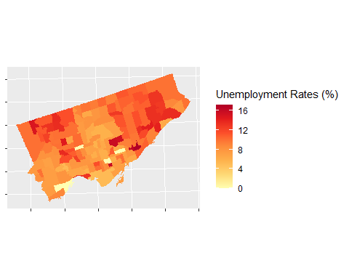

Unemployment Rates in Toronto, ON Neighbourhoods

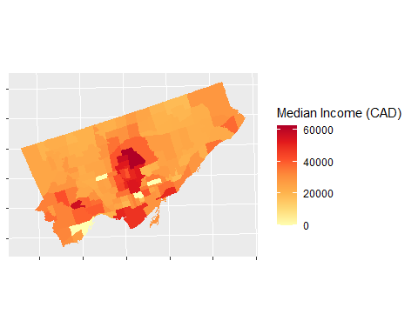

Median Individual Income in Toronto, ON Neighbourhoods

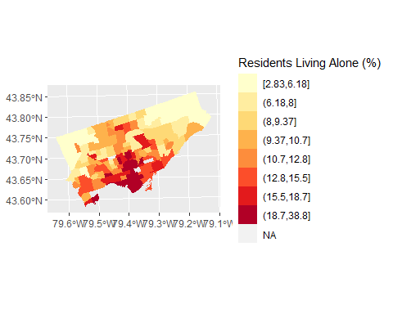

Proportion of Population Living Alone in Toronto, ON Neighbourhoods

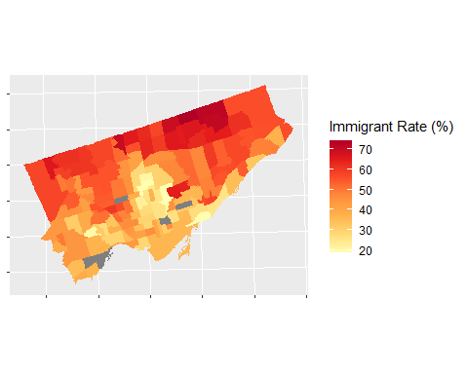

Percent of Immigrated Population in Toronto, ON Neighbourhoods

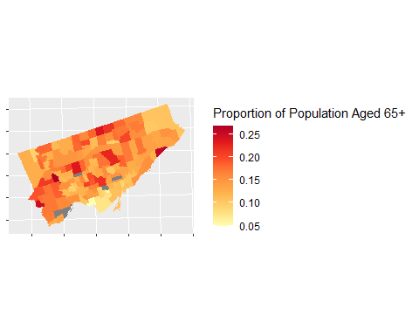

Proportion of Population over 65 years old in Toronto, ON

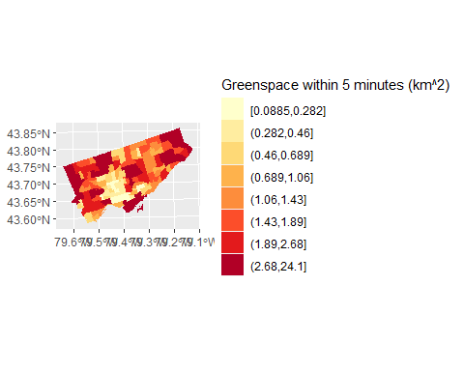

Amount of greenspace within 5 minute walking buffer based on average walking speed in Toronto, ON neighbourhoods

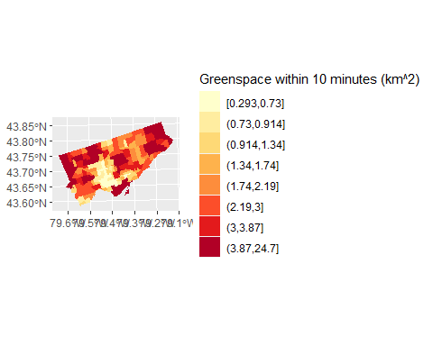

Amount of greenspace within 10 minute walking buffer based on average walking speed in Toronto, ON neighbourhoods

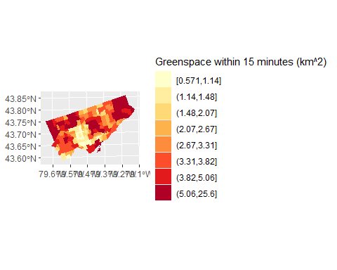

Amount of greenspace within 15 minute walking buffer based on average walking speed in Toronto, ON neighbourhoods

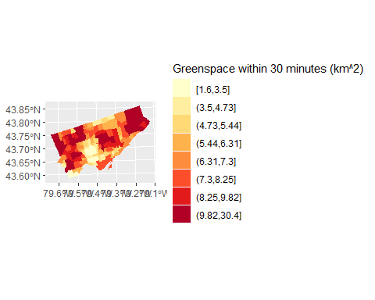

Amount of greenspace within 30 minute walking buffer based on average walking speed in Toronto, ON neighbourhoods

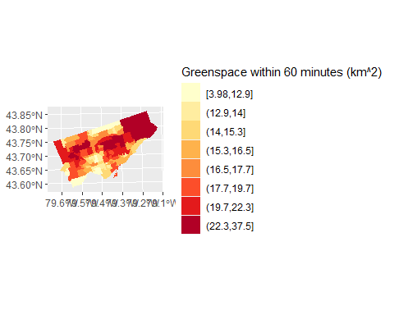

Amount of greenspace within 60 minute walking buffer based on average walking speed in Toronto, ON neighbourhoods

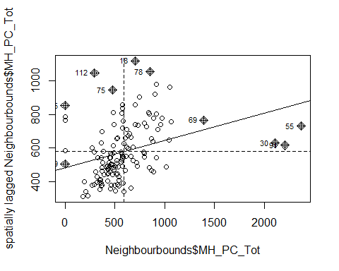

Moran’s scatterplot of empirical variable (observed)

## Joining, by = "key"

## PhantomJS not found. You can install it with webshot::install_phantomjs(). If it is installed, please make sure the phantomjs executable can be found via the PATH variable.

## No trace type specified:  
## Based on info supplied, a 'scatter' trace seems appropriate.  
## Read more about this trace type -> https://plotly.com/r/reference/#scatter

Local Indicators of spatial autocorellation (Moran’s I Map)

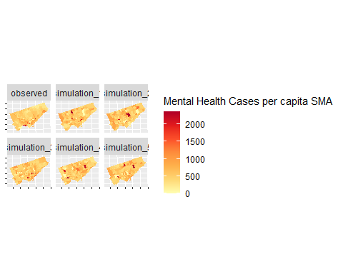

Maps showing the empirical distribution of mental health cases per capita and five simulated landscapes

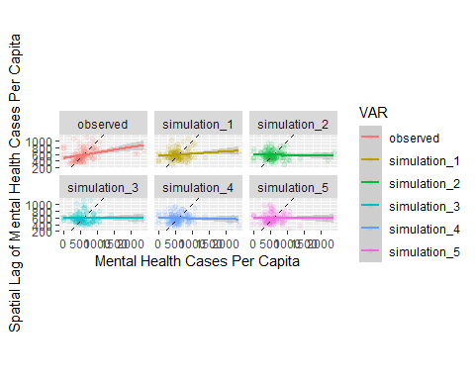

Moran’s scatterplots of empirical and simulated spatial moving averages of mental health cases per capita

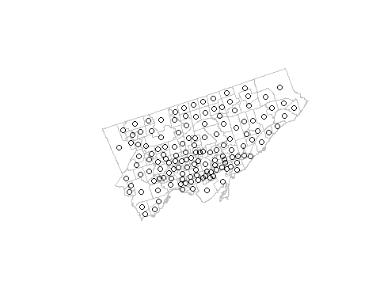

Spatial weights matrices of neighbouring neighbourhoods within a 5 minute walking distance

## Neighbour list object:  
## Number of regions: 140   
## Number of nonzero links: 0   
## Percentage nonzero weights: 0   
## Average number of links: 0   
## 140 regions with no links:  
## 1 2 3 4 5 6 7 8 9 10 11 12 13 14 15 16 17 18 19 20 21 22 23 24 25 26 27 28 29 30 31 32 33 34 35 36 37 38 39 40 41 42 43 44 45 46 47 48 49 50 51 52 53 54 55 56 57 58 59 60 61 62 63 64 65 66 67 68 69 70 71 72 73 74 75 76 77 78 79 80 81 82 83 84 85 86 87 88 89 90 91 92 93 94 95 96 97 98 99 100 101 102 103 104 105 106 107 108 109 110 111 112 113 114 115 116 117 118 119 120 121 122 123 124 125 126 127 128 129 130 131 132 133 134 135 136 137 138 139 140  
## Link number distribution:  
##   
## 0   
## 140

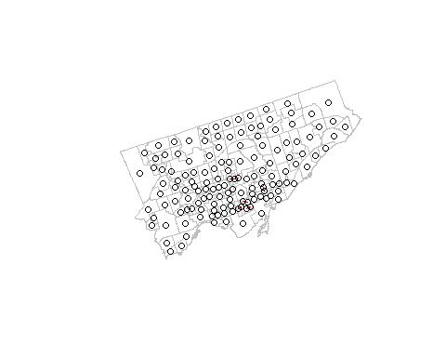

Spatial weights matrices of neighbouring neighbourhoods within a 10 minute walking distance

## Neighbour list object:  
## Number of regions: 140   
## Number of nonzero links: 12   
## Percentage nonzero weights: 0.06122449   
## Average number of links: 0.08571429   
## 129 regions with no links:  
## 1 2 3 4 5 6 7 8 9 10 11 12 13 14 15 16 18 20 21 22 24 25 26 27 28 29 30 31 32 33 34 35 37 38 39 40 41 42 43 44 45 46 47 49 50 51 52 53 54 55 56 57 58 59 60 61 62 63 64 65 67 68 69 70 71 72 73 74 75 76 77 78 79 80 81 82 83 84 85 86 87 89 90 92 93 94 95 96 97 98 99 100 101 102 103 104 105 106 107 109 110 111 112 113 114 116 117 118 119 120 121 123 124 125 126 127 128 129 130 131 132 133 134 135 136 137 138 139 140  
## Link number distribution:  
##   
## 0 1 2   
## 129 10 1   
## 10 least connected regions:  
## 17 19 36 48 66 88 91 108 115 122 with 1 link  
## 1 most connected region:  
## 23 with 2 links

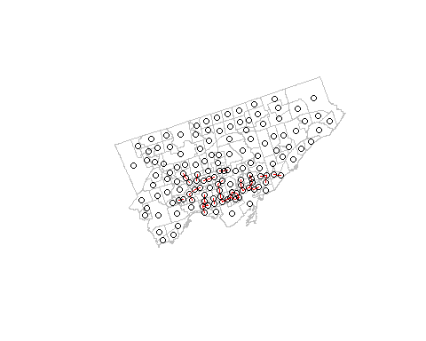

Spatial weights matrices of neighbouring neighbourhoods within a 15 minute walking distance

## Neighbour list object:  
## Number of regions: 140   
## Number of nonzero links: 78   
## Percentage nonzero weights: 0.3979592   
## Average number of links: 0.5571429   
## 91 regions with no links:  
## 5 6 7 8 9 10 11 12 15 16 20 21 22 24 25 26 27 28 29 31 33 35 37 38 39 42 43 44 45 46 47 49 50 51 52 53 57 59 60 61 63 64 65 67 68 70 73 74 76 78 79 80 81 83 84 87 89 92 93 94 95 97 98 99 100 102 103 106 107 111 112 113 116 117 118 123 124 125 126 127 128 130 131 132 133 134 136 137 138 139 140  
## Link number distribution:  
##   
## 0 1 2 3   
## 91 24 21 4   
## 24 least connected regions:  
## 3 4 14 17 18 30 32 40 72 75 85 86 90 96 101 104 105 110 114 120 121 122 129 135 with 1 link  
## 4 most connected regions:  
## 13 62 82 108 with 3 links

##   
## Call:  
## lm(formula = MH_PC_Tot ~ Area_5_Transform, data = Neighbourbounds)  
##   
## Residuals:  
## Min 1Q Median 3Q Max   
## -718.74 -156.05 -45.07 132.04 1763.51   
##   
## Coefficients:  
## Estimate Std. Error t value Pr(>|t|)   
## (Intercept) 1787.2 399.4 4.474 0.0000159 ***  
## Area_5_Transform -200.7 66.7 -3.009 0.00312 **   
## ---  
## Signif. codes: 0 '***' 0.001 '**' 0.01 '*' 0.05 '.' 0.1 ' ' 1  
##   
## Residual standard error: 328.5 on 138 degrees of freedom  
## Multiple R-squared: 0.06157, Adjusted R-squared: 0.05477   
## F-statistic: 9.053 on 1 and 138 DF, p-value: 0.003118

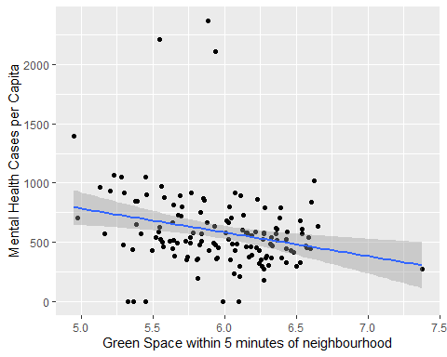

The relationship between green space avaliability within 5 minute walking distance of neighbourhoods and mental health related hosptial admissions

##   
## Call:  
## lm(formula = MH_PC_Tot ~ Area_5_Transform * Unemploy_r * Prop_Alone *   
## PropAge65Plus * Med_Ind_In * Prop_Immigrants, data = Neighbourbounds)  
##   
## Residuals:  
## Min 1Q Median 3Q Max   
## -428.94 -85.45 4.12 56.13 726.17   
##   
## Coefficients:  
## Estimate  
## (Intercept) 47088.568132  
## Area_5_Transform -12024.570067  
## Unemploy_r 24023.765002  
## Prop_Alone 3475682.339750  
## PropAge65Plus -237945.836333  
## Med_Ind_In 4.073163  
## Prop_Immigrants 2843.885342  
## Area_5_Transform:Unemploy_r -3883.229137  
## Area_5_Transform:Prop_Alone -565222.037279  
## Unemploy_r:Prop_Alone -682853.797626  
## Area_5_Transform:PropAge65Plus 58077.671335  
## Unemploy_r:PropAge65Plus -182059.547438  
## Prop_Alone:PropAge65Plus -21262967.850576  
## Area_5_Transform:Med_Ind_In -0.684320  
## Unemploy_r:Med_Ind_In -1.454598  
## Prop_Alone:Med_Ind_In -133.288570  
## PropAge65Plus:Med_Ind_In -37.593010  
## Area_5_Transform:Prop_Immigrants -431.979012  
## Unemploy_r:Prop_Immigrants -839.812741  
## Prop_Alone:Prop_Immigrants -94817.911674  
## PropAge65Plus:Prop_Immigrants -13699.739883  
## Med_Ind_In:Prop_Immigrants -0.157179  
## Area_5_Transform:Unemploy_r:Prop_Alone 117075.038891  
## Area_5_Transform:Unemploy_r:PropAge65Plus 30523.001442  
## Area_5_Transform:Prop_Alone:PropAge65Plus 3535004.238057  
## Unemploy_r:Prop_Alone:PropAge65Plus 4376405.034261  
## Area_5_Transform:Unemploy_r:Med_Ind_In 0.252321  
## Area_5_Transform:Prop_Alone:Med_Ind_In 23.339363  
## Unemploy_r:Prop_Alone:Med_Ind_In 25.022319  
## Area_5_Transform:PropAge65Plus:Med_Ind_In 6.576646  
## Unemploy_r:PropAge65Plus:Med_Ind_In 11.749052  
## Prop_Alone:PropAge65Plus:Med_Ind_In 835.348797  
## Area_5_Transform:Unemploy_r:Prop_Immigrants 141.162666  
## Area_5_Transform:Prop_Alone:Prop_Immigrants 15863.984506  
## Unemploy_r:Prop_Alone:Prop_Immigrants 15553.288346  
## Area_5_Transform:PropAge65Plus:Prop_Immigrants 2302.719242  
## Unemploy_r:PropAge65Plus:Prop_Immigrants 5293.462076  
## Prop_Alone:PropAge65Plus:Prop_Immigrants 540856.989824  
## Area_5_Transform:Med_Ind_In:Prop_Immigrants 0.028191  
## Unemploy_r:Med_Ind_In:Prop_Immigrants 0.036300  
## Prop_Alone:Med_Ind_In:Prop_Immigrants 2.942955  
## PropAge65Plus:Med_Ind_In:Prop_Immigrants 0.923335  
## Area_5_Transform:Unemploy_r:Prop_Alone:PropAge65Plus -758590.520871  
## Area_5_Transform:Unemploy_r:Prop_Alone:Med_Ind_In -4.438415  
## Area_5_Transform:Unemploy_r:PropAge65Plus:Med_Ind_In -2.051295  
## Area_5_Transform:Prop_Alone:PropAge65Plus:Med_Ind_In -148.738025  
## Unemploy_r:Prop_Alone:PropAge65Plus:Med_Ind_In -163.233603  
## Area_5_Transform:Unemploy_r:Prop_Alone:Prop_Immigrants -2687.832531  
## Area_5_Transform:Unemploy_r:PropAge65Plus:Prop_Immigrants -920.007350  
## Area_5_Transform:Prop_Alone:PropAge65Plus:Prop_Immigrants -92861.489147  
## Unemploy_r:Prop_Alone:PropAge65Plus:Prop_Immigrants -92792.135172  
## Area_5_Transform:Unemploy_r:Med_Ind_In:Prop_Immigrants -0.006418  
## Area_5_Transform:Prop_Alone:Med_Ind_In:Prop_Immigrants -0.531343  
## Unemploy_r:Prop_Alone:Med_Ind_In:Prop_Immigrants -0.507582  
## Area_5_Transform:PropAge65Plus:Med_Ind_In:Prop_Immigrants -0.176537  
## Unemploy_r:PropAge65Plus:Med_Ind_In:Prop_Immigrants -0.245220  
## Prop_Alone:PropAge65Plus:Med_Ind_In:Prop_Immigrants -15.606599  
## Area_5_Transform:Unemploy_r:Prop_Alone:PropAge65Plus:Med_Ind_In 29.170846  
## Area_5_Transform:Unemploy_r:Prop_Alone:PropAge65Plus:Prop_Immigrants 16315.559355  
## Area_5_Transform:Unemploy_r:Prop_Alone:Med_Ind_In:Prop_Immigrants 0.091795  
## Area_5_Transform:Unemploy_r:PropAge65Plus:Med_Ind_In:Prop_Immigrants 0.044262  
## Area_5_Transform:Prop_Alone:PropAge65Plus:Med_Ind_In:Prop_Immigrants 2.933798  
## Unemploy_r:Prop_Alone:PropAge65Plus:Med_Ind_In:Prop_Immigrants 2.920342  
## Area_5_Transform:Unemploy_r:Prop_Alone:PropAge65Plus:Med_Ind_In:Prop_Immigrants -0.540377  
## Std. Error  
## (Intercept) 390047.581417  
## Area_5_Transform 65586.822536  
## Unemploy_r 43027.318680  
## Prop_Alone 2659967.914754  
## PropAge65Plus 2638007.926984  
## Med_Ind_In 12.974028  
## Prop_Immigrants 9811.585288  
## Area_5_Transform:Unemploy_r 7217.687848  
## Area_5_Transform:Prop_Alone 446382.127883  
## Unemploy_r:Prop_Alone 304547.195039  
## Area_5_Transform:PropAge65Plus 438920.415672  
## Unemploy_r:PropAge65Plus 316465.714157  
## Prop_Alone:PropAge65Plus 18954493.593107  
## Area_5_Transform:Med_Ind_In 2.145541  
## Unemploy_r:Med_Ind_In 1.908996  
## Prop_Alone:Med_Ind_In 84.758971  
## PropAge65Plus:Med_Ind_In 97.191610  
## Area_5_Transform:Prop_Immigrants 1589.779628  
## Unemploy_r:Prop_Immigrants 978.009319  
## Prop_Alone:Prop_Immigrants 72153.867531  
## PropAge65Plus:Prop_Immigrants 72361.387974  
## Med_Ind_In:Prop_Immigrants 0.395693  
## Area_5_Transform:Unemploy_r:Prop_Alone 51427.215386  
## Area_5_Transform:Unemploy_r:PropAge65Plus 52586.953979  
## Area_5_Transform:Prop_Alone:PropAge65Plus 3146213.218208  
## Unemploy_r:Prop_Alone:PropAge65Plus 2281449.158283  
## Area_5_Transform:Unemploy_r:Med_Ind_In 0.321979  
## Area_5_Transform:Prop_Alone:Med_Ind_In 14.053313  
## Unemploy_r:Prop_Alone:Med_Ind_In 13.014921  
## Area_5_Transform:PropAge65Plus:Med_Ind_In 15.899110  
## Unemploy_r:PropAge65Plus:Med_Ind_In 14.558818  
## Prop_Alone:PropAge65Plus:Med_Ind_In 659.112520  
## Area_5_Transform:Unemploy_r:Prop_Immigrants 159.153687  
## Area_5_Transform:Prop_Alone:Prop_Immigrants 11640.119646  
## Unemploy_r:Prop_Alone:Prop_Immigrants 7665.023146  
## Area_5_Transform:PropAge65Plus:Prop_Immigrants 11660.642577  
## Unemploy_r:PropAge65Plus:Prop_Immigrants 7625.475437  
## Prop_Alone:PropAge65Plus:Prop_Immigrants 571731.164612  
## Area_5_Transform:Med_Ind_In:Prop_Immigrants 0.064035  
## Unemploy_r:Med_Ind_In:Prop_Immigrants 0.046659  
## Prop_Alone:Med_Ind_In:Prop_Immigrants 2.697825  
## PropAge65Plus:Med_Ind_In:Prop_Immigrants 3.027326  
## Area_5_Transform:Unemploy_r:Prop_Alone:PropAge65Plus 381851.055695  
## Area_5_Transform:Unemploy_r:Prop_Alone:Med_Ind_In 2.222380  
## Area_5_Transform:Unemploy_r:PropAge65Plus:Med_Ind_In 2.432897  
## Area_5_Transform:Prop_Alone:PropAge65Plus:Med_Ind_In 107.749876  
## Unemploy_r:Prop_Alone:PropAge65Plus:Med_Ind_In 98.651160  
## Area_5_Transform:Unemploy_r:Prop_Alone:Prop_Immigrants 1246.804038  
## Area_5_Transform:Unemploy_r:PropAge65Plus:Prop_Immigrants 1236.504405  
## Area_5_Transform:Prop_Alone:PropAge65Plus:Prop_Immigrants 91862.532995  
## Unemploy_r:Prop_Alone:PropAge65Plus:Prop_Immigrants 63393.126883  
## Area_5_Transform:Unemploy_r:Med_Ind_In:Prop_Immigrants 0.007694  
## Area_5_Transform:Prop_Alone:Med_Ind_In:Prop_Immigrants 0.434680  
## Unemploy_r:Prop_Alone:Med_Ind_In:Prop_Immigrants 0.338324  
## Area_5_Transform:PropAge65Plus:Med_Ind_In:Prop_Immigrants 0.488550  
## Unemploy_r:PropAge65Plus:Med_Ind_In:Prop_Immigrants 0.360913  
## Prop_Alone:PropAge65Plus:Med_Ind_In:Prop_Immigrants 22.514438  
## Area_5_Transform:Unemploy_r:Prop_Alone:PropAge65Plus:Med_Ind_In 16.649449  
## Area_5_Transform:Unemploy_r:Prop_Alone:PropAge65Plus:Prop_Immigrants 10260.964602  
## Area_5_Transform:Unemploy_r:Prop_Alone:Med_Ind_In:Prop_Immigrants 0.055978  
## Area_5_Transform:Unemploy_r:PropAge65Plus:Med_Ind_In:Prop_Immigrants 0.059261  
## Area_5_Transform:Prop_Alone:PropAge65Plus:Med_Ind_In:Prop_Immigrants 3.617478  
## Unemploy_r:Prop_Alone:PropAge65Plus:Med_Ind_In:Prop_Immigrants 2.773099  
## Area_5_Transform:Unemploy_r:Prop_Alone:PropAge65Plus:Med_Ind_In:Prop_Immigrants 0.454496  
## t value  
## (Intercept) 0.121  
## Area_5_Transform -0.183  
## Unemploy_r 0.558  
## Prop_Alone 1.307  
## PropAge65Plus -0.090  
## Med_Ind_In 0.314  
## Prop_Immigrants 0.290  
## Area_5_Transform:Unemploy_r -0.538  
## Area_5_Transform:Prop_Alone -1.266  
## Unemploy_r:Prop_Alone -2.242  
## Area_5_Transform:PropAge65Plus 0.132  
## Unemploy_r:PropAge65Plus -0.575  
## Prop_Alone:PropAge65Plus -1.122  
## Area_5_Transform:Med_Ind_In -0.319  
## Unemploy_r:Med_Ind_In -0.762  
## Prop_Alone:Med_Ind_In -1.573  
## PropAge65Plus:Med_Ind_In -0.387  
## Area_5_Transform:Prop_Immigrants -0.272  
## Unemploy_r:Prop_Immigrants -0.859  
## Prop_Alone:Prop_Immigrants -1.314  
## PropAge65Plus:Prop_Immigrants -0.189  
## Med_Ind_In:Prop_Immigrants -0.397  
## Area_5_Transform:Unemploy_r:Prop_Alone 2.277  
## Area_5_Transform:Unemploy_r:PropAge65Plus 0.580  
## Area_5_Transform:Prop_Alone:PropAge65Plus 1.124  
## Unemploy_r:Prop_Alone:PropAge65Plus 1.918  
## Area_5_Transform:Unemploy_r:Med_Ind_In 0.784  
## Area_5_Transform:Prop_Alone:Med_Ind_In 1.661  
## Unemploy_r:Prop_Alone:Med_Ind_In 1.923  
## Area_5_Transform:PropAge65Plus:Med_Ind_In 0.414  
## Unemploy_r:PropAge65Plus:Med_Ind_In 0.807  
## Prop_Alone:PropAge65Plus:Med_Ind_In 1.267  
## Area_5_Transform:Unemploy_r:Prop_Immigrants 0.887  
## Area_5_Transform:Prop_Alone:Prop_Immigrants 1.363  
## Unemploy_r:Prop_Alone:Prop_Immigrants 2.029  
## Area_5_Transform:PropAge65Plus:Prop_Immigrants 0.197  
## Unemploy_r:PropAge65Plus:Prop_Immigrants 0.694  
## Prop_Alone:PropAge65Plus:Prop_Immigrants 0.946  
## Area_5_Transform:Med_Ind_In:Prop_Immigrants 0.440  
## Unemploy_r:Med_Ind_In:Prop_Immigrants 0.778  
## Prop_Alone:Med_Ind_In:Prop_Immigrants 1.091  
## PropAge65Plus:Med_Ind_In:Prop_Immigrants 0.305  
## Area_5_Transform:Unemploy_r:Prop_Alone:PropAge65Plus -1.987  
## Area_5_Transform:Unemploy_r:Prop_Alone:Med_Ind_In -1.997  
## Area_5_Transform:Unemploy_r:PropAge65Plus:Med_Ind_In -0.843  
## Area_5_Transform:Prop_Alone:PropAge65Plus:Med_Ind_In -1.380  
## Unemploy_r:Prop_Alone:PropAge65Plus:Med_Ind_In -1.655  
## Area_5_Transform:Unemploy_r:Prop_Alone:Prop_Immigrants -2.156  
## Area_5_Transform:Unemploy_r:PropAge65Plus:Prop_Immigrants -0.744  
## Area_5_Transform:Prop_Alone:PropAge65Plus:Prop_Immigrants -1.011  
## Unemploy_r:Prop_Alone:PropAge65Plus:Prop_Immigrants -1.464  
## Area_5_Transform:Unemploy_r:Med_Ind_In:Prop_Immigrants -0.834  
## Area_5_Transform:Prop_Alone:Med_Ind_In:Prop_Immigrants -1.222  
## Unemploy_r:Prop_Alone:Med_Ind_In:Prop_Immigrants -1.500  
## Area_5_Transform:PropAge65Plus:Med_Ind_In:Prop_Immigrants -0.361  
## Unemploy_r:PropAge65Plus:Med_Ind_In:Prop_Immigrants -0.679  
## Prop_Alone:PropAge65Plus:Med_Ind_In:Prop_Immigrants -0.693  
## Area_5_Transform:Unemploy_r:Prop_Alone:PropAge65Plus:Med_Ind_In 1.752  
## Area_5_Transform:Unemploy_r:Prop_Alone:PropAge65Plus:Prop_Immigrants 1.590  
## Area_5_Transform:Unemploy_r:Prop_Alone:Med_Ind_In:Prop_Immigrants 1.640  
## Area_5_Transform:Unemploy_r:PropAge65Plus:Med_Ind_In:Prop_Immigrants 0.747  
## Area_5_Transform:Prop_Alone:PropAge65Plus:Med_Ind_In:Prop_Immigrants 0.811  
## Unemploy_r:Prop_Alone:PropAge65Plus:Med_Ind_In:Prop_Immigrants 1.053  
## Area_5_Transform:Unemploy_r:Prop_Alone:PropAge65Plus:Med_Ind_In:Prop_Immigrants -1.189  
## Pr(>|t|)  
## (Intercept) 0.9042  
## Area_5_Transform 0.8551  
## Unemploy_r 0.5784  
## Prop_Alone 0.1955  
## PropAge65Plus 0.9284  
## Med_Ind_In 0.7545  
## Prop_Immigrants 0.7728  
## Area_5_Transform:Unemploy_r 0.5922  
## Area_5_Transform:Prop_Alone 0.2096  
## Unemploy_r:Prop_Alone 0.0281  
## Area_5_Transform:PropAge65Plus 0.8951  
## Unemploy_r:PropAge65Plus 0.5669  
## Prop_Alone:PropAge65Plus 0.2657  
## Area_5_Transform:Med_Ind_In 0.7507  
## Unemploy_r:Med_Ind_In 0.4486  
## Prop_Alone:Med_Ind_In 0.1203  
## PropAge65Plus:Med_Ind_In 0.7001  
## Area_5_Transform:Prop_Immigrants 0.7866  
## Unemploy_r:Prop_Immigrants 0.3934  
## Prop_Alone:Prop_Immigrants 0.1930  
## PropAge65Plus:Prop_Immigrants 0.8504  
## Med_Ind_In:Prop_Immigrants 0.6924  
## Area_5_Transform:Unemploy_r:Prop_Alone 0.0258  
## Area_5_Transform:Unemploy_r:PropAge65Plus 0.5635  
## Area_5_Transform:Prop_Alone:PropAge65Plus 0.2650  
## Unemploy_r:Prop_Alone:PropAge65Plus 0.0591  
## Area_5_Transform:Unemploy_r:Med_Ind_In 0.4358  
## Area_5_Transform:Prop_Alone:Med_Ind_In 0.1012  
## Unemploy_r:Prop_Alone:Med_Ind_In 0.0585  
## Area_5_Transform:PropAge65Plus:Med_Ind_In 0.6804  
## Unemploy_r:PropAge65Plus:Med_Ind_In 0.4224  
## Prop_Alone:PropAge65Plus:Med_Ind_In 0.2092  
## Area_5_Transform:Unemploy_r:Prop_Immigrants 0.3781  
## Area_5_Transform:Prop_Alone:Prop_Immigrants 0.1772  
## Unemploy_r:Prop_Alone:Prop_Immigrants 0.0462  
## Area_5_Transform:PropAge65Plus:Prop_Immigrants 0.8440  
## Unemploy_r:PropAge65Plus:Prop_Immigrants 0.4898  
## Prop_Alone:PropAge65Plus:Prop_Immigrants 0.3474  
## Area_5_Transform:Med_Ind_In:Prop_Immigrants 0.6611  
## Unemploy_r:Med_Ind_In:Prop_Immigrants 0.4392  
## Prop_Alone:Med_Ind_In:Prop_Immigrants 0.2790  
## PropAge65Plus:Med_Ind_In:Prop_Immigrants 0.7613  
## Area_5_Transform:Unemploy_r:Prop_Alone:PropAge65Plus 0.0508  
## Area_5_Transform:Unemploy_r:Prop_Alone:Med_Ind_In 0.0496  
## Area_5_Transform:Unemploy_r:PropAge65Plus:Med_Ind_In 0.4020  
## Area_5_Transform:Prop_Alone:PropAge65Plus:Med_Ind_In 0.1718  
## Unemploy_r:Prop_Alone:PropAge65Plus:Med_Ind_In 0.1024  
## Area_5_Transform:Unemploy_r:Prop_Alone:Prop_Immigrants 0.0345  
## Area_5_Transform:Unemploy_r:PropAge65Plus:Prop_Immigrants 0.4593  
## Area_5_Transform:Prop_Alone:PropAge65Plus:Prop_Immigrants 0.3155  
## Unemploy_r:Prop_Alone:PropAge65Plus:Prop_Immigrants 0.1477  
## Area_5_Transform:Unemploy_r:Med_Ind_In:Prop_Immigrants 0.4070  
## Area_5_Transform:Prop_Alone:Med_Ind_In:Prop_Immigrants 0.2256  
## Unemploy_r:Prop_Alone:Med_Ind_In:Prop_Immigrants 0.1380  
## Area_5_Transform:PropAge65Plus:Med_Ind_In:Prop_Immigrants 0.7189  
## Unemploy_r:PropAge65Plus:Med_Ind_In:Prop_Immigrants 0.4991  
## Prop_Alone:PropAge65Plus:Med_Ind_In:Prop_Immigrants 0.4905  
## Area_5_Transform:Unemploy_r:Prop_Alone:PropAge65Plus:Med_Ind_In 0.0841  
## Area_5_Transform:Unemploy_r:Prop_Alone:PropAge65Plus:Prop_Immigrants 0.1163  
## Area_5_Transform:Unemploy_r:Prop_Alone:Med_Ind_In:Prop_Immigrants 0.1055  
## Area_5_Transform:Unemploy_r:PropAge65Plus:Med_Ind_In:Prop_Immigrants 0.4576  
## Area_5_Transform:Prop_Alone:PropAge65Plus:Med_Ind_In:Prop_Immigrants 0.4201  
## Unemploy_r:Prop_Alone:PropAge65Plus:Med_Ind_In:Prop_Immigrants 0.2959  
## Area_5_Transform:Unemploy_r:Prop_Alone:PropAge65Plus:Med_Ind_In:Prop_Immigrants 0.2384  
##   
## (Intercept)   
## Area_5_Transform   
## Unemploy_r   
## Prop_Alone   
## PropAge65Plus   
## Med_Ind_In   
## Prop_Immigrants   
## Area_5_Transform:Unemploy_r   
## Area_5_Transform:Prop_Alone   
## Unemploy_r:Prop_Alone *  
## Area_5_Transform:PropAge65Plus   
## Unemploy_r:PropAge65Plus   
## Prop_Alone:PropAge65Plus   
## Area_5_Transform:Med_Ind_In   
## Unemploy_r:Med_Ind_In   
## Prop_Alone:Med_Ind_In   
## PropAge65Plus:Med_Ind_In   
## Area_5_Transform:Prop_Immigrants   
## Unemploy_r:Prop_Immigrants   
## Prop_Alone:Prop_Immigrants   
## PropAge65Plus:Prop_Immigrants   
## Med_Ind_In:Prop_Immigrants   
## Area_5_Transform:Unemploy_r:Prop_Alone *  
## Area_5_Transform:Unemploy_r:PropAge65Plus   
## Area_5_Transform:Prop_Alone:PropAge65Plus   
## Unemploy_r:Prop_Alone:PropAge65Plus .  
## Area_5_Transform:Unemploy_r:Med_Ind_In   
## Area_5_Transform:Prop_Alone:Med_Ind_In   
## Unemploy_r:Prop_Alone:Med_Ind_In .  
## Area_5_Transform:PropAge65Plus:Med_Ind_In   
## Unemploy_r:PropAge65Plus:Med_Ind_In   
## Prop_Alone:PropAge65Plus:Med_Ind_In   
## Area_5_Transform:Unemploy_r:Prop_Immigrants   
## Area_5_Transform:Prop_Alone:Prop_Immigrants   
## Unemploy_r:Prop_Alone:Prop_Immigrants *  
## Area_5_Transform:PropAge65Plus:Prop_Immigrants   
## Unemploy_r:PropAge65Plus:Prop_Immigrants   
## Prop_Alone:PropAge65Plus:Prop_Immigrants   
## Area_5_Transform:Med_Ind_In:Prop_Immigrants   
## Unemploy_r:Med_Ind_In:Prop_Immigrants   
## Prop_Alone:Med_Ind_In:Prop_Immigrants   
## PropAge65Plus:Med_Ind_In:Prop_Immigrants   
## Area_5_Transform:Unemploy_r:Prop_Alone:PropAge65Plus .  
## Area_5_Transform:Unemploy_r:Prop_Alone:Med_Ind_In *  
## Area_5_Transform:Unemploy_r:PropAge65Plus:Med_Ind_In   
## Area_5_Transform:Prop_Alone:PropAge65Plus:Med_Ind_In   
## Unemploy_r:Prop_Alone:PropAge65Plus:Med_Ind_In   
## Area_5_Transform:Unemploy_r:Prop_Alone:Prop_Immigrants *  
## Area_5_Transform:Unemploy_r:PropAge65Plus:Prop_Immigrants   
## Area_5_Transform:Prop_Alone:PropAge65Plus:Prop_Immigrants   
## Unemploy_r:Prop_Alone:PropAge65Plus:Prop_Immigrants   
## Area_5_Transform:Unemploy_r:Med_Ind_In:Prop_Immigrants   
## Area_5_Transform:Prop_Alone:Med_Ind_In:Prop_Immigrants   
## Unemploy_r:Prop_Alone:Med_Ind_In:Prop_Immigrants   
## Area_5_Transform:PropAge65Plus:Med_Ind_In:Prop_Immigrants   
## Unemploy_r:PropAge65Plus:Med_Ind_In:Prop_Immigrants   
## Prop_Alone:PropAge65Plus:Med_Ind_In:Prop_Immigrants   
## Area_5_Transform:Unemploy_r:Prop_Alone:PropAge65Plus:Med_Ind_In .  
## Area_5_Transform:Unemploy_r:Prop_Alone:PropAge65Plus:Prop_Immigrants   
## Area_5_Transform:Unemploy_r:Prop_Alone:Med_Ind_In:Prop_Immigrants   
## Area_5_Transform:Unemploy_r:PropAge65Plus:Med_Ind_In:Prop_Immigrants   
## Area_5_Transform:Prop_Alone:PropAge65Plus:Med_Ind_In:Prop_Immigrants   
## Unemploy_r:Prop_Alone:PropAge65Plus:Med_Ind_In:Prop_Immigrants   
## Area_5_Transform:Unemploy_r:Prop_Alone:PropAge65Plus:Med_Ind_In:Prop_Immigrants   
## ---  
## Signif. codes: 0 '***' 0.001 '**' 0.01 '*' 0.05 '.' 0.1 ' ' 1  
##   
## Residual standard error: 194.6 on 71 degrees of freedom  
## (5 observations deleted due to missingness)  
## Multiple R-squared: 0.8089, Adjusted R-squared: 0.6393   
## F-statistic: 4.771 on 63 and 71 DF, p-value: 0.0000000003519

#Model with everything  
testmodel <- lm(formula = MH_PC_Tot ~Unemploy_r * Prop_Alone * PropAge65Plus * Med_Ind_In *Prop_Immigrants, data = Neighbourbounds)  
summary(testmodel)

##   
## Call:  
## lm(formula = MH_PC_Tot ~ Unemploy_r * Prop_Alone * PropAge65Plus *   
## Med_Ind_In * Prop_Immigrants, data = Neighbourbounds)  
##   
## Residuals:  
## Min 1Q Median 3Q Max   
## -618.37 -95.07 -8.57 77.35 1112.40   
##   
## Coefficients:  
## Estimate  
## (Intercept) 1060.4637904  
## Unemploy_r -1384.4439564  
## Prop_Alone 29845.5672901  
## PropAge65Plus -31044.7688833  
## Med_Ind_In -0.1643702  
## Prop_Immigrants 189.6270393  
## Unemploy_r:Prop_Alone 11829.6749243  
## Unemploy_r:PropAge65Plus 11451.3790970  
## Prop_Alone:PropAge65Plus 51943.0553446  
## Unemploy_r:Med_Ind_In 0.0641787  
## Prop_Alone:Med_Ind_In 1.9514368  
## PropAge65Plus:Med_Ind_In 2.0575972  
## Unemploy_r:Prop_Immigrants 9.6133154  
## Prop_Alone:Prop_Immigrants -1421.0116683  
## PropAge65Plus:Prop_Immigrants -244.0415603  
## Med_Ind_In:Prop_Immigrants -0.0038229  
## Unemploy_r:Prop_Alone:PropAge65Plus -85695.8469316  
## Unemploy_r:Prop_Alone:Med_Ind_In -0.6943562  
## Unemploy_r:PropAge65Plus:Med_Ind_In -0.5204216  
## Prop_Alone:PropAge65Plus:Med_Ind_In -18.3681589  
## Unemploy_r:Prop_Alone:Prop_Immigrants -191.0473516  
## Unemploy_r:PropAge65Plus:Prop_Immigrants -163.0276864  
## Prop_Alone:PropAge65Plus:Prop_Immigrants 1082.7274056  
## Unemploy_r:Med_Ind_In:Prop_Immigrants -0.0006467  
## Prop_Alone:Med_Ind_In:Prop_Immigrants -0.0284855  
## PropAge65Plus:Med_Ind_In:Prop_Immigrants -0.0112384  
## Unemploy_r:Prop_Alone:PropAge65Plus:Med_Ind_In 4.7405286  
## Unemploy_r:Prop_Alone:PropAge65Plus:Prop_Immigrants 1853.7675341  
## Unemploy_r:Prop_Alone:Med_Ind_In:Prop_Immigrants 0.0144112  
## Unemploy_r:PropAge65Plus:Med_Ind_In:Prop_Immigrants 0.0081573  
## Prop_Alone:PropAge65Plus:Med_Ind_In:Prop_Immigrants 0.3978293  
## Unemploy_r:Prop_Alone:PropAge65Plus:Med_Ind_In:Prop_Immigrants -0.1117155  
## Std. Error  
## (Intercept) 10462.2287223  
## Unemploy_r 1160.1477962  
## Prop_Alone 76940.4638970  
## PropAge65Plus 74350.0128529  
## Med_Ind_In 0.2538616  
## Prop_Immigrants 210.6366436  
## Unemploy_r:Prop_Alone 8658.8343607  
## Unemploy_r:PropAge65Plus 8516.7031222  
## Prop_Alone:PropAge65Plus 575170.4882362  
## Unemploy_r:Med_Ind_In 0.0367272  
## Prop_Alone:Med_Ind_In 1.8182509  
## PropAge65Plus:Med_Ind_In 1.8572268  
## Unemploy_r:Prop_Immigrants 21.9004952  
## Prop_Alone:Prop_Immigrants 1823.4737933  
## PropAge65Plus:Prop_Immigrants 1563.3269175  
## Med_Ind_In:Prop_Immigrants 0.0072578  
## Unemploy_r:Prop_Alone:PropAge65Plus 65691.9154891  
## Unemploy_r:Prop_Alone:Med_Ind_In 0.2855584  
## Unemploy_r:PropAge65Plus:Med_Ind_In 0.2601068  
## Prop_Alone:PropAge65Plus:Med_Ind_In 14.6137168  
## Unemploy_r:Prop_Alone:Prop_Immigrants 205.5988091  
## Unemploy_r:PropAge65Plus:Prop_Immigrants 164.3999552  
## Prop_Alone:PropAge65Plus:Prop_Immigrants 14669.7200871  
## Unemploy_r:Med_Ind_In:Prop_Immigrants 0.0009835  
## Prop_Alone:Med_Ind_In:Prop_Immigrants 0.0543989  
## PropAge65Plus:Med_Ind_In:Prop_Immigrants 0.0547443  
## Unemploy_r:Prop_Alone:PropAge65Plus:Med_Ind_In 2.0380051  
## Unemploy_r:Prop_Alone:PropAge65Plus:Prop_Immigrants 1662.9423572  
## Unemploy_r:Prop_Alone:Med_Ind_In:Prop_Immigrants 0.0084628  
## Unemploy_r:PropAge65Plus:Med_Ind_In:Prop_Immigrants 0.0069837  
## Prop_Alone:PropAge65Plus:Med_Ind_In:Prop_Immigrants 0.4750272  
## Unemploy_r:Prop_Alone:PropAge65Plus:Med_Ind_In:Prop_Immigrants 0.0648160  
## t value Pr(>|t|)  
## (Intercept) 0.101 0.9195  
## Unemploy_r -1.193 0.2355  
## Prop_Alone 0.388 0.6989  
## PropAge65Plus -0.418 0.6771  
## Med_Ind_In -0.647 0.5188  
## Prop_Immigrants 0.900 0.3701  
## Unemploy_r:Prop_Alone 1.366 0.1749  
## Unemploy_r:PropAge65Plus 1.345 0.1817  
## Prop_Alone:PropAge65Plus 0.090 0.9282  
## Unemploy_r:Med_Ind_In 1.747 0.0835  
## Prop_Alone:Med_Ind_In 1.073 0.2857  
## PropAge65Plus:Med_Ind_In 1.108 0.2705  
## Unemploy_r:Prop_Immigrants 0.439 0.6616  
## Prop_Alone:Prop_Immigrants -0.779 0.4376  
## PropAge65Plus:Prop_Immigrants -0.156 0.8763  
## Med_Ind_In:Prop_Immigrants -0.527 0.5995  
## Unemploy_r:Prop_Alone:PropAge65Plus -1.305 0.1950  
## Unemploy_r:Prop_Alone:Med_Ind_In -2.432 0.0168  
## Unemploy_r:PropAge65Plus:Med_Ind_In -2.001 0.0480  
## Prop_Alone:PropAge65Plus:Med_Ind_In -1.257 0.2116  
## Unemploy_r:Prop_Alone:Prop_Immigrants -0.929 0.3549  
## Unemploy_r:PropAge65Plus:Prop_Immigrants -0.992 0.3237  
## Prop_Alone:PropAge65Plus:Prop_Immigrants 0.074 0.9413  
## Unemploy_r:Med_Ind_In:Prop_Immigrants -0.658 0.5123  
## Prop_Alone:Med_Ind_In:Prop_Immigrants -0.524 0.6017  
## PropAge65Plus:Med_Ind_In:Prop_Immigrants -0.205 0.8378  
## Unemploy_r:Prop_Alone:PropAge65Plus:Med_Ind_In 2.326 0.0220  
## Unemploy_r:Prop_Alone:PropAge65Plus:Prop_Immigrants 1.115 0.2676  
## Unemploy_r:Prop_Alone:Med_Ind_In:Prop_Immigrants 1.703 0.0916  
## Unemploy_r:PropAge65Plus:Med_Ind_In:Prop_Immigrants 1.168 0.2455  
## Prop_Alone:PropAge65Plus:Med_Ind_In:Prop_Immigrants 0.837 0.4043  
## Unemploy_r:Prop_Alone:PropAge65Plus:Med_Ind_In:Prop_Immigrants -1.724 0.0878  
##   
## (Intercept)   
## Unemploy_r   
## Prop_Alone   
## PropAge65Plus   
## Med_Ind_In   
## Prop_Immigrants   
## Unemploy_r:Prop_Alone   
## Unemploy_r:PropAge65Plus   
## Prop_Alone:PropAge65Plus   
## Unemploy_r:Med_Ind_In .  
## Prop_Alone:Med_Ind_In   
## PropAge65Plus:Med_Ind_In   
## Unemploy_r:Prop_Immigrants   
## Prop_Alone:Prop_Immigrants   
## PropAge65Plus:Prop_Immigrants   
## Med_Ind_In:Prop_Immigrants   
## Unemploy_r:Prop_Alone:PropAge65Plus   
## Unemploy_r:Prop_Alone:Med_Ind_In *  
## Unemploy_r:PropAge65Plus:Med_Ind_In *  
## Prop_Alone:PropAge65Plus:Med_Ind_In   
## Unemploy_r:Prop_Alone:Prop_Immigrants   
## Unemploy_r:PropAge65Plus:Prop_Immigrants   
## Prop_Alone:PropAge65Plus:Prop_Immigrants   
## Unemploy_r:Med_Ind_In:Prop_Immigrants   
## Prop_Alone:Med_Ind_In:Prop_Immigrants   
## PropAge65Plus:Med_Ind_In:Prop_Immigrants   
## Unemploy_r:Prop_Alone:PropAge65Plus:Med_Ind_In *  
## Unemploy_r:Prop_Alone:PropAge65Plus:Prop_Immigrants   
## Unemploy_r:Prop_Alone:Med_Ind_In:Prop_Immigrants .  
## Unemploy_r:PropAge65Plus:Med_Ind_In:Prop_Immigrants   
## Prop_Alone:PropAge65Plus:Med_Ind_In:Prop_Immigrants   
## Unemploy_r:Prop_Alone:PropAge65Plus:Med_Ind_In:Prop_Immigrants .  
## ---  
## Signif. codes: 0 '***' 0.001 '**' 0.01 '*' 0.05 '.' 0.1 ' ' 1  
##   
## Residual standard error: 208.5 on 103 degrees of freedom  
## (5 observations deleted due to missingness)  
## Multiple R-squared: 0.682, Adjusted R-squared: 0.5863   
## F-statistic: 7.126 on 31 and 103 DF, p-value: 0.00000000000001536

=======

**Analysis**

*Choropleth Maps*

Population density choropleth Map : This map shows the population density per capita in each census tract of Toronto. Notably, a significant proportion of the population lives in the lower central area with some census tracts containing >20,000 people. Neighbourhoods surrounding this busy central district seem to have lower population density as you deviate further from the highly populated tracts downtown. The majority of neighbourhoods on the outskirts of this study area have a very low population density. Overall the population density of Toronto is heavily skewed towards the lower centre census tracts near downtown.

Mental Health Cases per Capita Choropleth Map :The mental health cases choropleth maps show a number of interesting results. The highest mental health hospital admissions per capita were primarily in the lower central area of the city but high rates are also seen in the southern portion. The mental health cases correlates with the population density map to a small degree implying population may also have a slight effect on mental health. Overall, the mental health cases between males and females were mostly similar with little variation, however there were more mental health admissions per capita for males.

Unemployment Rate Chloropleth Map : The unemployment rate data collected shows that neighbourhoods away from the central, high population density district, tend to have a higher unemployment rates when compared to other neighbourhoods. The majority of high unemployment rates occur on the outskirts of the study area with some deviation. When compared with the population density choropleth map there seems to be a slight inverse relationship. Implying a small correlation between unemployment rate and population density.

Income Choropleth Map : The income data show a significant difference between median income and average income by census tract. The data shows a clear income disparity in Toronto as the highest median income 60,000 CAD but the highest average income (in the same census tract) is ~ 200,000 CAD. It is likely that some ultra - wealthy individuals are outliers in the data causing the significant income disparity. The data shows that the wealthiest individuals live in central, and southern Toronto while the neighbourhoods around it are relatively similar.

Living Situation Chloropleth Map : The proportion of residents living with relatives is large along the boundaries of this study area, and lower in the areas of high population density. For residents living with non-relatives, this proportion increases in the central district due to its close proximity to universities which mean students are likely living with roommates. The proportion of those living alone is extremely high in the central district and closely correlates with the high mental health cases per capita graph. This data shows a strong correlation between these to factors.

Age Proportion in each Neighbourhood Chloropleth Map : There are a few pockets scattered around the study area that have a high proportion of people over the age of 65, but there is no clear pattern and it looks to have no correlation to previously graphed data. Immigration: Immigrant rates are the highest in the northern parts of the study area, hovering between 50 - 70%, and dropping as low as 20% in the central neighbourhoods. Four neighbourhoods have no immigration data. There is a very notable absence of immigrants in the high income subdivisions as seen in the income choropleth map.

Amount of green Space Chloropleth Map: These choropleth maps show the green space within the previously defined 5,10,15,30, and 60 minute buffers. The 5 minute , 10 minute , 15 minute , 30 minute , and 60 minute maps shows the green space that is accessible within each neighbourhood . As the buffers increase the maps become increasingly homogenous with the neighbourhoods near the middle length of Toronto having the highest access to green space. The concrete jungle of downtown has very little access to green space, this area of Toronto also had the highest mental health admissions per capita.Although a number of factors may be contributing to mental health rates, green space correlates quite well with the lower mental health admission areas.

*Spatial Weights Matrices*

A spatial weights matrix was created for each established distance buffer referenced in the introduction to help understand the geographic distribution and accessibility. As mentioned beforehand, a resident of neighbourhood X could very well walk to a park in neighbourhood Y. As seen in the figures generated with the present code, only a few links located in central Toronto show neighbourhoods accessible in 5 minute , 10 minute , and 15 minute walking time-frames, at an average walking pace. Based on our analysis, the average walking times/distances don’t allow the individual to walk over to a different neighbourhood park which supports our theory that individuals go to parks nearest to them.

*Spatial Moving Averages Scatterplots*

Looking at the scatterplots figure , the spatial moving average represents the difference between the empirical and simulated variables, along with the fitted regression line. In the figure, the slope of the line tends to be flat in the simulated variables, which is to be expected as these variables are null landscapes and therefore spatially random. On the other hand, the empirical variable has a slope that is closer to the 45-degree line than any of the simulated variables, suggesting that the values of the variable are not independent of their local mean, i.e., the probability of a non-random pattern is high. This result is significant since it indicates that our data shows spatial autocorrelation, allowing us to continue our tests to determine which parameters influence the data.

*Simulated Landscapes*

However, for the purpose of certainty, the simulated landscapes figure shows the distribution of the observed variable and five simulated (random) landscapes. It is readily apparent that the map with the empirical variable is different from the simulated variables, suggesting that the mental health cases for the population per capita of Toronto are not random. The highest average mental health cases per area appear to be around southern Toronto neighbourhoods, followed by the central area and decrease towards the north.

*Morans I*

Since the data is considered to be not spatially random, a Moran’s test seemed like the next step towards explaining the trends in mental health admissions per capita for the population of Toronto. It is important to work with values associated with area in order to acquire results that represent proportions, and not just absolute counts. The Moran’s I value had a p-value below 0.05 (~0.00016), indicating that the variables were spatially autocorrelated with a very safe Confidence Interval. The Moran’s map shows that the majority of statistically high cases of mental health admissions are seen in the south-west and south-central areas of the city. In contrast, the northeast has significantly lower mental health cases.

*Regression Model*

We created linear models comparing the amount of green space within each walking distance (5, 10, 15, 30, 60 minutes) and the number of mental health cases per capita. We found a small amount of significant correlation between mental health cases and the amount of green space available within 5, 10, 15, and 30 minutes of a neighbourhood (SEE TABLES ADD IN REFERNCE?). The highest correlation was seen in the 5-minute distance (Adjusted R squared of 0.051), this value and its significance continued to decrease as the distance increased. For the 60-minute walking distance, the smallest R squared value (0.02) showed a clear relationship between distance to green space and mental health cases.

The progressively lower R squared value suggests a minor correlation between the amount of green space available to Torontonians and mental health admissions to hospitals. This correlation was most significant at the closest walking distance of 5 minutes \ref{fig:LR-5}, and as this distance increased, the correlation and its significance decreased. This indicates that easy, more immediate access to green spaces has a positive impact on residents’ mental health.

As mentioned, there was only a small correlation between greenspace within a 5-minute walking distance and mental health cases. However, based on the available literature, access to green space is not the only factor that impacts one’s mental health. Mental health is affected by a number of socioeconomic factors including health, income, age, and physical activity to name a few (Nutsford et al., 2013; Alcock et al., 2014; Hassen, 2016; Lopes et al., 2020; and Rigolon et al., 2021) . When combined with these and other factors the availability of greenspace may have a more considerable impact on mental health.

Several linear models were created using the five minute greenspace buffer because it correlated best with improved mental health cases. In addition to the five minute buffer, other factors including income, age, unemployment, and if the individual lives alone or identifies as an immigrant were included in the linear model. Models were run to determine which of these variables best correlated with improved mental health. Overall, the model that had the highest correlation with mental health cases used the five minute green space buffer, unemployment rate, and proportion of individuals who live alone .

**Conclusion**

Relationships between green spaces in cities and their impact on mental health is extensive and conclusive. The more accessible a park or green space is, the happier and healthier its users and neighbors are (Francis et al., 2012; Barton and Rogerson, 2017; Callahan et al., 2020; Collins et al., 2020; Martin et al., 2020). This research group’s interest lied specifically in the demographic and urban aspects that had the greatest impact on the strength of this green-space and mental health relationship in the city of Toronto, ON, Canada. We obtained publicly available demographic and health data from City of Toronto Open data Portal, and performed a variety of spatial statistic tests that yielded conclusive results as well as informative maps and graphs. The study of patterns of spatial autocorrelation of mental health cases and green space accessibility in Toronto yielded the following conclusions.

* Moran’s I plot (TRUE) suggests statistically significant clustering. This suggests higher mental health-related hospital admissions in the SW and southern central areas of the city, and statistically less cases of mental health in the northeastern part of the city. Neighborhoods with less green space available (within reasonable walking distance) were linked to higher hospital admissions related to mental health issues. Regression analysis suggests a casual but significant relationship between a neighbourhood’s mental health and how accessible, empirically (not subjective to the “walkers”), the green spaces are to people living there.

-The conclusive relationship stated above was exacerbated by other factors. Neighbourhoods with high immigrant populations, high unemployment rates, low annual average incomes, high proportion of people living alone or senior citizens (over 65 years old) were demonstrated to be more sensitive to the accessibility of green spaces. This suggests that these groups are at higher risk of being mentally unhealthy when parks and green spaces become inaccessible to them. >>>>>>> 0aece65abb06f1a36c580341770fb5e24513703e

The present paper, alongside the available literature on the matter, demonstrate the necessity for modern cities to invest in green spaces that are available and easily accessible to specific groups of more vulnerable people. Urban planners must continue to focus on equitable solutions for new park infrastructure, promoting healthier cities with the help of spatial statisticians.

*Acknowledgements*

We thank the reader for their valuable time, as well as Dr Antonio Paez (SEES, McMaster University) and Rajveer Ubhi (Applied Spatial Statistics: ENVSOCTY 4GA3) for their assistance and valuable feedback during the 2021 Winter semester and the present paper.

**References**

Alcock, I., White, M. P., Wheeler, B. W., Fleming, L. E., & Depledge, M. H. (2014). Longitudinal Effects on Mental Health of Moving to Greener and Less Green Urban Areas. Environmental Science & Technology, 48(2), 1247–1255. <https://doi.org/10.1021/es403688w>

Barton, J., & Rogerson, M. (2017). The importance of greenspace for mental health. BJPsych. International, 14(4), 79–81. <https://doi.org/10.1192/s2056474000002051>

Bryan, S. N., & Katzmarzyk, P. T. (2009). Patterns and trends in walking behaviour among Canadian adults. Canadian Journal of Public Health, 100(4), 294-298.

Callaghan, A., McCombe, G., Harrold, A., McMeel, C., Mills, G., Moore-Cherry, N., & Cullen, W. (2020). The impact of green spaces on mental health in urban settings: a scoping review. Journal of Mental Health, 1–15. <https://doi.org/10.1080/09638237.2020.1755027>

Collins, R. M., Spake, R., Brown, K. A., Ogutu, B. O., Smith, D., & Eigenbrod, F. (2020). A systematic map of research exploring the effect of greenspace on mental health. Landscape and Urban Planning, 201, 103823. <https://doi.org/10.1016/j.landurbplan.2020.103823>

Dadvand, P., Bartoll, X., Basagaña, X., Dalmau-Bueno, A., Martinez, D., Ambros, A., … & Nieuwenhuijsen, M. J. (2016). Green spaces and general health: roles of mental health status, social support, and physical activity. Environment international, 91, 161-167.

Donahue, R. (2011). Pedestrians and park planning: How far will people walk. City Parks Blog.

Engemann, K., Pedersen, C. B., Arge, L., Tsirogiannis, C., Mortensen, P. B., & Svenning, J.-C. (2019). Residential green space in childhood is associated with lower risk of psychiatric disorders from adolescence into adulthood. Proceedings of the National Academy of Sciences, 116(11), 5188–5193. <https://doi.org/10.1073/pnas.1807504116>

Francis, J., Wood, L. J., Knuiman, M., & Giles-Corti, B. (2012). Quality or quantity? Exploring the relationship between Public Open Space attributes and mental health in Perth, Western Australia. Social science & medicine, 74(10), 1570-1577.

Hassen, A. N. (2016). Green Space in the City: How Toronto’s Green Spaces Promote Mental Health. Wellesley Institute. <https://www.wellesleyinstitute.com/healthy-communities/green-space-in-the-city-how-torontos-green-spaces-promote-mental-health/>.

Lopes, S., Lima, M., & Silva, K. (2020). Nature can get it out of your mind: The rumination reducing effects of contact with nature and the mediating role of awe and mood. Journal of Environmental Psychology, 71, 101489.

Martin, L., White, M. P., Hunt, A., Richardson, M., Pahl, S., & Burt, J. (2020). Nature contact, nature connectedness and associations with health, wellbeing and pro-environmental behaviours. Journal of Environmental Psychology, 68, 101389.

Moore, S., Gauvin, L., Daniel, M., Kestens, Y., Bockenholt, U., Dubé, L., & Richard, L. (2010). Associations among Park Use, Age, Social Participation, and Neighborhood Age Composition in Montreal. Leisure Sciences, 32(4), 318–336.

Nutsford, D., Pearson, A. L., & Kingham, S. (2013). An ecological study investigating the association between access to urban green space and mental health. Public Health, 127(11), 1005–1011. <https://doi.org/10.1016/j.puhe.2013.08.016>

Open Data Dataset. City of Toronto Open Data Portal. (2021). <https://open.toronto.ca/dataset/neighbourhoods/>

Open Data Dataset. City of Toronto Open Data Portal. (2021). <https://open.toronto.ca/dataset/parks/>.

Richardson, E. A., Pearce, J., Mitchell, R., & Kingham, S. (2013). Role of physical activity in the relationship between urban green space and health. Public Health, 127(4), 318–324. <https://doi.org/10.1016/j.puhe.2013.01.004>

Rigolon, A., Browning, M. H., McAnirlin, O., & Yoon, H. V. (2021). Green Space and Health Equity: A Systematic Review on the Potential of Green Space to Reduce Health Disparities. International journal of environmental research and public health, 18(5), 2563.

Shanahan, D. F., Fuller, R. A., Bush, R., Lin, B. B., & Gaston, K. J. (2015). The Health Benefits of Urban Nature: How Much Do We Need? BioScience, 65(5), 476–485. <https://doi.org/10.1093/biosci/biv032>

St. Michaels’s Hospital - SMH webDev team. (2021). Toronto Community Health Profiles Partnership-Data Tables. <http://www.torontohealthprofiles.ca/a_dataTables.php?varTab=HPDtbl>.

van den Berg, M., van Poppel, M., van Kamp, I., Andrusaityte, S., Balseviciene, B., Cirach, M., … Maas, J. (2016). Visiting green space is associated with mental health and vitality: A cross-sectional study in four european cities. Health & Place, 38, 8–15. <https://doi.org/10.1016/j.healthplace.2016.01.003>